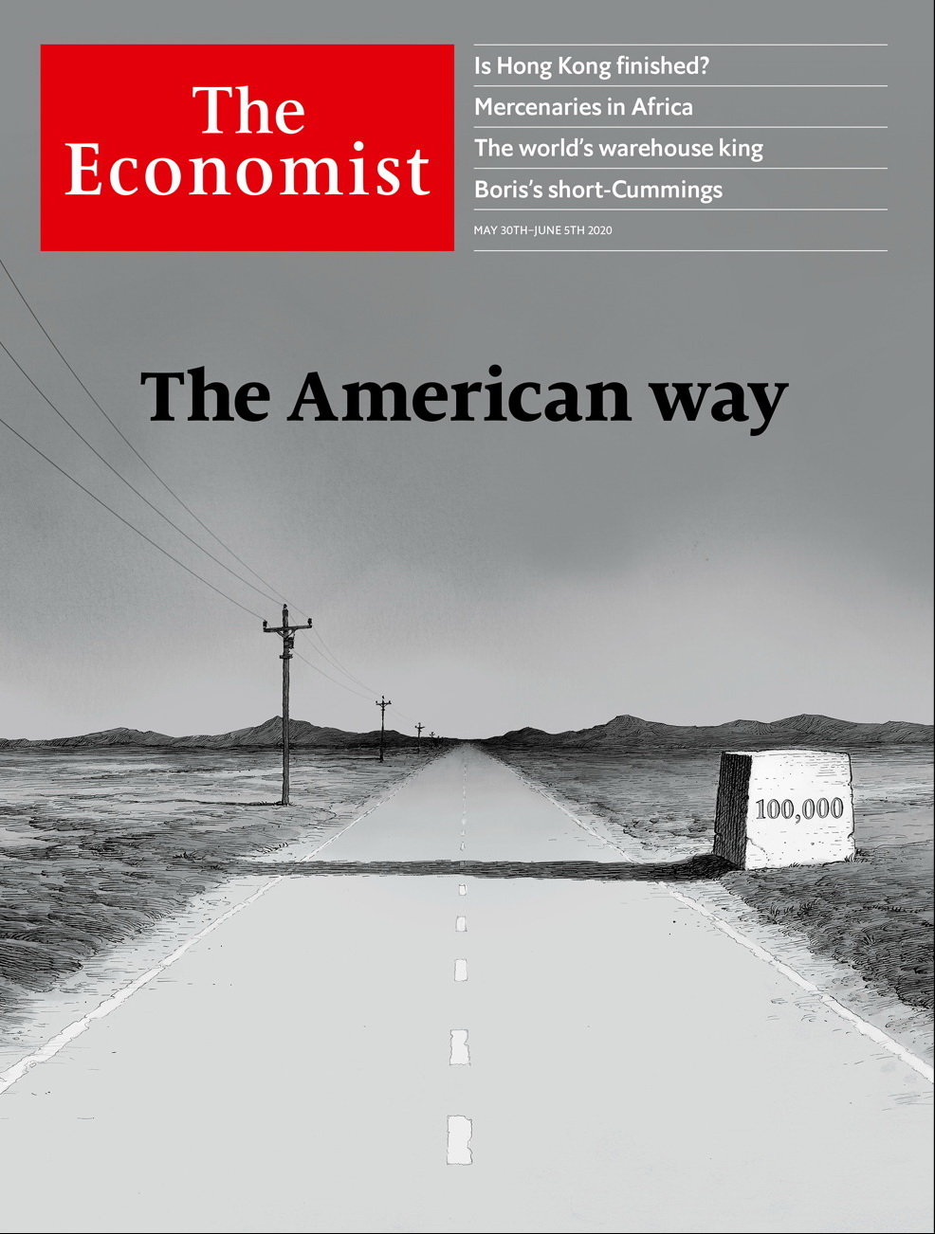

# Table of Contents

The world this week

Politics this week

Business this week

KAL’s cartoon

Leaders

Covid-19: The American way

China’s power: Dragon strike

State aid in Europe: A €2trn loophole

Global tourism: Summer break

Masks and covid-19: Face it

Letters

Letters to the editor: On Bolivia, bio-weapons, covid-19 research, food, “The Leopard”

Briefing

Covid-19 in America: 100,000 and counting

United States

Cyber-defence: Policing the Wild West

Google and China: Everything in moderation

The Mashpee Wampanoag: To lose your land twice

Troubled universities: College blues

Lexington: Black America in peril

The Americas

Brazil: Losing the battle

Mexico: The mystery of the missing mummies

Bello: Forwards and backwards

Asia

North Korea’s economy: Running out of juche

Universities in Australia: Bye degrees

India and China: Mountain claimers

Sexual minorities in Myanmar: Aygay angslay

Banyan: Take these broken wings

China

Hong Kong’s freedoms: Rule by fear

Chaguan: “Wolf Warrior” fantasies

Middle East & Africa

Wars in Africa: Are mercenaries no longer taboo?

Where dead men vote: Burundi’s sham election

Ping don’t cheque: Dial it up

Lebanon’s crisis: Devaluation gardens

Iran: The revolution will be televised

Europe

State aid: The visible hand

Covid-19 in Germany: The virus detectives

Espionage pacts: To your good stealth

Viral couture: Paris masked

Eastern Europe’s economies: Into the trough

Charlemagne: The benefits of Brexit

Britain

The Brexit negotiations: Every man to his island

Puppies: Barking mad

Dominic Cummings: Ill-advised

Education: Back to school, sort of

Carmaking: The Lotus position

Carmaking: Assembly without assembling

Summer holidays: On the beaches

Bagehot: I love the sound of breaking rules

International

Travel after covid: Lonely planet

Chinese tourists: Still grounded

Business

Chinese diaspora Inc: High-wire act

Asian business dynasties: Godfathers depart, too

Energy companies: Don’t worry, it’s all under control

Information technology: AI manoeuvres

Bartleby: From BC to AD

Carmaking: Kiss and make up

The grooming business: Things get hairy

Schumpeter: The warehouse king

Finance & economics

Private equity (1): More money, more problems

Private equity (2): From locusts to honey bees

Monetary policy in China: The thin red line

Buttonwood: The inflation bug

A change of plan: China's growth target

Carmen Reinhart: No fear of floating

Economic statistics: Crisis measures

Free exchange: A political economist

Schools brief

Move fast, mend things: Softening the blow

Science & technology

Covid-19 and face masks: We interrupt this transmission...

Antifouling technology: Keelhaul that ’bot!

Not yet, but soon: Crew Dragon is postponed

Recycling: Crackle, pop, snap

Books & arts

Artistic posterity: Still lives

Power in America: Clash of the titans

European history: A breed apart

The story of a cult novel: Perish and publish

Johnson: They can feel it all over

Home Entertainment: Damn fine coffee

Home Entertainment: Will to power

Economic & financial indicators

Economic data, commodities and markets

Graphic detail

Bogus academia: Garbage in

Obituary

Antonio Bolívar: The wisdom of the forest



### Friday, May 29, 2020

|  |  |
| --- | --- |
| The world this week | 3 |
| Leaders | 5 |
| Letters | 1 |
| Briefing | 1 |
| United States | 5 |
| The Americas | 3 |
| Asia | 5 |
| China | 2 |
| Middle East & Africa | 5 |
| Europe | 6 |
| Britain | 8 |
| International | 2 |
| Business | 8 |
| Finance & economics | 8 |
| Schools brief | 1 |
| Science & technology | 4 |
| Books & arts | 7 |
| Economic & financial indicators | 1 |
| Graphic detail | 1 |
| Obituary | 1 |

|  |  |  |
| --- | --- | --- |
|  | Sections | Leaders |

The world this week

Politics this week

.

Business this week

.

KAL’s cartoon

.

|  |  |  |
| --- | --- | --- |
|  | Sections | Leaders |

|  |  |  |  |
| --- | --- | --- | --- |
|  | Articles | Sections | Next |

# Politics this week

May 30th 2020 |

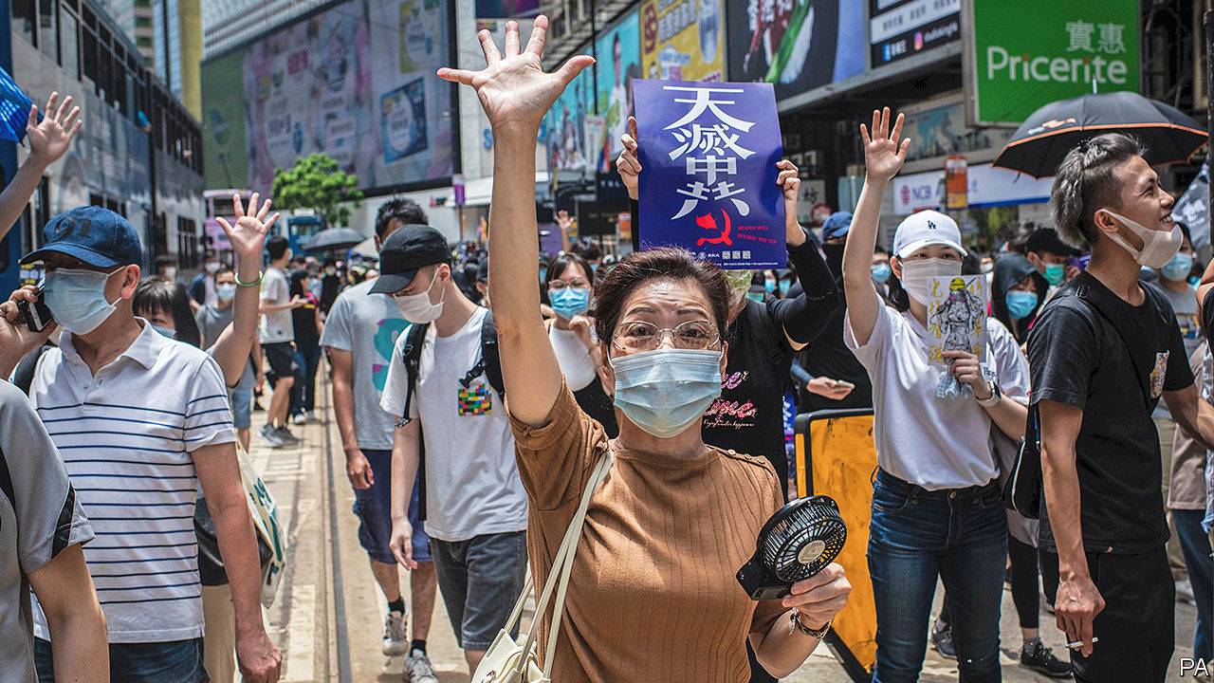

Protests erupted in Hong Kong after an announcement that the National People’s Congress, China’s rubber-stamp parliament, would impose a national-security law on the territory. The demonstrations were also fuelled by a proposal in the city’s legislature to make insulting China’s national anthem a crime. Mike Pompeo, America’s secretary of state, said that the “facts on the ground” showed that Hong Kong was no longer autonomous. This could pave the way for American action, including possibly treating the territory the same as the rest of China for trade and other purposes. See leader.

At the opening of the National People’s Congress in Beijing, the government abandoned a GDP target for the first time. The economy shrank by 6.8% in the first quarter.

A border dispute between India and China appeared to intensify. China reportedly sent soldiers and military vehicles onto land that India deems Indian, where they dug defensive positions. A Chinese state mouthpiece asserted a new territorial claim.

The Japanese government lifted restrictions in the last remaining prefectures under lockdown. It also unveiled a second stimulus, worth $1trn.

Rodrigo Duterte, the president of the Philippines, said schools would not reopen until a vaccine for covid-19 is available. That could mean a year or more of subpar education.

Four policemen were sacked in Minneapolis after a black man died while being restrained during an arrest. Video showed one officer kneeling on George Floyd’s neck to keep him on the ground. Protesters later clashed with police.

The University of California, America’s foremost public-college system, said it would phase out the use of SAT scores when deciding whom to admit. A faculty task-force had concluded that the tests were excellent predictors of academic success. But critics say they are unfair on those who cannot afford prepping courses.

Days after he began a new term in office Binyamin Netanyahu, the prime minister of Israel, stood trial on charges of bribery, fraud and breach of trust. He has denied wrongdoing and has called the justice system politically biased. Mr Netanyahu also told members of his Likud party that extending Israeli sovereignty over parts of the occupied West Bank was a priority for his new government.

America accused Russia of sending fighter jets to Libya to support Russian mercenaries fighting on behalf of Khalifa Haftar, a rebellious warlord. General Haftar launched an offensive on the capital, Tripoli, last year but has been pushed back by forces aligned with the internationally recognised Government of National Accord, which is supported by Turkey.

Authorities in Tanzania charged a comedian, Idris Sultan, after a video on social media showed him laughing at a photograph of the president, John Magufuli, in an oversize suit. Mr Sultan was initially charged with “bullying” the president. In court this was changed to using someone else’s mobile-phone SIM card.

Electoral officials in Burundi declared the ruling party’s candidate, Evariste Ndayishimiye, the winner in a presidential vote. Opposition parties say the election was rigged. Many dead people reportedly voted. See article.

More lockdown restrictions were eased in England. From mid-June, all shops will be allowed to reopen; outdoor markets from June 1st. The government also announced a UK-wide quarantine on international arrivals from June 8th, including Britons returning from abroad. Ireland, which is in Britain’s common travel area, is exempt.

By contrast, other European countries started to reopen their borders. Germany said it would lift warnings and allow its citizens to travel abroad from June 15th; it is pushing neighbouring countries to agree on common standards for social distancing. Greece and Italy will allow tourism from June, and Spain from July 1st. Cyprus offered to repay some holiday costs to tourists if they contract covid-19 while visiting the country.

The European Commission proposed a new seven-year budget for the EU that includes a €750bn ($825bn) post-covid recovery fund. The fund would distribute to member states €500bn in grants and €250bn in loans, and would be financed by borrowing based on guarantees provided by national governments. The plan builds on ideas proposed by France and Germany, but Austria, Denmark, the Netherlands and Sweden, the “frugal four”, are sceptical.

A judge on British Columbia’s Supreme Court ruled that extradition proceedings brought by the United States against Meng Wanzhou, the chief financial officer of Huawei, a Chinese telecoms giant, could continue. The decision means she cannot go home. Her arrest in Vancouver in December 2018 provoked a diplomatic row between Canada and China.

Two women became the first same-sex couple to marry in Costa Rica, immediately after it became legal. The ceremony was shown on a three-hour television broadcast about marriage equality.

## Coronavirus briefs

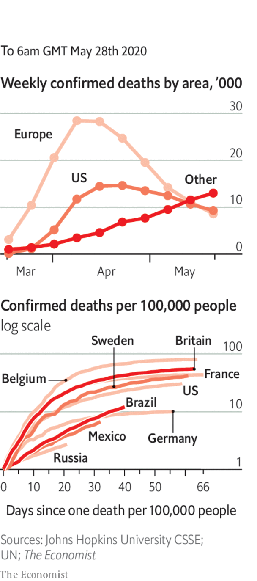

Countries in the Americas are the new centre of the pandemic, according to the WHO. Infections and deaths in Mexico have doubled over the past two weeks. Brazil now has the world’s second-highest number of cases, prompting the United States (more than 100,000 deaths) to ban non-American travellers who have been to the country.

Russia has also reported sharp increases in confirmed cases and deaths over two weeks; the actual numbers are thought to be much higher.

Spain revised its death toll down by more than 1,900 because of “duplicates” and wrongly attributed deaths.

A test-and-trace system was introduced in England.

India resumed domestic flights, amid much confusion at airports about whether planes would be allowed to land in certain states.

This article was downloaded by calibre from <https://www.economist.com/the-world-this-week/2020/05/30/politics-this-week>

|  |  |  |  |
| --- | --- | --- | --- |
|  | Articles | Sections | Next |

|  |  |  |  |
| --- | --- | --- | --- |
| Previous | Articles | Sections | Next |

# Business this week

May 28th 2020 |

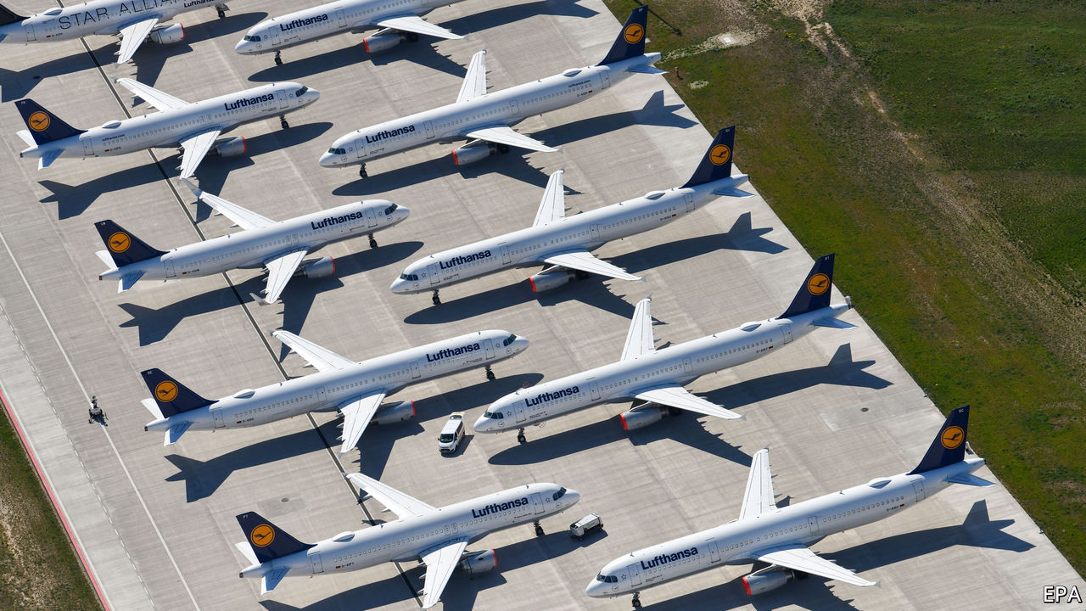

The German government offered to bail out Lufthansa, with an equity injection of €6bn ($6.6bn) and loans worth €3bn. The government, which would own a fifth of the airline, will nominate two people to sit on the company’s board. The board, however, initially refused to back the deal, after the EU required Lufthansa to give up slots at Frankfurt and Munich airports. Ryanair, Europe’s biggest discount carrier, said it would appeal against the bail-out (it is also protesting against the rescue of Air France-KLM), arguing that it would “strengthen Lufthansa’s monopoly-like grip on the German air travel market”. See article.

## Macron in the driver’s seat

In France the government said it would supply €8bn ($8.8bn) in aid to the country’s carmakers. Emmanuel Macron, the French president, hopes the money will “transform” the industry, providing incentives to produce electric and hybrid vehicles and increasing subsidies to motorists who buy greener cars. Some said the deal was merely old-fashioned dirigisme. The government is also finalising a separate €5bn loan for Renault. See article.

Aston Martin shook up its management team, and said Andy Palmer had agreed to step down as chief executive. The British maker of sports cars had a disappointing IPO in 2018; its share price has fallen by 90% since then. The changes in leadership were driven by Lawrence Stroll, a businessman and part-owner of a Formula One racing team, who put together a consortium to rescue Aston Martin earlier this year, becoming its chairman. The new CEO will be Tobias Moers, who is currently in charge of Mercedes-AMG. He starts his new job in August.

The pandemic claimed another high-profile business failure, when Hertz filed for bankruptcy protection in America. The car-hire company, which also owns the Dollar and Thrifty brands, saw its sales collapse when business travel and tourism came to a virtual halt. With a debt burden of at least $17bn Hertz had been struggling before the outbreak.

Uber decided to cut a quarter of its staff in India as part of the restructuring of its business that it recently announced. It is also closing its office in Singapore, as it considers a broader retrenchment of its ride-hailing services in Asia.

Amazon was reportedly in talks to buy Zoox, a startup that is developing electric-powered robotaxis. Amazon’s interest in autonomous-vehicle technology so far has focused on how it might enhance the delivery of its goods.

Latin America’s largest airline and its affiliates in Chile, Colombia, Ecuador and Peru filed for bankruptcy protection because of covid-19. Latam has its headquarters in Santiago, Chile’s capital, and also operates subsidiaries in Argentina, Brazil and Paraguay. It filed for bankruptcy protection in New York, where it has a listing.

China’s securities regulator sharply criticised legislation in America that would require companies to delist from American exchanges if they do not open their accounts to national audit rules. A bill passed the American Senate recently in the wake of an accounting scandal involving Luckin Coffee, a Chinese Starbucks, and is to be reviewed by the House of Representatives. But China’s regulator warned that the measures target China, have “clearly departed from professional considerations” and were “politicising” securities.

Buoyed by the further easing of lockdowns and an unexpected rise in American consumer confidence, stockmarkets retained their fizz of the past few weeks. The S&P 500 closed above the 3,000 mark for the first time since early March. Share prices in American banks have started to recover. JPMorgan Chase’s stock is up by 21% since mid-March, Bank of America’s by 25% and Citigroup’s by 43%.

## Back to work

The New York Stock Exchange partially reopened its floors to traders. Around 100 were allowed to return if they promised not to use public transport to get there and not to sue the exchange if they contract covid-19. The traders were allocated desks behind screens and given strict instructions on social distancing.

Retail sales in Britain plunged by 18.1% in April from March, the largest drop on record since the data began in 1988. Sales of alcohol continued to rise.

Carluccio’s, an Italian-dining chain that was one of the first casualties of Britain’s lockdown, sold 30 of its restaurants to the group that owns Giraffe, which serves an eclectic menu.

Warner Music launched plans for an IPO on the Nasdaq exchange. The music company’s vast stable of artists includes Ed Sheeran and Bruno Mars. It used to be part of what is now WarnerMedia until it was bought out by Sir Len Blavatnik’s Access Industries in 2011. If it is in tune with market sentiment, the listing could value the company at up to $13bn, well above the $3.3bn that Sir Len paid for it.

This article was downloaded by calibre from <https://www.economist.com/the-world-this-week/2020/05/28/business-this-week>

|  |  |  |  |
| --- | --- | --- | --- |
| Previous | Articles | Sections | Next |

|  |  |  |  |
| --- | --- | --- | --- |
| Previous | Articles | Sections | Next |

# KAL’s cartoon

May 30th 2020 |

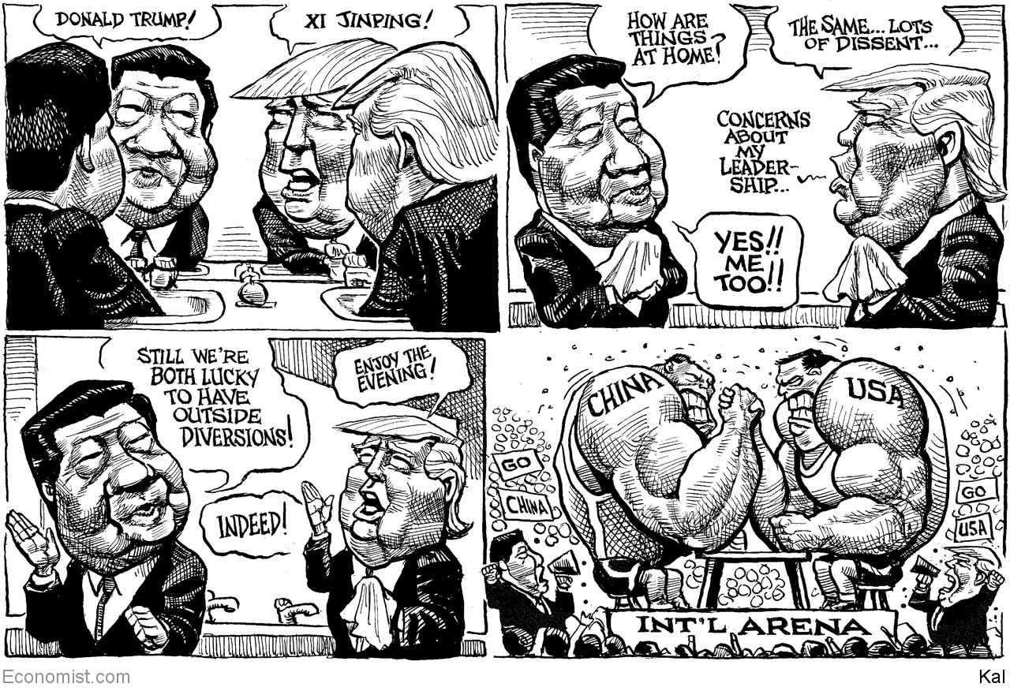

This article was downloaded by calibre from <https://www.economist.com/the-world-this-week/2020/05/30/kals-cartoon>

|  |  |  |  |
| --- | --- | --- | --- |
| Previous | Articles | Sections | Next |

|  |  |  |
| --- | --- | --- |
| The world this week | Sections | Letters |

Leaders

Covid-19: The American way

.

China’s power: Dragon strike

.

State aid in Europe: A €2trn loophole

.

Global tourism: Summer break

.

Masks and covid-19: Face it

.

|  |  |  |
| --- | --- | --- |
| The world this week | Sections | Letters |

|  |  |  |  |
| --- | --- | --- | --- |
|  | Articles | Sections | Next |

#### The American way

# How the world’s most powerful country is handling covid-19

Contrary to what many Americans think, the death rate in America is about the same as in Europe

May 28th 2020 |

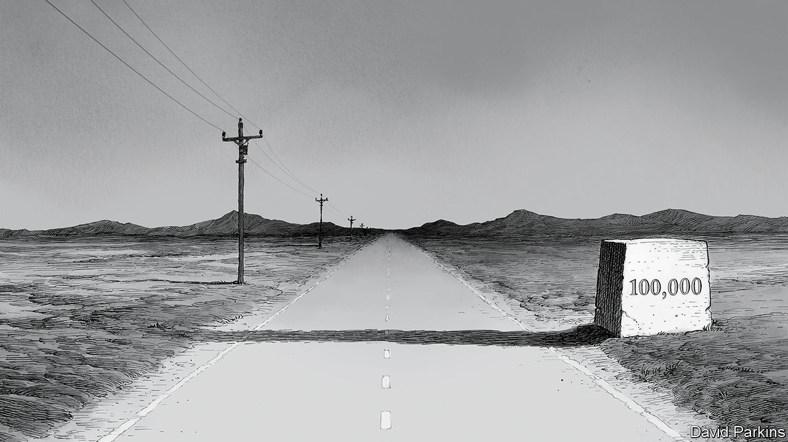

Editor’s note: Some of our covid-19 coverage is free for readers of The Economist Today, our daily [newsletter](https://my.economist.com/user#newsletter). For more stories and our pandemic tracker, see our [coronavirus hub](https://www.economist.com/news/2020/03/11/the-economists-coverage-of-the-coronavirus)

AMERICA HAS passed a grim milestone: 100,000 deaths from a novel coronavirus that began to spread half a year and half a world away. Many Americans think their president has handled the epidemic disastrously, that their country has been hit uniquely hard and that there is a simple causal relationship between the two. The 100,000, which does not include excess deaths mistakenly attributed to other causes, is higher than any other country’s. It has routinely been compared with the 60,000 American casualties in the Vietnam war. A Trump Death Clock in Times Square purports to show how many lives the president’s ineptitude has cost: as we went to press it stood at 60,262. Yet this widespread conviction that America has failed because of Donald Trump is not supported by the numbers. Or, at least, not yet.

The official death rate in America is about the same as in the European Union—which also has excess deaths, but has less erratic leaders and universal health care. Overall, America has fared a bit worse than Switzerland and a bit better than the Netherlands, neither of which is a failed state. New York has been hit about as hard as Lombardy in northern Italy; California acted early and is currently similar to Germany; so far, rural states have, like central Europe, been spared the worst. This reflects two things, both of which will matter now that America is reopening before it has the virus fully under control.

The first is that covid-19, when it first hit, displayed an indifference to presidents and their plans. Around the world it has killed in large, dense and connected cities like New York, London and Paris, and where people are crammed together, including care homes, slaughterhouses and prisons. In some countries, including America, testing was snarled up in red tape.

Having seen what was happening in China, Mr Trump could have acted sooner—as Taiwan, Singapore and Vietnam did. He has failed to do things ordinarily expected of an American president in a crisis, such as giving clear government advice or co-ordinating a federal response. Instead, he has touted quack remedies and spent the days when America passed its sombre milestone spreading suspicion of the voting system and accusing a television host of committing a murder that never happened. All this is reprehensible and it may have been costly. Yet, tempting as it is to conclude that the president’s failures bear most of the blame for covid-19’s spread through America, the reality is more complicated (see Briefing).

That leads to the second feature of the country’s response to covid-19. The virus was always going to be hard on a population with high levels of poverty, obesity and diseases such as diabetes, especially among minorities (see Lexington). But, to a remarkable degree, other layers of government have adapted around the hole where the president should have been. The federal system has limited the damage, thanks to its decentralised decision-making. Lockdowns vary by state, city and county. California responded as soon as it saw cases. In the north-east governors largely ignored the White House and got on with coping with the disease, earning the Republican governors of Maryland and Massachusetts the president’s enmity, but high approval ratings. In Florida, though the governor was reluctant to impose a lockdown, county officials went ahead and did so anyway.

Contrary to demands for nationwide rules, this is a strength not a weakness, and will become more so as the pandemic runs its course. In the best-organised states, which have built up testing capacity, it helps ensure that flare-ups can be spotted quickly and rules adjusted accordingly. Because each region is different, that is more efficient than a nationwide approach.

One way democracies can deal with the virus is to draw on reserves of trust. People must behave in ways that protect fellow citizens whom they have never met, even if they themselves are feeling fine. Americans trust their local officials far more than the president or the federal government. And when it comes to public health those local officials have real power. Without this balancing feature, America might today look like Brazil, where a president with a similar love of hydroxychloroquine and distaste for face masks is wreaking havoc (see article).

If the public-health response in the United States so far matches Europe’s, its economic response to the virus may turn out better. True, the unemployment rate in America is 15%, double that in the EU. Yet in Europe most governments are protecting jobs that may no longer exist once lockdowns end rather than focusing help on the unemployed as America’s has. The EU is probably delaying a painful adjustment. Congress, not known for passing consequential legislation with big bipartisan majorities, agreed on a vastly bigger fiscal stimulus than in the financial crisis a decade ago. With a Democrat in the White House and a Republican-controlled Senate, America might not have mustered a response that was either so rapid or so large.

America still has a hard road ahead. Were daily fatalities to remain at today’s level, which is being celebrated as a sign that the pandemic is waning, another 100,000 people would die by the end of the year. To prevent that, America needs to work with the system it has, trusting local politicians to balance the risks of reopening against the cost of lockdowns.

In the next months the infrastructure built during the lockdown must prove itself. Because the virus has yet to decline in some states, it may flare up in new places, which will then need targeted lockdowns. The capacity to test, vital to spotting clusters of infection, has increased, but is still lacking in some places. Almost all the states lack the contact tracers needed to work out who needs testing and quarantining. When it considers how to withdraw fiscal support, Congress should remember this.

That America and Europe have fared similarly in the pandemic does not absolve Mr Trump. This is the first international crisis since 1945 in which America has not only spurned global leadership but, by cutting funds to the World Health Organisation, actively undermined a co-ordinated international response. That matters, as does Mr Trump’s inability to cleave to a consistent message or to speak to the country in words that do not enrage half of the population. Yet four years after Mr Trump was elected, the time to be surprised by his behaviour has long gone. Luckily, he has mattered less than most Americans think.■

This article was downloaded by calibre from <https://www.economist.com/leaders/2020/05/28/how-the-worlds-most-powerful-country-is-handling-covid-19>

|  |  |  |  |
| --- | --- | --- | --- |
|  | Articles | Sections | Next |

|  |  |  |  |
| --- | --- | --- | --- |
| Previous | Articles | Sections | Next |

#### Dragon strike

# China has launched rule by fear in Hong Kong

The rest of the world should worry, too

May 28th 2020 |

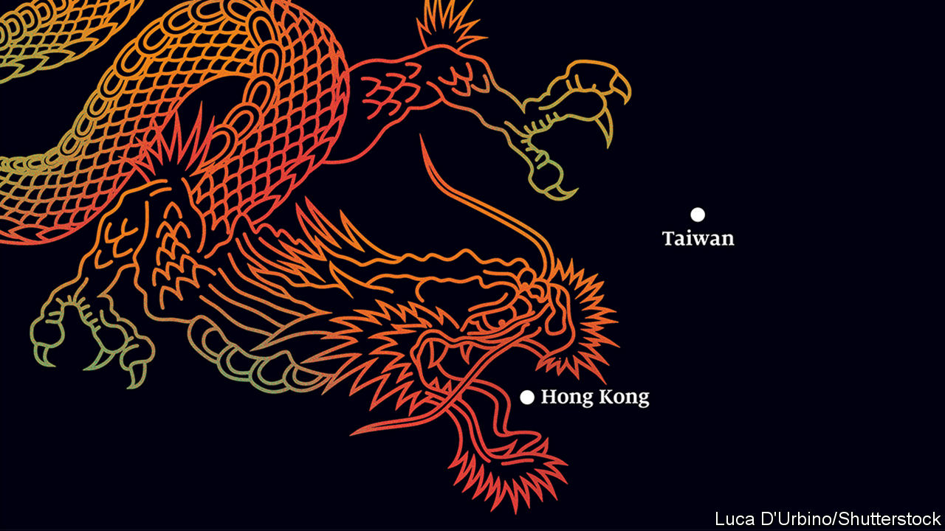

THE PEOPLE of Hong Kong want two things: to choose how they are governed, and to be subject to the rule of law. The Chinese Communist Party finds both ideas so frightening that many expected it to send troops to crush last year’s vast protests in Hong Kong. Instead, it bided its time. Now, with the world distracted by covid-19 and mass protests difficult because of social distancing, it has chosen a quieter way to show who’s boss. That threatens a broader reckoning with the world—and not just over Hong Kong, but also over the South China Sea and Taiwan.

On May 21st China declared, in effect, that Hong Kongers deemed to pose a threat to the party will become subject to the party’s wrath. A new security law, written in Beijing, will create still-to-be defined crimes of subversion and secession, terms used elsewhere in China to lock up dissidents, including Uighurs and Tibetans. Hong Kong will have no say in drafting the law, which will let China station its secret police there. The message is clear. Rule by fear is about to begin.

This is the most flagrant violation yet of the principle of “one country, two systems”. When the British colony was handed back to China in 1997, China agreed that Hong Kong would enjoy a “high degree of autonomy”, including impartial courts and free speech. Many Hong Kongers are outraged (see article). Some investors are scared, too. The territory’s stockmarket fell by 5.6% on May 22nd, its biggest drop in five years. Hong Kong is a global commercial hub not only because it is situated next to the Chinese mainland, but also because it enjoys the rule of law. Business disputes are settled impartially, by rules that are known in advance. If China’s unaccountable enforcers are free to impose the party’s whims in Hong Kong, it will be a less attractive place for global firms to operate.

China’s move also has implications far beyond Hong Kong. “One country, two systems” was supposed to be a model for Taiwan, a democratic island of 24m that China also sees as its own. The aim was to show that reunification with the motherland need not mean losing one’s liberty. Under President Xi Jinping, China seems to have tired of this charade. Increasingly, it is making bare-knuckle threats instead. The re-election in January of a China-sceptic Taiwanese president, Tsai Ing-wen, will have convinced China’s rulers that the chances of a peaceful reunification are vanishingly small. On May 22nd, at the opening of China’s rubber-stamp parliament, the prime minister, Li Keqiang, ominously cut the word “peaceful” from his ritual reference to reunification. China has stepped up war games around Taiwan and its nationalists have been braying online for an invasion.

China is at odds with other countries, too. In its building of island fortresses in the South China Sea, it ignores both international law and the claims of smaller neighbours. This week hundreds, perhaps thousands of Chinese troops crossed China’s disputed border with India in the Himalayas. Minor scuffles along this frontier are common, but the latest incursion came as a state-owned Chinese paper asserted new claims to land that its nuclear-armed neighbour deems Indian (see article). And, as a sombre backdrop to all this, relations with the United States are worse than they have been in decades, poisoning everything from trade and investment to scientific collaboration.

However much all the regional muscle-flexing appals the world, it makes sense to the Chinese Communist Party. In Hong Kong the party wants to stop a “colour revolution”, which it thinks could bring democrats to power there despite China’s best efforts to rig the system. If eroding Hong Kong’s freedoms causes economic damage, so be it, party bigwigs reason. The territory is still an important place for Chinese firms to raise international capital, especially since the Sino-American feud makes it harder and riskier for them to do so in New York. But Hong Kong’s GDP is equivalent to only 3% of mainland China’s now, down from more than 18% in 1997, because the mainland’s economy has grown 15-fold since then. China’s rulers assume that multinational firms and banks will keep a base in Hong Kong, simply to be near the vast Chinese market. They are probably right.

The simple picture that President Donald Trump paints of America and China locked in confrontation suits China’s rulers well. The party thinks that the balance of power is shifting in China’s favour. Mr Trump’s insults feed Chinese nationalist anger, which the party is delighted to exploit—just as it does any tensions between America and its allies. It portrays the democracy movement in Hong Kong as an American plot. That is absurd, but it helps explain many mainlanders’ scorn for Hong Kong’s protesters.

The rest of the world should stand up to China’s bullying. On the Sino-Indian border, the two sides should talk more to avoid miscalculations, as their leaders promised to in 2018. China should realise that, if it tries the tactics it has used in the South China Sea, building structures on disputed ground and daring others to push back, it will be viewed with greater distrust by all its neighbours.

In the case of Taiwan China faces a powerful deterrent: a suggestion in American law that America might come to Taiwan’s aid were the island to be attacked. There is a growing risk that a cocksure China may decide to put that to the test. America should make clear that doing so would be extremely dangerous. America’s allies should echo that, loudly.

Hong Kong’s options are bleaker. The Hong Kong Policy Act requires America to certify annually that the territory should in trade and other matters be treated as separate from China. This week the secretary of state, Mike Pompeo, declared that “facts on the ground” show Hong Kong is no longer autonomous. This allows America to slap tariffs on the territory’s exports, as it already does to those from the mainland. That is a powerful weapon, but the scope for miscalculation is vast, potentially harming Hong Kongers and driving out global firms and banks. It would be better, as the law also proposes, to impose sanctions on officials who abuse human rights in Hong Kong. Also, Britain should grant full residency rights to the hundreds of thousands of Hong Kongers who hold a kind of second-class British passport—much as Ms Tsai this week opened Taiwan’s door to Hong Kong citizens. None of this will stop China from imposing its will on Hong Kong. The party’s interests always trump the people’s. ■

This article was downloaded by calibre from <https://www.economist.com/leaders/2020/05/28/china-has-launched-rule-by-fear-in-hong-kong>

|  |  |  |  |
| --- | --- | --- | --- |
| Previous | Articles | Sections | Next |

|  |  |  |  |
| --- | --- | --- | --- |
| Previous | Articles | Sections | Next |

#### Europe’s bail-outs

# Government handouts threaten Europe’s single market

The dangers of Europe’s bail-outs

May 30th 2020 |

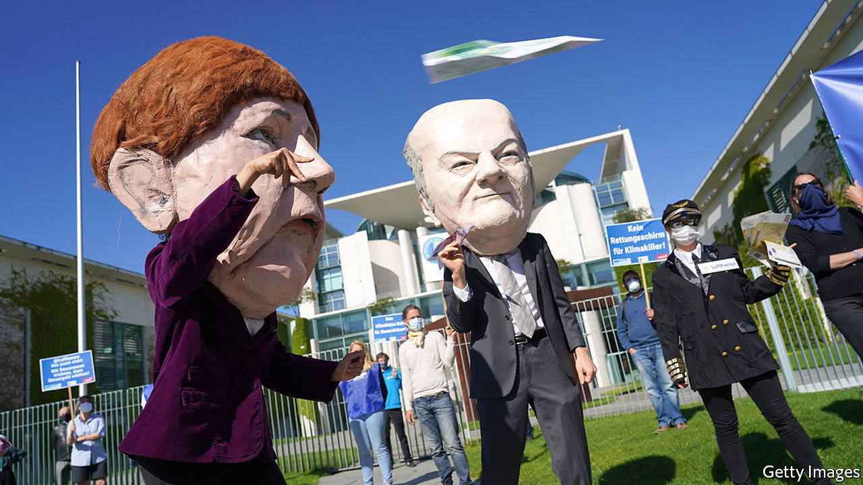

Editor’s note: Some of our covid-19 coverage is free for readers of The Economist Today, our daily [newsletter](https://my.economist.com/user#newsletter). For more stories and our pandemic tracker, see our [coronavirus hub](https://www.economist.com/news/2020/03/11/the-economists-coverage-of-the-coronavirus)

A BILLION OR two here, a giant government cheque there: the money doled out by European governments to support businesses is starting to add up. Some €2trn ($2.2trn) or so has been earmarked to keep firms afloat. The early beneficiaries included bakeries, bookshops and the like. Now it is increasingly the turn of corporate titans. This week France announced an €8bn package to support its carmakers, including a large loan to Renault. Lufthansa is negotiating a €9bn bail-out from Germany which may involve the state taking a 20% stake. Now the taps are open, more blue-chip bail-outs are expected.

In normal times such state aid is all but banned by the European Union to ensure a level playing field for firms across the bloc (see [article](https://www.economist.com/node/21786918)). The idea is to ensure that companies thrive on their merits, not government favours. Restricting state aid frustrates politicians of a dirigiste persuasion—there are lots—but is vital to spare taxpayers, consumers and competitors the burden of a rigged market.

The rules have been quietly shelved as Europe grapples with covid-19. Giving governments a temporary reprieve was unavoidable as national exchequers battle to stave off depression. But it also carries long-term dangers. Even before the crisis, France and Germany railed against European rulings that they say prevented the creation of corporate champions able to compete with rivals from China and America. Now they may seize the moment to try to water down competition rules permanently.

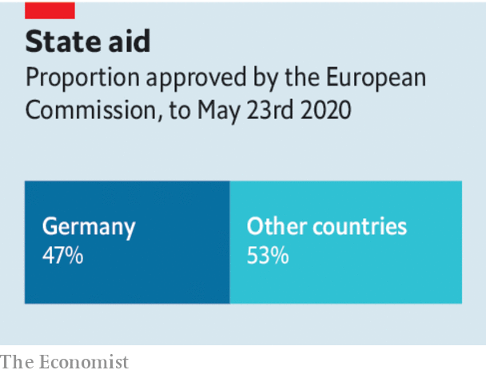

It is not hard to see the harm that free-flowing state money could do. Germany represents a quarter of the bloc’s GDP but nearly half of its state aid, because its buoyant public finances allow it to be generous. Tough luck if you are a company in Spain or Italy where tighter budgets mean smaller handouts. Politicians usually favour certain companies—famous flag-carriers instead of scrappy low-cost airlines, say. And the bail-outs invariably come with nationalist strings. Renault and other French carmakers are promising to keep production and research in France (see [article](https://www.economist.com/node/21786971)). Once the state becomes a shareholder or creditor, bosses know their firm’s prospects partly depend on a willingness to please their political masters.

How to ensure that the necessary evil of bail-outs does not cripple the single market? They should be tolerated only when all other options have been exhausted. In America even cruise-liners—a challenged business model if ever there was one—have raised bonds and found new shareholders. Europe has shallower capital markets, but plenty of investors with money to spend.

The risks of an uneven playing field will ease if bail-out money is distributed evenly around the EU. On May 27th the European Commission unveiled a €750bn plan to offer grants and loans from mainly rich countries to mainly poor ones. Though there is much haggling left to be done, this proposal heads in the right direction.

Most important, all bail-outs need to be carefully policed. This means ensuring that companies are not using public cash to run large losses or to pay for their expansion plans once the economy opens up. Governments may have to take shares in firms in order to safeguard taxpayers’ financial interests. But there should be rigorous enforcement of rules that encourage firms to repay loans and buy back government stakes quickly by banning them from paying dividends and bonuses. Bail-outs are taking place everywhere. But in Europe they are especially dangerous, because they can undermine economic integration and encourage politicians’ inexhaustible appetite to meddle in industry. Creating a giant, open and competitive market has been one of Europe’s great achievements. In the rush to help business it must not be eroded.■

This article was downloaded by calibre from <https://www.economist.com/leaders/2020/05/30/government-handouts-threaten-europes-single-market>

|  |  |  |  |
| --- | --- | --- | --- |
| Previous | Articles | Sections | Next |

|  |  |  |  |
| --- | --- | --- | --- |
| Previous | Articles | Sections | Next |

#### The summer holiday will be back

# How tourism will survive the pandemic

Foreign adventure, discovery and hedonism are on hold. They will be back

May 30th 2020 |

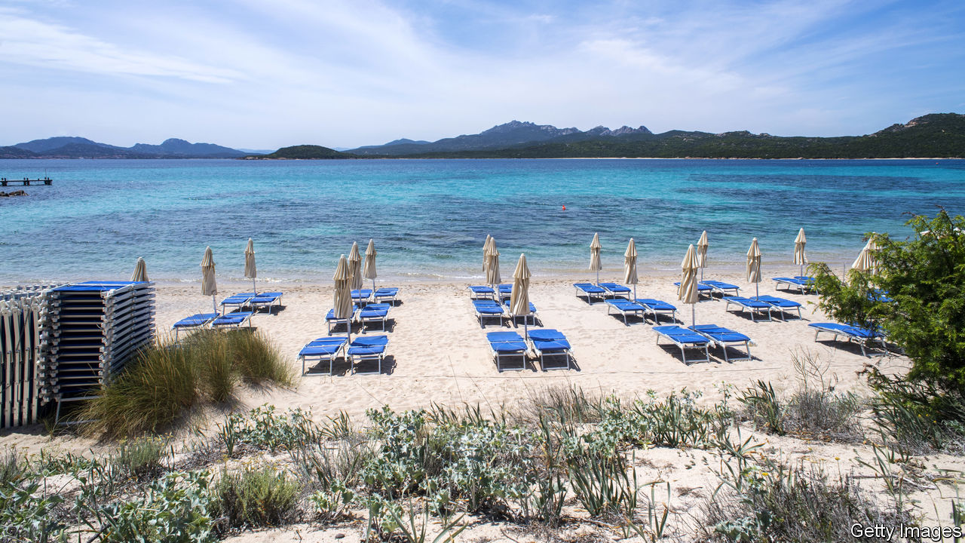

Editor’s note: Some of our covid-19 coverage is free for readers of The Economist Today, our daily [newsletter](https://my.economist.com/user#newsletter). For more stories and our pandemic tracker, see our [coronavirus hub](https://www.economist.com/news/2020/03/11/the-economists-coverage-of-the-coronavirus)

TOURISM IS THE most popular and least controversial form of globalisation. For those travelling abroad it promises an infinite variety of pleasures, from admiring Titians in Venice to sipping piña coladas in Goa. For the host countries it brings in cash—lots of it. The industry accounts for 7% of world exports and 330m jobs. But business is on pause (see [article](https://www.economist.com/node/21786898)). Ticket sales at Angkor Wat in Cambodia are down by 99.5% compared with last year and countless Mediterranean sunbeds lie empty. Around the world a vital question is being asked: what will happen to the summer holidays? The answer is that tourism will be back—but not in exactly the same form, and only if NIMBYS and governments don’t spoil the fun.

Over the past half-century the travel industry has grown faster than a beach-bar tab on a sunny afternoon. In 1970 fewer than 200m people went on holiday abroad; last year the figure was 1.5bn. Soaring incomes in China explain part of the increase. It has also become cheaper to fly and easier to browse for the perfect swimming pool online—Expedia lists 1m hotels and properties. Visa rules have been loosened. The average person in the rich world can travel to over 100 countries without a visa, compared with 50 half a century ago, and the rules have got easier for people in emerging economies, too. As the industry has boomed, small firms and workers have prospered from the business of holidays. Some 80 countries, including Tanzania, Thailand and Turkey, rely on tourism for a tenth or more of their exports.

These countries’ need for foreign exchange means that they are desperate to ensure this summer is not a write-off. Hotel firms are keen to fill rooms and younger consumers are prepared to take risks, judging by the packed beaches in America on Memorial Day. Nonetheless, caution is warranted. By jamming together people from around the world, tourism can be a lethal spreader of the virus. A single bar in an Austrian ski resort may have caused outbreaks across Europe, while cruise ships turned into floating biohazards. That means tourism in 2020 and 2021 will necessarily involve restrictions. One is filtering visitors by nationality. Cyprus plans to open on June 9th to most European tourists, but not those from Britain and Russia, two covid-19 hot-spots. America has just banned visitors from Brazil. Another fix is lower density. Brian Chesky, the boss of Airbnb, reports a surge in bookings for out-of-town dwellings. All told, the number of tourists this summer will be a fraction of normal levels.

In the long term, supposing a vaccine is found, the picture is brighter. Even if some consumers remain nervous, the industry will adapt. Marriott has appointed a cleanliness council and is introducing electrostatic disinfectant sprayers; Airbus is working on touchless bathrooms. Better testing will give travellers and governments confidence that outbreaks can be managed.

The big danger is that temporary barriers become hard to remove because of squabbling and lobbying. At the end of April more than 150 countries were closed to foreign tourists. Ongoing restrictions include quarantines and incompatible tracing apps. History suggests that it is complacent to assume these will just fall away. It took a global summit in 1920 to set rules on passports and travel after a world war and Spanish flu closed borders—and some western Europeans needed visas to go to America as recently as 1991. Already the politics of travel in Asia have caused tensions (see [Banyan](https://www.economist.com/node/21786931)). Meanwhile, NIMBYS may seek to keep tourists out of the world’s most beautiful but busiest cities.

This summer should be used to make tourism work better. That means taxes and more astute planning to tackle overcrowding. And as the global travel and airline industries restructure, there is a chance to speed up the introduction of aircraft with lower carbon emissions. It must not take decades before the world returns to the levels of openness that it had as recently as January. Tourism makes the world wealthier and happier. It should be on only a temporary break.■

This article was downloaded by calibre from <https://www.economist.com/leaders/2020/05/30/how-tourism-will-survive-the-pandemic>

|  |  |  |  |
| --- | --- | --- | --- |
| Previous | Articles | Sections | Next |

|  |  |  |  |
| --- | --- | --- | --- |
| Previous | Articles | Sections | Next |

#### Face it

# The case for mandatory masks

In places where covid-19 is still rife, governments should require people to wear face coverings in crowded public spaces

May 30th 2020 |

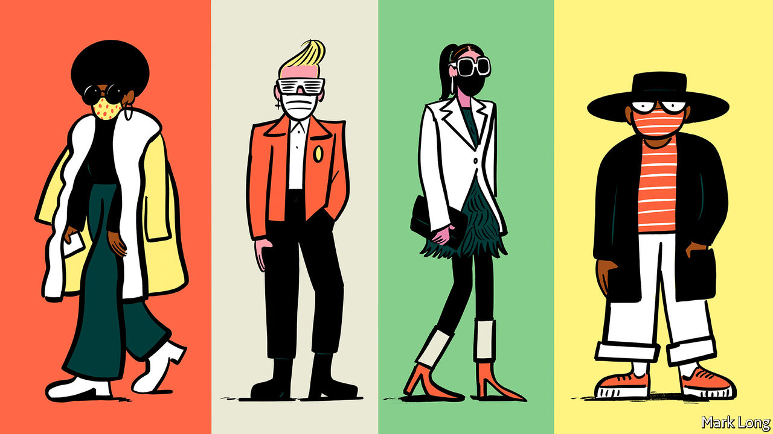

Editor’s note: Some of our covid-19 coverage is free for readers of The Economist Today, our daily [newsletter](https://my.economist.com/user#newsletter). For more stories and our pandemic tracker, see our [coronavirus hub](https://www.economist.com/news/2020/03/11/the-economists-coverage-of-the-coronavirus)

THE PANDEMIC has not been kind to fashionistas. Shops are closed and online purchases can be displayed only through the dismal prism of Zoom. Yet there is a chink of light in this dark sartorial night, for it offers the opportunity for self-expression through this season’s latest must-have item: the face mask.

The fact that the market for chic masks is well-developed in Paris (see article) is hardly surprising, but the explanation does not lie only in the exquisite taste of its citizens. Since May 11th Parisians have been required to wear masks on public transport or face a penalty of €135 ($150), so it is rare to see anybody on the Métro without one. On London’s Tube, by contrast, where the government merely advises people to wear one, only around a third of people are doing so.

In much of the rich world, governments now require people to wear masks when they are in crowded public spaces. Britain and America are among the few hold-outs. In America, where few states away from the east coast make them compulsory, the issue has been infected by the polarisation that bedevils the country’s management of the outbreak. That is regrettable, for masks could both save lives and allow people to get back to work.

People think of masks as protecting them from nasty stuff in the air. They can do that. But in the case of covid-19, their more important job is to protect others from an infected wearer. That is because of one of the peculiar characteristics of this disease: it seems likely that infection by people who have not, or not yet, developed symptoms accounts for about a third to a half of cases. So even if everybody with symptoms stays at home, the virus will still spread. Social distancing can help, but is hard to maintain in crowded places. Masks block the respiratory droplets that carry the virus, so make risky situations safer.

In normal times, governments should require solid evidence, such as a randomised controlled trial in which a treated group is compared with a control group, before advocating some new health practice. But these are not normal times, and the need for speed makes that impossible.

Besides, there are signs that masking is useful. Even home-made face-coverings can block spit. Experiments show that a tea towel over the mouth and face can block 60% of droplets—not as good as a medical mask, but a great deal better than nothing. That puts to rest the concern that advising the public to wear masks will deprive health workers of vital equipment.

East Asian countries’ success in controlling the disease argues in favour of masks. In many of their cities, masks have been worn for years to protect against pollution or disease, so people covered their faces as soon as they got wind of covid-19. In the West mask-wearing is alien. And in all of the countries where mask-wearing is common practice, the epidemic was swiftly suppressed.

This is not incontrovertible evidence in favour of masks. Other factors distinguish those mask-wearing countries from bare-faced Western nations: some (such as South Korea) had rigorous track-and-trace systems; some (such as Japan) do not shake hands. And countries that adopted masks only recently (such as Germany) have successfully suppressed the epidemic.

Yet the combination of this natural global experiment, laboratory studies and asymptomatic transmission suggests that masks can help keep people safe. The clincher is cost. Lockdown destroys economies. Social distancing damages them. Masks cost next to nothing. They will not by themselves stop an epidemic. Hand-washing, track-and-trace systems and widespread testing are all essential, too. But masks can do their bit to protect people and rebuild economies. And they can be stylish.■

This article was downloaded by calibre from <https://www.economist.com/leaders/2020/05/30/the-case-for-mandatory-masks>

|  |  |  |  |
| --- | --- | --- | --- |
| Previous | Articles | Sections | Next |

|  |  |  |
| --- | --- | --- |
| Leaders | Sections | Briefing |

Letters

Letters to the editor: On Bolivia, bio-weapons, covid-19 research, food, “The Leopard”

.

|  |  |  |
| --- | --- | --- |
| Leaders | Sections | Briefing |

|  |  |  |  |
| --- | --- | --- | --- |
|  | Articles | Sections | Next |

#### On Bolivia, bio-weapons, covid-19 research, food, “The Leopard”

# Letters to the editor

A selection of correspondence

May 30th 2020 |

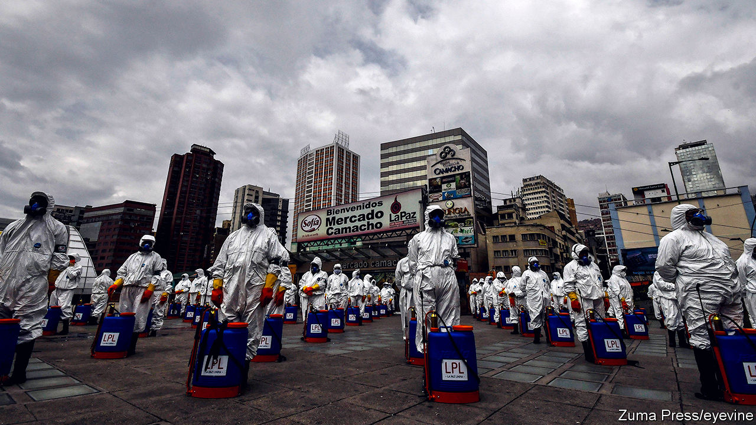

## A new constitution for Bolivia

As well as a dire need for fresh elections, Bolivia requires a new constitutional order (“[In limbo](https://www.economist.com/the-americas/2020/05/16/bolivia-needs-an-election-but-covid-19-makes-that-hard)”, May 16th). Our constitutional institutions were not able to handle the crisis that led to the ousting of Evo Morales as president in 2019. The proper path of presidential succession was not followed; Jeanine Áñez’s declaration that she was president was unlawful and polarising.

Bolivia is in a state of instability last seen 15 years ago. Back in 2005 my interim government was able to conduct fair elections. The resulting constitution of 2009 flowed from a legitimate process. It affirmed the rights of indigenous citizens. Yet the institutional provisions it designed have been ineffective. The Constitutional Court granted Mr Morales a “human right” to re-election and sanctioned Ms Áñez’s accession despite her lack of a constitutional mandate.

The problem is a fixation on presidentialism. Our weak national state is held hostage by the dominance of the powerful heads of both the central government and the states. Court-packing limits the development of an independent and efficient judiciary. The Plurinational Assembly (formerly our congress) plays little part in decision-making or promoting checks and balances. That means that the main pressure-point on the presidency has come from protesters taking to the streets calling for change.

The liberalisation of social traditions by expanding civil rights is facing a terrible backlash. A new constitution must end presidentialism. Our regions need to be more independent from La Paz. Corruption is better tackled through oversight at lower levels of government. But overall, we need a strong parliamentary system, to end caudillismo and bring true plurality to politics.

EDUARDO RODRíGUEZ VELTZÉ  
Former president of Bolivia, 2005-06  
La Paz

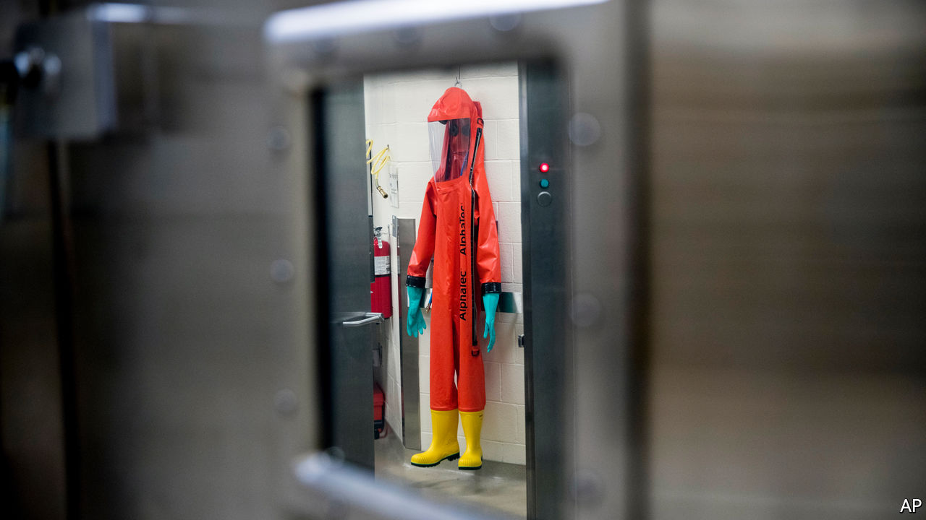

## Deadly diseases

Covid-19 has indeed raised concerns over the threat posed by biological weapons (“[Spore wars](https://www.economist.com/united-states/2020/04/23/the-havoc-wrought-by-covid-19-will-spark-new-concern-over-bio-weapons)”, April 25th). Fortunately, while advances in science and technology may be lowering the technical barriers to developing biological weapons, there are still many hurdles to overcome by anyone wishing to do so. One of these is provided by the Biological Weapons Convention and the widely accepted norm that it embodies against the use of disease as a weapon. As the preamble to the convention states, any use of a biological weapon would be “repugnant to the conscience of mankind”. Although a piece of paper alone will not stop a bio-attack, 183 countries have pledged to co-operate and come to each other’s aid in such an event.

The next review conference will take place in late 2021 and will provide the perfect opportunity to adapt the treaty to the challenges posed by technological advances and to reflect on the lessons learned from the current pandemic.

DANIEL FEAKES  
Chief  
Biological Weapons Convention Implementation Support Unit  
United Nations Office for Disarmament Affairs  
Geneva

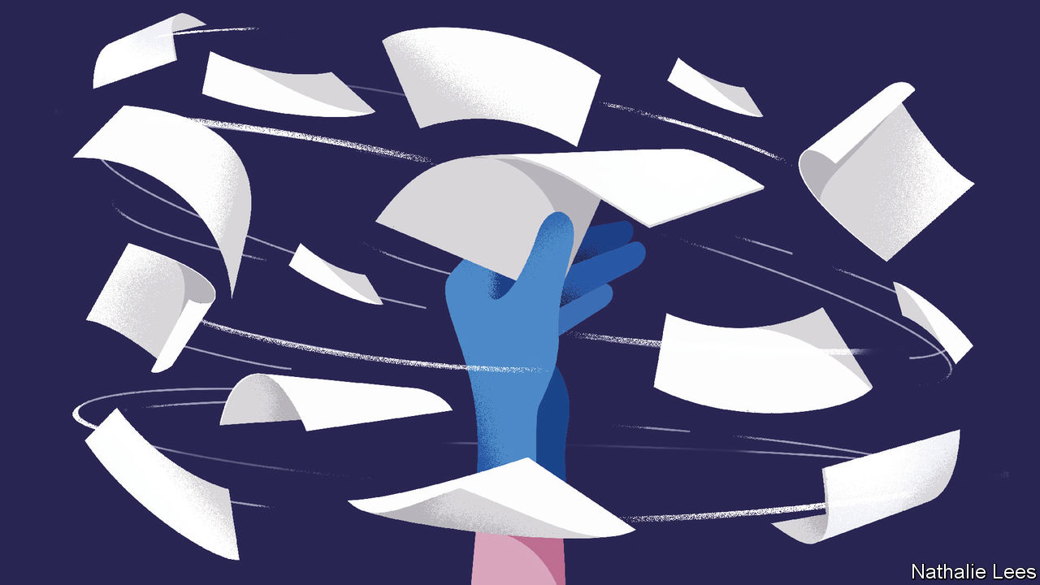

## Speeding covid-19 research

You looked at the speed at which research into covid-19 is being released and preprinted on servers without peer review (“[Reaping from the whirlwind](https://www.economist.com/science-and-technology/2020/05/07/scientific-research-on-the-coronavirus-is-being-released-in-a-torrent)”, May 9th). However, publishers are collaborating to ensure peer review is thorough. We heard from academics who were overwhelmed with requests for peer review and from authors needing quick turnaround times. We have thus created a common database of peer reviewers to which we are asking researchers from around the world to sign up.

Reviewers are asked to commit to work fast and that their reviews and identity be shared among publishers and journals if submissions get rerouted for any reason. So far more than 1,200 researchers from around the world have signed on. Authors submitting relevant research will be asked to agree that reviews can be portable between publishers. So if a journal thinks work is more appropriate elsewhere it can be passed on with reviews alongside it, to speed up the decision for those editors.

This previously unheard of level of collaboration across publishers stresses the importance of working together on this challenge. Many of us within the open-science community hope that some of these changes will become the norm when we come out of the pandemic, laying the groundwork for more systematic cross-publisher collaboration that would further advance the dissemination of research. For now though we hope that our effort benefits research into this public-health emergency.

SARAH GREAVES  
Chief publishing officer  
Hindawi  
London



## Nourishing thoughts

You called for “a new productivity revolution” to feed the world by 2050 (“[The food miracle](https://www.economist.com/leaders/2020/05/09/the-global-food-supply-chain-is-passing-a-severe-test)”, May 9th). It has already started, driven by the clever manipulation of crop biomes, gene editing (CRISPR technology), precision agriculture with big data, and the emergence of “new” protein sources, such as plant-based foods, insects and cultured meats. However, this revolution is happening in tandem with rejuvenated agricultural practices characteristic of previous centuries, which include composting, minimal tillage, integrating livestock and cropping, improving crop diversity and crop rotation. This is good news for farmers, consumers and our planet.

DAVID HUGHESEmeritus professor of food marketing  
Imperial College London

The food system has held up well over the past couple of months in tough circumstances. However, the main challenges lie ahead. Around 130m more people may face crisis levels of hunger by the end of 2020, a humanitarian tragedy unless strong domestic safety nets with international support can be put in place. Crops in sub-Saharan Africa are already affected by locusts and poor weather conditions in some regions.

Far from being “left free to work its magic”, the current food system needs a reset. There are $12trn “hidden” environmental costs—emissions, biodiversity loss, eutrophication—caused each year by the food system. And we need to move beyond a narrow focus on hunger to deal with people suffering from micronutrient deficiency (or hidden hunger) as well as those who are overweight and obese.

SHENGGEN FAN  
AGNES KALIBATA  
PAUL POLMAN  
JEREMY OPPENHEIM  
Food and Land Use Coalition  
London

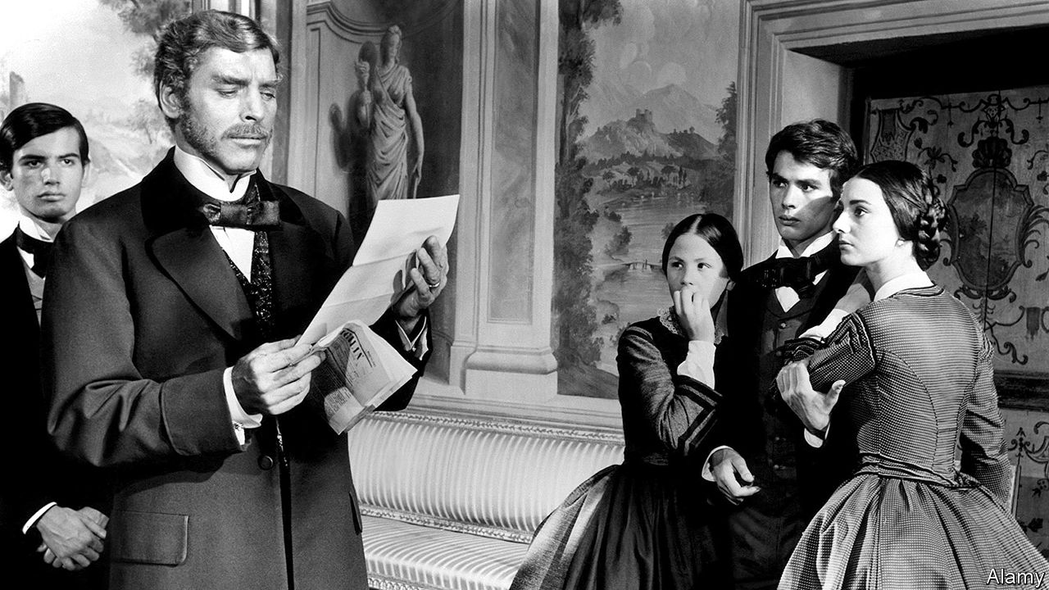

## Fact wrecking

Re-reading “The Leopard” ([Home entertainment](https://www.economist.com/books-and-arts/2020/05/02/travel-to-a-land-of-sun-and-dust-with-the-leopard), May 2nd) as the world debates what is or is not fake news brings to mind a quote from the melancholy finale of Giuseppe Tomasi di Lampedusa’s novel:

Nowhere has truth such a short life as in Sicily; a fact has scarcely happened five minutes before its genuine kernel has vanished, been camouflaged, embellished, disfigured, squashed, annihilated by imagination and self interest; shame, fear, generosity, malice, opportunism, charity, all the passions, good as well as evil, fling themselves onto the fact and tear it to pieces; very soon it has vanished altogether.

YACOV ARNOPOLIN  
London

This article was downloaded by calibre from <https://www.economist.com/letters/2020/05/30/letters-to-the-editor>

|  |  |  |  |
| --- | --- | --- | --- |
|  | Articles | Sections | Next |

|  |  |  |
| --- | --- | --- |
| Letters | Sections | United States |

Briefing

Covid-19 in America: 100,000 and counting

.

|  |  |  |
| --- | --- | --- |
| Letters | Sections | United States |

|  |  |  |  |
| --- | --- | --- | --- |
|  | Articles | Sections | Next |

#### 100,000 and counting

# America’s covid-19 experience is tragic but not that exceptional

The epidemic could get worse

May 28th 2020 | WASHINGTON, DC

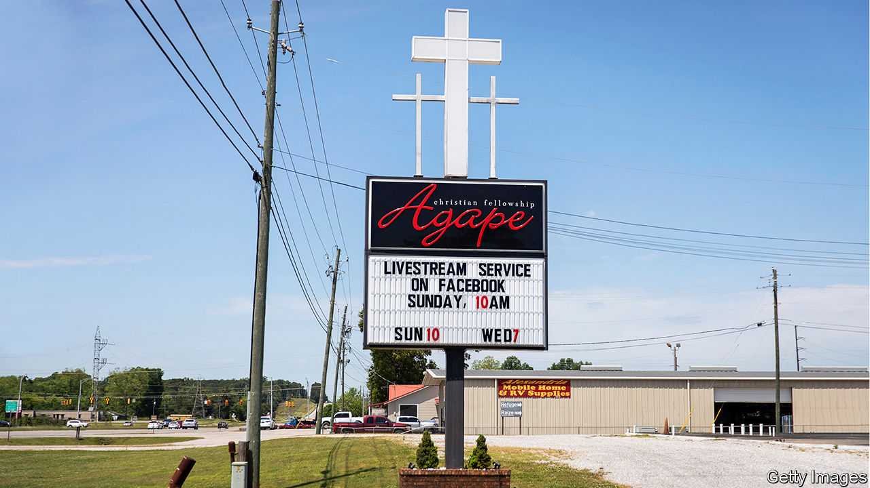

Editor’s note: Some of our covid-19 coverage is free for readers of The Economist Today, our daily [newsletter](https://my.economist.com/user#newsletter). For more stories and our pandemic tracker, see our [coronavirus hub](https://www.economist.com/news/2020/03/11/the-economists-coverage-of-the-coronavirus)

IN ABSOLUTE TERMS, America has been the country worst affected by the coronavirus pandemic. Nearly 1.7m of its inhabitants have been infected, a number which is still growing by around 20,000 every day. On May 27th the country passed its 100,000th confirmed death. Such official death tolls do not necessarily capture all of the lost, and the real tolls in some other countries may be much higher than they seem. But America’s official figure is more than 20 times that, say, of China, the country where the disease originated. China is unlikely to have managed to hush up 95% of its deaths.

In most countries such a national tragedy would bring with it a wave of unity. And in many places across America that is what has been seen. All sorts of communities have been suffused by a spirit of mutual aid. People have stopped their ordinary lives to flatten the infection curve, pooled cash to feed unemployed restaurant workers, clapped and banged on pots nightly to celebrate health workers, and held drive-in church services for socially isolated spiritual succour.

On the national stage, though, no such luck. President Donald Trump has done little if anything to bring the nation together or to provide effective leadership to the government’s executive branch. He has used the exceptionally prominent bully pulpit he engineered through daily prime-time press briefings to spread confusion, misinformation and folly.

To get beyond the spectacle of Mr Trump’s shortcomings, and the hatred and disdain with which all his actions are greeted in some quarters, requires seeing America’s experience of the epidemic for what it is: highly uneven geographically; disproportionately harmful to some minorities; but, in terms of its death rate, not as yet particularly bad when compared with many countries in Europe.

There were a number of structural reasons to imagine that America would be hit particularly hard by an epidemic such as this. Its health infrastructure is set up principally to maximise profits, and such a system’s incentives are not well aligned with pandemic preparedness. One cannot bill an insurer for surge-capacity ventilators, let alone spare intensive-care beds, for specialists in infectious diseases whose expensively acquired expertise is not normally needed or for stockpiles of personal protective equipment (PPE).

The health-insurance system is patchy and expensive, leaving many Americans with too little or no coverage. Researchers speculate that African-Americans may have had a particularly deadly experience of the virus in part because, being less likely to have adequate insurance than their fellow citizens, they tended to seek treatment later in the course of their disease, which typically leads to worse outcomes.

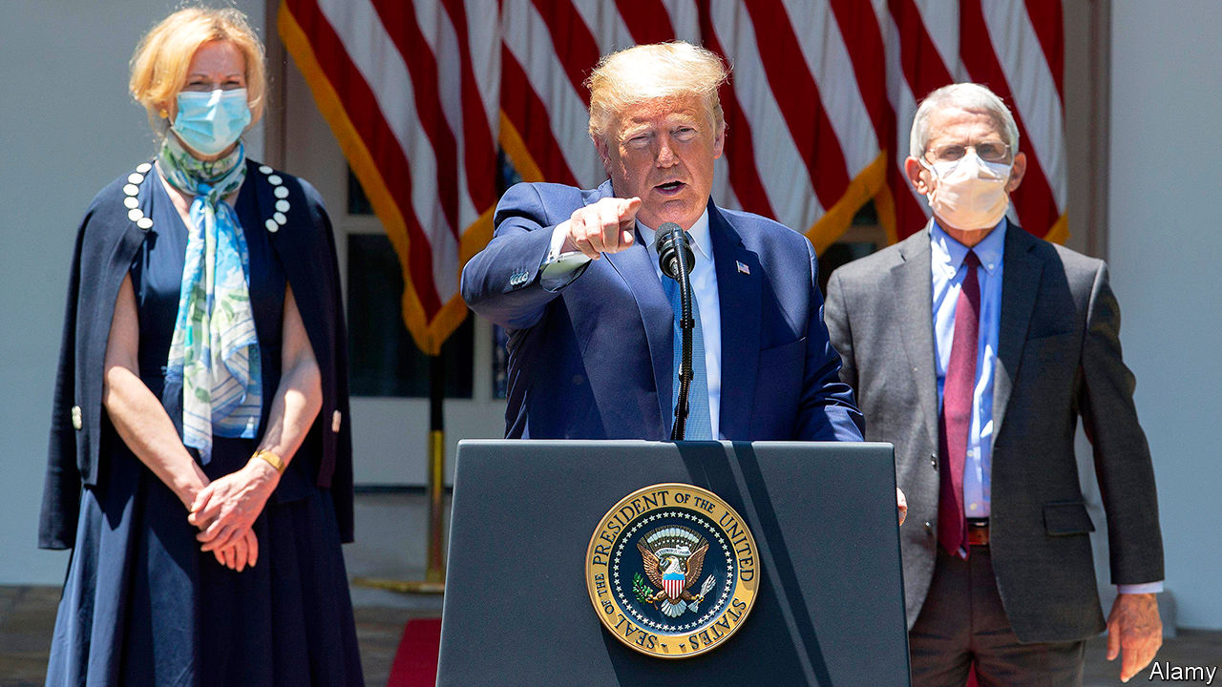

Odd man out

America, like China, has a younger population than Europe’s. Other things being equal, that should have helped. But other things were not equal. Americans have high levels of conditions that make the virus more lethal, such as diabetes, hypertension and obesity. Roughly 11% of Americans are diabetic, compared with 5% in Italy or France; more than one-third of adults are obese, compared with less than a quarter in Germany. The burden of cardiovascular and respiratory disease in America is substantially higher than it is in western European countries.

## Different in many ways

Despite all this, the statistics to date do not show America doing particularly badly. As of May 27th it had seen 301 deaths per million citizens. The 27 countries of the EU have between them seen a death toll of 125,000; 279 deaths per million people. But seven EU countries (including Belgium, France, Italy, the Netherlands and Spain) currently rank above America in their mortality rate. So does Britain, where the official rate is a shocking 559 per million. America thus looks to have fared better, so far, than most major European states, despite significant structural disadvantages when it comes to its people’s health and the system meant to maintain it.

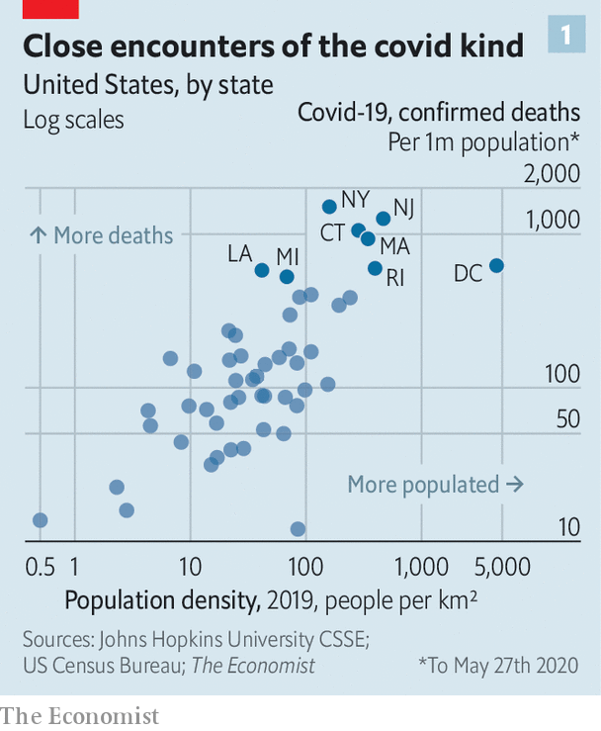

Against this, though, should be counted two other factors. The first is that America is less densely populated than Europe, and much less densely populated than the western European states that have been very badly hit. The pandemic has in general been worse in densely populated places. The parts of America which have been worst hit are those with western European population densities (see chart 1).

The second is that the infection began to spread in at least some parts of Europe significantly earlier than it did in America. Italy passed the 100-confirmed-deaths milestone on March 4th, almost two weeks before America did; South Korea had logged 3,000 cases before America’s first death was reported. There was thus a short grace period during which America might have shored up its response.

Current evidence suggests that the best thing to have done with that time would have been to get into lockdown sooner. Researchers at Columbia University have estimated that if America had implemented its social-distancing measures just one week earlier it could have reduced nationwide infections by 62% and deaths by 55%.

In America’s federal system the timing of shelter-in-place orders and other population-wide measures aimed at stopping the spread of the virus was always going to be a matter for states and cities. Those that went earlier can now be seen, in general, to have done better. A team of economists studying the differences in timing of shelter-in-place orders among states found that the average effect of social-distancing orders in America was to reduce caseloads by 44% within three weeks—with better results for high-population-density states.

The divergence between the East and West Coasts of the country shows the difference vividly. Seattle and San Francisco were early hotspots but shut down fast—which seems likely to be part of the reason that they avoided a meltdown like New York’s, where the unwillingness of Bill de Blasio, the mayor of New York City, to adhere to the advice of his public-health agency may have lost valuable time. San Francisco has seen just 40 deaths, compared with New York’s 21,000.

Some states might have shut down earlier had they had enough testing capacity to properly evaluate the spread of the virus. Alas the Centres for Disease Control and Prevention (CDC) botched the manufacturing of the test for the virus that it had created in January. Its failure might have been made good, at least to some extent, by private industry. But the Food and Drug Administration (FDA) was unwilling to license their efforts. Thus much of the head start which might have made America safer was lost.

## Special in some sort of way

This was not Mr Trump’s fault. He did not set the timing of the lockdowns, sabotage the CDC or fetter the private labs. But that does not exonerate him. His public statements in the early stage of the pandemic sought to minimise the threat that it posed to America well after scientific advice was making it clear that it would hit America hard. A clear, realistic warning from the White House might have concentrated the minds of state governments. And the jostling with the FDA could have been avoided had Mr Trump’s administration banged agency heads together and insisted on a co-ordinated, purposeful response.

America’s public-health services are a remarkable resource in terms of brainpower, analytic capability and experience, but they are also numerous and disparate. There are at least a dozen federal ones; local agencies number in the thousands. During the Ebola crisis of 2014 President Barack Obama appointed a tsar to keep the various necessary efforts aligned with one another. Mr Trump has done nothing similar. Nor does he feel he should have. On March 13th, when talking about the failure to get a serious testing infrastructure in place early on, he said, “I don’t take responsibility at all.”

There was no wartime management of the supply chains for testing reagents, swabs and other needed kit. Rather than acting as a co-ordinator, the federal government encouraged an internecine competition between states for PPE and ventilators. A federal agency outbid the commonwealth of Massachusetts for 3m medical-grade face masks, dramatically seizing them after they had been delivered to a New York port. Larry Hogan, the Republican governor of Maryland, was so worried about the federal government muscling in on an order of 500,000 testing kits from South Korea that state police spirited them away to a secret location straight from Baltimore airport.

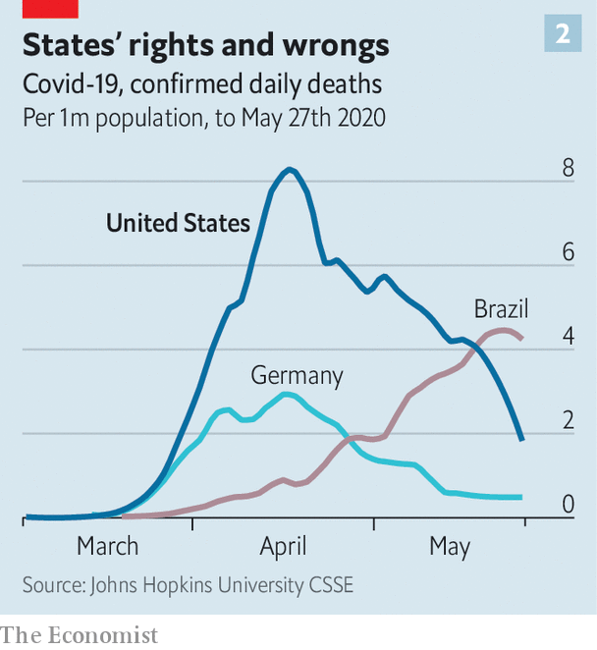

In assessing this friction, it is worth having a look at the fortunes of two other federated republics during the pandemic (see chart 2). In Brazil Jair Bolsonaro, the president, thinks that containing covid-19, which he once likened to “sniffles”, is not worth the economic cost (see article). He has tried, unsuccessfully, to prevent some states from locking down. When tasked with enforcing those lockdowns which have gone ahead, the police, who are generally sympathetic to the president, have been dilatory. Brazil’s death toll has been climbing steeply.

Germany provides a counter-example. Its states quickly set the country’s many private labs to work on testing; this wealth of testing capacity in the early stages of the epidemic allowed local public-health officials to trace contacts and close hotspots of transmission. Angela Merkel, the chancellor, clearly communicated the risks to the public. She and the heads of Germany’s states collectively agreed to shutter the economy just a day after the country had recorded its tenth death.

The degree to which Mr Trump’s denial of the problem and lack of engagement with the response made America’s epidemic worse is unknowable. But it is hard not to imagine that the country might have been better served by an approach more like Mrs Merkel’s. Germany’s overall death rate has remained considerably lower than that of other comparable European countries; it is one-third that of America’s.

In one area, though, Mr Trump’s mere presence has been integral to America’s outperformance of comparable countries, indeed of any countries: stimulus spending. The states’ actions have hit America’s economy hard. The official unemployment rate, 3.5% in February, was 14.7% in April. Almost 40m Americans have now filed for unemployment during the epidemic, roughly a quarter of the pre-crisis labour force. “Absent a historically unprecedented burst of hiring, the unemployment rate could remain in double digits [until some time in] 2021,” economists from the Federal Reserve Bank of San Francisco recently concluded.

The federal response to this incipient depression has been remarkably generous. Congress has provided ample unemployment benefits and a grant-and-loan scheme for big and small businesses. Its fiscal stimulus has so far amounted to something like 14% of GDP—higher than most European countries. Of the $9trn the IMF estimates to have been spent on fiscal stimulus globally, $2.8trn has been American. There has been a one-time grant of $1,200 to most Americans and a temporary $600 boost to weekly unemployment benefits, which means many of those laid off will be receiving more than they did in work until payments sink back to where they were on July 31st.

## Nothing works for everybody

There have been difficulties in getting some of this money out fast enough—state unemployment offices had few staff and run on antiquated software—and gaps in provision remain. Since the start of the crisis, food banks have distributed nearly 1bn meals, 20% more than usual. A recent survey found that more than one in six young children were not eating enough because of their parents’ loss of income. But there is more money in the hands of the unemployed than there might have been.

To get a sense of the counterfactual, compare the prompt generosity of this year’s action to what Congress provided in the wake of the financial crisis of 2007-09: $840bn. The difference is nothing that Mr Trump has done—co-ordination with Congress has been the treasury secretary’s task—but the simple fact of his election-year incumbency. Republican lawmakers are much more willing to loosen the purse strings under Mr Trump, not least because of the effect of the economy on his election prospects, than they were under Mr Obama. Had covid-19 struck late in President Hillary Clinton’s first term, rather than Mr Trump’s, it is a fair bet that there would have been similar hostility this time round, too.

Spending may ease the pain; but many states are nevertheless reopening businesses and easing restrictions on work and social gatherings. Thirsty patrons are snaking around the block to get into reopened bars in Dallas; vacationers at Missouri’s Lake of the Ozarks filled up swimming pools over the holiday weekend.

Again, it is the states which are doing this, not Mr Trump—despite his various attempts to undermine the shelter-in-place orders while they were in force. But the politics of Mr Trump’s presidency are a key part of how things have unfurled.

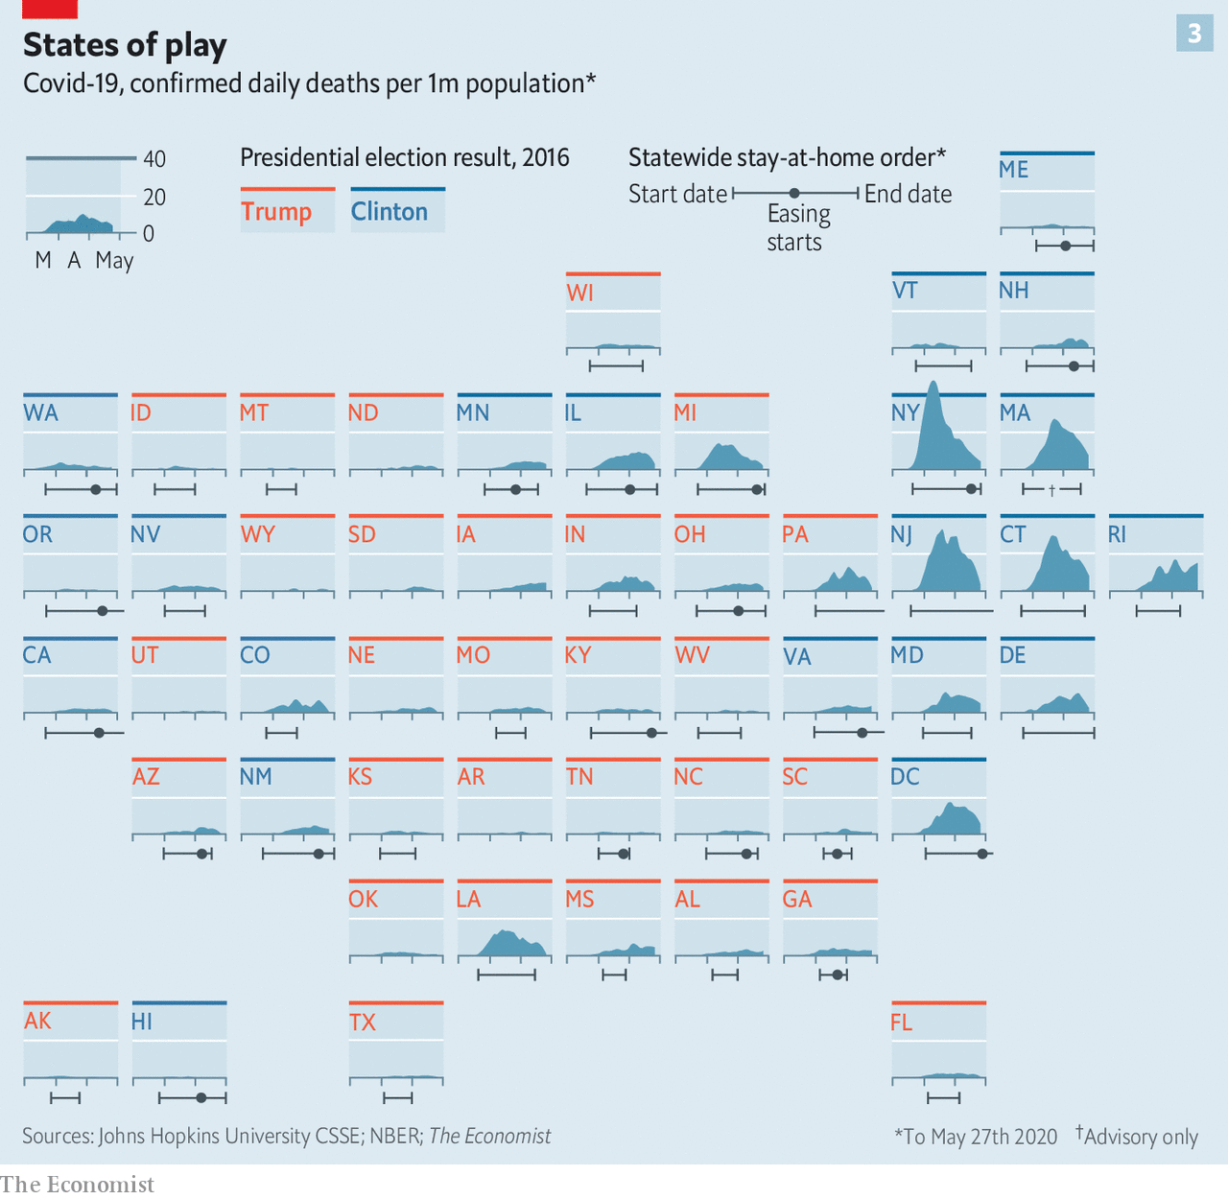

This is because the geographical underpinnings of covid-19 epidemiology and electoral politics are correlated. Low population density predicts both a low covid-19 death rate and a propensity for supporting the Republican Party. Places where Mr Trump has the most support tend to have atypically low experience of the medical effects of the epidemic (see chart 3). Recent polling by YouGov has found that only 9% of Republicans have had a family member, friend or acquaintance die of covid-19, compared with 15% of Democrats. Many Republicans in sparsely populated areas feel entirely justified in their exasperation with blanket stay-at-home orders.

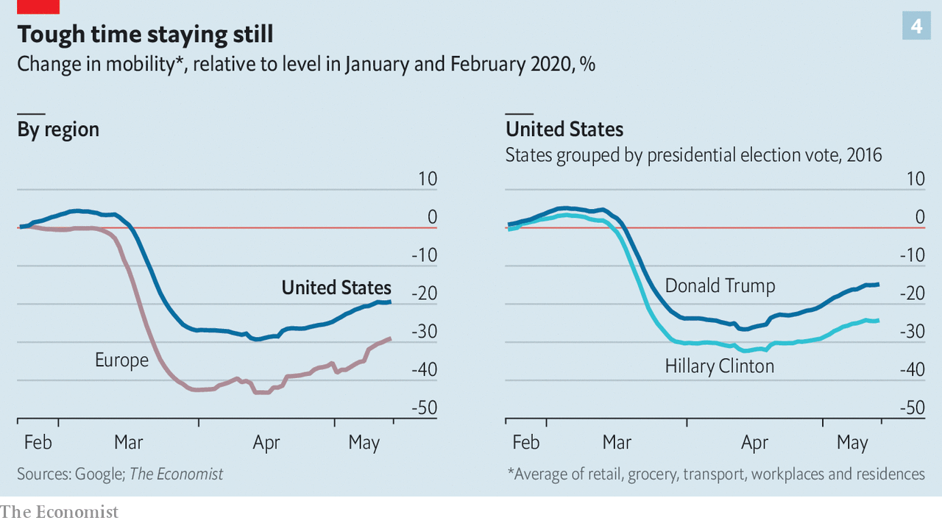

But the partisan divide on reopening is not just a matter of population density. Researchers at Stanford, Harvard and NYU, armed with location data from mobile phones, have found that throughout lockdown Republicans have been less likely to adhere to social-distancing orders than Democrats, even when living in places with similar levels of infection and similar official constraints on activity. This is in line with research by The Economist on movement during lockdown in America and elsewhere (see chart 4).

## The tyranny of the blood test

The right-wing media, which give their audiences a sense that lockdowns, mask-wearing and calls for greater testing are weak-willed coastal liberalism, have also played a role. Economists estimating the causal effect of watching Fox News, the television channel in closest alignment to the views of the president, find that it may have persuaded one-third of its viewers not to comply with stay-at-home orders. Nearly 4m Americans watch the network’s prime-time opinion shows each night.

America is not an outlier in the fact of its reopening; the same is happening in western Europe. But there is a crucial difference. European reopenings have been preceded by clear indications that the rate of infection was falling. The same is not true for all of America.

An epidemiological analysis published by researchers at Imperial College London, found that, as of May 17th, “the epidemic [was] not under control in much of the US”. In 24 states the number of further cases to be expected as a result of each new case remained above one. The situation has improved since then, but not by leaps and bounds. New York and surrounding hard hit states are showing declining levels of infection. In other states, such as Alabama and Mississippi, infection rates do not appear to be under control, perhaps because their lockdowns were not that well observed. Outside New York, New Jersey and Connecticut, hospitalisation rates have not changed since the start of May.

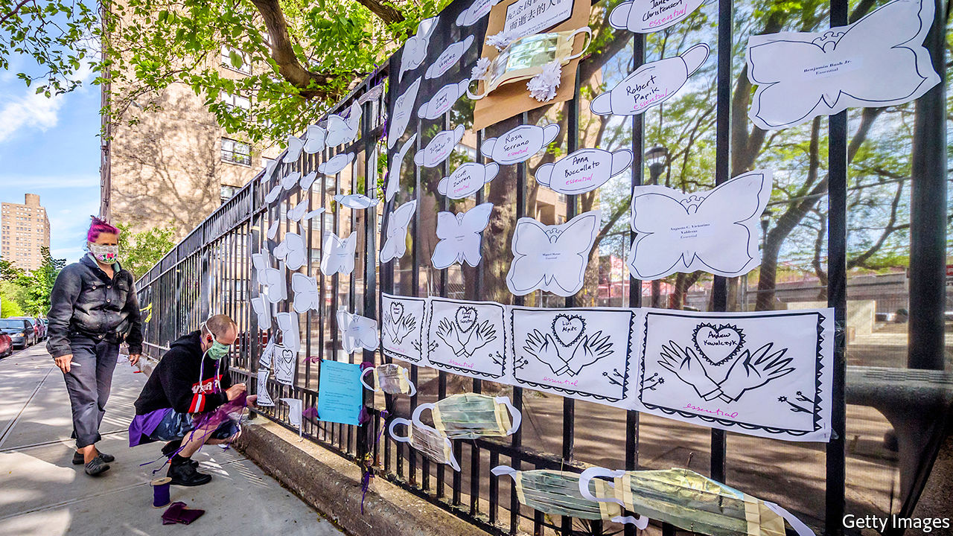

Time to remember—and to prepare

Part of the point of a sustained lockdown is to take the time it buys to build the capacity to deal with later recurrences with well-thought-through and resourced testing and contact-tracing programmes. These are not in place nationwide. “We had time to develop these capabilities that required a national co-ordinated effort, and we have not used this time,” says Leana Wen, a former health commissioner of Baltimore. “And I’m afraid that as a result, the sacrifices that people have made are in vain.” Anthony Fauci, the director of the National Institute of Allergy and Infectious Diseases since 1984, testified before the Senate that, should states skip guidelines and open prematurely, “There is a real risk that you will trigger an outbreak that you may not be able to control.” Local spikes in new cases, if they go unnoticed, will allow community spread to re-establish itself.

Experts have recommended that a disease-surveillance scheme up to the task of nipping such recurrences in the bud would require testing rates of at least 1m per day. Some want a rate double or triple that. But today’s rate is reported to be less than half the desideratum—about 400,000—and that is probably an overstatement. Some states are juicing their numbers by reporting the results of antibody tests (which reveal that someone has had the disease) alongside diagnostic tests (which reveal current infections), an apples-for-oranges mistake.

In spite of this, as far back as May 11th a barefaced Mr Trump triumphantly told a Rose Garden of mask-wearing journalists that the testing mission was accomplished: “We have met the moment and we have prevailed.” If that is by happy chance the case, it is no thanks to Mr Trump. But re-openings which feel premature after lockdowns which were sketchily observed suggest it may not be the case at all. There may be more sad records yet to be set. ■

This article was downloaded by calibre from <https://www.economist.com/briefing/2020/05/28/americas-covid-19-experience-is-tragic-but-not-that-exceptional>

|  |  |  |  |
| --- | --- | --- | --- |
|  | Articles | Sections | Next |

|  |  |  |
| --- | --- | --- |
| Briefing | Sections | The Americas |

United States

Cyber-defence: Policing the Wild West

.

Google and China: Everything in moderation

.

The Mashpee Wampanoag: To lose your land twice

.

Troubled universities: College blues

.

Lexington: Black America in peril

.

|  |  |  |
| --- | --- | --- |
| Briefing | Sections | The Americas |

|  |  |  |  |
| --- | --- | --- | --- |
|  | Articles | Sections | Next |

#### Cyber-defence

# America rethinks its strategy in the Wild West of cyberspace

The challenge of defence in the world’s most lawless battlefield

May 30th 2020 | WASHINGTON, DC

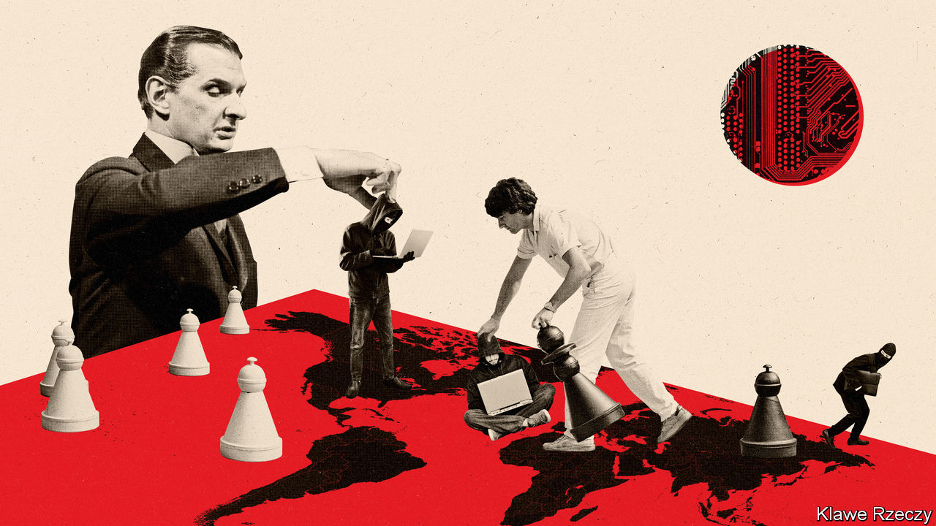

COVID-19 HAS been a phisherman’s friend. Millions of professionals are at home and online, adjusting to new routines and anxious about their jobs. That makes them perfect marks: apt to click on an email that purports to be from their boss or a supplier asking for payment. Law-enforcement officials in many countries have reported a rise in cybercrime since the pandemic started.

But according to the FBI and Department of Homeland Security, not all such attacks come from gangs or individuals looking to make a quick buck. On May 13th those agencies warned that cyber-actors affiliated with China were trying to steal covid-related data and intellectual property. China is not the only worry. Russian hackers may probe for weaknesses in American electoral systems; Iranians have targeted an American drugmaker; North Koreans have gone after cryptocurrency stores.

Just as the attacks of September 11th 2001 spurred America to change its counterterrorism strategy, repeated intrusions are doing the same for its cyber-security. Yet it first has to define the problem. Terrorist attacks tend to involve carnage, a political motive and an attribution. Cyber-assaults have a range of motives, including theft (North Korea’s raids on banks), digital disruption (Russia’s NotPetya strikes on Ukrainian and other infrastructure), sabotage (the Stuxnet attacks on Iran’s nuclear programme, probably by America and Israel) and political warfare (Russia’s interference in America’s election in 2016). Sometimes states use non-state actors to carry out cyber-attacks, much as some use terrorist proxies. Attackers may target private-sector networks in banks, hospitals or payment systems, which often appeal to the government for protection.

Defence is difficult. Potential targets are many and diffuse. Attackers’ identities are often obscure. They make use of vulnerabilities often unknown until exploited.

The National Defence Authorisation Act of 2019, which sets the Pentagon’s budget, set up a commission to rethink cyber-defence. The Cyberspace Solarium Commission, named after Project Solarium, Dwight Eisenhower’s effort in 1953 to create a durable cold-war strategy, and headed by Angus King, an independent senator from Maine, and Mike Gallagher, a Republican congressman from Wisconsin, had the misfortune to release its recommendations on March 11th, just before America went into lockdown. The commission made its first public presentation to lawmakers via video conference on May 13th.

America’s cyber-defence, it argues, is hobbled by jurisdictional boundaries. Intruders are nimble; America’s defence is ponderous. Responsibilities are scattered among the FBI, the National Security Agency (NSA, America’s signals-intelligence agency), the Pentagon’s Cyber Command, the Department for Homeland Security, the Cyber-security and Infrastructure Security Agency (CISA), and others.

The commission recommends creating a national cyber-director within the White House, a co-ordinating role much like that of director of national intelligence, which emerged from the 9/11 Commission’s report. It also recommends permanent congressional cyber-security committees and a beefed-up CISA. Yet the White House is cool on a new Senate-confirmed cyber-security post, and creating new congressional committees would mean convincing current ones to surrender jurisdiction.

More important than government structure, however, is working closely with the private sector. The commission recommends declaring some private servers, such as those for the energy, financial and telecoms industries, critical infrastructure. They would receive enhanced government monitoring in exchange for meeting more stringent security standards.

It also recommends building a platform, managed by CISA with help from other agencies including the NSA, where government bodies and private firms can share information about threats. The NSA’s British counterpart, GCHQ, has a similar system. Some companies may be reluctant to let an agency that has engaged in widespread, warrantless surveillance monitor their security, but Mr King believes the proposal “will have support from industry”.

If one way to halt cyber-attacks is to parry the blows, another is to punch back. After Russian electoral intervention in 2016, American officials grew convinced that their country was seen as a soft touch because it had not done so hard enough. “They don’t fear us,” lamented General Paul Nakasone, head of both the NSA and Cyber Command, in early 2018. The commission accordingly urges American hackers to “strike back with speed and agility”.

In practice, though, America’s approach has already shifted from punishment to pre-emption—not so much striking back as striking first. In April 2018 Cyber Command and the NSA announced a strategy built around “persistent engagement” and “defend forward”. The first of these reflects the belief that competition in cyberspace is not a series of set-piece battles, but a constant digital mêlée. The second embodies the principle that to prevent an attack, you should go to its source. Just as “our naval forces do not defend by staying in port,” says General Nakasone, “our forces must operate against our enemies on their virtual territory as well.” In August 2018 President Donald Trump rescinded Obama-era guidance and made it easier for Cyber Command to operate beyond Pentagon networks without presidential authorisation.

The more aggressive posture was road-tested during America’s mid-term elections. Cyber Command attacked servers belonging to Russia’s Internet Research Agency, the company that sowed social-media discord in 2016, and sent text and email messages to Russian operatives warning them that America was tracking them—the digital equivalent of a horse’s head in the bed. “We’re now opening the aperture, broadening the areas we’re prepared to act in,” noted John Bolton, then national security adviser, last summer.

Yet taking the fight to rivals presents challenges. The internet has no clean front lines. Attacks from enemy-held cyberspace can be routed through the networks of allies, says Max Smeets of the Centre for Security Studies in Zurich. In 2016 Cyber Command irritated Germany by wiping Islamic State propaganda on German servers without asking for permission. Mr Smeets says adversaries might route attacks via particular countries in the hope of driving wedges between America and its friends.

## Taking offence

Another problem is that if one defends far enough forward, it can look an awful lot like attacking. America is said to have secreted malicious code deep into Russian and Iranian infrastructure networks. The practice is akin to burying arms caches behind enemy lines for use in wartime: it makes it easier to strike back if Russia, which has probed America’s own power grids, crosses a line. But the same access can be used for unprovoked attack.

An alternative is to punch back by other means. America and several like-minded allies have grown bolder in publicly attributing major cyber-attacks to China, Russia, Iran and North Korea. In 2014 the Obama administration indicted five members of China’s armed forces for hacking into American companies. The Trump administration has brought similar charges against Iranian, Russian and North Korean hackers, including a dozen officers of the GRU, Russia’s military-intelligence agency, who intervened in the 2016 election. Though few American officials expect that foreign hackers will turn up in the dock, legal tools are still seen as useful for several reasons.

One is shame. Most countries do not like getting caught in the act. Second, Russian intelligence officers would rather avoid a sanctions listing that would cut off shopping trips to Paris and boarding schools in Britain. Third, the forensic evidence laid out within these indictments—even down to Google searches conducted by individual GRU officers—is a powerful way for America to hint at its reach.

Exposure also helps establish norms, defining what is considered beyond the pale in cyberspace. America and its allies argue that the existing laws of war, including ideas such as proportionality and distinctions between combatants and civilians, apply in the digital world (how this squares with suspected American attacks like Stuxnet is less clear). Russia, China, Cuba and others fear that this line of thinking might legitimise American retaliation.

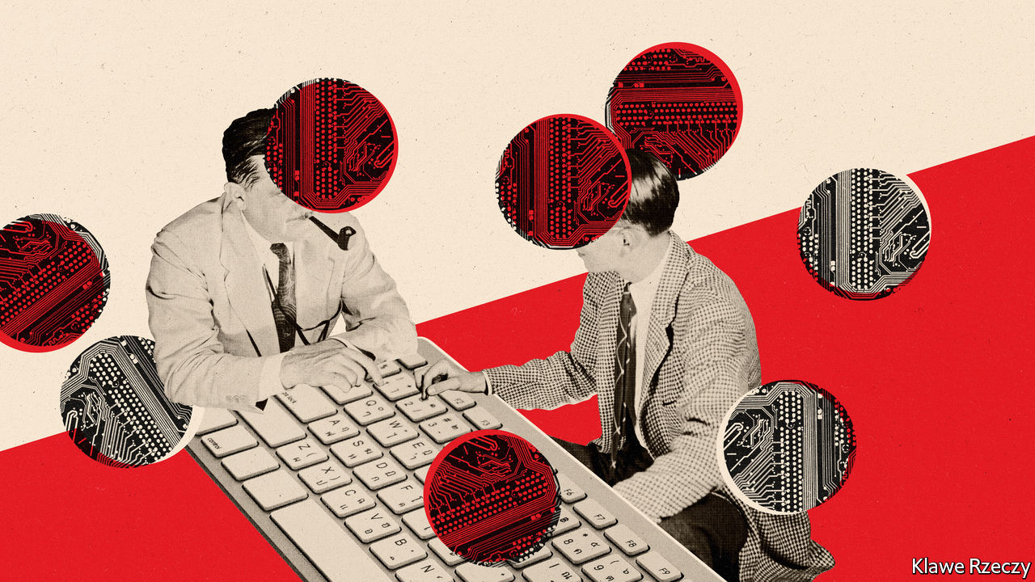

Double standards abound. America indicted Russian officers for hacking the Organisation for the Prohibition of Chemical Weapons, but the NSA has itself run riot in international institutions. And practical deals have not survived contact with reality. An agreement in 2015 between Barack Obama and Xi Jinping, China’s president, to ban commercial espionage is widely deemed to have fallen apart.

These divisions play out at the United Nations, where one group of experts, favoured by America and its allies, works parallel to a larger, Russian-dominated group. “What we’ve really seen is a kind of a fracturing of the process,” says Adam Segal of the Council on Foreign Relations. “There are some interesting ideas percolating through, but they will never be formalised or centralised in any important way.” So cyberspace remains a Wild West. ■

This article was downloaded by calibre from <https://www.economist.com/united-states/2020/05/30/america-rethinks-its-strategy-in-the-wild-west-of-cyberspace>

|  |  |  |  |
| --- | --- | --- | --- |
|  | Articles | Sections | Next |

|  |  |  |  |
| --- | --- | --- | --- |
| Previous | Articles | Sections | Next |

#### A YouTube mystery

# Google’s removal of anti-Beijing comments raises political eyebrows

The case of the vanishing comments

May 30th 2020 |

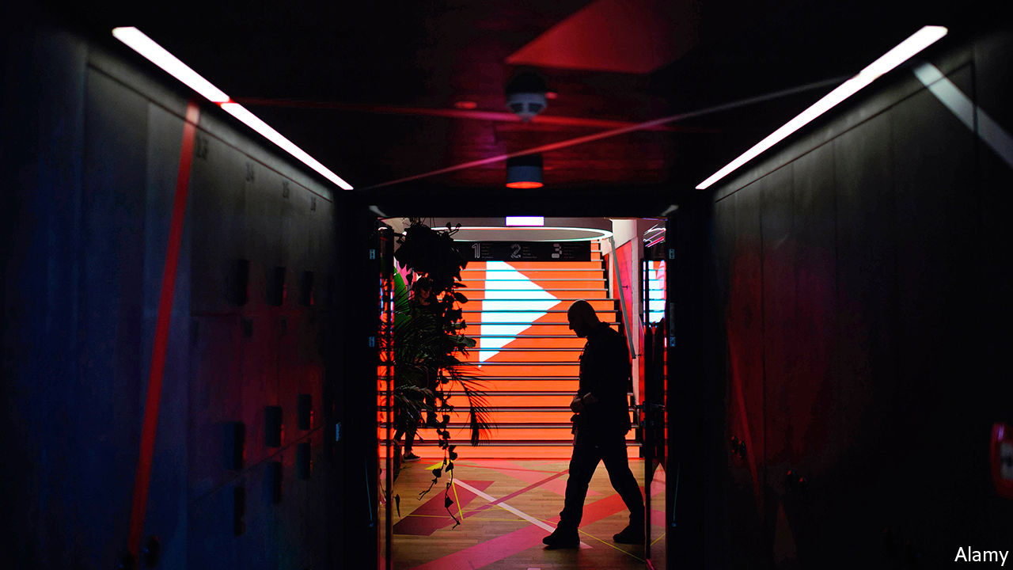

ON MAY 26TH Palmer Luckey, an American best known for making virtual-reality headsets, alerted the world to an odd phenomenon. YouTube was deleting all comments which mentioned Wumao, slang for propagandists paid by the Chinese Communist Party (CCP) to flood online forums with pro-CCP views. “Who at Google [YouTube’s parent] decided to censor American comments on American videos hosted in America by an American platform that is already banned in China?” Mr Luckey asked on Twitter.

Mr Luckey was not the first to notice this, but his tech heft drew an immediate response from the right of the political spectrum, with which he has had connections. Ted Cruz, a Republican senator from Texas, called it “very disturbing” and asked why YouTube was “censoring Americans on behalf of the CCP”. Jim Banks, a Republican congressman from Indiana, fired off a letter to Sundar Pinchai, Google’s boss. One would expect, he wrote, that the “spirit” of the First Amendment would be extended into the American firm’s online platforms.

Google says the moderation of Wumao and other anti-CCP terms was an “error”, which it has fixed. YouTube’s moderation systems, which are highly automated, had not taken “proper context into account and incorrectly removed some comments”.

But what context did the systems miss, and why? Google will not say. The conspiratorial suggestions popular with more hyperbolic sectors of the internet commentariat do not wash. The idea that Chinese spies who had infiltrated YouTube would risk blowing their cover just to mess up the moderation system is nonsense. So too is the suggestion that Google is somehow being paid off by the CCP; few issues cut across the partisan divide in American politics more effectively than the perception of a looming threat from China. For Google knowingly to censor any criticism of the CCP would have been political madness.

More likely, the explanation lies in the nature of the software Google uses to moderate content automatically, which uses a set of computer-science techniques called machine learning. Such software can update itself based on how users interact with the website, without any intervention from human programmers. This automated nature, combined with the software’s complexity, make it plausible for errors to arise in ways that are difficult to understand.

For example, if YouTube comments about Wumao and other CCP-critical phrases are flagged enough times by enough users as spam, hate speech or bullying, then the system could start removing them automatically. This could be the result of something as harmless as a furious comment war between pro- and anti-China factions, or of a campaign designed to influence the moderation software. Google says this was not the source of the error, but would not say what was.

It is also possible that the error occurred on Google’s side. Machine-learning systems need to be given context to understand the material they are to be used on, and Google probably contracted out the job of labelling the Chinese phrases that are being blocked. Its supplier may have labelled Wumao and other words as being in breach of Google’s community guidelines, without Google checking its work. Google declined to comment.

Problems with complex systems like this can be solved, but they are opaque not just through Google’s choice, but inherently through their technical design. If YouTube’s comment-moderation systems were nudged into the automated deletion of anti-CCP phrases, despite the application of the highest tech, similar holes will surely pop up in future.

The only way for Google to win this game of cat-and-mouse is to shut down YouTube comments entirely. Or it could gain an edge by spending a lot of money on humans to do the moderating. Neither is likely. Instead, such issues will probably keep providing sticks with which Mr Cruz and friends can beat the tech giant. With the outcome of a Department of Justice investigation into Google’s monopoly power looming, that may prove a liability. ■

This article was downloaded by calibre from <https://www.economist.com/united-states/2020/05/30/googles-removal-of-anti-beijing-comments-raises-political-eyebrows>

|  |  |  |  |
| --- | --- | --- | --- |
| Previous | Articles | Sections | Next |

|  |  |  |  |
| --- | --- | --- | --- |
| Previous | Articles | Sections | Next |

#### Native America

# What connects casinos, the first Thanksgiving and the Trump administration?

The Mashpee Wampanoag tribe, which stands to lose its land again

May 30th 2020 | NEW YORK

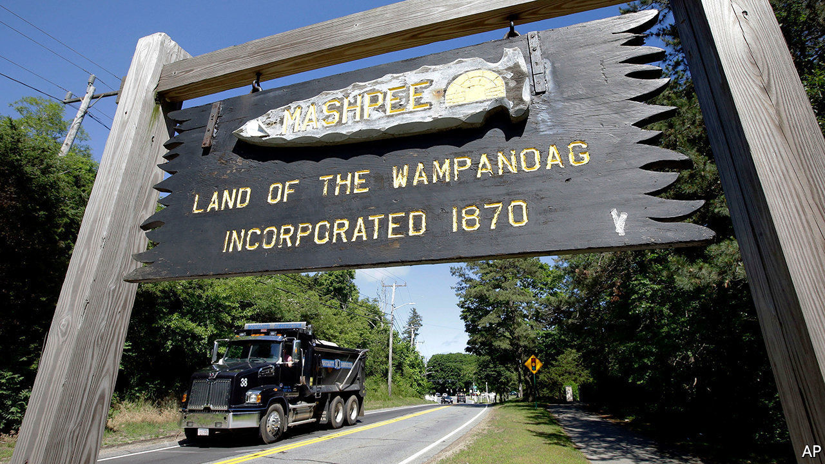

“UNLESS YOU walk in moccasins” it’s a difficult concept to capture, says Cedric Cromwell, chairman of the Mashpee Wampanoag tribe in Massachusetts, of the tribe’s link to its land. In March the federal Bureau of Indian Affairs informed Mr Cromwell that the reservation will be “disestablished”, meaning the land will be taken out of trust and would lose its federal protection. The tribe says this is a blow to tribal sovereignty and undermines the future and sustainability of the Mashpees. Taking land out of trust is exceedingly rare. It was last done in the 1960s.

The Mashpee Wampanoag tribe, also known as the People of the First Light, has occupied the same spot for more than 12,000 years. Every American child knows that the tribe befriended the newly arrived Pilgrims and was part of the first Thanksgiving in 1621. The tribe was not recognised as a sovereign nation until 2007, after decades of pushing for it. Federal recognition meant that it could resume control of some of its ancestral lands beyond Cape Cod, through a trust held by the government. The land is not subject to state or local tax laws and cannot be sold without the federal government’s approval.

In 2015 the Obama administration approved the transfer of lands in Taunton, a city in south-eastern Massachusetts. About 63% of Taunton’s voters endorsed the tribe’s plans to build a casino on the land. Not everyone was happy: two dozen residents living close to the proposed site sued to block not just the casino, but whether the land should be held in trust. One of the plaintiffs told the Boston Globe that it was not so much the casino they opposed, but the “incredible arrogance” of the federal government in building an Indian reservation in their backyard.

In 2018 the Department of Interior reversed the decision to recognise the reservation, rolling back the interpretation of what is an “Indian”. “They’re not supposed to change the rules on you mid-game,” says Heather Sibbison of Dentons, the tribe’s law firm. The tribe sued. A federal appeals court ruled in February that the tribe must show it was “under federal jurisdiction” in 1934, when the Indian Reorganisation Act was passed. This statute allowed Indian tribes to govern themselves and protected tribal land by putting it into trust.

The tribe has asked for a preliminary injunction to prevent the land from being taken out of trust until the cases are resolved. A judge will make a decision by early June on whether to grant the order. Congress, meanwhile, is working on a bill that would supersede the court ruling. A bill backed by both parties passed the House last year, but has yet to reach the floor of the Senate. Donald Trump is not a fan of Indian-run casinos. He believed that “so-called Indians” undercut his casinos in the 1990s. Some of his inner circle and donors are in the casino business and may agree.

Other tribes are worried about what the decision means for them. More than 100 other tribes have gained federal recognition since 1934 and hold thousands of acres of land in trust. Mr Cromwell said he was “blindsided” by the call in March from the Bureau of Indian Affairs. He thought the bureau was checking in to see how the tribe was coping with covid-19, which has hit Native Americans particularly hard.

The impact of disestablishment extends beyond the casino. The tribe had started building housing for its community and a childcare centre on the land. Those projects, along with a tribal courthouse, could be in jeopardy. Losing the land itself is a possibility, if they cannot pay taxes. Federal recognition is not at risk, but Ms Sibbison wonders what that is worth if land and sovereignty can be taken away.■

This article was downloaded by calibre from <https://www.economist.com/united-states/2020/05/30/what-connects-casinos-the-first-thanksgiving-and-the-trump-administration>

|  |  |  |  |
| --- | --- | --- | --- |
| Previous | Articles | Sections | Next |

|  |  |  |  |
| --- | --- | --- | --- |
| Previous | Articles | Sections | Next |

#### College blues

# Could a fifth of America’s colleges really face the chop?

Problems that predated the virus have been accelerated by it

May 30th 2020 | CHICAGO

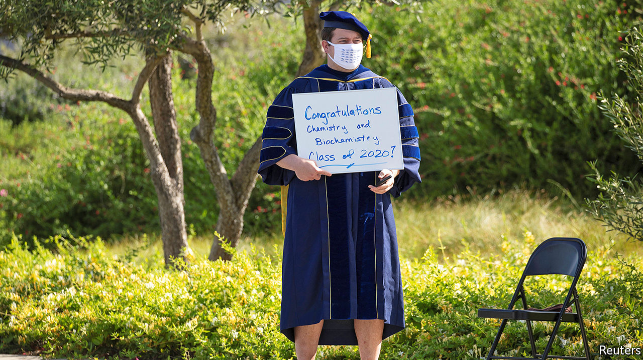

MARTYNA MALECKA, a criminology student at Stonehill College, can’t wait for classes to restart in August. Her campus in Easton, Massachusetts, “feels like a village”: its elegant red-brick buildings sprawl over 384 bucolic acres. She judges time spent there less of a coronavirus risk than staying at home in Chicago.

Universities everywhere have made valiant efforts to function remotely. A few, such as California State University, say they will continue teaching only online next year. Ms Malecka doubts that distance study works. She gets top marks, but laughingly admits she has “no idea” what she has learned after being at home since March. It is too easy to ignore lecturers who appear by video, she says, and some hardly set assignments. Like other students, families and faculty, she craves in-person learning.

Whether or not universities get back quickly to that, many are likely to suffer. Stonehill is private and Catholic, with 2,500 students and a $200m endowment. It looks in good shape, but many similar liberal-arts colleges, especially in the north-east and Midwest, are not. Their problems are long-standing. Nathan Grawe of Carleton College in Minnesota, who researches demography and higher education, says the core difficulty is the slipping fertility rate. Overall enrolment has drifted down over the past few years.

This squeezes smaller colleges hardest. A study by Parthenon-EY, an education consultancy, of over 2,000 colleges suggested 800 are so small or inefficient that they may go bust. Around one-fifth run budget deficits. Others pile up debts, fail to build sufficient endowments or sustain student numbers only by agreeing to painfully big discounts on fees. Mr Grawe points out that eight colleges were already closing each year before the pandemic.

Those that fail are usually small, among the 40% of higher-education institutions with fewer than 1,000 students. In the past decade these have seen enrolments slip faster than medium-sized ones. (The biggest typically still thrive.) Of the 72 colleges Parthenon found had shut since 2007, almost every one was small. They are vulnerable because they depend most on revenue from students; others find ways to hire out campuses for conferences, raise research funds, earn bequests and the like.

Robert Zemsky of the University of Pennsylvania, who co-wrote a recent book on the growing woes of universities, expects a “collapse, lots of closures” of smaller colleges, notably in the wider Midwest. He blames both demography and teaching methods that do not suit some students, noting how, at many universities, more than a quarter of freshmen quit in their first year. Curriculums, he says, are outdated, faculty are out of touch and four-year degrees should be cut to three to save costs and force a rethink of higher education.

Among the most vulnerable colleges are those that cater mostly to non-white students. “African-Americans are more than two times as likely to attend an institution at risk, compared with whites and Hispanics,” he says. Crystal Nix-Hines, a lawyer in Los Angeles who specialises in the education sector, also expects an “enormous winnowing” of historically black colleges.

Consolidation of higher education is overdue. Students increasingly prefer bigger and more urban institutions, so some smaller, rural ones will go. How many? Just before the pandemic, Mr Zemsky and his co-authors suggested that 10% of colleges would eventually close. He now expects 20% to shut or merge with others.

The pandemic further dims their prospects in several ways. Take universities’ efforts to recruit foreign students, who typically pay full fees. For each of the past three years, enrolments of foreign undergraduates have slid. A drop in Chinese students explains much of that. Travel bans and concern that America has bungled the coronavirus will only put off more.

The economic slump means some poorer families will not send youngsters to study. Others will delay. Funding from states for public universities is certain to fall. A report by Pew Charitable Trusts published on May 18th points out that states cut funds for higher education by 29% per student between 2008 and 2012. This time the slump is likely to be worse. Already Nevada and Ohio say they have plans to cut. The University of Michigan has talked of losing out on $1bn. Federal spending will rise ($14bn in emergency help went to universities and students under the Cares Act), but is unlikely to make up all the shortfall.

Finally, many universities face possibly costly legal trouble. Ms Nix-Hines counted 134 lawsuits, mostly class-action ones, levied against the “whole gamut” of private and public colleges by late May, mostly as students sought the return of tuition fees, saying they received a substandard service online. Some colleges might now seek a “liability shield” to protect against future prosecutions before they reopen. For universities, it all adds up to “their greatest challenge in history”, she says. That may sound alarmist, but it is probably true.■

Editor’s note: Some of our covid-19 coverage is free for readers of The Economist Today, our daily [newsletter](https://my.economist.com/user#newsletter). For more stories and our pandemic tracker, see our [coronavirus hub](https://www.economist.com/news/2020/03/11/the-economists-coverage-of-the-coronavirus)

This article was downloaded by calibre from <https://www.economist.com/united-states/2020/05/30/could-a-fifth-of-americas-colleges-really-face-the-chop>

|  |  |  |  |
| --- | --- | --- | --- |
| Previous | Articles | Sections | Next |

|  |  |  |  |
| --- | --- | --- | --- |
| Previous | Articles | Sections | Next |

#### Lexington

# The vulnerability of African Americans to the coronavirus is a national emergency

It is past time to fix a glaring disparity

May 28th 2020 |

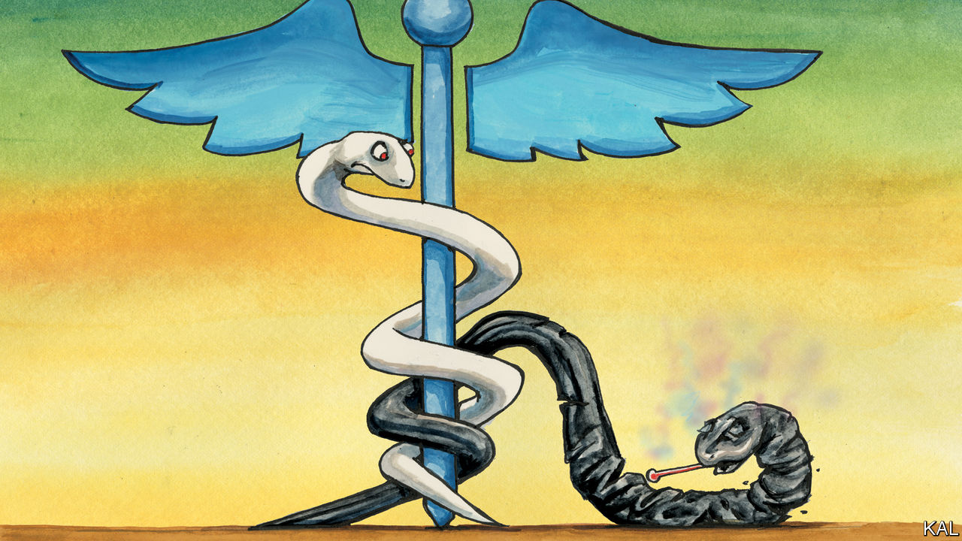

“THE MOST difficult social problem in the matter of Negro health”, wrote the sociologist W.E.B. Du Bois in 1899, was to understand why so few white Americans were bothered by it. The poor black lives Du Bois described in his pioneering study, “The Philadelphia Negro”, were spent “in the most unhealthy parts of the city and in the worst houses”, with minimal medical attention. They tended to be sickly and short. Yet he could think of “few other cases in the history of civilised peoples where human suffering has been viewed with such peculiar indifference.”

Modern medicine has since transformed the life expectancy of all Americans. But many of the disparities Du Bois observed remain. African-Americans are still the country’s poorest, poorest- housed and unhealthiest large group, with high incidences of asthma, diabetes, hypertension, cancer and obesity. In 1899 infant mortality was almost twice as high among blacks as among whites; now it is 2.2 times higher. If anything, African-American diets are unhealthier now than the rations of milk, bread and fried pork Du Bois described. So-called “food deserts” are a modern phenomenon. The 160,000 people who live in the District of Columbia’s two poorest and overwhelmingly black wards, 7 and 8, east of the polluted Anacostia river, have only three supermarkets. They also have the sparsest health care in the city, with no major hospital.

Little wonder blacks have been so stricken by covid-19. The disease kills in tandem with the ailments they suffer from the most. The latest data suggest one in 2,000 African-Americans has died of it, even though the southern states, where over half live, have been relatively spared. Partly for that reason, black Americans are not unusually likely to catch the virus. Yet those who do are 2.4 times likelier to die than whites and 2.2 times likelier than Asians and Latinos. In Washington, DC, blacks are less than 47% of the population, but account for 80% of its 445 coronavirus deaths.

A visit to a makeshift testing facility in Ward 7, across the river from the Washington Redskins’ crumbling and abandoned former stadium, provides a snapshot of this calamity. Bertina, a 64-year-old teacher wearing sweatpants and a Redskins’ bandanna (“Don’t photograph me, I look like a bum”) said her aunt had died of the virus in Atlanta after three hospitals had refused to admit her. Seventeen-year-old M’Kya said she had heard her brother, incarcerated in New York, had the virus. Overweight and sweating heavily, she was visibly unwell; she hoped it might be her allergies.

The facility, where both women had come to have their nostrils swabbed for the virus, is another symptom of a general failure. It was launched three weeks ago as a philanthropic endeavour by Howard University—America’s first black medical school—to address a shortage of testing in the part of Washington that needs it most. “You can tell things are bad when a dermatologist is running covid-19 tests!” said Ginette Okoye, a Howard professor wrapped in a mask, goggles and layers of protective clothing.

Though there are many causes of black ill-health, the solution probably starts with improving blacks’ access to health care. There have been three significant efforts to do so since slavery, which all to varying degrees spluttered in the face of a backlash from whites.

The first, during Reconstruction, was a decade-long effort on behalf of freed slaves, which constituted the first government intervention in health care. The second, in 1964-65, was a bundle of laws and edicts, including the passage of the civil-rights and Medicaid acts and court rulings to desegregate hospitals. It gave African-Americans access to the regular health-care system for the first time. Yet the legacy of Jim Crow remained, as Wards 7 and 8 illustrate, in a patchy extension of services to black areas—and sometimes worse. Doctors in Macon County, Alabama, continued their 40-year “study of untreated syphilis in the Negro male” until 1972. (They didn’t tell the 400 sharecroppers under observation that they had syphilis. They told them they had “bad blood”.)

The advances of the civil-rights period led to a big improvement in black health, which by the mid-70s had levelled off. Barack Obama’s Affordable Care Act, which followed the example of Medicaid in trying to improve the health care of all poor Americans, can be viewed as the third major effort to correct the disparity. The 20m Americans who received health insurance under the act were likeliest to be black or Latino. Yet the fury this elicited among some whites—fuelled by a vague feeling that their tax dollars were being squandered on the undeserving—helped get Donald Trump elected. Having failed to repeal the act, as he had promised to, the president has since sought to shrink it through technical changes.

Some dare hope the pandemic may lead to a fourth push to close the gap. “I’m always optimistic—especially when there are trillions of dollars circulating,” said Muriel Bowser, Washington’s mayor. African-Americans’ electoral heft might help. Even Mr Trump has been courting their votes; Joe Biden’s health-care plan was aimed at blacks even before the pandemic struck.

## Never again

Covid-19 has also made clear that such an intervention should not be considered ideological. Perhaps government action is not the best way to raise blacks economically, as conservatives argue; but their poor health cannot be improved otherwise. The virus afflicts the industrious and work-shy alike—a point made by Mr Trump’s trim African-American surgeon-general, Jerome Adams, when he acknowledged his own asthma, high blood pressure and heart disease. Indeed the most industrious blacks—such as Bertina’s son, labouring in harm’s way at Costco—are likeliest to expose themselves and succumb to the virus. Poor black health is a disincentive to work that work alone cannot fix.

It only remains to be seen, to revert to Du Bois’s difficult problem, whether a majority of Americans can be mobilised behind the issue. That must surely be possible, after the vulnerability of millions has been so cruelly exposed. If not now, indeed, when?■

Editor’s note: Some of our covid-19 coverage is free for readers of The Economist Today, our daily [newsletter](https://my.economist.com/user#newsletter). For more stories and our pandemic tracker, see our [coronavirus hub](https://www.economist.com/news/2020/03/11/the-economists-coverage-of-the-coronavirus)

This article was downloaded by calibre from <https://www.economist.com/united-states/2020/05/28/the-vulnerability-of-african-americans-to-the-coronavirus-is-a-national-emergency>

|  |  |  |  |
| --- | --- | --- | --- |
| Previous | Articles | Sections | Next |

|  |  |  |
| --- | --- | --- |
| United States | Sections | Asia |

The Americas

Brazil: Losing the battle

.

Mexico: The mystery of the missing mummies

.

Bello: Forwards and backwards

.

|  |  |  |
| --- | --- | --- |
| United States | Sections | Asia |

|  |  |  |  |
| --- | --- | --- | --- |
|  | Articles | Sections | Next |

#### A tropical tragedy

# Brazil’s losing battle against covid-19

The country entered the pandemic with some advantages. Because of Jair Bolsonaro it is squandering them

May 28th 2020 | SÃO PAULO

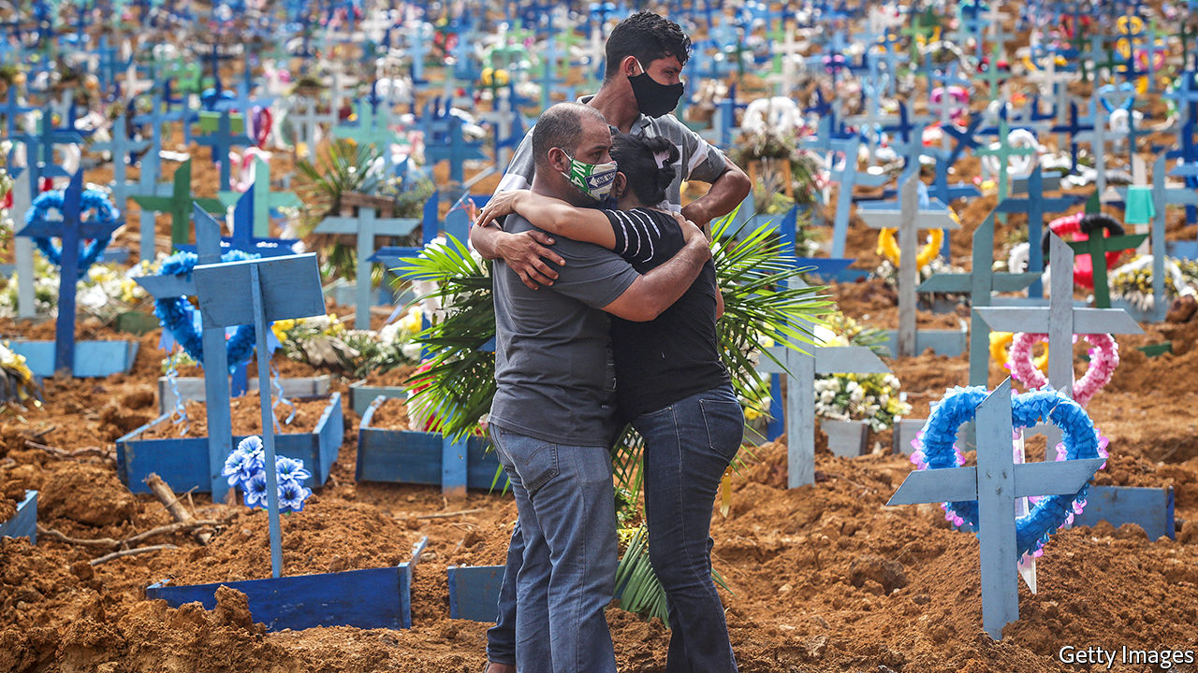

Editor’s note: Some of our covid-19 coverage is free for readers of The Economist Today, our daily [newsletter](https://my.economist.com/user#newsletter). For more stories and our pandemic tracker, see our [coronavirus hub](https://www.economist.com/news/2020/03/11/the-economists-coverage-of-the-coronavirus)

ON MAY 18TH Bruno Covas, the mayor of São Paulo, Brazil’s biggest city, announced an unscheduled five-day holiday to discourage people from going out. The residents of Paraisópolis, a favela of perhaps 100,000 people in southern São Paulo, where covid-19 deaths are rising at a faster rate than anywhere else in the city, saw the festive side. A popcorn vendor set up shop to serve the stream of patients entering a clinic. School-aged boys flew kites nearby. “Brazil adapted well to this new reality,” joked one, pointing to crowded rooftops and the dancing diamonds overhead.

Brazil’s covid-19 curve looks like a kite string. On May 28th it had 411,821 confirmed cases and 25,598 deaths. The United States, the only country with more cases, barred Brazilians from entering from May 26th. The World Health Organisation has declared South America “a new epicentre”, with Brazil the worst affected country. A study in 133 cities by the Federal University of Pelotas in the southern state of Rio Grande do Sul concluded that Brazil’s caseload is seven times the official number.

Brazil entered the pandemic with strengths. Like the United States it has a federal system. Governors (and mayors) have the power to declare lockdowns. Brazil’s free Unified Health System (SUS), modelled on Britain’s National Health Service, serves 80% of the population, though poorly in some regions. In earlier crises, such as the H1N1 (“swine flu”) epidemic in 2009 and the mosquito-borne Zika outbreak in 2015, the three levels of government and the SUS co-operated effectively.

More contagious than H1N1, covid-19 exploits Brazil’s weaknesses. Rich travellers brought the virus, but it is now concentrated in poor neighbourhoods like Paraisópolis, where people are packed together and have jobs without contracts or benefits. That makes social distancing hard. A monthly benefit of 600 reais ($110) introduced in April has helped millions of informal workers, but long queues of people unable to obtain it are still forming at banks.

What makes social distancing harder is that Brazil’s populist president, Jair Bolsonaro, scoffs at the medical establishment and its advice. He has quarrelled with and lost two health ministers since the crisis began. His attitude to covid-19 resembles that of President Donald Trump: both tout hydroxychloroquine, a malaria drug that is useless against covid-19 and can be dangerous, according to a new study in the Lancet.

Mr Bolsonaro’s attitude causes more damage, however. Brazil’s federal system is more president-centred than America’s. To work well in a crisis, all levels of government must co-operate. Luiz Henrique Mandetta, Brazil’s health minister when the outbreak began, held daily meetings with state and municipal health secretaries to plan for getting and distributing money, tests and equipment to combat the pandemic. But after Mr Bolsonaro sacked him on April 16th those meetings ended. “The SUS is a three-legged animal,” Mr Mandetta says. “If you cut off one of its legs, it starts to go in circles.”

Rich states with relatively strong health systems are coping better. In the state of São Paulo co-ordination among municipal and state health agencies and the private sector helped open thousands of hospital beds, including in stadiums and convention centres. Even so, in the city more than 90% of intensive-care beds are occupied. Douglas Cardozo, an auxiliary nurse at Hospital do Campo Limpo, south of Paraisópolis, says that staff lack bodysuits and other necessities. At least 50 patients a day check in with covid-19 symptoms, he says. Two colleagues have died from it.

In poorer regions of Brazil the health system is buckling. Less than a month after the first covid case was reported on March 13th in Manaus, a city of 2m in the Amazon rainforest, the mayor said that its system had collapsed. A promised field hospital has failed to materialise and mass graves are being dug for victims, some of whom are dying on boats en route to the city.

The weaker the health system, the more it needs the protection of strict lockdowns. But Mr Bolsonaro has made these a wedge issue. He shows up at weekly protests in Brasília, the capital, against quarantines. Unlike in some European countries, Brazilians do not come to their front doors and windows to applaud health workers. Their covid clamour signals conflict. When Mr Bolsonaro says something incendiary, his fans drive around blasting car horns in approval while his critics bang pots and pans. In municipalities where support for Mr Bolsonaro is strong, adherence to social distancing is correspondingly weak, according to a recent paper by Nicolas Ajzenman, an economist, and two other authors.

This forces governors and mayors to fight on several fronts. Mr Bolsonaro mounted a legal challenge to their quarantine orders, which the Supreme Court rejected on April 15th. João Doria, the centre-right governor of São Paulo state, says that to implement a strict lockdown “would mean a clear confrontation with millions of Brazilians” who support Mr Bolsonaro. (Critics say he wants to avoid angering businessfolk.) Some Brazilians are merely confused. They ask themselves: “whom should I listen to, the governor or the president?” says Mr Doria.

This adds to the economic and cultural forces that jam people together even as the president divides them. Just half in São Paulo are adhering to lockdown rules. To stop the virus’s spread 70% is needed, says the state’s government. On bustling Avenida Senador Teotônio Vilela on the city’s southern periphery more than 20 shoppers browse in a variety store, ducking in and out under half-lowered metal shutters. Reinildo Carneiro, a construction worker, donned a puppy-print mask and popped into a bar in Paraisópolis for a game of snooker. “You’re more vulnerable if you get depressed from staying at home,” he says. Beer kills the virus, he read on WhatsApp.

Mr Bolsonaro will not set him straight. His presidency is consumed by melodrama. In a two-hour video of a cabinet meeting released by the country’s Supreme Court and watched by millions of Brazilians, he gave himself over to unhinged and profanity-filled rants against police investigations of his sons but had little to say about protecting citizens from the pandemic. Widespread testing, a precondition for easing lockdowns safely, is not happening. By May 26th Brazil had processed fewer than 500,000 tests, just a tenth of the number acquired by the health ministry. Its testing rate is far lower than that of European countries and the United States.

Governors are yielding to pressure anyway. Mr Doria announced plans to begin opening parts of his state, including the city of São Paulo. At the city’s São Luis cemetery 3,000 fresh graves await covid-19 victims. Several hundred have been filled. The cemetery’s old average of 11 burials a day has jumped to more than 40, says a gravedigger. Most graves are covered with flowers but unmarked due to a backlog in engraving the plaques. A banner warns about Zika. None is needed for covid-19, says the gravedigger. “Once people lose a family member, they finally believe.”■

Editor’s note: This article has been updated to include more information about Mr Doria’s plans to open up parts of São Paulo state.

This article was downloaded by calibre from <https://www.economist.com/the-americas/2020/05/28/brazils-losing-battle-against-covid-19>

|  |  |  |  |
| --- | --- | --- | --- |
|  | Articles | Sections | Next |

|  |  |  |  |
| --- | --- | --- | --- |
| Previous | Articles | Sections | Next |

#### Death and taxes

# Mexico’s missing mummy mystery

Heedless of curses, The Economist goes to investigate

May 30th 2020 | GUANAJUATO

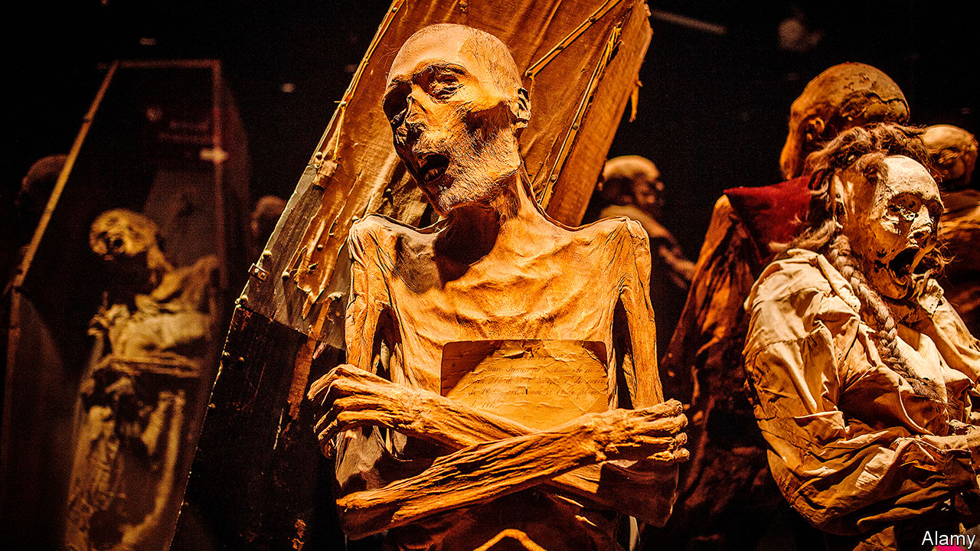

WITH ITS steep hills, candy-coloured buildings and winding passageways, Guanajuato has a claim to be Mexico’s most beautiful city. Its main tourist attraction may be the country’s most ghoulish. The Museum of Mummies, set underneath the city’s Santa Paula cemetery, contains 117 specimens. They are encased in glass, some standing, some recumbent, clothed and naked, their faces alive with agony. When local media reported in May that 22 mummies had gone missing, the city’s living residents grimaced.

The claim comes from Paloma Reyes Lacayo, who was the museum’s chief between 2015 and 2018. Mistrustful of its current managers, she requested an inventory. Some of the mummies did not appear on it. Locals suspected that someone in the city’s hierarchy had purloined its patrimony. Nonsense, says the city’s cultural director, Jesús Antonio Borja. The mummies are all present and accounted for.

They are the offspring of Guanajuato’s dry, hot climate and Mexico’s political history. After the country’s government separated church and state in the 1850s, towns created their own cemeteries. To defray the cost of Santa Paula cemetery the local government levied a burial tax on survivors, payable every five years. If the money did not come, the cemetery disinterred the remains. Not many years after its founding workers began to discover that Guanajuato’s arid heat had preserved some of the bodies that had been buried above ground in Spanish-style wall vaults. “Mexico is so generous that its wonders happen by accident,” mused Juan Villoro, a writer, in a recent newspaper column. “Egypt dedicated centuries to the art of embalming. Here the mummies appear without effort.”

They have slowly gained fame. In “Las Momias de Guanajuato”, a wrestling film released in 1972, they come alive and attack El Santo, Mexico’s most popular luchador. In the film’s thrilling climax he prevails by choke-slamming them in Santa Paula cemetery. The museum, now in a pandemic pause, draws 620,000 visitors a year, three times the city’s population. It is the city’s second-biggest source of revenue after property tax.

The late El Santo’s son, who wrestles as El Hijo del Santo, rejoiced when the city issued a press release claiming that no mummies had gone missing. “I am sharing great news,” he tweeted. Mr Borja has invited more sceptical observers to come to Guanajuato to confirm his headcount.

The Economist accepted. Our tally: 59 mummies on display in the main museum, 22 in storage and 36 in a separate exhibition space in the nearby town of Sangre de Cristo. No absentees. The inventory Ms Reyes had requested had listed only the mummies on display.

That may not be the end of the spat over Guanajuato’s mummy management. Ms Reyes, who has degrees in biochemical engineering and cultural management, accuses Mr Borja of irresponsibly sending mummies for exhibitions in other cities. A similar museum in Sicily never lends out its mummies. Mr Borja answers that Ms Reyes failed to deal with a fungus that infected a mummy in 2016.

The two are at odds over plans for a new museum, which will cost 200m pesos ($9m). Mr Borja says it will relieve crowding and provide space for mummy maintenance. Ms Reyes says Guanajuato’s pro-business government wants a new site for the museum because shops are more profitable neighbours than gravestones.

No one questions the power exerted by the mummies themselves. To some residents, they are ancestors rather than display objects. Some visitors see in their arrested decomposition a sign that life refuses to surrender fully to death. Ms Reyes calls the time she spent caring for them “the best years of my life”. The fuss she helped create at least gives them more time in the sun.■

This article was downloaded by calibre from <https://www.economist.com/the-americas/2020/05/30/mexicos-missing-mummy-mystery>

|  |  |  |  |
| --- | --- | --- | --- |
| Previous | Articles | Sections | Next |

|  |  |  |  |
| --- | --- | --- | --- |
| Previous | Articles | Sections | Next |

#### Bello

# Why a president from the 1980s offers lessons for Colombia today

What Iván Duque should learn from Virgilio Barco

May 28th 2020 |

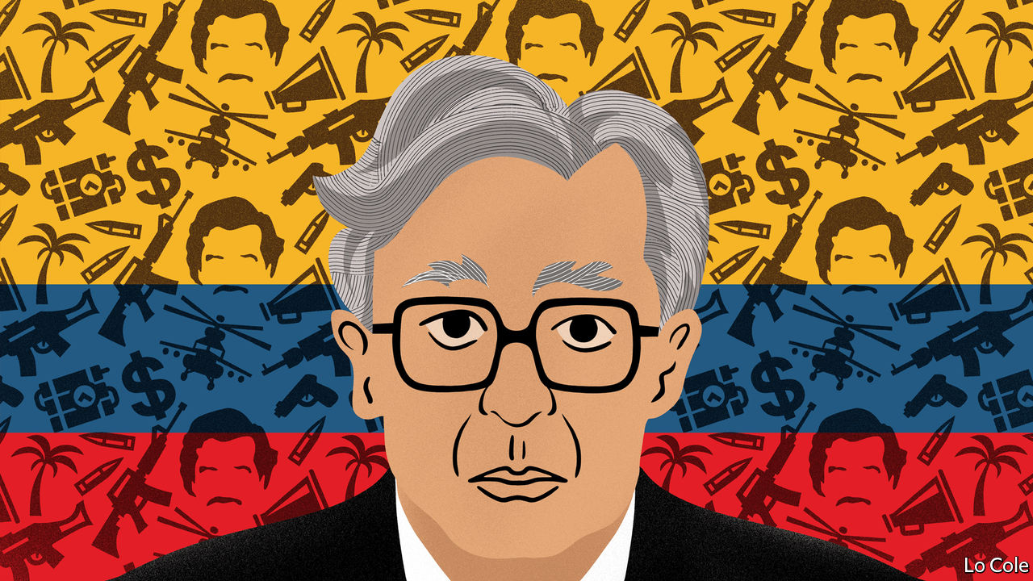

“IT IS DIFFICULT to find in the recent history of the West a democratic state confronted with such serious threats as Colombia was in the mid-1980s.” So writes Malcolm Deas, a British historian, in a biography published last year of Virgilio Barco, the country’s president from 1986 to 1990. Colombia had the world’s highest murder rate, as Pablo Escobar and his drug-trafficking friends ran amok, slaughtering judges, journalists and ministers. The state’s writ did not run in many rural areas, where the FARC and other left-wing guerrillas battled right-wing paramilitaries, all financing themselves from extortion, kidnapping or cocaine. With Colombian politics suffering from a surfeit of veto players, from ex-presidents to business lobbies, academics began to talk of a “blocked society”.

Barco began the unblocking. He ended a cosy power-sharing arrangement between his Liberal party and the Conservatives and set in motion the writing of a new constitution. He correctly identified the narcos as a more pressing threat than the guerrillas, with some of whom he made peace. He began to strengthen a weak state and launched a development programme for conflict-ridden areas. Several of his successors continued his work. In this century Álvaro Uribe, a right-winger, expanded the army, caused the paramilitaries to disband (formally, at least) and beat back the FARC, allowing Juan Manuel Santos to conclude a peace agreement in 2016.

Outwardly, Colombia is in much better shape today. Violence has fallen steeply. Colombians are less poor, healthier and better educated than they were in the 1980s. Between them the current president, Iván Duque, big-city mayors and the health service have coped well with covid-19. Colombia has recorded 16 deaths per million people, compared with 120 in Peru and 44 in Chile. The hospitals have spare beds, allowing the government to ease its lockdown.

Mr Duque, who is sponsored by Mr Uribe, has seen his approval rating rise from 23% in February to 52% in April. Yet he would be rash to relax. Peace has allowed new aspirations: mass protests last year focused on better education and pensions. But Colombia’s progress has all but halted since the peace agreement, and in some ways before that. Many crucial issues, from judicial reform to tackling corruption, have been shirked.

There are new worries. Partly because it has never managed to raise enough taxes, Colombia has been less ambitious in trying to offset the covid-19 recession than Peru or Chile. With poverty and unemployment surging, discontent is bound to return. This is all the more worrying because the security forces seem to be losing their grip. Earlier this month a dozen officers were fired after it was revealed that army intelligence spied on opposition politicians, journalists, activists and even a senior aide to Mr Duque. The dictatorial regime of Nicolás Maduro in Venezuela claims, plausibly, to have infiltrated Colombian intelligence. Meanwhile, a Mexican drug “cartel” and assorted armed groups are running free on the Pacific coast.

Some of Mr Duque’s opponents accuse him, in part unfairly, of failing to implement the peace agreement. “The big complaint is not peace, it’s security,” says a former defence official. “It’s what they were supposed to be good at.” The peace agreement offered the chance to shrink the army, expand the police and concentrate on bringing the rule of law to rural areas. Instead, Mr Duque’s government has allowed the army to become politicised, and has failed to exercise civilian oversight of it.

Mr Duque is young, personable and a good orator. But Mr Uribe controls his party. The government’s achievements include absorbing 1.8m Venezuelan migrants, a law to get broadband to rural areas and, so far, coping with covid-19. But with more than half his four-year term still to go, they risk being wiped out by recession and, with it, a probable rebound in crime.

As for Barco, he was an unlikely leader. An engineer, educated at MIT when few Colombians studied abroad, he seemed distant, was a poor communicator and, many said, an inept politician. But having worked his way up in the Liberal party, he had much political and government experience. He quietly emancipated himself from his predecessors and his party’s bosses, kept his distance from business lobbies and was his own man with a clear programme, writes Mr Deas. In all those things, Mr Duque would do well to emulate him.

This article was downloaded by calibre from <https://www.economist.com/the-americas/2020/05/28/why-a-president-from-the-1980s-offers-lessons-for-colombia-today>

|  |  |  |  |
| --- | --- | --- | --- |
| Previous | Articles | Sections | Next |

|  |  |  |
| --- | --- | --- |
| The Americas | Sections | China |

Asia

North Korea’s economy: Running out of juche

.

Universities in Australia: Bye degrees

.

India and China: Mountain claimers

.

Sexual minorities in Myanmar: Aygay angslay

.

Banyan: Take these broken wings

.

|  |  |  |
| --- | --- | --- |
| The Americas | Sections | China |

|  |  |  |  |
| --- | --- | --- | --- |
|  | Articles | Sections | Next |

#### Running out of juche

# Standoffish North Korea discovers the limits of self-reliance

Economic damage is forcing it to lift a self-imposed quarantine

May 30th 2020 | SEOUL

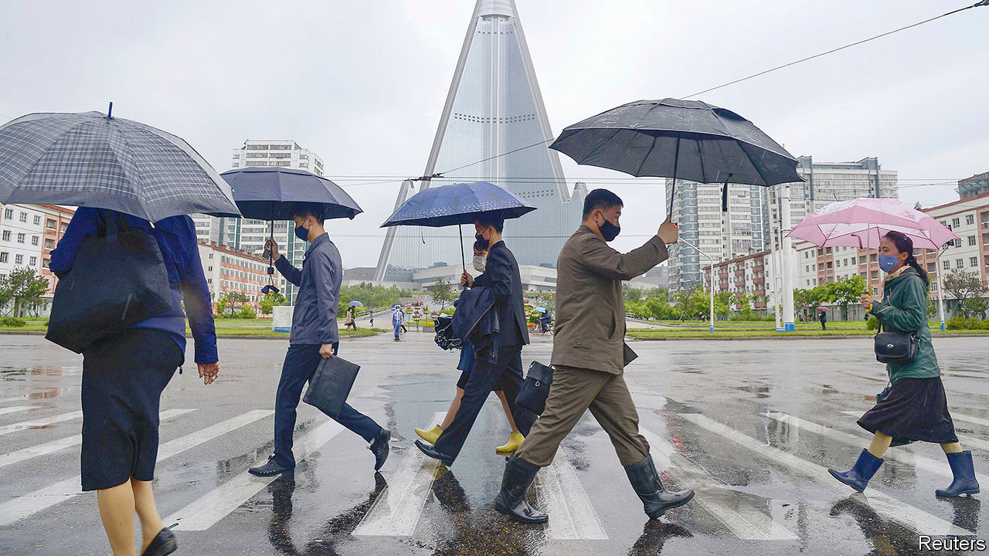

THE ECONOMY was not on the agenda when Kim Jong Un, North Korea’s dictator, appeared at a party meeting on May 23rd after his second three-week absence from public view in as many months. According to state media, the Supreme Leader promoted several military officials and laid out plans to beef up the North’s nuclear deterrent. That was exactly the sort of action Mr Kim should avoid, America’s national security adviser responded, if he wanted North Korea to have a “great economy”.

Over the past few months, the North’s economy has looked even less great than usual. The leadership’s decision in January to shut the country off from the world to prevent the spread of covid-19 (of which North Korea continues to claim to have no cases) has meant sealing the border with China, through which it conducts almost all its trade. Beside causing hardship for ordinary North Koreans, the self-imposed blockade also seems to have affected privileged people in Pyongyang, the capital. The government’s attempt to limit the impact on state coffers through a compulsory bond-buying scheme seems to have exacerbated the problem. North Korea’s cherished policy of juche, or self-reliance, may have reached its limits.

Even before the pandemic hit, the most recent tightening of sanctions had reduced North Korea’s trade with China. According to Chinese customs data, exports to the North declined from just under $350m in the first two months of 2016 to less than $250m during the same period in 2019. Imports from North Korea dropped from $350m to less than $50m in the same period. These numbers do not tell the full story, because they exclude deliveries of crude oil from China via pipeline. Nor do they include smuggling by ordinary North Koreans, nor the regime’s illicit trading activities, such as ship-to-ship transfers of oil on the high seas.

Even so, sanctions seemed to be causing pain. In his New Year speech, Mr Kim warned his people that leaner days lay ahead and that the country needed to become still more self-reliant—a break with the promises of growth and prosperity that had previously marked his tenure.

The decision in January to close the Chinese border has compounded the problem, by bringing official trade between the two countries almost to a halt. Imports from China dropped below $200m in January and February and below $20m in March. Exports disappeared almost completely. The lockdown also seems to have ended what little private-sector smuggling there had been, with traders in China reporting nigh-on-insurmountable controls.

The impact of these developments on life in North Korea is even harder to discern than usual, given that the border restrictions have also reduced the already meagre flow of information out of the country. There are no signs of an acute shortage of food and other essentials, but prices have gyrated. In the border town of Hyesan, the price of a kilo of rice rose by more than 20% between January and April, according to DailyNK, a website specialising in news from North Korea. The price of petrol also jumped, it reports, and the North Korean currency, the won, tumbled against the Chinese yuan and the American dollar. Big regional differences in prices suggest there may have been restrictions on domestic movement as well as the border closure, says Teodora Gyupchanova of NKDB, an NGO in Seoul.

The impact on livelihoods is likely to be compounded by the fact that late spring is traditionally the lean season in North Korea, when winter stores run low but few crops are ready to harvest. In early April Rodong Sinmun, the government’s mouthpiece, which had been printing lots of its usual reports about the over-fulfilment of production plans, admitted that the people were suffering “hardships”. It said the country “lagged behind” others in economic development and would require an extra dose of “self-reliance” to overcome this failing.

Reports of panic-buying of imported goods in Pyongyang’s glitzy department stores suggested shortages, or at least pervasive rumours that such items might soon be in short supply. There were also reports of rising prices for Chinese-made goods in other parts of the country. Factories that make consumer goods, such as clothes and shoes, have been encouraged to find alternatives to imported raw materials, rather than waiting for the border to reopen.

Meanwhile, the apparent shortage of foreign currency has probably been hampering progress on pet projects such as new holiday resorts, which are designed to please cronies of the regime. It has responded by tapping reserves held by businesses. It has launched an extensive bond-buying programme to finance more than half the annual budget, with some firms compelled to use their foreign-currency reserves to purchase government debt. Given North Korea’s patchy record of repaying its debts and the methods used to persuade people to buy the bonds (one mining boss has reportedly been executed for refusing), the programme looks like little more than a polite form of expropriation.

Chris Green of the University of Leiden believes that it may be part of a longer-term strategy to restore state control over the economy. “There was a time early on in the Kim Jong Un era [when] big enterprises were allowed to accumulate their own hard-currency supply, but that is apparently no longer desirable.” However, North Korea’s entrepreneurs, used to the regime’s periodic attempts to seize their money, are adept at hiding it.

Whether the government was having trouble funding itself, or was worried that the officials who form the bedrock of the regime were upset about the shortages of imported goods, Mr Kim seems to have decided that complete isolation is unsustainable. Restrictions on the border appear to be easing, with some goods reportedly getting through again in recent weeks. Prices for rice and petrol have fallen. Of course, the looser restrictions might yet result in some less sought-after imports, such as cases of covid-19. ■

This article was downloaded by calibre from <https://www.economist.com/asia/2020/05/30/standoffish-north-korea-discovers-the-limits-of-self-reliance>

|  |  |  |  |
| --- | --- | --- | --- |
|  | Articles | Sections | Next |

|  |  |  |  |
| --- | --- | --- | --- |
| Previous | Articles | Sections | Next |

#### Bye degrees

# Australia’s foreign-student bubble has burst

But the government is reluctant to help stricken universities

May 30th 2020 | SYDNEY

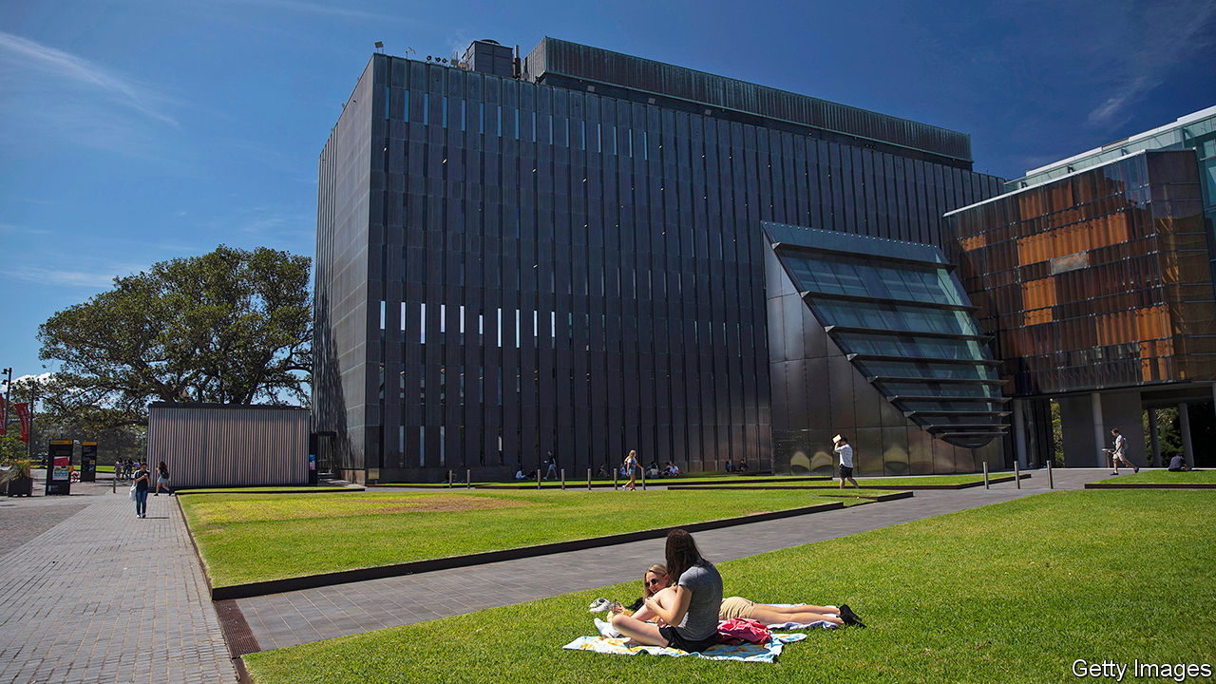

AUSTRALIA’S OLDEST university campus should be heaving on a sunny autumn afternoon. Before the pandemic, the University of Sydney hosted more than 70,000 students. At lunchtime they would cram into its cafés and crowd onto its lawns. Now its grounds are practically deserted. Although Australia has almost quashed covid-19, social-distancing rules forced the campus to close in March, and only a few stragglers have stayed on amid the historic sandstone and modern plate glass.

The abrupt halt to international travel is even more painful for Australian universities than their counterparts in other English-speaking countries (see [article](https://www.economist.com/node/21786922)), because they lean more heavily on revenue from foreign students. More than 440,000 such students enrolled in Australian institutes of higher education in 2019. At the last count, they took up roughly 30% of all places. Almost 40% of them came from a single country, China.

The foreign students are lucrative. In 2018 they brought in almost A$9bn ($5.8bn) in revenue—just over a quarter of all university funding, and far more per head than local students bring in through fees and government subsidies. The boom turned education into Australia’s fourth-biggest export, behind coal, iron ore and natural gas. It funded world-class research centres, shiny new learning facilities and vast collections of art. Vice-chancellors’ pay packets swelled (in big universities they rake in well over A$1m). Campuses bulged to sizes, as an academic at La Trobe University puts it, “matched only by the epic institutions in India and China”.

For years, this has been the subject of heated political debate. Universities say they were forced to woo foreign students because the government does not give them enough money to cover their rising costs. Michael Spence, the vice-chancellor of the University of Sydney, says: “The education of domestic students doesn’t break even.” If Australia is “more dependent on student fees than comparable systems around the world,” he argues, “that’s a decision successive governments have made.”

Some in the current conservative coalition government retort that universities have brought the crisis on themselves. They “bet big on the international-student dollar” and “have become badly over-exposed”, James Paterson, a senator, recently declared. Vice-chancellors have “privatised the profits” from foreign students, “building Taj Mahals to themselves”, a conservative commentator complains. Even some of those employed by universities are critical. “It wasn’t a Ponzi scheme,” says the academic at La Trobe, “but it’s in that ballpark.”

Now, argues Salvatore Babones of the Centre for Independent Studies, a think-tank, “the chickens have come home to roost.” Australia’s academic year starts in January, so as covid-19 first appeared in China, a flight ban locked out an army of its students just as they should have been enrolling. Some wriggled back in through third countries, but Australia has since closed its borders to non-citizens, and they are not likely to reopen until at least the end of the year.

Universities Australia, which represents the industry, is not sure exactly how many foreign students it has lost. The University of Sydney has fallen 17% short of its enrolment target for 2020, according to Mr Spence, and now faces a budget shortfall of A$470m. Across the industry, revenue could fall by A$3bn-4.6bn, according to Universities Australia, putting 21,000 jobs at risk, many of them in research.

Since students who do not enroll this year will not pay fees in 2021 or after, a quick bounceback seems impossible. Peter Hurley of Victoria University’s Mitchell Institute, another think-tank, estimates that the industry might lose A$19bn over the next three years. Building projects and casual staff have already been axed.

So far, the government has been disinclined to help. It says it will still fund the places of domestic students, even if they drop out rather than embrace online learning. But it has excluded universities from its A$60bn wage-subsidy scheme, JobKeeper. Dan Tehan, the education minister, has called for “a greater focus on domestic students”.

Few seem to think universities will fail. Smaller, regional institutions are in the most danger, but since they are an important source of jobs, state and federal governments might be persuaded to prop them up. They will, however, have to shrink to survive. Universities will be “smaller in staffing and smaller in revenue”, says John Dewar, La Trobe’s vice-chancellor. There could be “a massive change in the types of courses they offer”, Mr Hurley predicts. That seems to be just what the government wants. ■

This article was downloaded by calibre from <https://www.economist.com/asia/2020/05/30/australias-foreign-student-bubble-has-burst>

|  |  |  |  |
| --- | --- | --- | --- |
| Previous | Articles | Sections | Next |

|  |  |  |  |
| --- | --- | --- | --- |
| Previous | Articles | Sections | Next |

#### Mountain claimers

# A border dispute between India and China is getting more serious

China is nibbling away at Indian territory and digging in

May 28th 2020 |

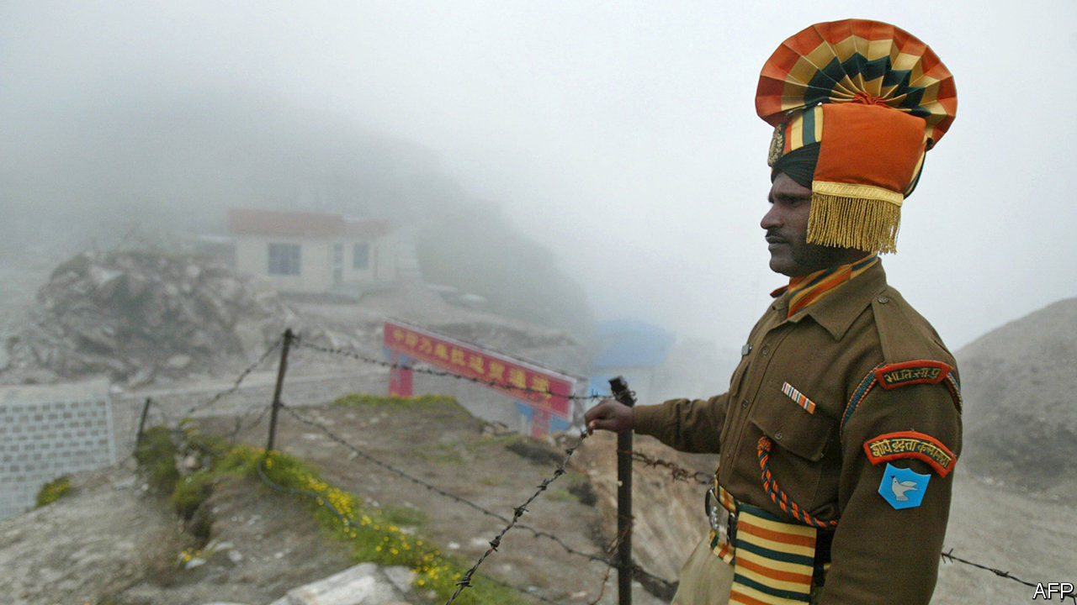

WHEN INDIAN and Chinese soldiers brawled at Pangong lake high in the Himalayas earlier this month—a punch-up serious enough to leave many in hospital—General M.M. Naravane, India’s army chief, was unworried. Such “temporary and short-duration face-offs” happened from time to time in remote stretches of the 4,000km (2,500 miles) border between the two countries, he said. Both sides had “disengaged”. But a week later he dashed north to the headquarters of the 14th Corps in nearby Leh, the regional capital, suggesting that something more serious was afoot.

According to Indian press accounts, Chinese troops have crossed the undefined border with India at several points, some reportedly penetrating 3-4km over punishing terrain. They are said to have destroyed Indian posts and bridges, and dug in with tents and trenches. Incursions have been reported at the confluence of the Galwan and Shyok rivers, the Hot Springs area and Pangong lake, the site of the original scrap (see map).

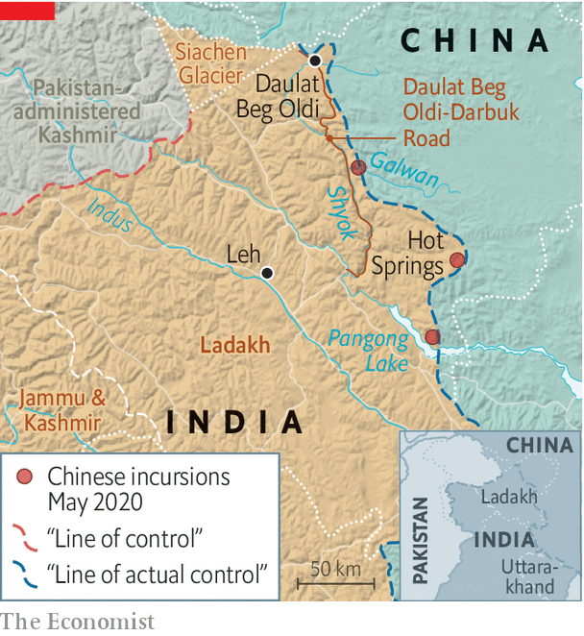

There is considerable uncertainty over the precise size and location of the forces involved, but Ajai Shukla, a former army colonel now with the Business Standard, an Indian newspaper, estimates that three Chinese brigades—each comprising thousands rather than hundreds of soldiers—might be involved, one several hundred kilometres to the south near the Indian state of Uttarakhand. Though this might evoke images of an invading land army, the bulk of troops are likely to be to the rear, on the Chinese side, in support of intruders nibbling at Indian territory.

General Naravane is correct to say that face-offs are not unusual. But the present imbroglio is odd both because of the scale of forces involved and because some of the incursions are occurring in an area, west of the Galwan river valley, that China was not thought to claim. In fact, the valley was overrun by China in a brief border war in 1962, but handed back—unlike several big chunks of territory that India still claims but China continues to occupy. On May 25th the Global Times, a state-run tabloid in Beijing, asserted: “The Galwan Valley region is Chinese territory.”

One reason for China’s ire may be the uptick in the Indian army’s construction work on the Indian side of the border. In particular, the road to Daulat Beg Oldi, the world’s highest airstrip and the site of a Sino-Indian standoff in 2013, was completed last year. The road, which runs along the Shyok river to the west of the Chinese positions in the Galwan valley, makes it easier for India to move troops for routine patrols or reinforcement in a crisis.

The recent construction of offshoots from that road running towards the border probably triggered the Chinese intrusions. “The situation remains tense,” notes P. Stobdan, a former Indian diplomat, with “troops ... chasing each other in high-speed patrol boats” on Pangong lake. ■

This article was downloaded by calibre from <https://www.economist.com/asia/2020/05/28/a-border-dispute-between-india-and-china-is-getting-more-serious>

|  |  |  |  |
| --- | --- | --- | --- |
| Previous | Articles | Sections | Next |

|  |  |  |  |
| --- | --- | --- | --- |
| Previous | Articles | Sections | Next |

#### Aygay angslay

# Gay people in Myanmar have adopted a secret language

Their slang can help protect them from abuse

May 30th 2020 | YANGON

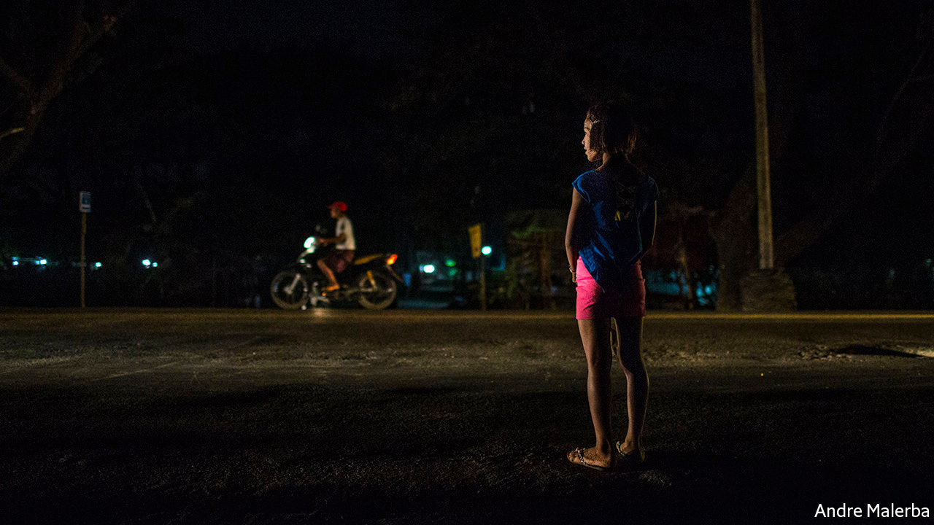

WEDNESDAY HAS just turned into Thursday in Yangon, Myanmar’s biggest city, and pleasure-seekers are on the prowl in a glitzy neighbourhood. Drivers slow down to inspect sex workers waiting by the kerb. Three of them, all transgender women, chat brightly. Your correspondent tries to eavesdrop but even her translator cannot understand. Theresa, the most forthright of the three, withdraws the lollipop from her mouth. “Yeah, we’re speaking bansaka,” she shrugs.

A dialect of Burmese spoken by gay and transgender people in Myanmar, bansaka, meaning slang, involves switching vowels within words (coffee, a loan word from English, becomes keefaw) and giving new meaning to Burmese words. Puns feature heavily. Asin, an adjective used to describe gemstones of great clarity, refers to an attractive man. Neologisms often riff on popular culture. To say one likes reading Tayza magazine, once popular among young men, is to signal that one is attracted to such people.

The overall result is gibberish to outsiders. That’s the point. Sexual minorities often invent their own secret languages to conceal their identities and speak privately. Gay and transgender Burmese switch to bansaka when they want to gossip about somebody nearby. “When an ugly customer walks in wanting to look like Beyoncé,” explains Thu Yain Maung Maung, a make-up artist, “you’d bitch about this with your colleagues.”

In private, gay people deploy bansaka as a sign of affection and invent new words and even gestures to entertain each other. Moe Aung of Kings N Queens, an LGBT advocacy group, laughs as he and his friend explain the latest addition to their repertoire. The “OK” hand gesture, with thumb and index finger forming a circle and the remaining three fingers flared out, resembles wa lone, a letter in the Burmese alphabet; “wa” also refers to a full belly. To those in the know, the hand gesture therefore means “I’ve had enough, stop” and sometimes “Stop talking”.

Some 90% of Burmese are Buddhist, and many of them believe that being gay or transgender is punishment for sexual sins committed in a past life. LGBT people are seen as morally corrupt, a view which is bolstered by colonial-era laws that still criminalise homosexual sex. The more feminine the man, the fiercer the contempt. “Going from man to woman, you lose status and rank,” says La Min, a transgender woman. LGBT people routinely endure discrimination and abuse at school and in the workplace; many also report being assaulted by family members or the police, according to David Gilbert of Australian National University.

Bansaka can provide a modicum of protection. When Mr Moe Aung, who performs as a drag queen, wants to go to a public toilet, “I might want a friend to go with me for my safety. That conversation needs to be private. If I don’t use slang in that situation people can look at me funny.” He says that going solo invites rape.

Most gay men and transgender women learn bansaka at work, in the few jobs open to them: spirit mediumship, hairdressing, make-up and floristry. “[These jobs] offer more than employment,” says Mr Gilbert. “They operate more like alternative families.” Employees typically live together, in their workplaces. Younger members of staff, or “children”, pick up the lingo from their boss or “mother”.

Today bansaka offers less protection than it used to. Over the past 15 years, the public has cottoned on. Though most don’t understand it, they “do recognise that it’s bansaka”, says Mr Thu Yain Maung Maung, and have even adopted some words. Bansaka may also be losing its utility for the young. Hein Maung, a gay 24-year-old, says that gay youths hardly speak it anymore; instead they communicate privately with each other via social media. But Mr Moe Aung is sceptical. His organisation hosts picnics attended by lots of youngsters who find learning bansaka fun. “The slang will never disappear,” he says, before flashing the “OK” hand gesture. ■

This article was downloaded by calibre from <https://www.economist.com/asia/2020/05/30/gay-people-in-myanmar-have-adopted-a-secret-language>

|  |  |  |  |
| --- | --- | --- | --- |
| Previous | Articles | Sections | Next |

|  |  |  |  |
| --- | --- | --- | --- |
| Previous | Articles | Sections | Next |

#### Banyan

# Asian countries try to build travel “bubbles”

These will not be as carefree as they sound

May 30th 2020 |

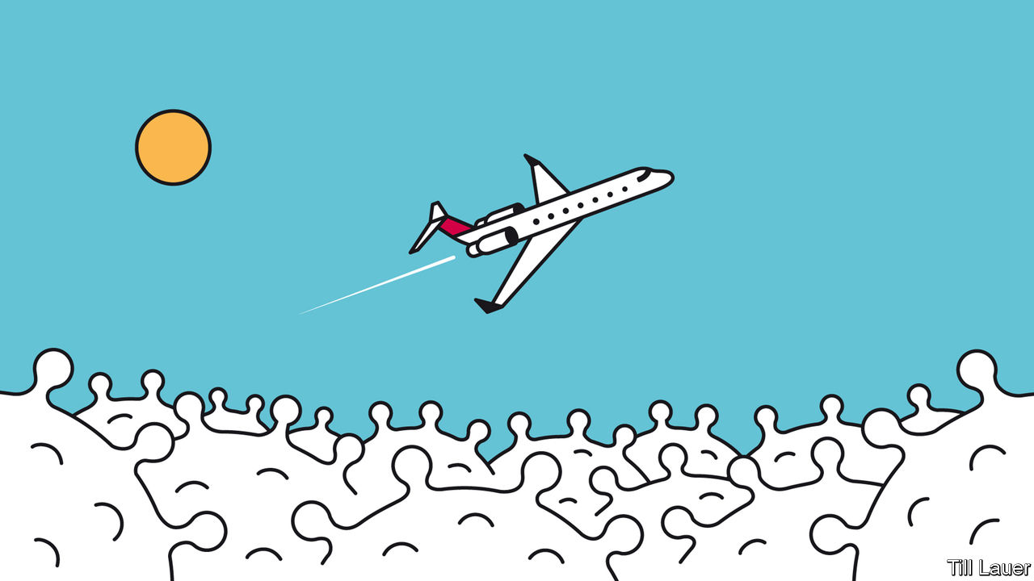

IN CONTRAST TO most of Europe and America, still buffeted by covid-19, swathes of East Asia and the Pacific have climbed through the worst of the turbulence and can glimpse blue skies again. Testing and tracing, prompt social distancing and swiftly mobilised health-care systems have brought impressive results: Vietnam claims no deaths, Hong Kong only four and Taiwan just seven. Japan has brought new daily infections down below 40 and has lifted a state of emergency. Local transmission is close to or at zero in Hong Kong, where offices and schools have reopened, South Korea, Taiwan, Vietnam and, of course, China. Down Under, Australia and New Zealand are also blinking in the sunlight.

But the ascent to blue skies remains purely metaphorical. As economies start to normalise, the glaring exception is international air travel. When Banyan recently returned on one of only two flights a day from Tokyo to Hong Kong, where he is resident, crew outnumbered passengers. On his last evening in Japan, when an Airbus flew over the neighbourhood, a thousand heads craned in awe to see it. At Hong Kong airport, every scrap of apron is taken up with Cathay Pacific’s grounded fleet.

The pressing question is how to restart international travel safely. Compulsory two-week quarantines, such as the one for returning Hong Kongers, are unfeasible for tourists and business travellers. One answer is “bubbles” or “air bridges” joining jurisdictions that have all but banished the virus and believe in each other’s testing and honesty. But setting them up is far from simple.

Australia and New Zealand lead the way with a proposed “covid-safe travel zone”, better known as the trans-Tasman bubble. It should make a big difference. Tourism used to generate a fifth of New Zealand’s foreign earnings, and the 1.5m Australians who travelled across the ditch last year made up nearly half of all visitors. Kiwis flocked the other way, too, visiting families and friends. Winston Peters, New Zealand’s deputy prime minister, hopes the bubble will be running in time for the looming ski season. Ann Sherry, co-chair of the Australia New Zealand Leadership Forum, thinks a trial might be ready for the school holidays in July.

The devil is in the details. New Zealand is close to eliminating covid-19. Australia’s “aggressive suppression” is still finding a few new cases daily. There is no decision yet on whether local transmissions should be quashed completely before trans-Tasman travel can resume. Meanwhile, confusion reigns over a hodgepodge of different rules across Australia’s eight states and territories. Some, such as Queensland, ban incoming travellers; others force them to quarantine for 14 days. New Zealand’s prime minister, Jacinda Ardern, says “it matters” whether travellers can move freely once inside Australia. Another snafu involves the smartphone apps both countries use for contact tracing—how to get them to talk to each other? Not easy, says Jill Slay, a cyber-security expert at La Trobe University.

Whether the bubble can be expanded quickly is also unclear. Small countries in the Pacific including Fiji and the Cook Islands, which have kept the virus at bay, are keen to join. Many islanders live and work in Australia and New Zealand, which in turn supply a big chunk of the tourists who are the islands’ other main source of cash. But Pacific countries worry that Australian tourists might bring the disease with them. They lack testing facilities. Workers may be allowed to travel first.

Other covid-conquerors such as Hong Kong, South Korea and Taiwan would like to enter the bubble. But working out all the necessary protocols could take months or years and could be derailed by a second wave of infections. Other approaches are being discussed. Singapore proposes “green lane” arrangements with a handful of countries with equivalent or lower risks of community transmission. The travel would have to be essential, and numbers strictly limited.

Meanwhile, Taiwan is pioneering work with Stanford University, first reported by the Financial Times, to create a “safe-travel protocol”. Next month 500 human guinea pigs will travel from San Francisco to Taipei. Passengers will be tested before a preflight period of quarantine. They will then be tested every two days in quarantine when they land. The aim is to find the shortest safe quarantine period for brief business trips, rather than the typical two weeks. But for anything other than essential travel, the regime is no bundle of fun: more decompression chamber than bubble.

Editor’s note: Some of our covid-19 coverage is free for readers of The Economist Today, our daily [newsletter](https://my.economist.com/user#newsletter). For more stories and our pandemic tracker, see our [coronavirus hub](https://www.economist.com/news/2020/03/11/the-economists-coverage-of-the-coronavirus)

This article was downloaded by calibre from <https://www.economist.com/asia/2020/05/30/asian-countries-try-to-build-travel-bubbles>

|  |  |  |  |
| --- | --- | --- | --- |
| Previous | Articles | Sections | Next |

|  |  |  |
| --- | --- | --- |
| Asia | Sections | Middle East & Africa |

China

Hong Kong’s freedoms: Rule by fear

.

Chaguan: “Wolf Warrior” fantasies

.

|  |  |  |
| --- | --- | --- |
| Asia | Sections | Middle East & Africa |

|  |  |  |  |
| --- | --- | --- | --- |
|  | Articles | Sections | Next |

#### Rule by fear

# China’s national-security bill for Hong Kong is an attempt to terrify

It could turn the territory into a Sino-American battleground

May 28th 2020 | HONG KONG

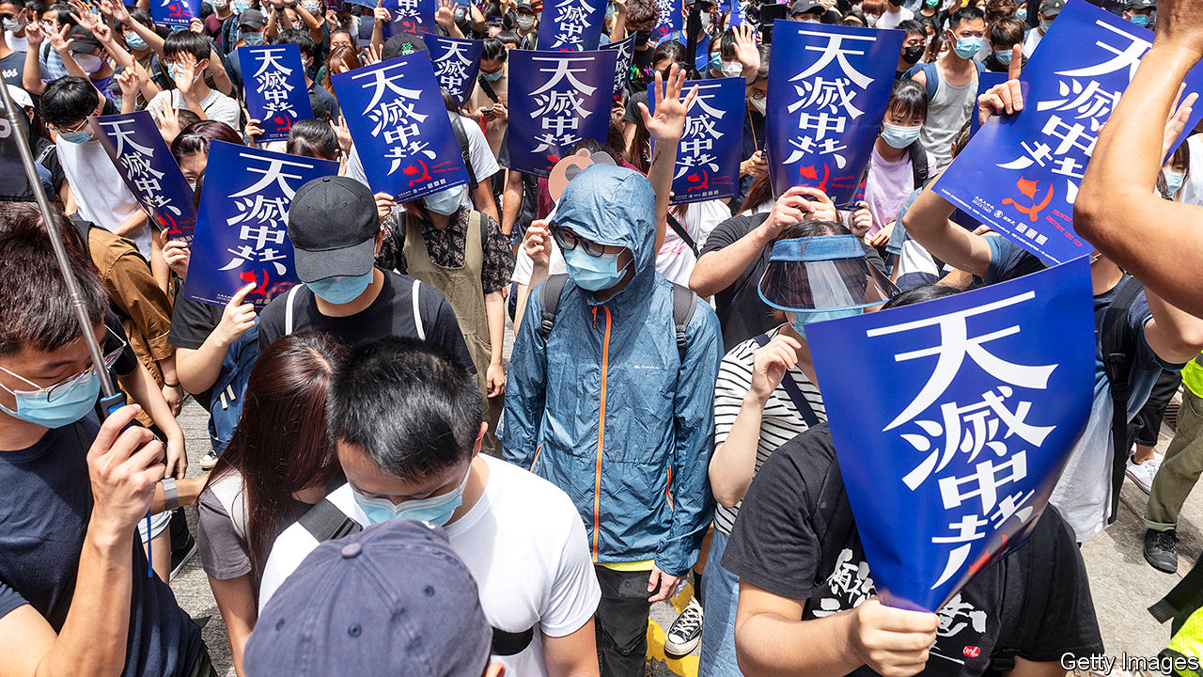

THE ARMOURED vehicles of China’s security forces have not rolled onto Hong Kong’s streets, as last year officials in Beijing hinted they might amid anti-government turmoil in the territory. But late in May Chinese officials may have done more than their troops would have to kill the notion of a “high degree of autonomy” in Hong Kong, which was promised when it returned to China in 1997. As Chinese legislators gathered in the capital for an annual, coronavirus-delayed meeting, the body’s standing committee dropped a bombshell.

The committee said it had reached a “decision” that China would impose a national-security law on Hong Kong. The territory’s own legislature would have no role in drafting it. The bill would prevent and punish “any conduct that seriously endangers national security”, including separatism, subversion of state power, terrorism and “activities by foreign and overseas forces” that “interfere” in Hong Kong’s affairs. It could be promulgated in Hong Kong as early as late June.

America is not waiting. On May 27th its secretary of state, Mike Pompeo, declared that “facts on the ground” showed Hong Kong was no longer autonomous. This opens a new front in the intensifying struggle between China and America. Mr Pompeo’s words mean that what many businesses in Hong Kong had once treated as unthinkable is becoming more possible. Namely, America could decide to impose the same tariffs, trade restrictions and visa requirements on Hong Kong as it does on the rest of China. That would cause as much if not more distress in the territory than the draconian new bill.

Officials in Beijing and Hong Kong have gone into overdrive to reassure foreign investors in the international city. Carrie Lam, its chief executive, used to say in private that if the central government were to impose a national-security law in this way, the perception would be highly negative. Now she finds herself arguing that by targeting acts of secession and interference by “external forces” (never defined), the new law is doing foreign business a favour. Last year’s open defiance of the police by protesters will no longer be tolerated. Hong Kong can go back to business.

Briefing diplomats, businesspeople and journalists on May 25th, China’s foreign-affairs commissioner in the territory, Xie Feng, said the new law would merely plug a legal “loophole” exploited by a “small minority of criminals” backed by dark foreign forces bent on splitting China. Foreign investors and other business folk, Mr Xie purred, had no reason to panic. On a more threatening note, he suggested that anyone who did sound the alarm was out to block China’s development. Mr Xie urged his audience to await “details” of the proposed legislation—then people would see there was nothing to worry about.

Yet as Margaret Ng, a barrister and former member of Hong Kong’s quasi-parliament, the Legislative Council (Legco), points out, the details are “almost irrelevant”. The proposed law, she says, would blow a hole both in the handover agreement that China signed with Britain, and in China’s own mini-constitution for Hong Kong, the Basic Law. It is fundamental to Hong Kong’s guarantees that it makes its own criminal laws and that people in the territory may be punished only under Hong Kong law by Hong Kong agencies.

The new bill would wreck that. True, the central government is making use of a clause in the Basic Law that allows it to legislate for Hong Kong. But that is permitted only in matters relating to diplomacy, defence and “other matters outside the limits” of Hong Kong’s autonomy. Democrats in Hong Kong argue that the proposed bill is within Hong Kong’s scope. Article 23 of the Basic Law says Hong Kong should enact laws “on its own” against treason, secession, sedition and subversion, as well as to prohibit ties between Hong Kong bodies and foreign political organisations (though an attempt to do so in 2003 was abandoned after a huge protest).

The central government, then, has no legal authority to add a national-security law to the Basic Law’s annexe. Hong Kong’s Bar Association also points to a lack of any assurance that the new bill will comply with the International Covenant on Civil and Political Rights, which the Basic Law pledges to uphold.

There is a final breach of Hong Kong’s legal and other norms. Mainland organisations may be set up in the territory to “safeguard” national security and oversee the new legislation. The implications are profound, including the possible stationing in Hong Kong of China’s secret police. It is hard to imagine how their will would not prevail in any matter relating to interpretation of the new bill and who should be targeted. The Basic Law says no arm of the central government may interfere in the administration of Hong Kong’s own affairs. But secret agents do, such as those who grabbed a Hong Kong bookseller in 2015 and spirited him away to the mainland.

Three broad and interconnected sets of questions now need answers. First, how will Hong Kongers react? As coronavirus restrictions ease, will anger erupt on the streets again? Second, how will companies doing business in Hong Kong respond? Can Hong Kong continue to serve as a global hub for finance, commerce and the media—a place comfortably apart from mainland China? Or will firms up sticks and run for Singapore or even Taiwan? Can China, indeed, count on Hong Kong as the pre-eminent place to raise “red” capital for its firms? Lastly, what steps might follow from Mr Pompeo’s pronouncement? What impact on the calculations of both citizens and businesses in Hong Kong might America’s actions have?

For Hong Kong’s young, the identity of a generation was forged in last year’s protests. These began in June in opposition to a draft bill that would have allowed Hong Kongers accused of crimes in China to be extradited, without recourse, to the mainland. The protests quickly snowballed into a broader rebellion against both the local and central government. Over time they became more violent—participants began using slings, arrows and petrol bombs against the police, who became ever readier to resort to tear-gas, rubber bullets, water cannon and occasional live rounds. Hong Kong had seen nothing like it since the Communist Party itself instigated riots in the British colony in the 1960s.

The protests eventually ebbed last year as activists turned their attention to elections for the territory’s district councils, the only tier of government fully elected by universal suffrage. Pro-democracy candidates swept them in a landslide, a powerful rebuff to the establishment and its backers in Beijing. A point had been made, and many protesters returned to their work or studies. Then, in January, when life looked like returning to something closer to normal, the pandemic struck. The authorities handled it well—there have been only four deaths from covid-19. An unintended blessing was that the cycles of confrontation subsided as people became cautious about leaving their homes.

But the central government will not let bygones be bygones. It has been tightening the screws on Hong Kong all year. In January President Xi Jinping installed a loyalist, Luo Huining, to head the central government’s outpost in Hong Kong, the Liaison Office. Once it was supposed merely to facilitate mainland enterprises’ dealings. Instead, it has grown to become Hong Kong’s pre-eminent centre of power. Its networks run through business, civil society, schools, newspapers and political parties. It controls Hong Kong’s largest publisher and bookstore chain.

In China’s provinces and major cities, the party secretary wields the real power—governors and mayors are secondary. So it is in Hong Kong. Once, the Liaison Office was barely heard. Now it pronounces on nearly everything and regularly denounces the pro-democracy camp. In April, when legal experts reminded the office that Article 22 of the Basic Law forbids interference by mainland entities in Hong Kong’s domestic affairs, the office said it was exempt from this rule. The Hong Kong government appeared embarrassed at first. But Mrs Lam later backed the Liaison Office’s position—confirming, by doing so, that it held more sway than her government.

Also that month, 15 grandees of the pro-democracy movement, including Martin Lee, Hong Kong’s best-known champion, and Ms Ng, the barrister, were arrested and accused of unlawful assembly. To many Hong Kongers the simultaneous rounding up of so many luminaries smacked of instructions from Beijing. In May the mainland intervened angrily when an exam for school leavers invited a nuanced view of Japan’s role in China’s pre-communist history. At China’s instruction, Legco is debating a law against insults to the national anthem (at international football matches, Hong Kong fans often boo the song).

That law had its second reading on May 27th. People who had planned to gather near Legco to protest against it and the new national-security bill were kept away by hundreds of police. At demonstrations elsewhere police fired pepper bullets and rounded up more than 360 people, including schoolchildren in uniform. As with attempted protests on May 24th (pictured), the first of any size this year, a new police tactic was apparent: move hard and fast, swamp the area and make mass arrests.

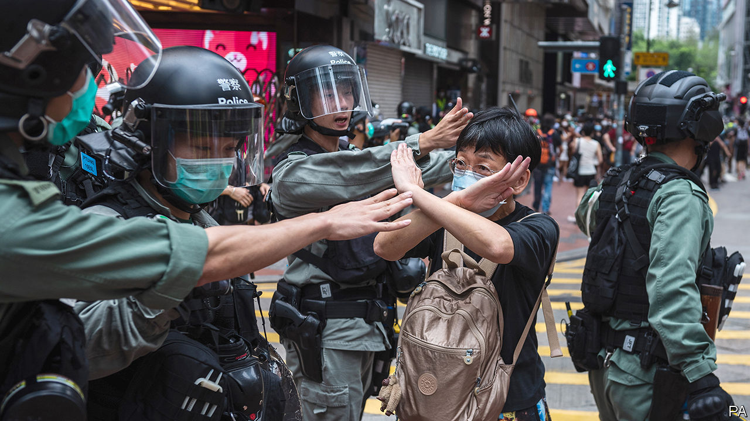

Given such methods, it is hard to predict whether protests can grow. Young Hong Kongers face dismal job prospects and see the space for political expression rapidly shrinking. They may see little to lose in one last summer of defiance before facing the full wrath of new anti-subversion laws. But to control covid-19 all public gatherings are banned, which makes it easier for the police to stop protests. The restriction will remain in place at least until June 4th, the anniversary of the crushing of the Tiananmen Square protests in 1989 which Hong Kongers traditionally mark with a mass vigil. Police have refused permission for the usual event. Thereafter, police will reject many applications for protests, as they did last year citing possible violence.

Furthermore, support for demonstrations may be ebbing. Last year the biggest ones attracted up to 2m people. This week office-workers groaned when managers urged them—once again—to work from home because of the risk of disruption to transport by protesters. After last year’s chaos and this year’s anti-virus measures, much of Hong Kong is desperate for normal life. Some ordinary folk with little interest in politics or love for China have cheered news of the national-security legislation.

A bellwether of public support for street action will be July 1st, the anniversary of the start of Chinese rule and a traditional day of protests. If many turn out, then it could be another long, hot summer. But after the arrests of nearly 9,000 people for offences related to the unrest, many of the most ardent demonstrators may be out of action. Some have fled to Taiwan.

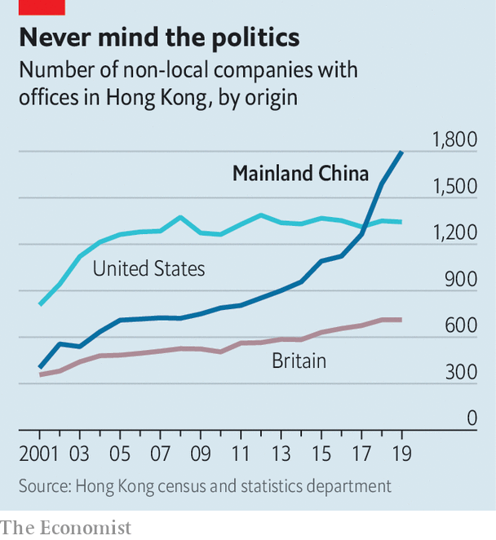

As for business, Hong Kong’s foreign chambers of commerce were unusually vocal against last year’s extradition bill but now seem to be more muted. Mainland firms will certainly grin and bear it, and they are becoming the backbone of Hong Kong’s economy. The number of foreign firms with their Asian headquarters in Hong Kong fell last year. But in 2018 the number of mainland businesses with offices of any kind in the city eclipsed the number of American firms for the first time (see first chart). Mainland companies accounted for 73% of the Hong Kong stockmarket at the end of last year, compared with 60% five years before. Many mainland firms also turn to the city when selling their bonds (see second chart). In 2018 they were responsible for about 70% of the corporate bonds issued in Hong Kong, says Natixis, a French bank.

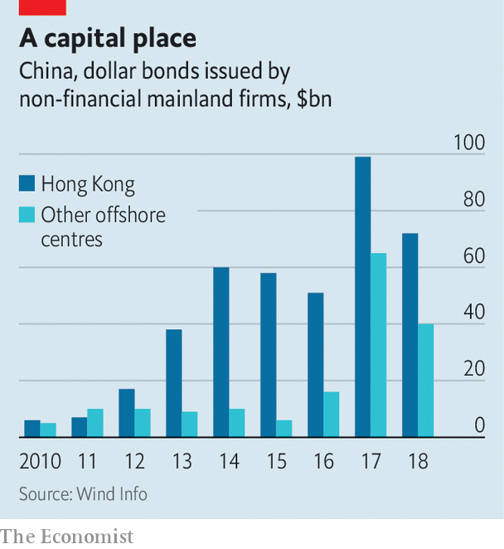

As tensions grow between China and America, Chinese firms seeking to raise capital abroad are increasingly drawn to Hong Kong rather than New York. Baidu, an online-search giant, may even delist from NASDAQ and offer its shares in the territory instead. Other Chinese tech firms, including NetEase, Ctrip and JD.com, may follow Alibaba in seeking a secondary listing in Hong Kong. At the other end of the territory’s business spectrum is refugee capital that has escaped the mainland to avoid scrutiny by the Chinese government. But if you are an individual hiding your money from officials on the mainland, “I’m not even sure you are still in Hong Kong by now,” says one observer.

The chances of national-security laws ensnaring foreign businesspeople may be remote. Yet fear had already been causing some to have second thoughts, even before the announcement about the security law. British businesses say they are struggling to persuade executives to move to Hong Kong. The cruel detention in China of Michael Kovrig and Michael Spavor, two Canadians who have been held since December 2018 as pawns against America’s bid to extradite the daughter of Huawei’s founder from Vancouver, deters some long-time residents of Hong Kong from crossing the border into the mainland. As a foreign official puts it: “Two foreigners have been detained without a specific charge for more than 530 days. And we are told everything is strictly according to law. So my question is: is this the way the national-security laws work? Are these the institutions that are coming to Hong Kong?”

Eyes now are on Washington. Mr Pompeo’s decision to notify Congress that Hong Kong is no longer autonomous sets a potent legal mechanism in motion. The Hong Kong Policy Act of 1992, amended and toughened last year, allows the American government to treat Hong Kong as a separate entity for trade and other purposes, as long as it is demonstrably freer than the rest of China. The White House must now lead a multi-agency discussion about which of Hong Kong’s privileges to revoke.

Any moves to end Hong Kong’s special privileges pose a dilemma. America could apply anti-dumping measures and other tariffs on the territory. But they are hard to deploy with precision and would not greatly affect mainland interests, says James Green, who was the head of trade policy at the American embassy in Beijing until 2018. Some speculation—including talk of Mr Trump using an executive order to make it more difficult to convert Hong Kong dollars into greenbacks—is hard to credit, because it would involve using legal powers usually reserved for pariah states like Iran or North Korea.

Among more likely measures are the imposition of sanctions on officials who abuse human rights in Hong Kong, such as by denying them visas and freezing their assets. Another possible step involves changes to Hong Kong’s status as a partner trusted to enforce controls on the export of sensitive items and technologies. American officials grumble that shell companies in the territory are shipping controlled items to Iran or mainland China, and say Hong Kong seems nervous of working closely with America in case that angers China. And the Senate is mulling a bipartisan bill that calls for sanctions against banks that have dealings with human-rights abusers in Hong Kong. Measures could even include cutting off access to America’s financial system.

Mr Trump may be cautious. He signed last year’s bill, which amended the Hong Kong Policy Act to give it more teeth, but only reluctantly. (He had earlier suggested he might veto it to promote a trade deal with China.) He may balk at an escalation. But but these are febrile, unpredictable times in the Sino-American relationship and American politics. As a congressional staffer puts it, television scenes of heads being cracked on Hong Kong’s streets could play into the “whole Democratic notion that President Trump is soft on autocrats and weak on human rights.” So more dramatic steps by America are growing more likely, as accusations in Beijing of foreign meddling grow shriller. Not only are Hong Kong’s freedoms in peril. So too are badly strained ties between the two great powers on which its future most depends. ■

This article was downloaded by calibre from <https://www.economist.com/china/2020/05/28/chinas-national-security-bill-for-hong-kong-is-an-attempt-to-terrify>

|  |  |  |  |
| --- | --- | --- | --- |
|  | Articles | Sections | Next |

|  |  |  |  |
| --- | --- | --- | --- |
| Previous | Articles | Sections | Next |

#### Chaguan

# China’s “Wolf Warrior” diplomacy gamble

Foreign policy is not like an action film

May 28th 2020 |

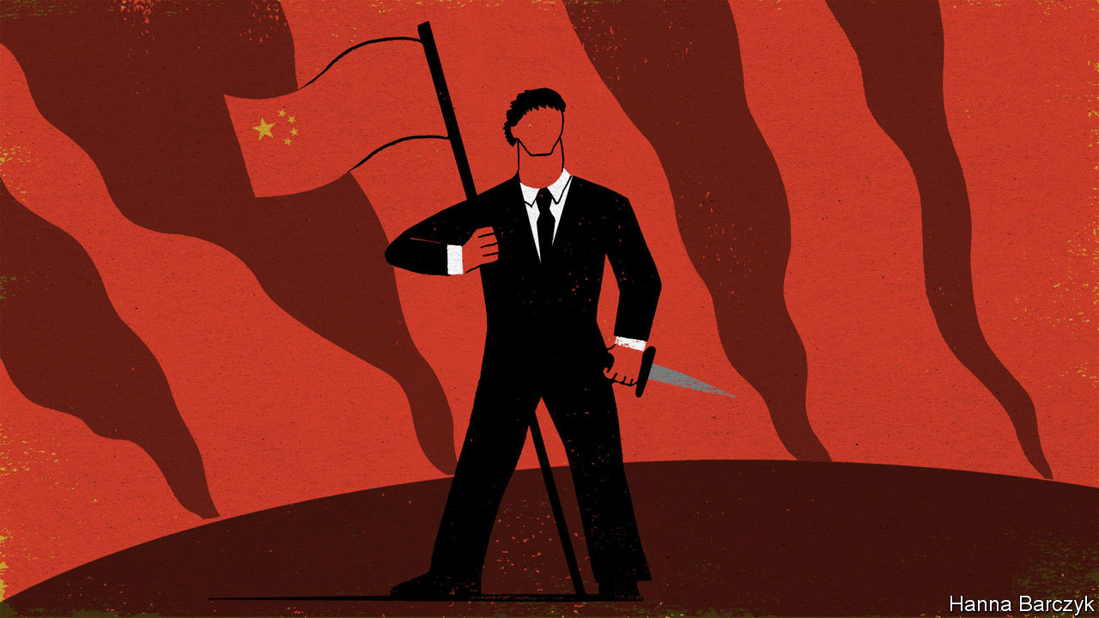

LATE ONE night this week, Chaguan brewed strong green tea and rewatched the highest-grossing film in Chinese history, “Wolf Warrior 2”. This action flick is both preposterous and oddly compelling, offering clues about the sort of China that modern-day patriots yearn to see on screen. That China is formidable. At one point the film’s hero, Leng Feng, a retired Chinese commando, uses a home-made crossbow to take on African mercenaries armed with tanks. Then he kills their American boss, a murderous racist who—moments before Leng punches him to death—sneers: “People like you will always be inferior to people like me.” The China of the film is self-confident. A crowd-pleasing scene shows warships of the People’s Liberation Army steaming towards a war-torn, pandemic-stricken corner of Africa to evacuate Chinese citizens, past American warships fleeing in the opposite direction.

The China of the movie is respected. A climactic scene sees the hero halt a battle by sticking a Chinese flag on his arm and holding it aloft. He then leads a convoy of Chinese and African refugees to safety between two rival armies, as awestruck commanders bellow: “Hold your fire! It’s the Chinese!”

Three years after its release, this noisy fantasy is back in the news. In an era of crises, from a global pandemic to an ever sharper contest between China and America, Chinese envoys and state media have gone on the attack. Ambassadors and official mouthpieces have threatened and insulted governments and elected politicians on every continent. Some have promoted conspiracy theories that America’s army spread covid-19. In China, this trend is being dubbed “Wolf Warrior diplomacy” by fans and critics alike. Actually, that is an insult to wolf warriors.

It is not hard to find Chinese who cheer the foreign ministry’s pugnacious new style. Against that, some members of China’s foreign-policy establishment express alarm over this assertiveness, calling it a mistake born of inexperience. That is letting foreign ministry hotheads off too easily. A well-travelled bunch, China’s quarrel-picking diplomats know how they sound. They are using aggression as a signal that China has grown strong, and is tired of waiting for the world to show respect and deference. To diplomatic and national-security hawks in Beijing, if some countries have to feel pain in order to understand that China’s rise is inevitable and that resistance is futile (and that no help is coming from an America consumed with its own problems), then that pain is itself a useful education. Nor is this approach about to stop. Reporters at the annual meeting of China’s legislature, the National People’s Congress, asked the foreign minister, Wang Yi, about “Wolf Warrior diplomacy”. He did not endorse the term but embraced its spirit. China’s diplomats “never pick a fight or bully others, but we have principles and guts”, he said. “We will push back against any deliberate insult to resolutely defend our national honour and dignity.”

Leng the wolf warrior would only half approve. His China is not merely feared. It is admired because it is generous, in deed and in spirit. In the film, doctors at a Chinese-funded hospital have given their lives to develop a vaccine for a deadly virus. Tasked with rescuing Chinese workers from a remote factory, Leng brings their African wives and colleagues too, even lying that a local boy is his son to sneak him aboard a Chinese ship. The film is strikingly respectful of international law. A lantern-jawed naval commander launches missiles to save the day only when a radio operator shouts news from the Chinese ambassador: “Sir, we have received authorisation from the United Nations!” The film ends with a giant passport filling the screen, and a promise that China will use its strength to protect citizens in danger abroad. Some Chinese audiences so liked this magnanimous, self-confident vision of their country that they sang the national anthem in their cinema seats.

The real-world China of 2020 is not magnanimous. Start with notions of brotherhood with Africa. In April thousands of African traders living in the southern city of Guangzhou were tested for covid and forced into quarantine, regardless of their travel histories. Some Africans were left to sleep on the streets after being evicted by landlords. Others were told by Chinese police to delete social-media posts complaining about mistreatment. Rather than apologise, Chinese diplomats and state media went on the offensive, declaring that “so-called discrimination against Africans” never happened and blaming anti-China forces for spreading “fake news”.

Cinematic promises to protect Chinese worldwide are not being kept, either. With officials desperate to avoid importing covid cases from America or elsewhere, flights to China remain severely limited, stranding hundreds of thousands of students abroad. Their fate divides netizens on Chinese social media, with many scorning overseas students as spoiled, unpatriotic rich kids.

## Over the long run, being obnoxious has costs

This pandemic is that rare event: a crisis that frightens every country on Earth. Alas, the moment finds China in an exhaustingly narcissistic mood. Mr Wang, the foreign minister, declares covid-19 an “all-round test” of China’s social system and governance, which China has comprehensively passed. Such swagger offends plenty of foreign governments, especially when they are told to thank and praise China before they are allowed to buy Chinese medical kit. As for rising geopolitical tensions, Chinese officials deny any connection with their assertiveness. Instead they place all blame on established powers sulking about relative decline.

China is not the only large country consumed with its own grievances. America First is a narcissistic slogan, too. But there is at least a bleak candour to President Donald Trump’s pitch to the world. Unblushing self-interest is his brand. In contrast Chinese envoys talk of being a responsible, globally minded major power. Then they turn round and stoke nationalism at home, and play the obnoxious bully abroad. Fighting as a lone wolf is dangerous in an action film. It is even riskier as a foreign policy. ■

This article was downloaded by calibre from <https://www.economist.com/china/2020/05/28/chinas-wolf-warrior-diplomacy-gamble>

|  |  |  |  |
| --- | --- | --- | --- |
| Previous | Articles | Sections | Next |

|  |  |  |
| --- | --- | --- |
| China | Sections | Europe |

Middle East & Africa

Wars in Africa: Are mercenaries no longer taboo?

.

Where dead men vote: Burundi’s sham election

.

Ping don’t cheque: Dial it up

.

Lebanon’s crisis: Devaluation gardens

.

Iran: The revolution will be televised

.

|  |  |  |
| --- | --- | --- |
| China | Sections | Europe |

|  |  |  |  |
| --- | --- | --- | --- |
|  | Articles | Sections | Next |

#### Soldiers of misfortune

# Why African governments still hire mercenaries

Professional gunmen are cheap, efficient and deniable

May 30th 2020 |

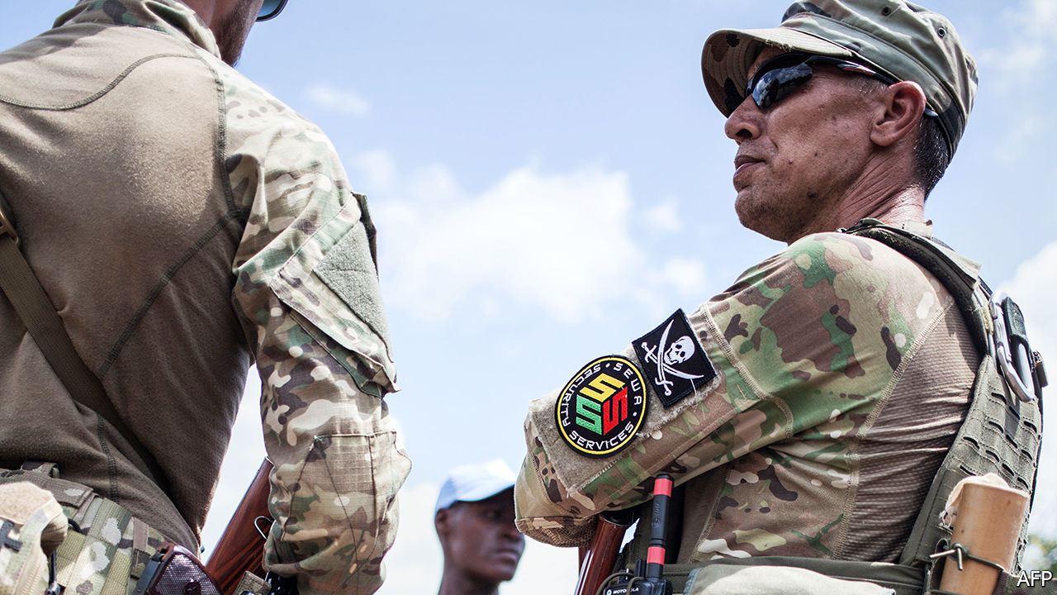

WHEN PRESIDENT FILIPE NYUSI wanted help last year to tackle a jihadist insurgency in northern Mozambique, various private military firms were keen to oblige. Mr Nyusi chose Russia’s Wagner Group, which vowed to make short work of the rebels. But after a bunch of its men were killed, it pulled out, humiliated.

In its place, the government has hired a firm with a very different pedigree: the Dyck Advisory Group (DAG), led by a South Africa-based colonel, Lionel Dyck. Mr Dyck served in the army of Rhodesia, the white-run state that became Zimbabwe at independence in 1980. In the 1970s, when Mr Dyck wore its uniform, the Rhodesian army used to attack Mozambique and the Zimbabwean guerrilla bases that Mr Nyusi’s Frelimo party was hosting. Times change, as do alliances.

Despite a UN treaty banning mercenaries, their day is far from over. Some analysts think there are now more of them in Africa than ever. But can they ever be a force for good? Some of them served in special forces known for their ruthlessness during the dying days of white rule in southern Africa. Since then many have worked in Iraq and Afghanistan before returning closer to their old haunts.

In the years after most African countries gained independence, mercenaries were notorious for supporting secessionist movements and mounting coups. They fought for Moïse Tshombe in Katanga as it tried to break away from Congo in the early 1960s, and in Biafra when it sought to secede from Nigeria in the late 1960s. More recently Simon Mann, a former officer in Britain’s special forces, tried to overthrow the dictator of oil-rich Equatorial Guinea in 2004, but ended up in jail.

Western governments have in the past winked at mercenary activity that served their commercial interests. But nowadays Russia is seen as the leading country egging on mercenaries to help it wield influence. It does so mainly through Wagner, whose founder, Yevgeny Prigozhin, is close to President Vladimir Putin. Shortly after Mr Nyusi met Mr Putin in Moscow last year, Wagner was awarded the contract for Mozambique, which has rich gasfields and is developing Africa’s largest energy project.

Wagner has been hired to prop up a number of shaky African regimes. In Sudan it tried to sustain the blood-drenched dictatorship of Omar al-Bashir. He was ousted last year after big protests. In 2018 hundreds of Wagner men arrived in the Central African Republic to guard diamond mines, train the army and provide bodyguards for an embattled president, Faustin-Archange Touadéra. In Guinea, where Rusal, a Russian aluminium giant, has a big stake, Wagner has cosied up to President Alpha Condé, who has bloodily faced down protests against a new constitution that lets him have a third term in office.

In Libya, despite a UN arms embargo, Wagner is reported to have deployed 800-1,200 operatives in support of a rebel general, Khalifar Haftar, who has been trying to defeat the UN-recognised government. On May 26th America’s military command for Africa said Russia had flown modern fighter jets to Libya to give air support to Wagner. It released satellite photos purporting to show the jets at al-Jufra airbase. It seems, however, that Wagner has been failing in Libya too, with hundreds of its men being forced to retreat.

Private military firms typically say they fill gaps in security that would otherwise lead to chaos. In the Central African Republic, for example, France withdrew almost all of its peacekeeping troops in late 2016, leaving a UN force and a small European training mission that struggled to keep order. Wagner has hardly fared better. In north-eastern Nigeria in 2015 a South African firm called STTEP (Specialised Tasks, Training, Equipment and Protection), had some success in bolstering the Nigerian army in its fight against the jihadists of Boko Haram. However, its contract was cancelled by a new president, Muhammadu Buhari, who reckoned his own forces should finish the job alone. They have signally failed to do so.

Mercenaries have three main advantages over regular armies. First, they give plausible deniability. Using them, a government such as Russia’s can sponsor military action abroad while pretending not to. Second, they tend to be efficient, experienced, nimble and flexible. Third, they are cheaper than regular armies. Whereas soldiers receive lifelong contracts and pensions, mercenaries are often paid by the job. They are also better value for money than the heavy, expensive weaponry that African governments often import, which is not much use against terrorists. DAG’s hardware in Mozambique is reported to include several helicopters (one of which recently crashed after being shot at by jihadists) and some small aircraft, but nothing hugely expensive.

Colonel Tim Collins, a veteran of Britain’s Iraq campaign who has been running a private military firm in Afghanistan, says that “for the money Britain spends on booze at Christmas” such firms could provide African governments with a continental force (not that they would ask for one). He points out that in Sierra Leone in 1995, mercenaries from Executive Outcomes played a key part in routing the murderous rebels of the Revolutionary United Front. That bare-bones force was co-founded by a South African, Eeben Barlow, who now chairs STTEP. Manned mainly by former apartheid-era commandos, Executive Outcomes had previously helped the Angolan government to defeat the rebels of UNITA, which South Africa had once fostered.

DAG’s website claims it has undertaken “security-based operations” in at least eight countries, including the Central African Republic, Malawi and South Africa. Zimbabwe’s president, Emmerson Mnangagwa, is said to be close to Mr Dyck, who caught his eye back in 1981. That was when he led a battalion of the mainly black Rhodesian African Rifles in suppressing a mutiny of disgruntled ex-guerrillas loyal to Prime Minister Robert Mugabe’s bitter rival, Joshua Nkomo, leaving many dead.

OAM Middle East, another security firm run by a former Rhodesian, John Gartner, lists no fewer than 18 African countries where it has operated. Many such companies stress their credentials as wildlife conservationists, using helicopter gunships to deter poachers.

Although opposed to mercenaries on paper, the UN may have softened its stance of late. It now has a code of conduct for how they may work and has itself used them to help with things such as logistics, neutralising landmines and training security teams. Chris Kwaja, a Nigerian who chairs a “working group on the use of mercenaries” for the UN’s High Commissioner for Human Rights, thinks they can be useful as long as they are subject to “binding international instruments”. Some private military firms now accept ethics clauses written into their contracts.■

This article was downloaded by calibre from <https://www.economist.com/middle-east-and-africa/2020/05/30/why-african-governments-still-hire-mercenaries>

|  |  |  |  |
| --- | --- | --- | --- |
|  | Articles | Sections | Next |

|  |  |  |  |
| --- | --- | --- | --- |
| Previous | Articles | Sections | Next |

#### Where dead men vote

# Burundi’s rigged election

A landslide victory for the president’s hand-picked successor

May 30th 2020 |

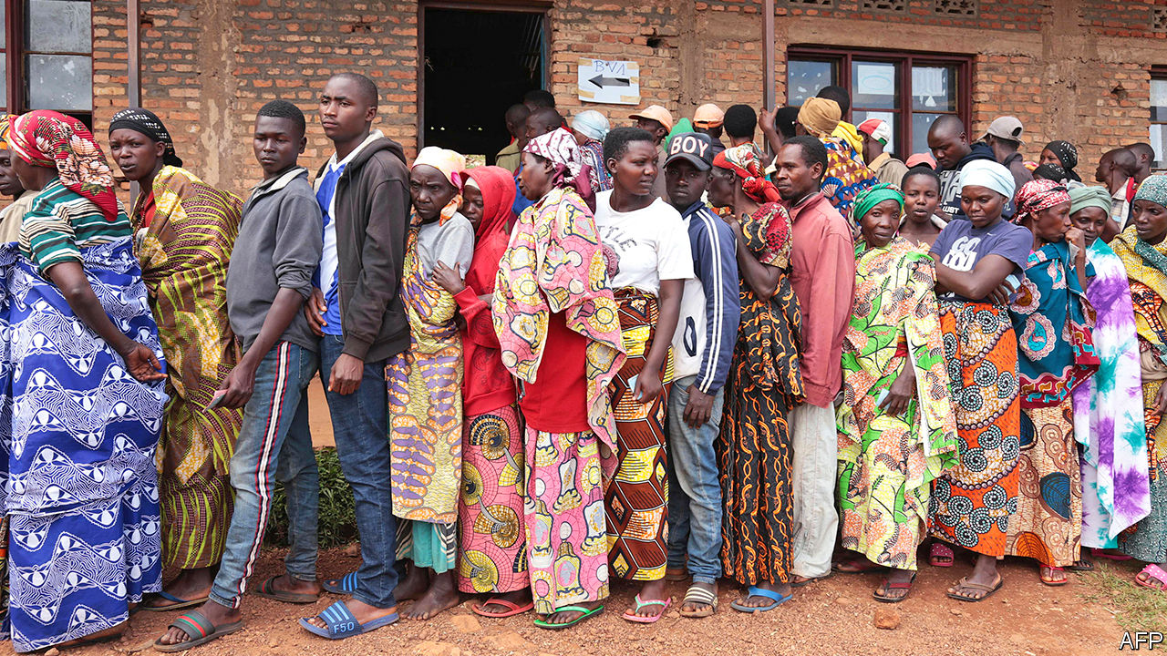

AS PEOPLE ELSEWHERE hunkered down at home to avoid covid-19, millions in Burundi crowded into polling stations on May 20th to vote in the general election. Among the many voters were scores of dead people, activists allege. Human-rights watchdogs said that members of the ruling party, CNDD-FDD, boosted its tallies by adding the ballots of people locked up in jail—and of those who had died.

“When I saw the same person voting for the third time I complained,” says one voter. He was sent packing by officials and told to “stop creating problems”.

Shenanigans such as these might explain why, for instance, in Bukeye in Muramvya province 4,000 more votes were cast than there were voters on the register. Another reason could be that some boxes already had papers in them when polling stations opened, suggests Aimé Magera, spokesman for the National Freedom Council (CNL), an opposition party. Few in Burundi were surprised when the ruling party’s candidate, Evariste Ndayishimiye, was declared the winner with 69% of the vote. Mr Ndayishimiye, an ex-general, was handpicked by Pierre Nkurunziza, the outgoing president who has ruled since 2005. Mr Nkurunziza is no stranger to controversy. In 2015 he won a third term, despite a constitutional limit of two. (He said his first term didn’t count, as he was chosen by parliament, rather than directly elected.)

Agathon Rwasa, the leader of the CNL, called the election a “fiasco” and plans to challenge the result in the constitutional court. Yet Burundi’s judiciary is not seen as independent. In 2015 the constitutional court ruled in favour of Mr Nkurunziza’s third term, days after the court’s vice-president fled into exile saying judges had received death threats.

More than 400 of Mr Rwasa’s supporters are in prison. Many were rounded up on polling day. In the months leading up to the election an exiled Burundian watchdog, Ligue Iteka, counted 67 killings, more than 200 arbitrary arrests and some 20 cases of torture. In Busiga in northern Burundi members of the ruling party’s fearsome youth wing painted red crosses on the doors of opposition supporters.

This sort of nastiness has been common in Burundi in recent years. Having at last agreed to retire, Mr Nkurunziza will become an adviser to his successor with the new title of “supreme guide to patriotism”. The next president will be legally obliged to consult him on matters of national unity and security.

So far, Mr Nkurunziza has appeared unfazed by covid-19. His party held huge rallies in the run-up to the election while his spokesman suggested that Burundi would be spared for putting “God first”. There are only 42 registered cases in the country, though hospital staff whisper that beds are full of undiagnosed sufferers. Handily, the pandemic did mean that no foreign election observers could get into the country. A delegation from the East African Community was warned just 12 days before the election that its members would be quarantined for two weeks.

The country is relatively calm, for now. Many fear that if they start protesting against the result, Mr Nkurunziza will enforce a belated lockdown—to stop the spread of covid-19, of course. ■

This article was downloaded by calibre from <https://www.economist.com/middle-east-and-africa/2020/05/30/burundis-rigged-election>

|  |  |  |  |
| --- | --- | --- | --- |
| Previous | Articles | Sections | Next |

|  |  |  |  |
| --- | --- | --- | --- |
| Previous | Articles | Sections | Next |

#### Dial it up

# The covid-19 crisis is boosting mobile money

In Rwanda, transactions rose fivefold during a lockdown

May 30th 2020 | KAMPALA

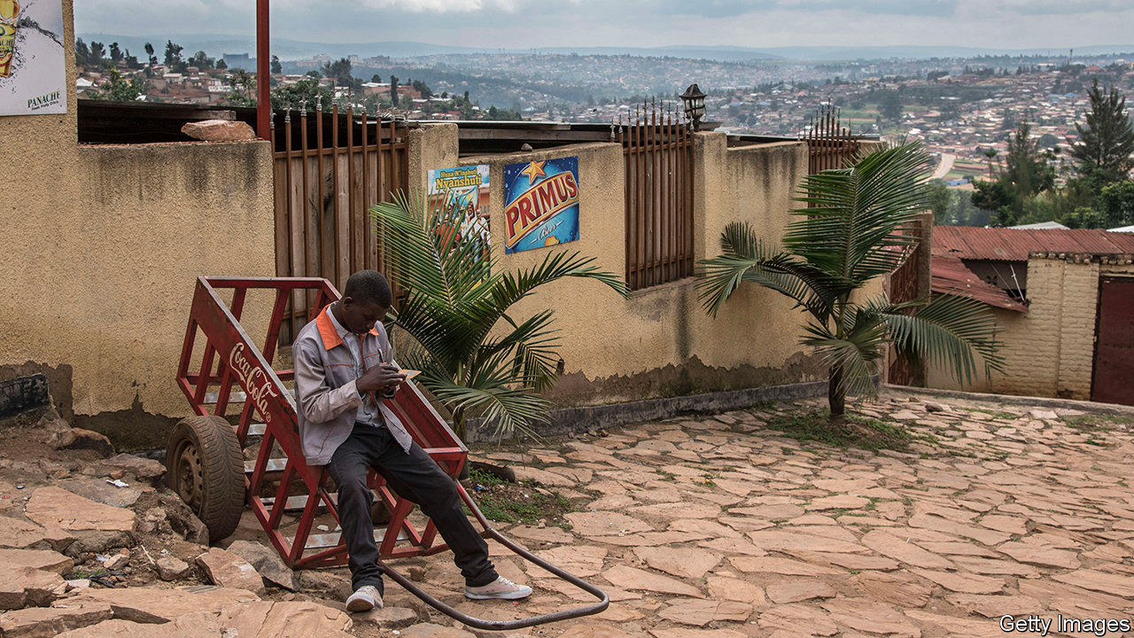

THE STORY of mobile money is one that turns during crises. In Kenya in 2008, violence broke out after a disputed election the year before. As supporters of the rival candidates clashed on the streets, ordinary folk were afraid to go out. Many started sending money to each other by phone using a newfangled service called M-Pesa. The habit stuck. Today M-Pesa is the most celebrated mobile-money service in the world. It processes 11bn transactions a year and has spawned imitators across Africa and farther afield.

Could covid-19 have a similar catalytic effect in other countries? In Rwanda the number of mobile-money transfers doubled in the week after a lockdown was imposed in March, according to data collected by the telecommunications regulator and analysed by Cenfri, a South African think-tank. By late April users were making 3m transactions a week, five times the pre-pandemic norm (see chart). The value of transfers between individuals had risen six-fold to 40bn Rwandan francs ($42m).

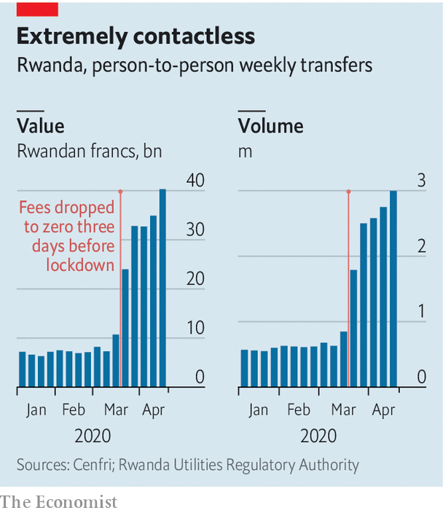

The data do not show what caused the spike. Maybe Rwandans switched to digital payments because restrictions on movement made it hard to use cash; perhaps they were sending help to loved ones in need. A third explanation is that official policy changed. Just before the lockdown, the central bank told telecoms companies to eliminate charges on all mobile-money transfers for a three-month period. It also raised transaction limits.

The picture elsewhere is mixed. Tayo Oviosu of Paga, a Nigerian payments firm, says the number of customers signing up to use its mobile wallet has been 330% higher in this financial quarter than in the one before. MTN, a South African telecoms firm, says it has seen a rise in payments across its 16 African markets. Operators and regulators have agreed to reduce charges in several countries temporarily, sacrificing profits. “The transactions have gone up but I think we have been earning less money,” says Raghunath Mandava, the boss of Airtel Africa, another mobile-phone company.

But the crisis has also made people poorer. In Kenya, where mobile money is well established, the central bank reports a 10% rise in the number of daily transactions but a 5% fall in their total value. Although the volume of digital transfers has risen in many countries, housebound users are loading and withdrawing cash less often, says Ruan Swanepoel of the GSMA, a global association of mobile operators. The use of these “cash-in, cash-out” services fell by half in the weeks after a curfew was imposed in Kenya, reckon Caribou Digital, a research firm, and MicroSave Consulting, a consultancy. That is a blow to the thousands of agents who earn commission on the transactions they handle.

Many of these effects will be temporary. Lockdowns are already starting to ease. In several countries transaction charges are being restored: without them, the mobile-money business is unprofitable. But as the M-Pesa story shows, habits formed during a crisis can sometimes outlast it. One of the biggest barriers to mobile-money adoption is that people do not trust the service, says Hennie Bester of Cenfri. The pandemic is forcing them to set aside their wariness, perhaps for good. ■

Editor’s note: Some of our covid-19 coverage is free for readers of The Economist Today, our daily [newsletter](https://my.economist.com/user#newsletter). For more stories and our pandemic tracker, see our [coronavirus hub](https://www.economist.com/news/2020/03/11/the-economists-coverage-of-the-coronavirus)

This article was downloaded by calibre from <https://www.economist.com/middle-east-and-africa/2020/05/30/the-covid-19-crisis-is-boosting-mobile-money>

|  |  |  |  |
| --- | --- | --- | --- |
| Previous | Articles | Sections | Next |

|  |  |  |  |
| --- | --- | --- | --- |
| Previous | Articles | Sections | Next |

#### Devaluation gardens

# Hobbyists hope to halt hunger in Lebanon by growing their own crops

Expensive food is pushing people to the brink

May 30th 2020 | BEIRUT

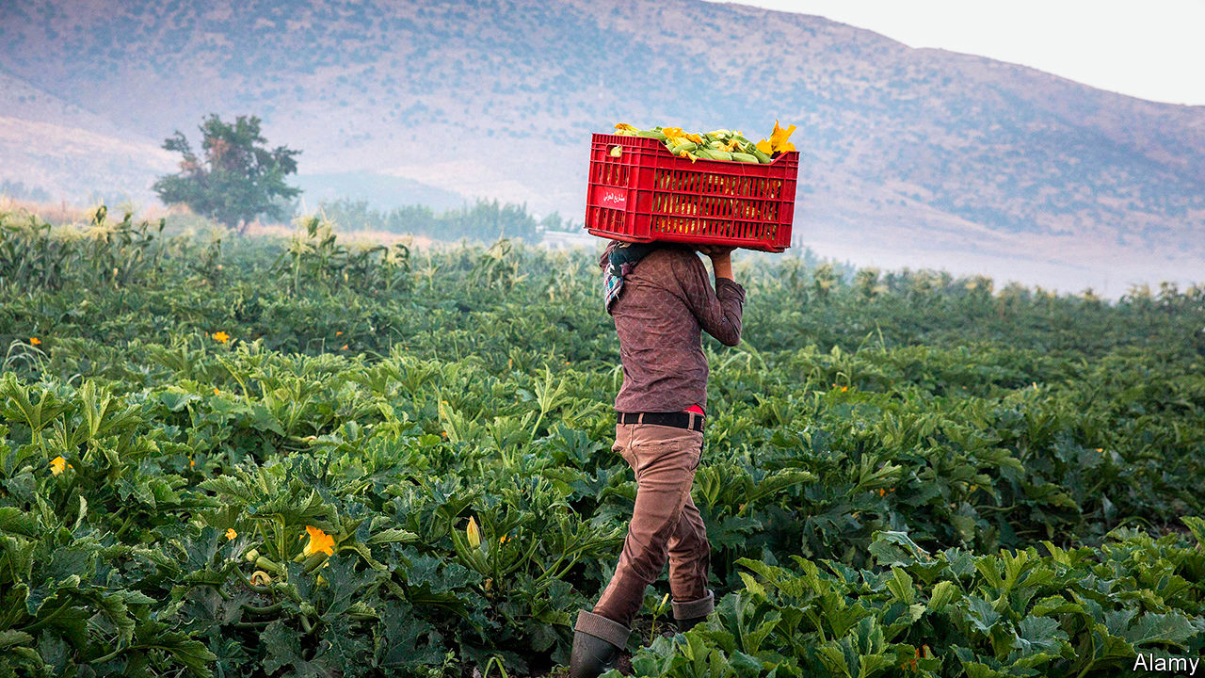

THE COVID-19 pandemic has brought no end of comparisons to Spanish flu, which raced around the globe in 1918. For Lebanon, though, that decade’s defining event was not flu but famine: years of hunger that killed half the population during the first world war. History feels newly relevant as the country tips into depression and food prices soar. Trapped at home these past months, often in their ancestral villages, some Lebanese have tried their hand at growing their own food. On a rooftop in Beirut, tomato vines crawl towards the sky. A designer spends weekdays behind a computer and weekends plucking broad beans in the mountains. Young people swap tips on what to grow and when.

Famous for its food, Lebanon is better at preparing the stuff than producing it. Some 20-25% of workers are involved in agriculture (including part-time and seasonal work on family plots). About 13% of the land is arable, with microclimates suited to nearly every crop. Rolling fields in the Bekaa valley can grow winter wheat and summer vegetables. The Mediterranean coast supports a year-round rotation.

Yet agriculture generates less than 3% of GDP and Lebanon imports 80% of its food. Farms are often too small to benefit from economies of scale. One-third of factories in Lebanon make packaged food, everything from poultry to pickles. Again, though, almost 90% of these are small, family-owned businesses, estimates Mounir Bissat, a director of Lebanon’s industrial syndicate.

Now a worsening currency crisis threatens to devastate the industry. The Lebanese pound has lost 63% of its value since October. This ought to help farmers and producers, as consumers shift to local products—but little about Lebanon’s food business is truly local. Most of its inputs, such as seeds, fertiliser and animal feed, are imported. The government subsidises fuel, but for everything else suppliers must obtain dollars on the black market, which has sent prices soaring. Potatoes and onions cost a third more than they did last spring. Tomato prices have more than doubled. Pine nuts are so expensive that people joke about using them in lieu of diamonds on engagement rings. Triangle, a local think-tank, estimates that even simple dishes like mujaddara, a mix of rice and lentils topped with fried onions, now cost 50% more to prepare.

Farmers are trapped in a cycle of debt. With cheap credit scarce, they take loans from companies that import agricultural supplies. Riad Saade, the head of the Centre de Recherche et d’Etudes Agricoles Libanais, puts outstanding debts at $140m. That seems a pittance compared with the broader economy (banks are staring at losses of up to $80bn). But farmers may struggle to repay even that sum. Weak demand and a weaker currency will cause their revenues to plunge. Mr Saade estimates the value of field crops sold in 2020 at just $58m, down from $181m in 2018.

Poor practices add to the burden. The ill-funded agriculture ministry offers little help. Farmers often get technical advice from their suppliers—and some of it is bad. “These companies have a vested interest in people using more of their products,” says Hadi Jaafar, an agriculture professor at the American University of Beirut. Lebanese farmers lay down 330kg of fertiliser per hectare of arable land, one of the highest rates in the world. Pesticide use is also similarly high.

Hobbyists can help, but only so much. Almost 90% of Lebanese live in urban areas. In greater Beirut, home to a third of the population, few have more than a balcony or rooftop for planting. Hassan Diab, the prime minister, has promised to subsidise staple imports, a temporary fix (if a costly and inefficient one). Farmers need access to credit and proper scientific advice. Some economists have called for a temporary freeze on their debts. Factories need reliable electricity and better transport, both of which the government has failed to sort out for decades. Investment in agriculture would bring not only food but jobs and exports—all badly needed in a country that can no longer live beyond its means. ■

This article was downloaded by calibre from <https://www.economist.com/middle-east-and-africa/2020/05/30/hobbyists-hope-to-halt-hunger-in-lebanon-by-growing-their-own-crops>

|  |  |  |  |
| --- | --- | --- | --- |
| Previous | Articles | Sections | Next |

|  |  |  |  |
| --- | --- | --- | --- |
| Previous | Articles | Sections | Next |

#### The revolution will be televised

# The battle over state TV in Iran

Come for the entertainment, stay for the propaganda

May 30th 2020 | TEHRAN

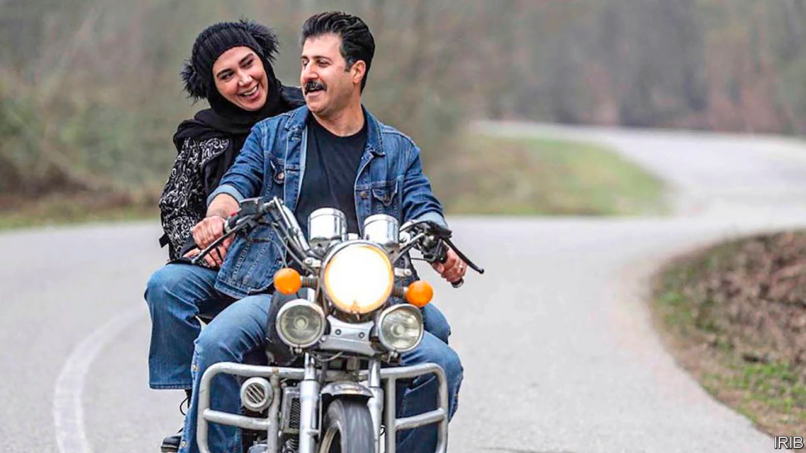

THE COMEDY series “Payetakht” (Capital) has been one of the most popular shows on Iranian state TV since it began airing in 2011. It follows a family from the north who get into all sorts of trouble. In one season, for example, they take a balloon ride in Turkey—and end up in Syria, fighting jihadists. Such storylines allow the show to promote official policy, such as Iran’s support for President Bashar al-Assad of Syria. But in a more recent episode the shot of two newly-weds on a motorcycle (pictured) enraged conservatives. It seemed to emulate a film made before the Islamic revolution in 1979, a period they view with sanctimonious disdain.

Was the offending scene a result of negligence or the work of a “fifth column”? An internal probe aims to find out. But the row has already shed light on a larger struggle over state TV. Young hardliners think their pious and conservative older managers are not pious enough. The young hotheads want to use the airwaves to spread Iran’s revolutionary theology.

At the moment few people are watching. Viewership of state TV has been declining for years, according to IRIB, the state broadcasting monopoly. This is partly a result of a boom in satellite dishes. The government banned them in 1994, but that hasn’t stopped Iranians from watching Western entertainment on satellite TV channels broadcast from abroad. Iranian versions of Netflix and apps such as Instagram also draw viewers. Meanwhile, IRIB has done itself no favours. Many Iranians switched off after 2009, when state channels aired false reports about reformist presidential candidates and promoted the fishy victory of the hardline incumbent, Mahmoud Ahmadinejad.

That trend has continued. During the presidential elections of 2013 and 2017 state TV touted the hardline opponents of Hassan Rouhani, who won both races and continues to be a target of harsh attacks. Many have been aired on a channel called “Ofogh” (Horizon), which was created in 2014 and is overseen by the young crowd. They have since taken control of other networks, such as the popular Channel 3. Now they are seeking two of the top jobs at IRIB, in charge of news and programming. The youngsters accuse the current leaders of corruption. More importantly, they say the old guard is too cosy with Mr Rouhani and others who have favoured engagement with the West. In their eyes the scene in “Payetakht” and others like it are out of step with revolutionary ideology.

But, desperate to win back viewers, the youngsters are crossing their own red lines. They show Western-style programmes on Channel 3, such as Iranian versions of “Who Wants to be a Millionaire?” and “America’s Got Talent”. They have hired relatively liberal celebrities to host new shows. It seems to be part of a strategy: regain an audience before injecting them with a strong dose of propaganda. Take the series “Gando”, which appeared on Channel 3 last year. It was a thriller based loosely on the story of Jason Rezaian, an Iranian-American reporter charged with espionage and imprisoned for 544 days before being released in a prisoner swap in 2016. (Mr Rezaian denies all charges.) The show’s message was clear: those who reach out to the West are weak and traitorous, while hardliners want to protect Iran.

Networks on the other side of the divide use similar tactics. A satellite channel called Manoto, which appears sympathetic to the ousted monarchy, began by broadcasting entertaining shows and documentaries. But after gaining an audience it started airing slanted reports critical of the government and shows that portray the late shah, Muhammad Reza Pahlavi, in a positive light. In order to attract more viewers still, broadcasters of all stripes might consider telling it straight.

This article was downloaded by calibre from <https://www.economist.com/middle-east-and-africa/2020/05/30/the-battle-over-state-tv-in-iran>

|  |  |  |  |
| --- | --- | --- | --- |
| Previous | Articles | Sections | Next |

|  |  |  |
| --- | --- | --- |
| Middle East & Africa | Sections | Britain |

Europe

State aid: The visible hand

.

Covid-19 in Germany: The virus detectives

.

Espionage pacts: To your good stealth

.

Viral couture: Paris masked

.

Eastern Europe’s economies: Into the trough

.

Charlemagne: The benefits of Brexit

.

|  |  |  |
| --- | --- | --- |
| Middle East & Africa | Sections | Britain |

|  |  |  |  |
| --- | --- | --- | --- |
|  | Articles | Sections | Next |

#### The visible hand

# Europe’s habit of propping up firms may outlast the pandemic

State-aid rules have been relaxed, and may stay so

May 30th 2020 |

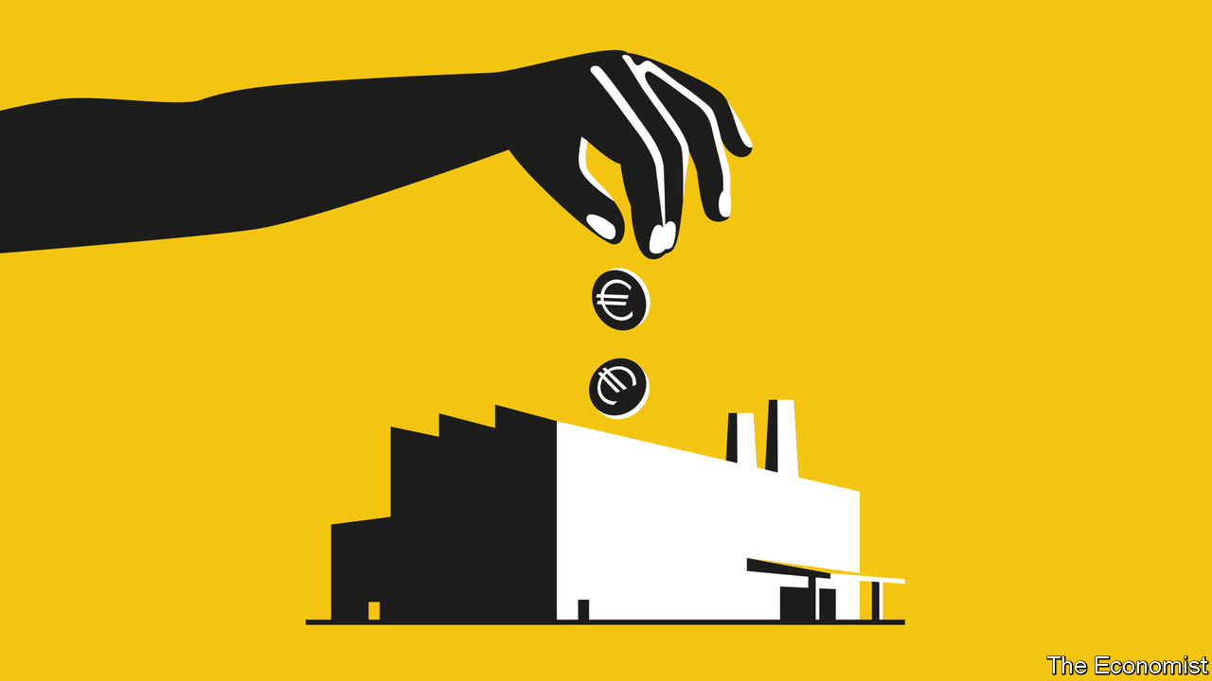

Editor’s note: Some of our covid-19 coverage is free for readers of The Economist Today, our daily [newsletter](https://my.economist.com/user#newsletter). For more stories and our pandemic tracker, see our [coronavirus hub](https://www.economist.com/news/2020/03/11/the-economists-coverage-of-the-coronavirus)

IT NORMALLY TAKES the European Commission about six months to review an EU member state’s request to derogate from the rules against subsidising domestic industry. Not these days. Since the outbreak of covid-19 roiled economies everywhere, requests to circumvent “state-aid” rules are often approved in under 24 hours, even on weekends. A trickle of demands from all over the bloc has turned into a flood. Nearly 200 subsidy schemes and bail-outs worth over €2trn ($2.2trn), equivalent to Italy’s GDP, have been cleared by eurocrats.

The single market at the heart of the European economy is built partly on the premise that national governments do not unduly aid “their” firms. Policies preventing them from doing so date back to the very first flushes of European integration. Now Europe finds itself in uncharted policy territory. Never have the rules been loosened to the extent they have been today. Politicians are brokering aid packages to industry in a way no one in living memory has been allowed to do.

Trouble is: they might get used to it. Even before the crisis, Europe was moving in a dirigiste direction. Now a breach has opened in a set of rules that had curtailed politicians’ penchants for picking winners. When rules were loosened in past crises, notably in 2008, the state-aid regime quickly snapped back to its old self afterwards. But fewer countries support the principles behind state-aid rules nowadays. So the new relaxed norms may endure beyond the crisis, perhaps permanently. That would mark a new economic era for Europe.

European state-aid rules are a policymaking oddity. American states, for example, can and do try to poach companies from each other with promises of tax breaks, soft loans and the like. Europe went for the subsidy equivalent of a disarmament pact. All aid that isn’t expressly allowed to companies is banned, even to state-owned firms. Governments are regularly taken to task for everything from granting football clubs subsidised land to giving multinationals sweetheart tax deals. Policing this is one of the real powers wielded by Brussels, where the rules are enforced by the same commission officials who regulate antitrust.

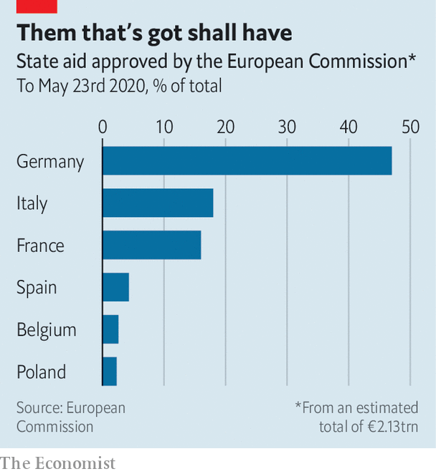

Tensions have long brewed between that bit of the commission, overseen since 2014 by Margrethe Vestager, the competition commissioner, and some member states. France and Germany have repeatedly demanded competition rules be bent to allow the creation of “European champions”. They were furious last year when Ms Vestager blocked the planned merger of the rail bits of Siemens and Alstom.

Merging companies is one way to create champions, but gorging them with state aid is just as effective. That is now allowed, albeit temporarily. Granted, the goal right now is not to create champions so much as to prevent unnecessary bankruptcies and job losses. But if the rules remain eased for too long, the money sloshing to companies will aim less to rescue them in crisis than to boost their prospects afterwards.

Already some countries, notably Spain, have complained that the free-spending regime threatens the single market. That is because a few rich countries are doing most of the spending. Almost half the state aid paid out across Europe is done by Germany, which is big, wealthy and entered the crisis with relatively little debt. Smaller and poorer countries worry that their firms, which have not been so generously aided, will get gobbled up.

Politicians are busy untilting the playing field. On May 27th Ursula von der Leyen, the commission’s president, unveiled a €750bn package of loans and grants that will redistribute money from those with the ability to pay (Germany) to those struggling to (Spain). National capitals will now haggle over a final deal.

Ms Vestager says higher German spending has been on the EU’s wish-list for years. As for long-term risks to the state-aid regime, she emphasises that the easing of the rules is temporary. She has insisted that companies which were in bad shape before covid-19 struck cannot be rescued; troubled firms that get government bail-outs must pay them back. Those that get the most help cannot pay dividends or bonuses until they repay most of the state aid.

Old Brussels hands say the commission has little choice but to give states leeway in the crisis. “Governments will simply ignore EU rules if they don’t flex enough—that’s what the commission wants to avoid,” says one lawyer. Once everyone has bought into the system’s fast-track approval process, the rules can be tightened, for example by demanding that aid to companies is gradually withdrawn.

The aftermath of the crisis of 2008 gives backers of the state-aid regime confidence that such tightening will happen. But this time looks different. A decade ago Europe was in the ascendant, implementing its new fundamental treaty. Aid had gone mainly to unpopular banks seen to have gamed the system, so throttling that aid was politically easy. Fiscal weaknesses had yet to be exposed by the euro crisis.

In 2020, by contrast, bail-outs are seen as necessary and companies blameless. The crisis has amplified voices demanding that supply chains be repatriated to Europe, which would be easier if states could pay more subsidies. Britain, which long backed vigorous curbs on state aid, has left the club. Southern Europe gets nailed by state-aid rules regularly, and would not mind seeing the back of them. Ireland and the Netherlands have fallen foul of Ms Vestager for giving tax breaks to multinationals, a form of forbidden aid. Poland and Italy like the Franco-German plans to create industrial champions.

Ms Vestager says the concept of a “level playing field”—backed by state-aid rules—remains as important as ever. But concerns that China and America are pampering their own firms with subsidies are widespread. Even before covid-19, Europe had made concessions, allowing industrial projects of the sort politicians favour (such as factories to make high-tech batteries for electric cars) to get government largesse.

A Franco-German deal made possible the whopping package Mrs von der Leyen is now touting. While suggesting that the EU receive huge new powers, Emmanuel Macron and Angela Merkel, France’s and Germany’s leaders, also called for the commission to “adapt” state-aid rules permanently to favour industry. That may prove a difficult recommendation to ignore. ■

This article was downloaded by calibre from <https://www.economist.com/europe/2020/05/30/europes-habit-of-propping-up-firms-may-outlast-the-pandemic>

|  |  |  |  |
| --- | --- | --- | --- |
|  | Articles | Sections | Next |

|  |  |  |  |
| --- | --- | --- | --- |
| Previous | Articles | Sections | Next |

#### The virus detectives

# Germany’s contact tracers try to block a second covid-19 wave

A low-tech technique that worked in Asia is working in Europe, too

May 30th 2020 | BERLIN

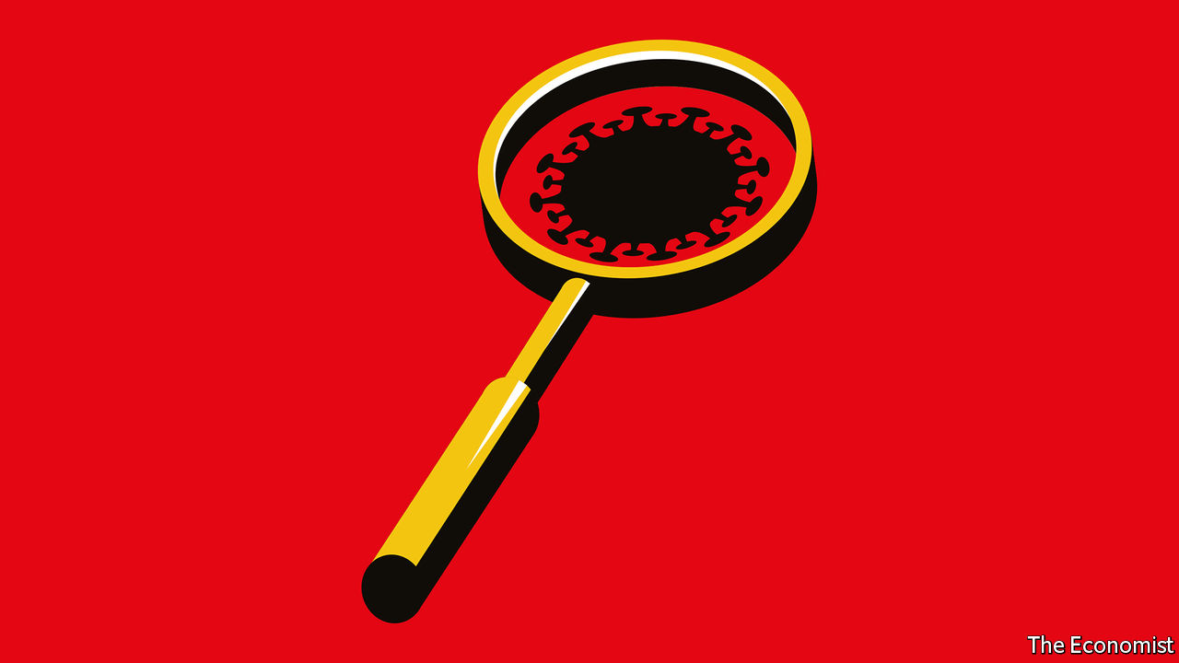

IF YOU HAD fallen asleep three months ago in Germany and woken up today you might not immediately notice much amiss. In much of the country shops are bustling, museums have reopened, and any bar that can pass for a restaurant is pulling in custom. If the shuttered theatres and conference halls dampen the spirits, consolation may be found in the beer gardens, in full swing under the spring sun.

New covid-19 infections in Germany are now consistently below 500 a day. But as German states lift restrictions they must try to prevent a second wave. Masks are compulsory on public transport and in shops, and social-distancing rules remain in place (if often ignored). Borders and schools are partially shut. But perhaps most important in fighting contagion are Germany’s phalanx of contact-tracers—part detectives, part social workers, part medical auxiliaries and part data clerks.

Their work has three elements. First, to obtain from people who have tested positive for covid-19 a list of their recent contacts, and to categorise them. (Spending 15 minutes face-to-face with an infected person, for example, places you in a high-risk bracket.) Second, to alert those people and instruct them, if needed, to self-isolate for 14 days. Third, to check in with them periodically and get them tested, in some cases even if they show no symptoms.

In some countries contact-tracers work from home or outsourced call centres. In Germany they are housed in one of 375 Gesundheitsämter (public health offices), such as one in north Berlin recently visited by your correspondent. In a light-filled room lined with maps and charts, two dozen people (of a total staff of 98) were managing various aspects of the pandemic, from manning phones to tapping in data. Doctors were on hand, ready to be dispatched to administer tests. The work has changed in recent weeks, says Lukas Murajda, head of the office: 80% of the contacts his team follows up are now in care homes for the elderly or other residential centres.

The Robert Koch Institute (RKI), a federal health agency, provides local offices with guidance and basic software to crunch their data. It has also recruited and helped train 500-odd “containment scouts” to help overloaded areas. But the offices retain considerable leeway to organise their own work. Some struggle to co-operate or share information, a task already hampered by data-privacy rules. (Certain information may only be shared via fax.)

But the advantages of decentralisation far outweigh the drawbacks. Health workers who know their regions are better placed to chase down infection chains in potential hotspots like meat-processing plants. Better-off health offices often ditch the RKI software and build or buy their own. “That’s the beauty of it,” says Peter Tinnemann, an epidemiologist at the Charité University Hospital in Berlin. “Local workers adapt solutions to local circumstances.” Some regions are struggling to meet the federally mandated target of five contact tracers per 20,000 inhabitants. But if they have seen no new cases for a week or more, they may see no reason to try.

There are valuable lessons in the history of contact-tracing, a technique long deployed to manage outbreaks of tuberculosis and sexually transmitted diseases. “People underestimate the nature of the work,” says Marcel Salathé, a Lausanne-based digital epidemiologist. Inexperienced tracers may be unprepared for interviewees who react defensively to intrusive questions, or who fear their answers will send friends to quarantine. The two-day training of Mr Murajda’s recruits is limited to technical matters, though psychologists are on hand to help. Offices need multilingual staff to reach non-German-speakers. Most tracers read to their charges from prepared scripts, but the better-trained may deviate from it. Rather than ask directly about contacts, for example, they might jog interviewees’ memory by asking general questions about their social networks.

Having abandoned contact-tracing in March, only this week did Britain kick it back into gear. American states have also struggled to up their efforts. In Germany the Gesundheitsämter have long been underfunded; many in particular lack doctors, who can earn more in hospitals. Yet most offices maintained contact-tracing throughout the pandemic, even if understaffed spots in rural areas struggled when daily infections were in their hundreds. Many pulled in furloughed colleagues, like teachers or librarians. Some called on the army. Baden-Württemberg, an especially hard-hit state, ramped up contact-tracing staff from 500 to 3,000 and never saw infections spiral out of control, says Manne Lucha, its social-affairs minister.

Manual contact tracing has its limits: even the most helpful patient will struggle to identify fellow passengers on a train. Like other countries, Germany hopes to automate some tracing with a mobile app using Bluetooth. Yet its development has been plagued by technical and data-privacy woes; officials now hope to launch it in mid-June. Even then, technology can only support manual contact tracing, not replace it, says David Holtgrave, dean of the school of public health at the University of Albany, in New York state. Germany’s virus detectives have plenty of work ahead. ■

Editor’s note: Some of our covid-19 coverage is free for readers of The Economist Today, our daily [newsletter](https://my.economist.com/user#newsletter). For more stories and our pandemic tracker, see our [coronavirus hub](https://www.economist.com/news/2020/03/11/the-economists-coverage-of-the-coronavirus)

This article was downloaded by calibre from <https://www.economist.com/europe/2020/05/30/germanys-contact-tracers-try-to-block-a-second-covid-19-wave>

|  |  |  |  |
| --- | --- | --- | --- |
| Previous | Articles | Sections | Next |

|  |  |  |  |
| --- | --- | --- | --- |
| Previous | Articles | Sections | Next |

#### To your good stealth

# A beery European spy club is revealed

How the Danes, Swedes, Germans and Dutch shared secrets

May 28th 2020 |



A DANE, A Swede, a German and a Dutchman walk into a bar. It is 1979 and spooks from the four countries are conferring in a Munich suburb over dark and malty lagers. For years they had co-operated in the business of signals intelligence, or SIGINT—intercepting messages and cracking codes—and wanted a name for their budding spy pact. “They looked at their glasses, filled with Doppelbock beer of the local brand Maximator,” writes Bart Jacobs, a Dutch computer-science professor, “and reached a decision.”

In a paper published last month, Mr Jacobs revealed the existence of the Maximator alliance for the first time. It was formed in 1976, when Denmark joined forces with Germany and Sweden to intercept and decipher messages sent by satellites. The Netherlands joined two years later, bringing its intercept stations in the Caribbean to the party. France came along in 1985. The group is alive and well today.

Maximator’s history is a fine illustration of the chicanery involved in good cryptology. As well as plucking signals out of the ether, the group would swap details of weaknesses in cipher machines which encrypted diplomatic and military messages. How did they know of those weaknesses? Crypto AG, a Swiss firm that dominated the global market, turns out to have been co-owned by the CIA and its German counterpart, the BND. They would sell rigged machines to friends and enemies alike, including several NATO countries. Without letting on how it knew, Germany slipped information about those machines’ flaws to its Maximator partners.

The revelation of Maximator is a reminder that the Five Eyes—a globe-girdling intelligence pact between America, Britain, Canada, Australia and New Zealand—is not the only game in town. Other eavesdropping alliances have coalesced around common goals, like the war in Afghanistan. For instance, the Fourteen Eyes, officially known as SIGINT Seniors Europe, brings together the countries in Five Eyes and Maximator, along with Spain, Norway, Belgium and Italy. “These groupings are not exclusive,” says a British insider, but “more of a patchwork focused on particular shared interests.” None is as wide-ranging and intimate as the Five Eyes.

Nevertheless, Maximator is staunchly European, something that carries certain advantages as transatlantic divisions grow wider. “German and French engineers work very well together,” notes Bernard Barbier, a former head of SIGINT for French intelligence, who once proposed a fused Franco-German spy agency. “In contrast,” he laments, “a British engineer with a French engineer is complicated.” Maximator also appears to have been especially secretive, unknown even to many people within the spy agencies involved. “I’ve seen some spectacular stuff that I think the Five Eyes would very much like to have,” says a former Dutch intelligence official. “And it couldn’t be shared.” ■

This article was downloaded by calibre from <https://www.economist.com/europe/2020/05/28/a-beery-european-spy-club-is-revealed>

|  |  |  |  |
| --- | --- | --- | --- |
| Previous | Articles | Sections | Next |

|  |  |  |  |
| --- | --- | --- | --- |
| Previous | Articles | Sections | Next |

#### Paris masked

# Covid masks give the French a new way to be chic

They are compulsory, so they may as well be stylish

May 30th 2020 | PARIS

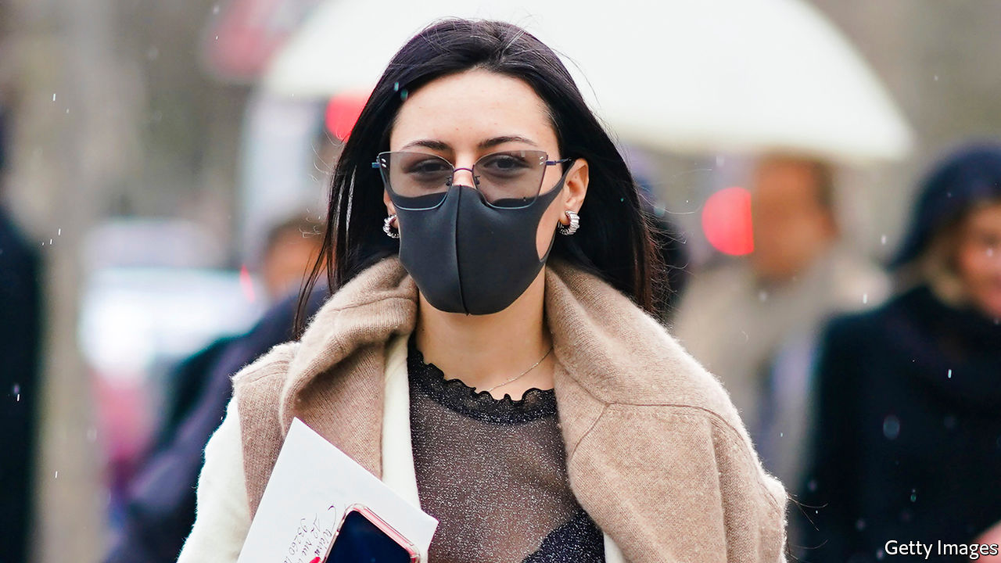

A WOMAN CYCLES by in a pistachio-green mask that matches the colour of her bicycle. Masks in black, the perennial fall-back for the stylish, are the new staple in the fashionable quarters of the French capital. Since the government made mask-wearing compulsory on public transport on May 11th, elegant Parisians have ditched the mass-market pale-blue surgical ones for a dash of coronavirus chic.

Erik Schaix, a designer, sells couture models in charcoal-grey denim and batik print at his Paris boutique. They meet a demand “to get away from the pharmacy utility version”, says a sales assistant, and “add a bit of fantasy.” When Emmanuel Macron dropped in on a school wearing a navy-blue mask with a small French flag on the trim, its manufacturer was “flooded with calls” the next day, says Thomas Delise, who runs the firm. Based in eastern France, Bonneterie Chanteclair makes high-filtration masks approved by the French army, and Mr Delise had sent the president a mask on the chance he might wear it. Now the firm is launching that model in 44 different shades. A limited-edition mask with Breton stripes sold out in half an hour.

Mask-wearing presents a particular problem in France. “The Enlightenment ideal realised by the French revolution was built against the masks that aristocrats adorned themselves with,” argued Frédéric Keck, an anthropologist, in Le Monde. To the French, some suggest, the uncovered face represents modernity and liberation from religious, patriarchal or other prescriptions.

Yet Parisians have embraced the look with panache. “It’s the new statement T-shirt,” said Jean-Paul Gaultier, a designer. Home-made masks may even be a form of silent rebellion at the government’s original advice against mask-wearing. Parisians have a long history of defiant style even at times of disaster. In post-revolutionary France, aristocrats who had lost relatives to the guillotine are said to have attended “victims’ balls”, at which women tied a jaunty blood-red choker around the neck. Under Nazi occupation, Parisiennes fixed wooden wedges under their sandals to fashion high heels. Today’s mask may not be the accessory of choice. But Parisians are turning it into a choice accessory.

Editor’s note: Some of our covid-19 coverage is free for readers of The Economist Today, our daily [newsletter](https://my.economist.com/user#newsletter). For more stories and our pandemic tracker, see our [coronavirus hub](https://www.economist.com/news/2020/03/11/the-economists-coverage-of-the-coronavirus)

This article was downloaded by calibre from <https://www.economist.com/europe/2020/05/30/covid-masks-give-the-french-a-new-way-to-be-chic>

|  |  |  |  |
| --- | --- | --- | --- |
| Previous | Articles | Sections | Next |

|  |  |  |  |
| --- | --- | --- | --- |
| Previous | Articles | Sections | Next |

#### Into the trough

# Eastern Europe’s covid-19 recession could match its post-communist one

The whole EU faces a downturn, but the east is especially fragile

May 28th 2020 | BERLIN

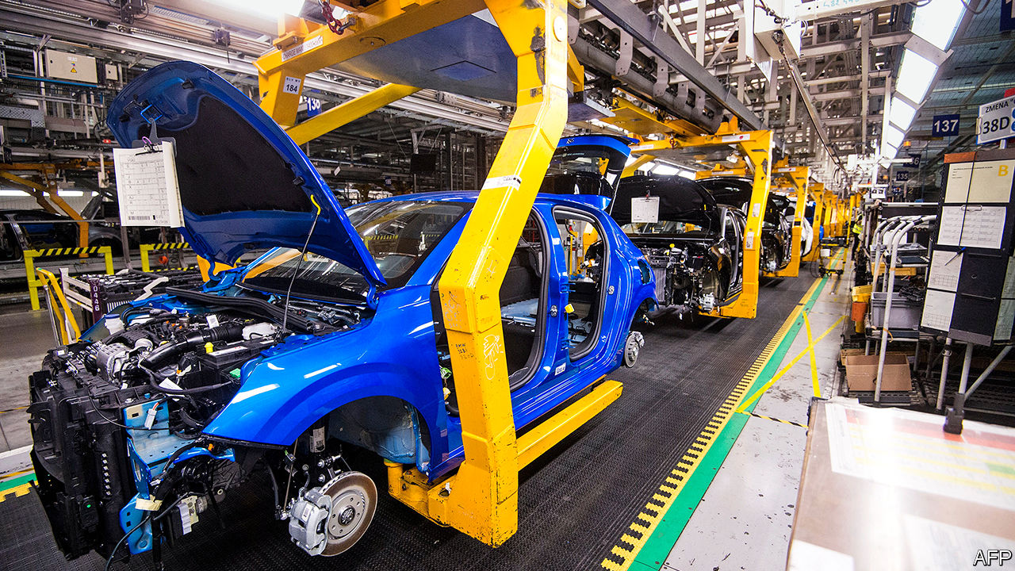

Editor’s note: Some of our covid-19 coverage is free for readers of The Economist Today, our daily [newsletter](https://my.economist.com/user#newsletter). For more stories and our pandemic tracker, see our [coronavirus hub](https://www.economist.com/news/2020/03/11/the-economists-coverage-of-the-coronavirus)

EUROPE HAS so far been hit the hardest of any continent by covid-19, but the pandemic has been more tornado than hurricane, ravaging some areas while leaving others nearly unscathed. Eastern Europe has been less affected than the west, and even eastern Germany less than western Germany. Southern Europe has suffered more than the north. Gaps between neighbours can be striking: Spain’s excess mortality per person is more than triple that in Portugal, and France’s quadruple that in Germany. Economically, too, the impact is uneven. As forecasts of the pandemic’s economic damage emerge, central and eastern Europe look especially precarious.

It is not that the rest of the continent is doing well. In the first quarter of 2020 the EU suffered its deepest economic contraction on record. Its GDP shrank by 3.5% compared with the previous quarter. Europe’s biggest economy, Germany, dwindled by 2.2% in the same period. Figures for the second quarter, when lockdowns were at their most stringent, are expected to be much worse. Recent data suggest the union’s economic activity in March and April dropped by approximately 30% compared to the previous year. On May 6th the European Commission predicted a “deep, uneven recession”, with GDP this year contracting by 7.5% for the EU as a whole and a bit more in the part that uses the euro. Some forecasters are even gloomier: Morgan Stanley, an investment bank, sees the euro zone’s GDP falling by 11%.

The depth of each country’s recession will depend on the duration of its lockdown, the stringency of social distancing and the strength of consumption, explains Jacob Nell, an economist at Morgan Stanley. The bank thinks Germany’s economy will shrink by 8% in 2020, whereas France’s will contract by 11% and Italy’s by 15%. Germany’s lockdown was one of the lightest in Europe: factories and public transport operated throughout, and shops, restaurants, hairdressers, libraries, zoos and some schools have reopened. France, Spain and Italy forced far more of their economy into a covid coma.

Like Germany, eastern Europe has had low rates of infection and death, and is relaxing its lockdowns early. Slovakia, for instance, recorded just 1,513 confirmed cases of covid-19 and 28 deaths; neighbouring Austria had 16,557 cases and 643 deaths. Eastern Europeans did well in part because they knew they were vulnerable: fearing that the pandemic could quickly overwhelm their creaky health-care systems, they locked down hard and fast and contained the virus quickly. (Health-care expenditure per head in Poland and Hungary, for example, is about one-quarter that of Austria at purchasing-power parity.) It helped that few eastern Europeans ski at fancy resorts in Italy or Austria, which turned out to be coronavirus hotspots.

Yet the economic pain may be worse in much of the east than in the west. “Eastern Europeans dealt with the pandemic efficiently,” notes Richard Grieveson of the Vienna Institute for International Economic Studies (WIIW), “but this recession will be as bad as the transition recessions”—those following the collapse of communism. In the five years after the fall of the Berlin Wall in 1989, annual output in former Soviet-bloc countries fell by more than 40%.

Eastern European countries are vulnerable for three reasons. First, their economies are export-dependent, leaving them at the mercy of demand in other countries. As a proportion of GDP, exports of goods and services range from 96% in Slovakia and 85% in Hungary down to 67% in Bulgaria and 61% in Latvia. By way of comparison, in Spain the ratio is 35%.

A second reason is that eastern European governments have less capacity to finance rescue packages. They cannot run large deficits because investors are wary of lending to them. Most have low levels of public debt, but their credit ratings tend to be poor. Austria’s debt, as a percentage of GDP, is more than three times as high as Bulgaria’s. Yet its bonds are rated AA+ by Standard and Poor’s, a ratings agency, while Bulgaria’s are BBB.

Finally, many countries in the east rely heavily on one of the industries hardest hit by the pandemic: tourism. In Croatia, for example, it generates 25% of GDP. The WIIW thinks Croatia’s economy will contract by about 11% in 2020.

On the bright side, central Europe could benefit from its dependence on Germany, which is expected to recover quickly. It is by far the biggest trading partner of the Visegrad countries (the Czech Republic, Slovakia, Hungary and Poland). Morgan Stanley expects Germany to expand by 6.4% in 2021, and German businesses are growing more confident about this year’s outlook, according to a survey last week by the Ifo Institute. Being outside the euro zone has its advantages, too: the WIIW expects the Czech Republic and Poland to be helped by the devaluation of the koruna and the zloty (see chart).

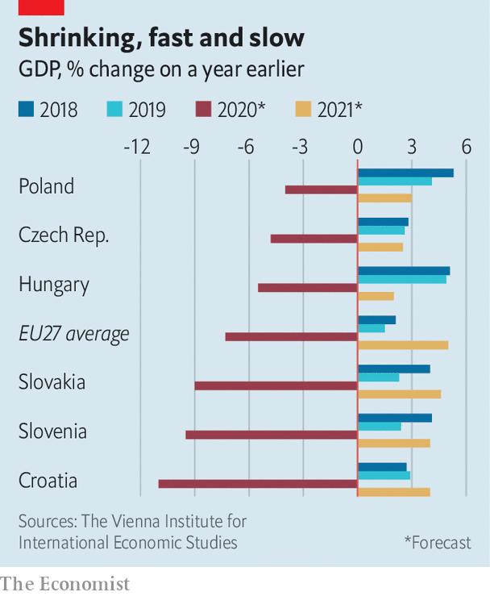

Mr Grieveson thinks the crisis will fundamentally change some aspects of the region’s economies, sometimes for the better. Central and eastern Europe could benefit from “nearshoring” (moves by China-wary western European manufacturers to bring production closer to home). The rise in online shopping, which is expected to continue even after the pandemic abates, might help too. Related services, such as call centres and warehouses, could be outsourced to the region.

The Commission’s forecast notes that the recovery will be “uncertain”, especially in hard-hit countries that were weak before the pandemic struck. An incomplete recovery in one country, it warns, could dampen economic growth everywhere. It is a call to Europeans to do what Germans did after the fall of the Berlin Wall: help each other out for the benefit of all. ■

This article was downloaded by calibre from <https://www.economist.com/europe/2020/05/28/eastern-europes-covid-19-recession-could-match-its-post-communist-one>

|  |  |  |  |
| --- | --- | --- | --- |
| Previous | Articles | Sections | Next |

|  |  |  |  |
| --- | --- | --- | --- |
| Previous | Articles | Sections | Next |

#### Charlemagne

# The EU’s recovery fund is a benefit of Brexit

The bloc takes steps that would have been impossible with Britain as a member

May 30th 2020 |

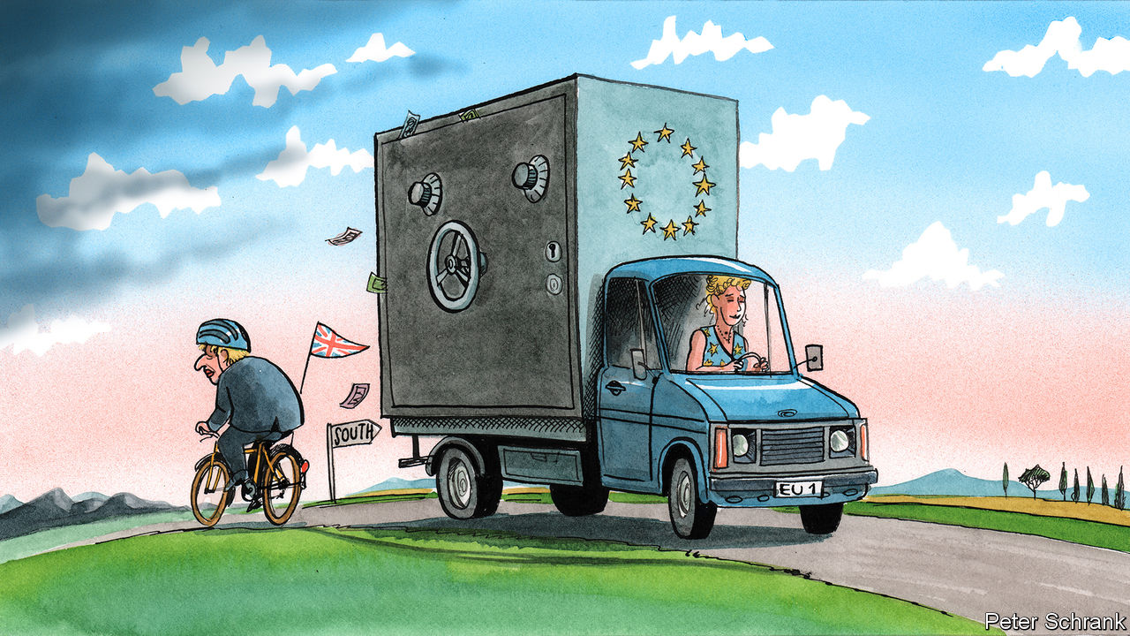

CONSIDER A COUNTERFACTUAL. A few years after the referendum in which Britain narrowly voted to stay in the EU, David Cameron hands power to a loyal chancellor, George Osborne. Upon taking office, Mr Osborne faces a global pandemic and Britain’s deepest recession since 1706. To cap it all, an unwelcome proposal from Brussels arrives: a €750bn ($825bn) recovery fund earmarked for the struggling economies of southern Europe, paid for with debt issued by the bloc. Britain is on the hook for about €90bn. “I did warn you, George,” writes Boris Johnson, now editor of the Evening Standard, London’s local newspaper, in a gleeful column.

Had history taken that route, Britain would have vetoed the scheme that EU officials hope will dig the bloc out of its economic hole, points out Sir Ivan Rogers, the country’s former ambassador to the EU. Reality turned out differently. Britain voted to leave, Mr Johnson became prime minister and Mr Osborne edits a local newspaper in London. And, for the first time, the EU is taking a path that would have been blocked by its former member.

With Britain gone, the EU is coalescing. The scheme to issue a mix of grants worth €500bn and loans of €250bn to countries struggling with the effects of covid-19 is a step towards a more integrated bloc. Some breathlessly compare the move to America’s decision to mutualise debts in 1790. For others, it is less a leap than a shuffle: the EU has issued debt in this way before, if on a far smaller scale. In any case, the big member states are all on board. France and Germany proposed a plan similar to the European Commission’s, while Spain and Italy called for an even more generous one.

Yet even without the British, the path is not entirely clear. Austria, Sweden, the Netherlands and Denmark — the so-called “frugal four” — have criticised the scheme. Each has a veto in the coming talks, like every other member state. In a paper, the foursome demanded that aid must be paid back, not granted outright, and must come with strict promises of economic reform. Any fund will be negotiated as an add-on to the EU’s €1.1trn seven-year budget, which still has some souvenirs of British obstinacy. The “frugal four” are fond of rebates, the complicated systems of cashback for countries who pay in more than they receive, whichhave greased EU budget negotiations ever since Britain’s prime minister, Margaret Thatcher, demanded one in the 1980s.

Without Britain, the dynamics of the debate have changed. Budgetary hawks have far less weight than when they could rely on Britain’s support. Now they have no big ally. The crucial shift came when Germany, traditionally opposed to mutualised debt, gave its backing to the fund. Together the foursome have only 42m citizens—not even a tenth of the EU’s population and smaller than Spain’s. Their critiques of aid plans are restrained by the fact that each governing coalition contains stridently pro-EU parties. In Austria, Sebastian Kurz, the fiscally conservative chancellor, governs alongside the Green party, which is much keener on handing cash to needy Italians. In the Netherlands, the Christian Democratic Appeal’s hardline finance minister, Wopke Hoekstra, sits in government with the Europhile liberals of D66.

The fissures that do still exist, such as the division between the 19 states in the euro zone and the eight outside it, are narrower than when Britain was a member. During the euro crisis of 2010-12, Britain chose not to chip in to rescue funds for any euro-zone member apart from Ireland. Instead of help, Mr Cameron, then Britain’s prime minister, offered lectures on the structural flaws of the euro—the equivalent of a neighbour extolling the virtues of fire safety while the house next door is burning.

Running the recovery fund through the EU’s budget means all members are financially responsible for it, even if most of its beneficiaries sit in the euro zone. Sweden and Denmark, which are outside that currency area, seem happy to help, though they do not agree on how. Economic need is motivation enough: over 70% of Swedish exports end up in the EU. If the single market burns, so do they. Even countries such as Poland have fallen into line with the idea of a recovery fund, as long as it does not cut into the regular EU aid (“cohesion funds”) that flows from west to east. A one-size-fits-all approach to policies becomes more viable now that Britain, the most oddly shaped member, has departed.

Relying so heavily on the EU’s budget to fix the bloc’s ills has drawbacks. Chunks of EU funds aimed at building infrastructure in eastern Europe have often ended up in surprising places, such as the pockets of businessmen close to Viktor Orban, Hungary’s leader. If not trousered by some ne’er-do-well, the cash is sometimes ill spent, as deserted airports in southern Europe attest.

But the EU is not doomed to repeat old mistakes. Rules of spending have tightened. A new European Public Prosecutor’s Office will investigate any misuse of funds. In any case, dishing out bales of cash covered in EU flags is not the worst idea when countries clobbered by the pandemic are losing faith in the entire project. Polls suggest four in ten Italians want to leave the bloc. After Britain’s slapstick departure, no government is likely to put such a question to a vote. But it would be foolhardy to ignore the signals.

## The dash for cash

Whenever money is involved, the EU descends into an undignified brawl. Yet the outline of a deal is emerging. A compromise whereby the “frugal four” keep their rebates, eastern Europe continues to receive generous transfers, and Italy and Spain get their recovery fund seems feasible. France is able to cast itself in a lead role, while Germany reassures itself that nothing can happen in the bloc without its blessing. A scrap is still necessary. Part of this is choreography so leaders can declare victory at home; part of this is leaders grabbing what they can. With the seven-year budget and the recovery fund totalling €1.85trn, there is plenty to wrestle for, and even a planned negotiation can turn nasty. During the coming summer of arguments over cash, it may seem as if Britain never left. ■

Editor’s note: Some of our covid-19 coverage is free for readers of The Economist Today, our daily [newsletter](https://my.economist.com/user#newsletter). For more stories and our pandemic tracker, see our [coronavirus hub](https://www.economist.com/news/2020/03/11/the-economists-coverage-of-the-coronavirus)

This article was downloaded by calibre from <https://www.economist.com/europe/2020/05/30/the-eus-recovery-fund-is-a-benefit-of-brexit>

|  |  |  |  |
| --- | --- | --- | --- |
| Previous | Articles | Sections | Next |

|  |  |  |
| --- | --- | --- |
| Europe | Sections | International |

Britain

The Brexit negotiations: Every man to his island

.

Puppies: Barking mad

.

Dominic Cummings: Ill-advised

.

Education: Back to school, sort of

.

Carmaking: The Lotus position

.

Carmaking: Assembly without assembling

.

Summer holidays: On the beaches

.

Bagehot: I love the sound of breaking rules

.

|  |  |  |
| --- | --- | --- |
| Europe | Sections | International |

|  |  |  |  |
| --- | --- | --- | --- |
|  | Articles | Sections | Next |

#### Brexit

# Deadlock looms at Brexit talks next week

The chances Britain will leave the EU without a trade deal are rising

May 30th 2020 |

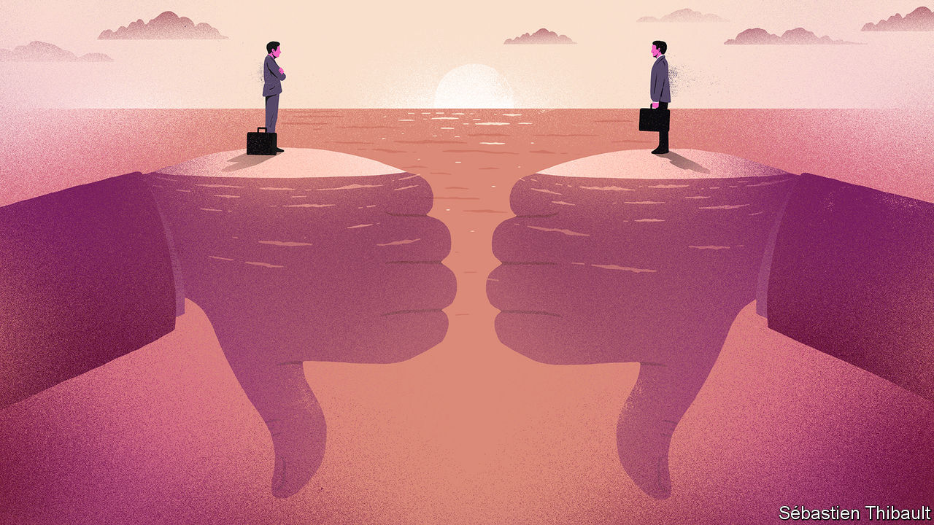

IT IS NO surprise that negotiations on Britain’s future relationship with the EU have been difficult. The two sides have dug into opposing positions on such issues as a level playing-field for competition, fisheries and the role of the European Court of Justice. Negotiating on politically contentious matters by video link, thanks to covid-19, makes it much harder to feel out necessary compromises. And the clock is ticking: the deadline for a deal is December 31st, when the transition period is due to end.

Next week sees the final round of talks before a summit in June due to assess progress. The previous one ended in a bad-tempered exchange of letters between the British negotiator, David Frost, and his EU counterpart, Michel Barnier. Mr Frost called for the EU to think again about its proposals. Mr Barnier said success was possible only if tangible and parallel progress was made in all areas. Both sides have published opposing draft treaties. Since each is under a mandate that can be changed only by their political masters, who are preoccupied by covid-19, expectations of any progress next week are low.

This is compounded by mistrust over implementing the withdrawal agreement, especially the protocol that keeps Northern Ireland in the EU’s customs union. Next week also sees the second meeting of the joint committee supervising this agreement. The EU is pleased that Britain has belatedly accepted that there will be border and customs checks between Northern Ireland and the British mainland. But it frets that not enough preparations have been made, especially against the risk that the negotiations may end without any trade deal in place.

For this is now a genuine prospect. Mujtaba Rahman of the Eurasia Group, a consultancy, says it is even possible that the June summit may decide to abandon the negotiations, though Charles Grant of the Centre for European Reform, a think-tank, suggests the crunch is more likely to be in the autumn. A recent poll by the UK in a Changing Europe (UKinaCE), an academic think-tank, found that over 70% of its Brexit analysts believe a trade deal is unlikely to be agreed by the end of the year.

Such a gloomy prognosis is triggering renewed debate about the year-end deadline. The withdrawal treaty provides that, before the end of June, it can be extended by up to two years by agreement. But Boris Johnson is viscerally opposed to an extension. He has even made clear that he would veto any EU request for more time. Why such stubbornness, given that he also claims to want a deal?

One answer is that he and his team associate talk of extending deadlines with Theresa May’s weak government. They also maintain that an extension would betray those who voted for Brexit in 2016 and for the Tories last December. This is hard to swallow, since Brexit formally happened in January and most voters seem to back an extension. An opinion poll by Best for Britain, a lobby group, found that two-thirds of respondents supported the idea, with almost half of those who voted Leave in 2016 also being in favour.

The government also thinks a tight deadline and tough bargaining increases pressure on Brussels to offer concessions. Mr Johnson harks back to last October, when he won changes to Mrs May’s withdrawal agreement that the EU had insisted could not be reopened. Yet what actually happened was that he accepted the EU’s original preferred option for averting a hard border in Ireland, which was to keep Northern Ireland alone in a customs union, implying controls in the Irish Sea.

A darker explanation is that Downing Street thinks the massive impact of covid-19 will swamp any adverse effects from leaving without a trade deal. Some ministers think covid-19 may now make a complete break with the EU easier to sell politically, especially if the blame can be placed on an intransigent Brussels. Yet the damage from reverting to World Trade Organisation terms would be large and enduring. A new study by the UKinaCE team reckons that, compared with the status quo, it would lower GDP by 8.1% after ten years.

To avoid this, an extension could be made more palatable. One possibility would be to go for less than a year, and insist that even this would be used only if a deal cannot be done sooner. Another idea, proposed by Raoul Ruparel, a former European adviser to Mrs May, is to agree to an extension only to sort out the practical implementation of a deal that still has to be reached in broad outline by December. Anand Menon, UKinaCE’s director, says an extension is needed even in the event of no deal, because covid-19 has left businesses on both sides ill-prepared for the disruption this could create.

An alternative is to ignore the end-June deadline for an extension and leave it to the autumn to decide. After all, Mrs May’s various extensions of the Article 50 Brexit deadlines were all done at the last minute. Yet there is a big legal problem. The withdrawal treaty was drawn up under Article 50. If its end-June deadline is not met, Article 50 can no longer be used because Britain is a third country. That means any extension in the autumn would have to go through a separate treaty. Worse, such a treaty might have to be ratified by national and, in some cases, regional parliaments.

In short, the risk of ending the year without a trade deal with the EU and with no extension of the deadline looks uncomfortably high. And, after months when covid-19 wholly usurped the agenda, Brexit is back to the fore.■

This article was downloaded by calibre from <https://www.economist.com/britain/2020/05/30/deadlock-looms-at-brexit-talks-next-week>

|  |  |  |  |
| --- | --- | --- | --- |
|  | Articles | Sections | Next |

|  |  |  |  |
| --- | --- | --- | --- |
| Previous | Articles | Sections | Next |

#### The dog business

# Rising puppy prices

Demand is up, and the canine supply chain is vulnerable

May 30th 2020 |



“I DESPERATELY WANTED a Labrador or a Basset hound,” says Imogen Patton, a maternity nurse from Somerset. “I had to give up, because all the breeders said their pups were sold out before they were even born.”

A dearth of puppies was not among the shortages anticipated as a result of the crisis, but Britain is suffering from one. Families looking for ways to entertain their offspring and adult children worried about lonely aged parents are after them. But rocketing prices are driven up not just by the increase in demand: dog-market developments have made the supply chain vulnerable to disruption.

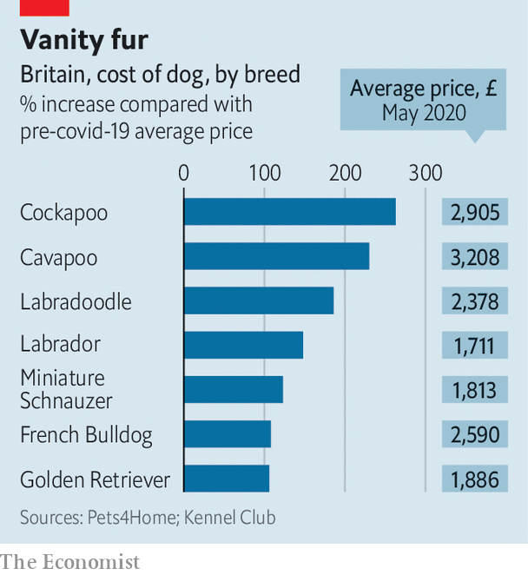

Pedigree hounds used to be working dogs—breeds created by Victorian aristocrats in a period of heady innovation that produced most modern canines. Pet dogs were mongrels, until rising disposable incomes turned pups into luxury items and drove up demand for Kennel Club-registered breeds. In the past decade a new trend has emerged: the designer crossbreed. These posh mongrels with pure-blood parents are outstripping their pedigree Kennel Club cousins in popularity (see chart). But they are just as difficult to produce.

In contrast with the parents of bog-standard mongrels, which have little trouble hooking up, pedigree bitches and studs are often separated by geography. Lockdown has created an unexpected barrier. “I couldn’t travel to visit the stud dog,” laments Julia Porter, a breeder of Norfolk terriers from Herefordshire. Stranded miles from suitable partners, her pooches have been spared a spring of pregnant servitude.

Even where breeders own both stud and bitch and the puppy production-line is therefore unimpeded, there is some reluctance to satisfy the onrush of new customers. “Some people, you can just tell by the language—‘have you got any pups for sale’ or ‘have you got any girls’—and you can tell by the grammar and spelling,” says Brian Dash, who breeds Labrador retrievers. By contrast Stephen Charlton, who breeds Cockapoos (cocker spaniel-poodle crosses, pictured), does not screen his customers’ grammar. “I’ve never had to shine a spotlight on anybody to see if they are worthy of having a puppy,” he says. “That mentality is prevalent within the Kennel Club’s high-end, behind-closed-doors breeding world.”

Yet many breeders are concerned that lockdown will prevent new puppies from socialising with other puppies, and that owners will dump them once lockdown is lifted. “The only safe thing a breeder can do at the moment is hang on a few more weeks,” says Esther Bannister, a German-shepherd breeder. “I’ve actually told the Kennel Club to take my name off their ‘Find A Puppy’ list.” The reticence of some is driving up prices for more mercenary breeders. “‘Greeders’ is what I would call them,” says Mr Charlton, who worries that unscrupulous profiteers are turning the trade into a “click and collect’’ delivery service.

One consequence may be new sources of supply. The Dogs Trust, a charity, fears that criminal gangs are now bringing pregnant dogs into the country from Romania. Another is that some customers are trading down. “People are selling German shepherds that aren’t even pedigrees,” says Catriona Stevens, an outraged breeder. Perhaps even the authentic mongrel will have its day again.■

Editor’s note: Some of our covid-19 coverage is free for readers of The Economist Today, our daily [newsletter](https://my.economist.com/user#newsletter). For more stories and our pandemic tracker, see our [coronavirus hub](https://www.economist.com/news/2020/03/11/the-economists-coverage-of-the-coronavirus)

This article was downloaded by calibre from <https://www.economist.com/britain/2020/05/30/rising-puppy-prices>

|  |  |  |  |
| --- | --- | --- | --- |
| Previous | Articles | Sections | Next |

|  |  |  |  |
| --- | --- | --- | --- |
| Previous | Articles | Sections | Next |

#### Politics

# The damage Dominic Cummings has done to Boris Johnson

Arrogance and populism don’t go

May 30th 2020 |

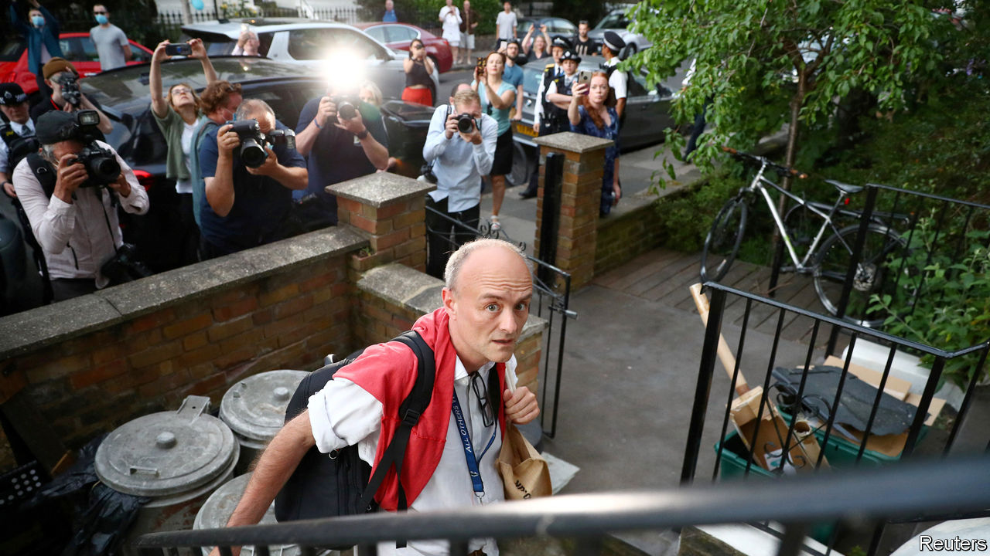

DOWNING STREET aides have a habit of creating headaches for their bosses. Damian McBride, Gordon Brown’s pressman, quit over a smear campaign. Andy Coulson, who did the same job for David Cameron, resigned over his role in the tabloid phone-hacking scandal. Such rows are often complex, who-knew-what-when stories that delight insiders, but which the public would soon forget.

Boris Johnson hopes that’s so in Dominic Cummings’s case. His chief aide drove 270 miles from London to his parents’ farm in late March, while most Britons were following the government’s edict to “stay home”. More than three dozen Tory MPs have protested and a minister has resigned. Cabinet ministers have been rolled out to defend the aide, a spectacle described as “humiliating and degrading” by William Wragg, the Tory chair of Parliament’s Public Administration and Constitutional Affairs Committee. Mr Johnson’s approval ratings are bleeding. More than half of voters, including a majority of Leavers, think Mr Cummings should go.

Mr Johnson is determined he should not. On May 27th he told MPs it was time to “move on” from the “political ding-dong about what one adviser may or may not have done”. Yet this affair feels less like a backstairs intrigue and more like the parliamentary expenses scandal of 2009, which undermined confidence in lawmakers. Like those MPs who billed the taxpayer for Mars Bars and swimming-pool maintenance, Mr Cummings’s wrongdoing is pretty trivial. (Breach of the lockdown laws, which he denies, carries a £30 ($37) fine for first offenders who pay promptly.) But the public, many of whom have sacrificed the opportunity to meet newborn grandchildren, visit dying relatives or attend funerals in order to follow the rules, could instantly grasp the story.

As in 2009, anger has mixed with ridicule. Mr Cummings’s claim he drove to Barnard Castle, a beauty spot, on his wife’s birthday in order to test his eyesight is the butt of jokes and memes online. Just 8% of Britons accept the alibi, a similar proportion to those who believe the earth is flat.

Mr Johnson’s administration—which he calls the “people’s government”—is particularly vulnerable to accusations of hypocrisy. He and his aide owe victory in the EU referendum and 2019 election to harnessing suburban England’s resentment of political elites. Mr Cummings’s fiery blogs rail against ministers who treat voters with contempt, are deaf to popular anger and fail to fire incompetent officials. His stammering defence at a press conference on May 25th that the “stay home” regulation was open to interpretation appeared a parody of the behaviour he once denounced. Appeals to Britain’s culture war—dismissing the reports of his trip as “fake news” by “campaigning newspapers”—fell flat. Voters now think the Tories are more “out of touch” than Labour by a margin of two to one, a big shift since January.

Mr Johnson’s keenness to keep his adviser has demonstrated how remarkable a figure Mr Cummings is. His press conference in the Downing Street rose garden, a space normally reserved for foreign dignitaries, accorded him a status unusual for an adviser, whose code prohibits them from making public comments.

His importance lies in part in his vision, and Mr Johnson’s lack of one. Mr Johnson became prime minister with little idea what he wanted to do with the job, other than “Get Brexit Done”; his agenda for government—to “level up” poorer regions, boost scientific research and break hard with Europe—comes straight from his aide’s blogs. Mr Cummings has also built himself a formidable power base. Many Downing Street aides, working on communications, Brexit policy and in Mr Johnson’s private office, are loyal graduates of the Vote Leave campaign Mr Cummings ran, while independent-minded ministers and aides have been shoved out. Yet Mr Cummings’s power rested on his reputation as a strategic genius. This week he did not look so clever. ■

Editor’s note: Some of our covid-19 coverage is free for readers of The Economist Today, our daily [newsletter](https://my.economist.com/user#newsletter). For more stories and our pandemic tracker, see our [coronavirus hub](https://www.economist.com/news/2020/03/11/the-economists-coverage-of-the-coronavirus)

This article was downloaded by calibre from <https://www.economist.com/britain/2020/05/30/the-damage-dominic-cummings-has-done-to-boris-johnson>

|  |  |  |  |
| --- | --- | --- | --- |
| Previous | Articles | Sections | Next |

|  |  |  |  |
| --- | --- | --- | --- |
| Previous | Articles | Sections | Next |

#### Back for summer

# English schools reopen, but not without a fight

Why the government has struggled to manage the return to class

May 30th 2020 |

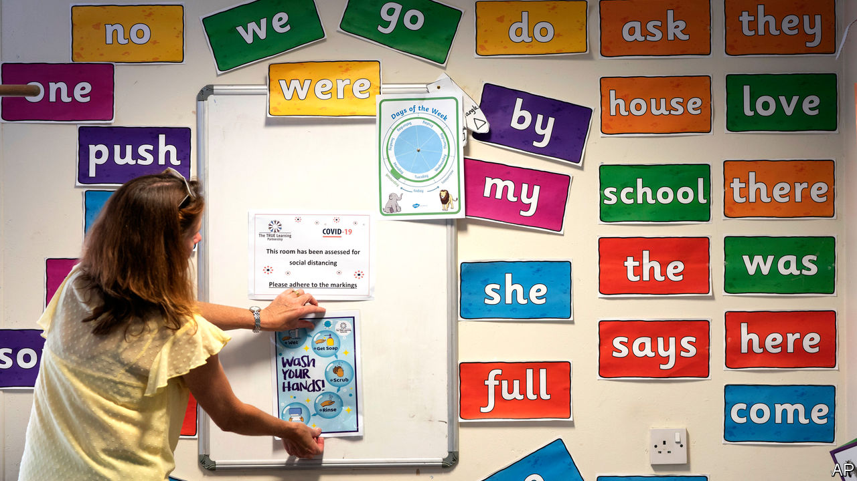

ON MAY 10TH, in the speech in which he began to lift the lockdown, Boris Johnson said he hoped schools would welcome back pupils at the start of June. The announcement was heavily caveated. Getting older children in before the summer break was an “ambition”. Primary schools would reopen with only three year groups. “I must stress again that all of this is conditional, it all depends on a series of big ifs,” the prime minister warned.

If the statement was designed to reassure, it did not succeed. The National Education Union, the country’s biggest teaching union, reckons that around 35 local councils in England are advising their schools to hold off; a rebellion the union has loudly supported. In some cases, schools won’t open because of problems putting in place precautions. More often, it is because they are unconvinced it is safe even with precautions. According to Teacher Tapp, a pollster, 60% of state-school teachers say they are “nervous” to return.

This nervousness is partly because reopening schools is inherently tricky. Modelling from the Scientific Advisory Group for Emergencies, which informs the government’s view it is safe, is sensitive to assumptions about how much children spread the virus, which is still uncertain. Although there is little doubt that keeping classrooms empty will cut the amount children learn and their parents’ productivity, the extent to which this is the case is hard to guess.

Even things that are clear—such as the fact that children are at little risk themselves from the virus—are hard to communicate. “We’re being asked by lots of parents: ‘Is my child safe if he or she goes back to school?’” says Sir Jon Coles, head of a charity which runs 85 schools, and who has advised the department for education on reopening. Misconceptions abound. One is that four- and five-year-olds will be expected to keep 2 metres apart. The government recognises this will not be possible, but to mitigate the risk of infection they will be kept in groups of no more than 15.

Yet lots of this is true across Europe, too, where the reopening of schools has proved less difficult. Some English teachers’ unions have been notably recalcitrant, perhaps because they know English people are nervous of ending the lockdown, and they therefore think this is a battle they can win. And the government messed up its negotiations: it annoyed the unions unnecessarily by going against their views on which years should return to school first, and by springing the approach on them.

It is harder for the government to order schools around in a system, like England’s, in which accountability is fragmented. “Schools have a vast amount of autonomy,” notes one former education secretary. “That is a strength of the system but there are times—and this is one—where it can create a tension.” In deciding whether to reopen, some heads are thus stuck between the wishes of the government and the wishes of their teachers’ unions.

The hope at the department for education is that, as children return to school, parents and teachers will be reassured it is safe; something which seems likely. Yet four in ten primary-school teachers expect less than half of their pupils to actually return when gates open. The way the government and the unions have handled the return to school has made it more fraught than it needed to be. ■

Editor’s note: Some of our covid-19 coverage is free for readers of The Economist Today, our daily [newsletter](https://my.economist.com/user#newsletter). For more stories and our pandemic tracker, see our [coronavirus hub](https://www.economist.com/news/2020/03/11/the-economists-coverage-of-the-coronavirus)

This article was downloaded by calibre from <https://www.economist.com/britain/2020/05/30/english-schools-reopen-but-not-without-a-fight>

|  |  |  |  |
| --- | --- | --- | --- |
| Previous | Articles | Sections | Next |

|  |  |  |  |
| --- | --- | --- | --- |
| Previous | Articles | Sections | Next |

#### Carmaking

# Lotus benefits from its Chinese connection

The sports-car maker gets back to work

May 30th 2020 |



NOTORIOUS MECHANICAL capriciousness once led frustrated owners to propose that Lotus was an acronym for “Lots of trouble, usually serious”. The cars are now reliable, but the accusation could be levelled at the firm, whose 72-year history is of elusive profits and periodic threats of bankruptcy. Yet just as petrolheads put a reputation for sobriety aside to own a brand burnished by past racing glory so too has Geely, a privately owned Chinese carmaker, which acquired a controlling stake in 2017.

For now, admits Phil Popham, the carmaker’s boss since 2018, the “brand is bigger than the business”. Last year 1,700 cars rolled off the production line in its Norwich factory, which has the capacity to build 10,000. But at least the Lotus badge remains attached to cars. Since the heyday of British sports-car manufacture in the 1960s many of the marques such as Austin Healey, Sunbeam and Triumph have perished. Lotus suffered from a string of unsuitable owners.

Geely might succeed where others have failed because it comes with financial backing, and a track record of expanding abroad and turning round struggling car firms. In the decade since it acquired Volvo the Swedish firm has thrived. Since taking over the company that manufactures London Taxis in 2013 it has developed a smooth-driving electric black cab that has cleaned up London’s air by reducing emissions and improving the mood of tetchy cabbies.

Geely is rumoured to be pumping around £1.5bn ($1.8bn) into the firm, an estimate that Mr Popham says is “conservative”. The cash will pay for the firm’s first new model for a decade—the Evija £2m electric hypercar, a “halo” vehicle designed to restore Lotus’s reputation for technology and speed; 130 of them will be made. A cheaper new sports car will follow in 2021.

The relationship should benefit both sides. The British firm can piggyback on Geely’s investment by outsourcing the development of a new platform, the basic underpinning of a car, and the costs of electrifying all future models. Geely can tap British expertise in aerodynamics and building light vehicles, important for keeping down the tonnage of electric cars with hefty batteries.

The tie-up may also insulate Lotus from some of the worst effects of the viral slowdown on Western carmakers, which will be aiming to cut costs and retrench. Forecasts suggest that China’s carmakers will not suffer as badly as those in the rest of the world. But questions remain over how well sports cars which mostly sell for between £55,000 and £110,000, and that are basically toys, will sell in a post-covid world of recession and gloom.

This article was downloaded by calibre from <https://www.economist.com/britain/2020/05/30/lotus-benefits-from-its-chinese-connection>

|  |  |  |  |
| --- | --- | --- | --- |
| Previous | Articles | Sections | Next |

|  |  |  |  |
| --- | --- | --- | --- |
| Previous | Articles | Sections | Next |

#### Manufacturing

# How covid-19 is changing carmaking

Firms are getting back to work, but work is slower

May 30th 2020 |

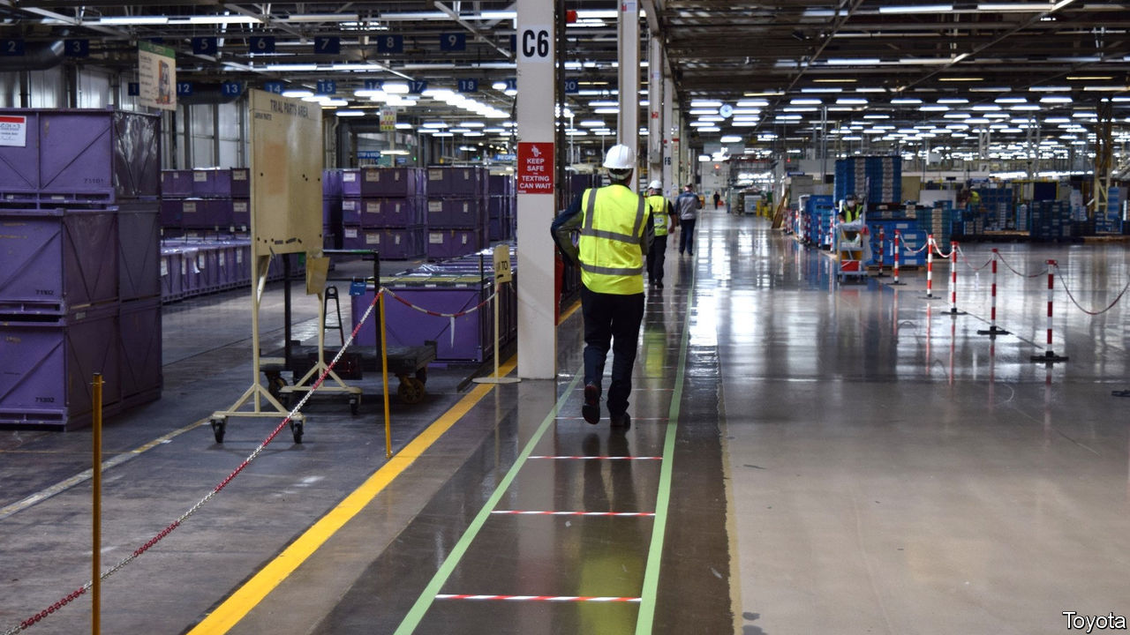

CAR ASSEMBLY lines are not designed for social distancing. But firms whose factories stood idle for several weeks are starting to make vehicles again. In a capital-intensive industry in which production processes have been refined to maximise efficiency, even small changes to prevent the spread of covid-19 will make it hard to operate at former levels.

The SMMT, an industry body, reckons that Britain will churn out just over 1m vehicles in 2020, nearly 20% fewer than last year. Revving up is easier for some. Smaller makers of pricier cars tend to have more flexible production processes than bigger firms. Lotus (see box) and Bentley reopened their factories on May 11th. Jaguar Land Rover and BMW’s Mini restarted a couple of weeks ago and Toyota’s plant in Burnaston near Derby got back to work on May 26th. A restart is imminent at Vauxhall-Opel’s plant in Ellesmere Port in Cheshire. Nissan in Sunderland will follow in a couple of weeks.

Adaptation to ensure social distancing starts at the factory gate or before. Arrival, departure and break times are particularly difficult to manage. So carmakers are requiring employees to change into workwear at home to minimise close contact at work. Some firms want them to make their own lunch until canteens can reopen. Eating areas, with gaps between individual tables, resemble exam halls. At Ellesmere Port, where there were two entrances and car parks, there will now be five of each; work will end half an hour early to prevent one shift meeting the other on the way in.

In some areas—such as the body shop, where cars’ shells are welded together by robots—social distancing is fairly easy. Elsewhere keeping people 2m apart is hard. Some car bosses privately moan that the difference between the distance recommended in Britain and the 1.5 metres that is standard in European factories puts them at a disadvantage. Floor markers, one-way systems, temperature checks and plastic screens will become common. Some firms are making gloves, masks and protective goggles mandatory.

Processes are also being rearranged. Mini will slow its line to allow the tasks once done by five or six people at a time to be completed individually. Full personal protective equipment will also be employed where necessary, such as at Ellesmere Port where final assembly of interiors requires a person on each side of the car with its doors open.

Keeping plants clean is now a focus for all firms. One of the engineers at Toyota UK has devised a “multitool” resembling a knuckle-duster with a hook that can be 3D printed on-site and used to open doors, to press the button on vending machines and microwave ovens and to carry out a range of other tasks without skin contact. Toyota will take an extra half an hour between shifts to clean equipment. Vauxhall will stop the line every hour for five minutes to do the same.

Carmakers are starting slowly and tentatively, partly to test new procedures and partly because the level of demand is still unclear. A crumb of comfort for Vauxhall, which relies heavily on the home market, is the recent announcement that Britain’s car showrooms will open for business again on June 1st. But as four-fifths of British-made vehicles are destined for export, global demand and the logistics of getting cars abroad to countries at different stages of lockdown will matter more.

If demand rebounds carmakers may struggle to keep up. Toyota reckons it will take three months before it hits previous production levels. Others reckon output will probably be permanently crimped but by how much is unclear. Vauxhall will start by making 125 cars a day at Ellesmere Port compared to 360 before the virus struck. It expects to get back to only 85% of its previous output. Adapting factories and work patterns, supplying protective gear and the like, comes at a cost. But the alternative, for now, is not making cars at all.■

Editor’s note: Some of our covid-19 coverage is free for readers of The Economist Today, our daily [newsletter](https://my.economist.com/user#newsletter). For more stories and our pandemic tracker, see our [coronavirus hub](https://www.economist.com/news/2020/03/11/the-economists-coverage-of-the-coronavirus)

This article was downloaded by calibre from <https://www.economist.com/britain/2020/05/30/how-covid-19-is-changing-carmaking>

|  |  |  |  |
| --- | --- | --- | --- |
| Previous | Articles | Sections | Next |

|  |  |  |  |
| --- | --- | --- | --- |
| Previous | Articles | Sections | Next |

#### Sad summer

# Holiday resorts need tourists but don’t want them

Britain’s prettiest places fear an influx of people carrying lethal baggage

May 30th 2020 | PADSTOW AND ORKNEY

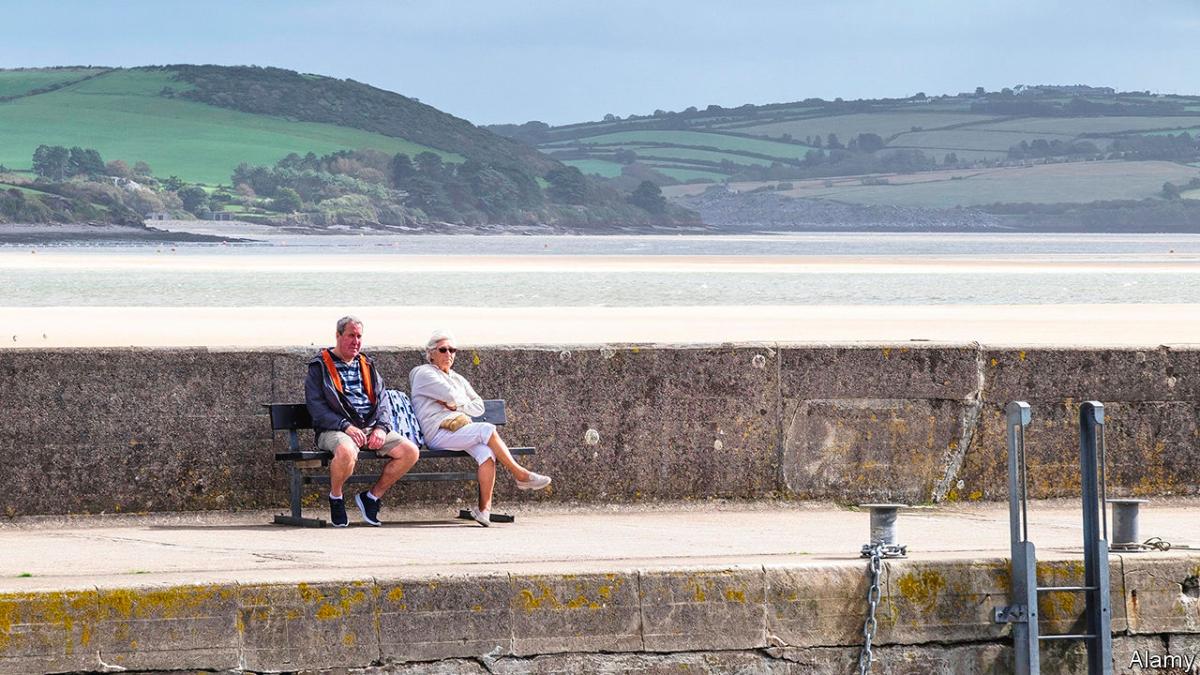

Editor’s note: Some of our covid-19 coverage is free for readers of The Economist Today, our daily [newsletter](https://my.economist.com/user#newsletter). For more stories and our pandemic tracker, see our [coronavirus hub](https://www.economist.com/news/2020/03/11/the-economists-coverage-of-the-coronavirus)

ON A BALMY day in the half-term holidays, a local man in late middle age sits on a bench at the top of a hill in Padstow, greeting everyone who passes by. “Afternoon!” he bellows each time. “Lovely weather!” Then, “Where’ve you come from, then?” or, occasionally, “What are you up to, then?” Few have come far, and they are not up to much. This Cornish town, where every second cottage seems to have the telltale key safe of a holiday let, is nearly empty. The benches on either side of the man, who confesses to being bored by lockdown, are deserted. Hardly any boats disturb the estuary. The seagulls remain ready to pounce, but the ice-cream shops and chippies that supply their prey are mostly shut.

That could soon change. Matt Hancock, the health secretary, has warned against “big, lavish, international” holidays this summer. The government’s decision that from June 8th most incomers to Britain, including those returning from holidays, will have to self-isolate for a fortnight should boost demand for small, frugal, domestic ones. If the virus is spreading at a low enough rate, the government plans to allow much of the hospitality sector to re-open in July so long as social-distancing measures are implemented. Hordes of cooped-up city-dwellers will head for south-west England, by far the most popular destination for domestic tourists.

They may not be welcome. So far, it is the English region with the lowest number of covid-19 infections per person. Many are therefore less than keen on an influx from virus hotspots. In Padstow, a sign in the window of a fudge shop urges any holidaymakers to go back home or self-isolate in their holiday let for a week. “Don’t pop to the beach,” it reads. “Don’t nip out to watch the sunset.” A family who arrived in town for the bank holiday weekend left after being challenged by an asthmatic resident who pointed out that she had been avoiding the beach. “Why is it fair that you can treat this as a holiday?” she asked.

Cornwall faces an extreme version of the challenge confronting every place coming out of lockdown: how to save lives and livelihoods in a county where tourism supports one in five jobs. David Lockyer, who runs the National Lobster Hatchery, a conservation charity in Padstow, embodies the conundrum. “Personally I’d like to see the lockdown for quite a period of time,” he says. “People are concerned that if we open the gates up we’ll see a big wave [of infections] down here.” But the charity relies almost entirely on tourism revenue, half of which it takes between July and September. “I’m in this real dilemma.”

Many rural areas popular with tourists also have an oldish population. Almost a quarter of the inhabitants of Scotland’s Orkney Isles are aged 65 or over, compared with 13% in Glasgow. So vulnerable is the archipelago’s population that most of those on its smaller islands, such as North Ronaldsay, which is known for its seaweed-eating sheep, have not even visited the main island during the lockdown. That caution seems to be paying off: Orkney’s covid-19 death rate has been less than a tenth of Britain’s. Yet the islands, too, depend on the income from visitors. Crispin Worthington, an 80-year-old who has been self-isolating with his wife in a fishing village, accepts that an influx of outsiders could mean a longer period of confinement for them. Still, he says, “money from tourists is necessary for Orkney”.

Sooner or later, Padstow will have to open up too. Rick Stein, a celebrity chef, employs 650 people there, about two-thirds of whom live in or near the town. All have been furloughed since his four restaurants, cookery school and holiday accommodation shut. His son, Jack, explains that the company loses money from November to April, making the next few months particularly crucial. “We’re just hoping we get some of the summer,” he says. But he is aware that the topic is a touchy one. He stresses that the family will canvass locals’ views and take government advice before reopening. “We don’t want to be seen to be profiting from tragedy.”■

This article was downloaded by calibre from <https://www.economist.com/britain/2020/05/30/holiday-resorts-need-tourists-but-dont-want-them>

|  |  |  |  |
| --- | --- | --- | --- |
| Previous | Articles | Sections | Next |

|  |  |  |  |
| --- | --- | --- | --- |
| Previous | Articles | Sections | Next |

#### Bagehot

# Dominic Cummings and Boris Johnson: united by a shared contempt for rules

Both believe that great men ought to be free of everyday restrictions

May 30th 2020 |

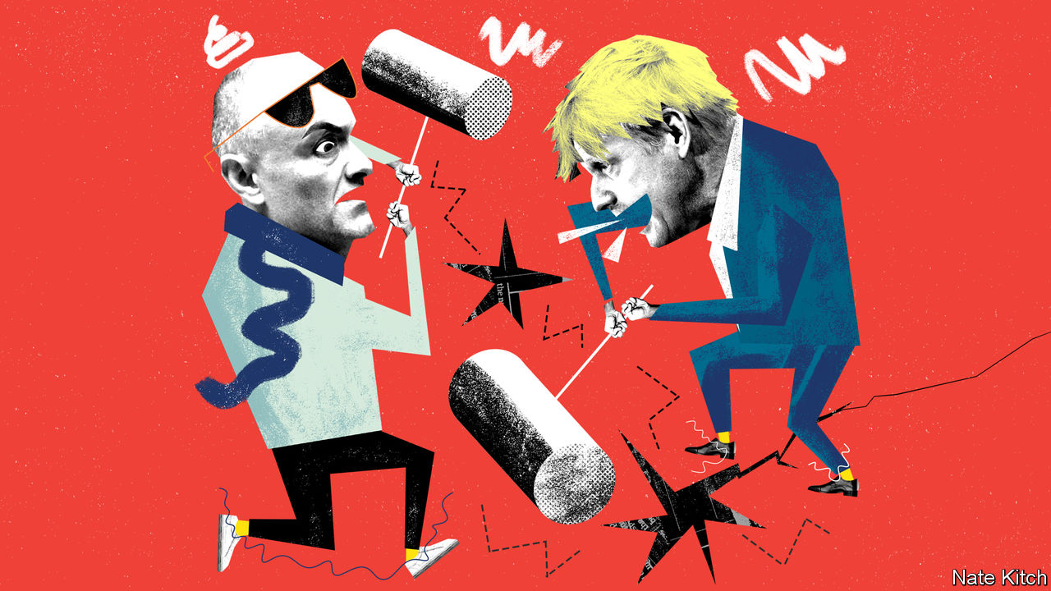

SENIOR ADVISERS are supposed to act as lightning conductors for their bosses. Dominic Cummings is a lightning generator. He has repeatedly produced sparks that have badly singed Boris Johnson—by arguing that Parliament should be prorogued, picking fights with every institution in the land and trying to hire an infant eugenicist as a Downing Street adviser. But nothing he’s done has matched his decision to drive his family 270 miles north during the lockdown, defying the government’s slogan at the time, “stay home, protect the NHS, save lives”, that he helped devise.

On May 25th Mr Cummings tried to defuse the crisis by conducting an hour-long press conference in the Downing Street garden. But like so much that Mr Cummings does his intervention only added to the brouhaha. Why was the prime minister allowing a back-room aide a platform that is usually reserved for visiting dignitaries? Why did Mr Cummings’s account of his movements, which involved the bizarre claim that he took a side-trip from Durham to Barnard Castle to test his eyesight, make so little sense?

Britain is obsessed by the Cummings affair because it turns on two things that are noxious in all democracies, but doubly so in one as class-obsessed as Britain: entitlement and hypocrisy. Caroline Nokes, one of many Tory MPs who have criticised Mr Cummings, proclaimed that “there cannot be one rule for most of us and wiggle room for others”. Metro, a middle-of-the-road newspaper, splashed “stay elite” on its cover, a play on the government’s new slogan, “stay alert”. Mr Johnson’s approval rating has fallen by 20 points since the scandal broke.

The government calculates that this storm will eventually blow over. Mr Johnson has an 87-seat majority and does not have to face the electorate for another four years. There will be plenty of dramas between now and then. But the story is nevertheless revealing about the nature of the two men who sit at the apex of British government and the bond that unites them. Both have a long-standing habit of breaking rules whenever it suits them. Both are pseudo-populists who see the masses as bit players—rather like the extras in “Ben Hur” or “Spartacus”—in a world that is largely made by great men. Even if this incident burns itself out, their peculiar project will eventually be torn apart by its internal contradictions.

Mr Cummings has spent his life in politics breaking things—big things like Britain’s membership of the European Union, but also small things like rules and regulations. He was declared in contempt of Parliament for refusing to appear before the House of Commons committee of privileges over his leadership of the Vote Leave campaign. David Cameron called him a “career psychopath” and refused to allow him to continue to work for Michael Gove as a special adviser. A senior civil servant dubbed him a “mutant virus”. A prominent Tory MP settled for “an unelected foul-mouthed oaf”.

This enthusiasm for breaking rules is the result of intellectual conviction. Mr Cummings’s blog is, among other things, an essay on why the rules that bind lesser mortals should not apply to him. He argues that history is driven forward by high-IQ mavericks who can see a new world gestating in the womb of the old. He is in awe of great scientists and mathematicians who revolutionise entire intellectual fields. But his own role models are Promethean statesmen who create new political orders—Bismarck is a particular favourite—or visionaries within government who create high-performance organisations free from the chains of bureaucracy. This champion of populism is, in fact, engaged in a mission to turn Britain into a “meritocratic technopolis”, as he puts it. Mr Cummings takes particular pleasure in quoting William James’s dictum: “When superior intellect and a psychopathic temperament coalesce...we have the best possible conditions for the kind of effective genius that gets into the biographical dictionaries.”

Mr Johnson has been equally keen on breaking rules. He was sacked by the editor of the Times for making up a quote and by the leader of the Conservatives for lying about an affair. He has fathered an unspecified number of children. When he worked as a freelance car-reviewer for GQ magazine his editors complained about the ridiculous number of parking tickets he acquired. Conrad Black, the proprietor of the Spectator when he was the editor, described him as “ineffably duplicitous”.

Mr Johnson’s critics smell an Etonian sense of entitlement in all this. Yet one of the most striking things about Mr Johnson is his willingness to upset his own class in pursuit of his personal ambitions. If the leadership of the Conservative Party were still determined by the magic circle of establishment grandees who ruled it in the 1950s, rather than the 150,000 or so Daily Telegraph readers who make up the party’s membership, he would still be lounging on the backbenches. Helen Thompson, a Cambridge academic, has called him “a pagan whose singular character and embrace of risk sets him apart from his caste.”

## Better to be an actor than a critic

Mr Johnson shares Mr Cummings’s enthusiasm for great men who are willing to make big bets. In his biography of Churchill he celebrates his hero’s combination of genius and “death-defying self-belief”. Yet there is a difference. If Mr Cummings wants to change the world, Mr Johnson simply wants to put himself in charge of it. As he writes of Churchill: “His enemies detected in him a titanic egotism, a desire to find whatever wave or wavelet he could, and surf it long after it had dissolved into spume on the beach…”

One of the problems with this vision is that it is hard to reconcile with the humdrum work of running a government. A willingness to break rules may serve you when you’re trying to up-end the old order but it becomes a problem when you’re trying to administer a new one. This is particularly true if you’re engaged in a fight against a plague that demands everybody should obey the same rules, regardless of whether or not they are “the kind of effective genius that gets into the biographical dictionaries”. ■

Editor’s note: Some of our covid-19 coverage is free for readers of The Economist Today, our daily [newsletter](https://my.economist.com/user#newsletter). For more stories and our pandemic tracker, see our [coronavirus hub](https://www.economist.com/news/2020/03/11/the-economists-coverage-of-the-coronavirus)

This article was downloaded by calibre from <https://www.economist.com/britain/2020/05/30/dominic-cummings-and-boris-johnson-united-by-a-shared-contempt-for-rules>

|  |  |  |  |
| --- | --- | --- | --- |
| Previous | Articles | Sections | Next |

|  |  |  |
| --- | --- | --- |
| Britain | Sections | Business |

International

Travel after covid: Lonely planet

.

Chinese tourists: Still grounded

.

|  |  |  |
| --- | --- | --- |
| Britain | Sections | Business |

|  |  |  |  |
| --- | --- | --- | --- |
|  | Articles | Sections | Next |

#### Lonely planet

# What awaits tourists when they re-emerge from lockdown?

Covid-19 will change the way people travel

May 30th 2020 | HEATHROW AND PROVENCE

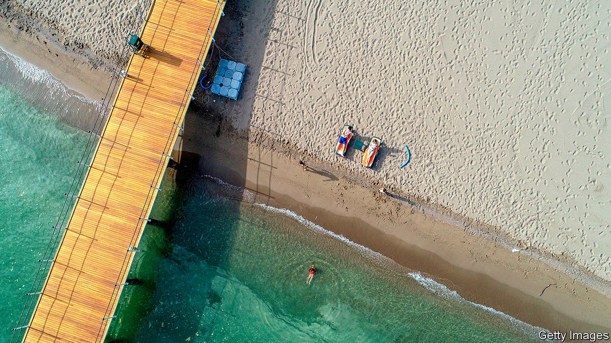

Editor’s note: Some of our covid-19 coverage is free for readers of The Economist Today, our daily [newsletter](https://my.economist.com/user#newsletter). For more stories and our pandemic tracker, see our [coronavirus hub](https://www.economist.com/news/2020/03/11/the-economists-coverage-of-the-coronavirus)

MOST STRIKING is the absence—of cars outside the building, of people inside it, of any activity at all. So astonished was Alaba, an Uber driver, as he approached Heathrow airport on a Saturday morning in May that he circled the final roundabout twice, crying, “This can’t be Heathrow.”

Inside an employee stood ready to hand out facemasks, with no one to give them to. The vast check-in hall was nearly deserted. Just one lane at security was operating. Many of the lights were off. The departures board showed six flights for the entire day.

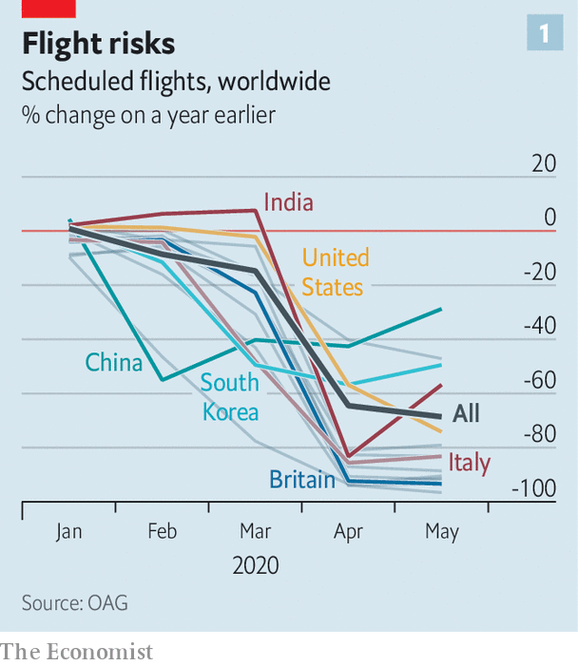

International travel has all but stopped. Borders are closed. Hotels are empty. In April last year 6.8m passengers passed through Heathrow. This April just over 200,000 did—fewer than a pandemic-less daily average. Flight movements across Europe are down by nearly 85% (see chart 1). In America the Transportation Security Administration screened 3.2m passengers in its airports last month, down from 70m during the same period last year. Some countries, such as India, stopped all road and rail transport, grounded all flights and shuttered airports. And as countries creak open, they are picking and choosing which nationalities to allow in. The old rules have gone out of the window.

And so for many 2020 will be a year without holidays. The fear of disease will keep people at home. Travel is already a luxury. Even in rich Europe, with its generous holiday entitlements, three in ten cannot afford a week’s annual holiday away from home. Those who have lost jobs or who are worried about recessions may cut travel from their budgets. For those who still dream of foreign beaches, the biggest obstacle will be getting anywhere. Many restrictions—including border closures and quarantines post-arrival—are still in place.

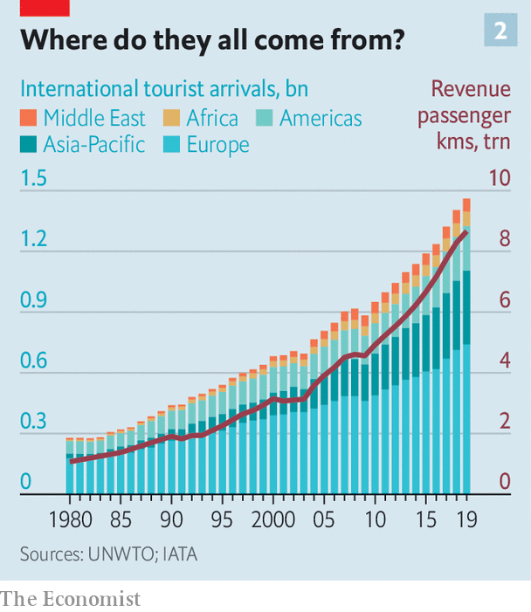

Tourism is a giant of the global economy. People went on 1.4bn foreign trips in 2018, twice the number in 2000 (see chart 2). In that time a rich-country habit became a global one. Such was the scramble to attract tourists, countries started projecting themselves as global travel brands (think Incredible India! or Epic Estonia). By the industry’s reckoning, 330m jobs—from well-paid airline pilots to tour guides and dishwashers working unseen in expensive resorts—depend on travellers. Many of those are local; about three-quarters of all tourism in rich countries is within national borders, according to the OECD, a club of mostly rich countries.

The health of national exchequers, as well as the shape of sectors from restaurants to hotels and luxury goods (which are often bought while people are on holiday), will depend on what tourism looks like when it is allowed to resume. Hotels and airlines are using the upheaval as an opportunity to rework how they function. Families are rethinking how and where they can safely take their holidays. Many of the changes will last only until a vaccine for covid-19 appears. But some will stick. How people start to travel in 2020—or 2021—will shape how they travel for years thereafter.

In normal times international tourists spend $1.6trn each year—more than Spain’s GDP. The jobs tourism creates cannot be offshored, and often appear in places where few other opportunities exist. A Barcelona bar selling sangria to a German tourist may not look like an exporter, but its impact on the national accounts is much the same as if it had shipped the bottle north. In fact as a source of global export revenues, tourism is bigger than the food or car industries.

## The travel bug

But forecasts for 2020 range from the abysmal to the apocalyptic. The UN World Tourism Organisation predicts a fall in international travel spending of $910bn-1.2trn this year. It predicts that arrivals will tumble by 60-80%. Of the 217 destinations the body tracks, 72% have closed their borders to international tourists. Europe will be hit especially hard. It receives over half of the world’s tourists every year. Most are due to arrive soon. More than other tourism hotspots, summers are vital: 59% of all tourism-related receipts in Greece are booked from July to September. Tourism is a rare example of an industry where southern Europeans outshine (and often host) their northern counterparts.

Some are taking tentative steps towards reopening. Greece and Italy hope to welcome international tourists this summer. Regional “travel bubbles” are being considered in parts of Europe and Oceania (see [Banyan](https://www.economist.com/node/21786931)). But many would-be travellers will have to stay in their own countries.

In South Korea, which never locked down entirely, three-quarters of all planned trips by air in April were domestic, compared with a tenth normally, according to Skyscanner, a price-comparison website. Around the world car-rental searches are up, too. According to Airbnb, a home-rental website, domestic bookings everywhere have more than doubled, to 30% of total reservations. Even more striking, many people are booking properties within 50 miles (80km) of where they live. Being able to drive home is useful if lockdown conditions change suddenly.

Travelling within China, which was the first country to impose a lockdown and now appears to have its outbreak largely under control, is returning to something close to normality (see [article](https://www.economist.com/node/21786898)). But even in America, which is still reporting more than 20,000 fresh cases every day, the first weekend of May saw spikes in hotel occupancy, according to Keith Barr of IHG, a hotel group that includes the InterContinental and Holiday Inn chains. “The level of demand surprised me. I didn’t think anybody would be travelling right now,” he says. Given closed borders, the demand is all domestic.

For now European leaders, from Italy to France, are hoping that locals who cannot leave will replace foreigners who cannot enter. That might work, to some extent and in some countries. But many tourist hotspots, like Iceland or Caribbean islands, have too few locals to replace absent foreigners. Malta, which each year hosts nearly six foreign visitors for every native, might get a quarter of the 2.9m tourists it attracted last year, reckons Johann Buttigieg of the Malta Travel Authority—if its borders reopen in time for summer. Residents of countries that export more tourists than they receive, such as Britain, South Korea and Germany, will struggle to squeeze onto their own beaches.

Even more “balanced” countries, like the Netherlands, will struggle to slot domestic tourists into the gap left by foreigners: a pricey Airbnb overlooking an Amsterdam canal is more appealing to a New Yorker than to a stranded Rotterdammer. Backpacker hostels, which are as charming to skint foreign youngsters as they are unappealing to locals, are in for a tough spell. Camping grounds attracting relatively local caravaners will do better.

Meanwhile, urban destinations have fallen out of favour—why go to New York if Broadway is closed? Rural getaways by contrast are in demand. IHG’s busiest hotels are ones situated by beaches. STR, a travel-research firm, says occupancy rates at some seaside spots in America’s south were as high as 60%.

That might lead to what Brian Chesky, Airbnb’s boss, calls travel redistribution: people taking trips to out-of-the-way places rather than the usual metropolises. Airbnb, which can offer rooms almost anywhere, was already banking on a trend for people to move off the beaten track and save money by shunning tourist hotspots. That trend has become turbocharged. Mr Chesky says he used to think it would take 20-30 years for travellers’ habits to change. Now he thinks it will happen in mere weeks or months.

Upending the world’s travel habits even for a few months will have long-term effects. If tourists discover the virtues of new locations, they will want to return.

People are either looking for flights far further into the future or far closer to now—not so much last-minute as last-second travel, jokes Luca Romozzi of Sojern, a travel consultancy. Booking (and paying) later will change the business model of airlines and hotels, which have long bankrolled themselves with customers’ advance payments. Worse, most travel vendors now have to agree to flexible cancellation terms if they are to attract any kind of custom.

## You can turn this world around

The economics of providing travel services will change in other ways. Making things easier to clean and reducing touchpoints will be priorities. Hotels are ditching carpets in favour of bare floors. Throw cushions are being thrown out. Restaurant menus will probably become digital or appear on chalkboards. Kitchens will offer fewer dishes, to simplify the cooking process and to avoid wasting stocked ingredients in case of more enforced closures.

Other disappearances will be more noticeable. The buffet has probably seen its last supper. Check-in will be automated. “We obviously still want to provide a welcome, but actually printing a key is just a transaction. That’s not really a welcome,” says Arne Sorenson of Marriott, the world’s biggest hotel chain. Expect mobile check-in, room keys on phones and more voice-activated room controls.

Such proposals are part of an immediate reaction to the pandemic—in-your-face health measures that form a sort of “hygiene theatre”. Countries such as Greece are selling themselves as less infected by covid-19. A Portuguese minister boasted of its wonderful nurses should travellers fall ill there, such as the one who tended to Boris Johnson, the British prime minister.

Using health and hygiene as marketing tools is a return to old form. Richard Clarke of Bernstein, a research firm, notes that an ad for Holiday Inn from the 1970s emphasised cleanliness as the chain’s main selling point, ahead of location and comfort. It will come to the fore again, to the benefit of big brands. People may put up with spartan digs if they know they have been thoroughly disinfected. Marriott now boasts of a “Global Cleanliness Council”.

Airports will also emphasise hygiene. “I think the move to minimising contact during any travel experience will just push us over the edge to having a contactless journey,” says John Holland-Kaye, Heathrow’s chief. “Once you get into the terminal, you’ll scan your passport, have an image of your face taken, drop your bags,” and then stroll through checkpoints as cameras use facial recognition to open gates.

Some of this may sound far-fetched, but citizens of some three dozen countries can already use e-gates to get through passport control on arrival at Heathrow and many other airports, allowing them to go from gate to kerb without talking to another person. Security will still involve slowing down, but even there it should soon be possible to leave laptops and liquids inside the bag. Automation will reduce the need to touch trays. Hand-sanitiser is already everywhere. Once implemented, such changes are unlikely to be undone.

By contrast the in-flight experience may change much less in the long term. Observant travellers will notice tweaks. In-flight magazines will probably disappear. Meal services may be reduced to bags of snacks and bottles of water for a while.

## Stuck in the middle with you

But crucial things—such as the middle seat on airplanes—will not disappear. Airlines are clear that it would destroy their business model, which requires around two-thirds of seats to be filled to make a profit. “We don’t think it is necessary and either we don’t fly or we have to increase prices by 45-50%, or 100% for some” airlines, says Alexandre de Juniac of the International Air Transport Association, aviation’s main trade body. Lower fuel costs will help somewhat with operational expenses, but airlines also have high fixed costs.

Instead, Mr de Juniac advocates a globally co-ordinated system of checks and safety measures that include health declarations from passengers, temperature checks at departure and arrival points, widespread use of facemasks and enhanced cleaning of aircraft. Some of these changes will endure and could increase costs. Adding several cabin cleanings a day will reduce the number of flights a single plane and crew can fly. This is particularly harmful to low-cost airlines, whose business models rely on quick turnarounds.

Not all these changes will be universal. People have diverse tastes, different reasons to travel and varying appetites for risk. Budgets also dictate their choice of destination and activity. Americans who might have gone to the Caribbean will have to make do with Florida. Chinese luxury-shoppers can turn to high-end malls at home. But Scottish sun-seekers or Saudis escaping the desert summer will want to get back on planes. The poshest travellers, who can afford first-class flights and private suites, will have less reason to fear disease. Places that appeal to a mostly younger crowd will probably function as close to normal as possible within governmental guidelines. Nobody wants to go to a socially distanced nightclub.

Giant cruise-liners carrying thousands of often-old people will take longer to recover their appeal—if they ever do. They guaranteed a steady flow of visitors to islands with few other sources of hard currency. A dozen countries rely on tourism to generate over 60% of their export income, according to the UN’s parasol counters, all of them renowned for their beaches. The Caribbean has seen a slew of credit-rating downgrades as a result. If travel curbs do not ease before the crucial winter season, downgrades will translate into defaults.

Much attention has been lavished in recent years on the problems of overtourism for a handful of superstar cities such as Venice and Barcelona. But most destinations have found a happy balance between tourism and normal life. It is those places that will feel its absence hardest. As Mr Buttigieg says, speaking from a deserted Malta, “Nobody realised how important tourism was until it was gone.” ■

This article was downloaded by calibre from <https://www.economist.com/international/2020/05/30/what-awaits-tourists-when-they-re-emerge-from-lockdown>

|  |  |  |  |
| --- | --- | --- | --- |
|  | Articles | Sections | Next |

|  |  |  |  |
| --- | --- | --- | --- |
| Previous | Articles | Sections | Next |

#### Still grounded

# How China emerges from lockdown will affect global tourism

Will footloose Chinese shoppers still feel welcome abroad?

May 30th 2020 |



YOU CAN wave to the giant Mickey Mouse mascot, but not get close enough for a jolly selfie. Such are the rules at Disneyland Shanghai, which reopened on May 11th. Visitor numbers are capped at 30% of the sprawling park’s capacity. Meanwhile the Forbidden City in Beijing can now take only 5,000 visitors a day, just 6% of its normal cap.

China is leading the way out of travel lockdowns—but still largely within its own borders. Over the Labour Day weekend at the start of May, some 115m Chinese went on domestic holidays, a healthy 60% of last year’s number. Capacity on Chinese domestic flights was down by only 10% year-on-year in the first week of May. But foreign flights are still rare: each carrier gets one flight to every destination once a week.

Whether—and how fast—the Chinese rediscover their yen for venturing abroad matters a lot to the rest of the world. Once a tourism tiddler, China is now a giant: no country sends more tourists overseas. The surge of Chinese travellers accounts for a quarter of the rise in global spending on tourism since 2000. The 150m foreign trips by mainlanders (including to Hong Kong and Macau) in 2018 added up to 10% of all global departures, up from 1% in two decades. China is also now the fourth most-visited country behind France, Spain and America.

Purveyors of services beyond aviation and accommodation depend on it. Chinese tourists spend lavishly on overseas jaunts, around double the global average. Last year they accounted for 81% of South Korea’s duty-free sales. Over a third of all the luxury baubles sold by the likes of Louis Vuitton and Gucci are bought by Chinese splurgers, according to Bain, a consultancy. And over two-thirds of that is overseas, notably in Europe. If tourism sags, posh stores there will lose custom to luxury shops in China (despite selling the same stuff more cheaply).

Gloria Guevara of the World Travel and Tourism Council, a trade body, says Chinese may feel a whiff of stigmatisation thanks to the pandemic. “I think the Chinese will continue to travel and will travel internationally at the right time [but] at the beginning will want to travel to countries where they feel more welcome.” Alternatively, once the virus has largely been eradicated at home, Chinese tourists may decide that they are less keen to visit places where the contagion may still be lurking.

Editor’s note: Some of our covid-19 coverage is free for readers of The Economist Today, our daily [newsletter](https://my.economist.com/user#newsletter). For more stories and our pandemic tracker, see our [coronavirus hub](https://www.economist.com/news/2020/03/11/the-economists-coverage-of-the-coronavirus)

This article was downloaded by calibre from <https://www.economist.com/international/2020/05/30/how-china-emerges-from-lockdown-will-affect-global-tourism>

|  |  |  |  |
| --- | --- | --- | --- |
| Previous | Articles | Sections | Next |

|  |  |  |
| --- | --- | --- |
| International | Sections | Finance & economics |

Business

Chinese diaspora Inc: High-wire act

.

Asian business dynasties: Godfathers depart, too

.

Energy companies: Don’t worry, it’s all under control

.

Information technology: AI manoeuvres

.

Bartleby: From BC to AD

.

Carmaking: Kiss and make up

.

The grooming business: Things get hairy

.

Schumpeter: The warehouse king

.

|  |  |  |
| --- | --- | --- |
| International | Sections | Finance & economics |

|  |  |  |  |
| --- | --- | --- | --- |
|  | Articles | Sections | Next |

#### Chinese diaspora Inc

# South-East Asian tycoons’ high-wire act

Ethnic-Chinese business dynasties contend with competing demands from their adopted homes and their newly assertive ancestral land

May 30th 2020 | SINGAPORE

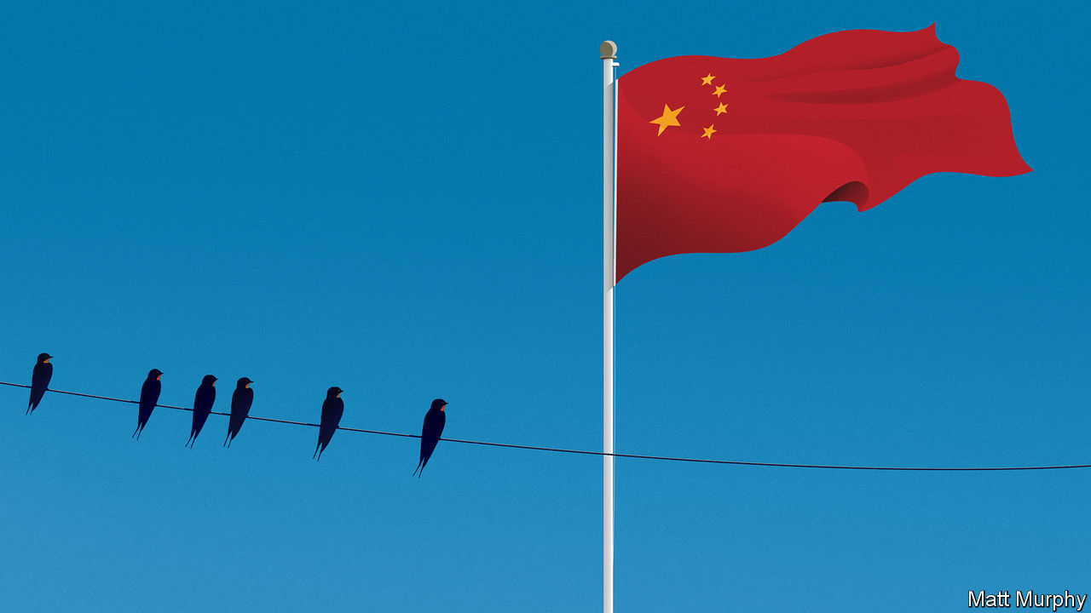

IN 1919 CHIA EK CHOR moved to Bangkok and set up a small shop importing seeds from his home Chinese province of Guangdong. Two generations later the business, Charoen Pokphand (CP) Group, is Thailand’s pre-eminent conglomerate, peddling everything from chickens and pigs to cars and phones. The founding patriarch, who died in 1983, adopted a Thai version of the family name, Chearavanont. But he maintained a deep affection for his ancestral home. When recited in Mandarin, the first characters of his four sons’ names—Zhengmin, Daimin, Zhongmin, Guomin—spell out “fair, great China”.

The family’s bonds with China are not just emotional. Two-fifths of CP’s $68bn in annual revenues come via hundreds of Chinese subsidiaries running animal-feed factories, supermarkets and much else besides. CP holds a big stake in a Chinese technology-and-insurance giant, Ping An. And it is a favourite partner of Chinese investors in Thailand, including SAIC, a carmaker with which CP makes fancy MG sports cars and pickups.

The Chearavanonts’ past and present mirror those of other wealthy ethnic-Chinese clans in South-East Asia. Although they make up less than 10% of the region’s 650m or so people, they dominate swathes of its $3trn economy. Many have prospered thanks to familial ties with China—and vice versa. “China cultivates them and they cultivate China in turn,” says George Yeo, a former foreign minister of Singapore.

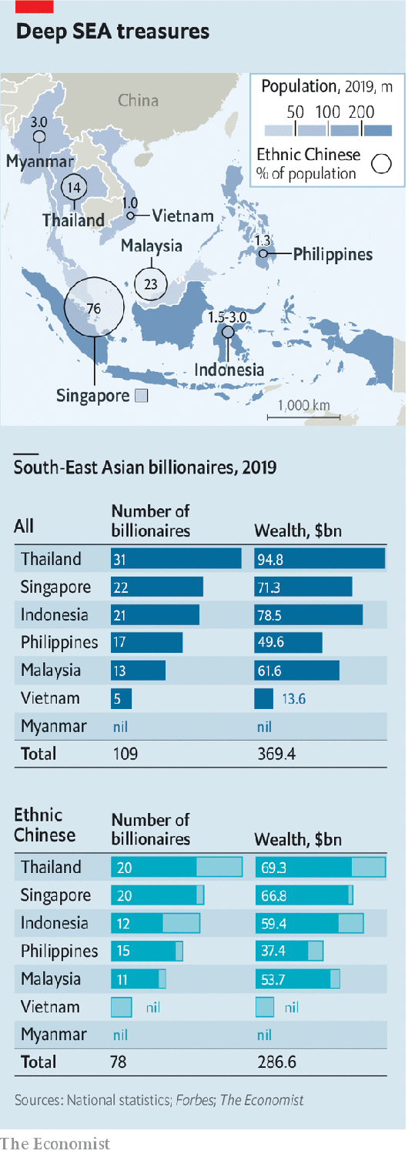

According to The Economist’s analysis of data from Forbes magazine, last year more than three-quarters of $369bn in South-East Asian billionaire wealth was controlled by huaren (a Mandarin term for “overseas Chinese” who are citizens of other countries). A lot resides in Singapore, a rich majority-huaren city-state. But plenty is spread from Indochina and Indonesia to the Philippines (see chart).

Malaysia’s Robert Kuok oversees an empire that spans everything from sugar to Shangri-La hotels. In Indonesia Lippo Group, owned by the Riady family, is active in banking, property and health care. On last year’s list 15 of 17 Filipino billionaires were ethnic Chinese; SM Group, run by the Sy clan, has high-end malls across China. Myanmar is too poor for billion-dollar fortunes, but many of its leading businessmen are Chinese-Burmese, like Serge Pun of Yoma, a property-to-banking concern, or Aik Htun of Shwe Taung Group, with interests in infrastructure and real estate.

These businesses have helped the region become China’s largest trading partner this year, surpassing the European Union. Slowing globalisation and anti-Chinese sentiment in the West—worsened by China’s early mishandling of covid-19 and now its power grab in Hong Kong (see article)—create an incentive for huaren and China to tighten their bonds.

It won’t be easy. President Xi Jinping’s ill-defined “Chinese dream” project to revive China’s greatness demands more fealty from the diaspora. At the same time the huaren’s adoptive polities are growing a bit more suspicious of their huge neighbour to the north. Forging new commercial ties in the land of their ancestors without drawing fire at home will require every ounce of the huaren’s famed political skills.

Although Chinese settlers first arrived in South-East Asia in the 15th century, many founders of today’s top huaren business dynasties fled south to escape poverty and violence in the early 1900s. Most assimilated culturally and, like Chia, took local names. They prospered first as traders, then in some cases by cosying up to power. Liem Sioe Liong of Salim Group, a noodles-to-finance conglomerate, enjoyed famously close ties with Suharto, Indonesia’s dictator from 1967 to 1998, picking up lucrative monopolies and licences in areas from flour-milling to clove imports.

Around the region such links helped the tycoons build vast, vertically integrated groups as Asia boomed in the 1990s. Together these constituted what has sometimes been described as a “bamboo network” of firms with Chinese roots, united by Confucian values of diligence and thrift. Trading and feuding with one another in turn, their bosses ended up dominating industries from farming to finance.

They also benefited mightily from China’s opening up. When this process began in the 1980s China’s Communist leaders turned to huaren tycoons for money and expertise. If Western capital played a part in China’s rise, diaspora investment mattered as much. In 1979 CP became the first foreign enterprise to set up in the Shenzhen special economic zone, where businesses could toy with a freeish market. As well as selling sugar, Mr Kuok soon began opening Shangri-La hotels in China, offering comfy, familiar rooming to business travellers. He now runs dozens of them there. Genting Group, another huaren house from Malaysia, is building a fancy hotel for China’s winter Olympics in 2022. All the while, China has been buying South-East Asia’s commodities, like rubber and palm oil, often from huaren groups. Indonesia’s Sinar Mas, run by the Widjaja family, is among China’s largest paper suppliers (it also sells instant noodles and protein bars).

Today China wants to move beyond such basics, says John Riady, whose grandfather, Mochtar, founded Lippo (which derives a fifth of its sales from China). Mr Riady, who heads the group’s property arm, speaks of a new stage in relations between China and ancestrally huaren businesses like his. China covets upscale investments, especially from companies with advanced technology. And huaren firms see Chinese tie-ups as a source of new ideas.

## Nesting behaviour

Take CP. It has built a gigantic state-of-the-art poultry-processing plant outside Beijing, where millions of fowl are minded by robots. Suphachai Chearavanont, the Thai group’s (third-generation) chief executive, says it has poured roughly $400m into Chinese startups in areas like biotechnology, data and logistics. Lippo has taken a small stake in Tencent, a Chinese internet giant.

As China has grown richer the huaren have also sought to bring Chinese investment back home. CP has struck deals with giants such as China Mobile, which bought a minority stake in the Thai firm’s mobile division. CP’s digital-payments business counts Ant Financial, an arm of Alibaba, the biggest of China’s technology titans, among its shareholders. Ant has also teamed up with Emtek, a media group controlled by Eddy Sariaatmadja, another huaren, to invest in mobile-payments and e-commerce businesses.

Chinese money is flowing to a new generation of huaren, too. Grab and Sea Group, two Singapore-based technology “unicorns” founded by ethnic-Chinese entrepreneurs, have been backed by Didi Chuxing, a ride-hailing firm, and Tencent, respectively. Alibaba has invested in Tokopedia, an Indonesian tech darling with huaren co-founders.

China is also pouring cash into South-East Asian infrastructure, as part of Mr Xi’s Belt and Road Initiative (BRI). Most BRI projects are built by Chinese state firms, but that still leaves opportunities for sharp-eyed locals. In Indonesia the Riadys are working with Chinese partners to erect an $18bn township outside Jakarta, next to a planned Chinese-built high-speed railway. In Myanmar Yoma’s Mr Pun is overseeing the construction of a new city outside the commercial capital, Yangon, with Chinese help. CP will soon begin laying big new tracks in Thailand with China Railway Construction Corporation. Although Chinese private lenders are, in the words of one tycoon, “very stingy” when it comes to bankrolling non-Chinese firms abroad, different rules are said to apply to Mr Xi’s pet projects. One “branded ‘BRI’ is more likely to get money”, says Mr Pun.

Such initiatives—and commercial ties with China more broadly—now draw more attention from the huaren’s home countries, not all of it positive. South-East Asian Chinese have long been accused of divided loyalties. After the Asian crash of 1997, when some overindebted groups folded leaving legions of unemployed, anger at the huaren-dominated monied elite sometimes boiled over into violence. In 1998 native Indonesians’ calls to curb KKN—short for “corruption, collusion and nepotism” in the local vernacular—led to race riots directed at ethnic-Chinese businesses.

Mercifully, ugly incidents like those are no longer common. But huaren wealth still breeds resentment. Malaysia’s long-standing bumiputera (“sons of the soil”) system of quotas and subsidies favouring poorer ethnic Malays did not stop some of the predominantly Muslim majority from launching a nasty “buy Muslim” campaign against ethnic-Chinese-owned businesses last year. Around the same time Indonesian security forces stymied a plot to bomb Chinese business centres in Jakarta. As the region grapples with deep coronavirus recessions, Chinese minorities could again become the object of popular ire.

Besides averting a backlash from their compatriots, huaren tycoons dealing with China must also take care not to upset Beijing. First Pacific, a financial firm partly owned by Salim Group, learned this the hard way when Albert Del Rosario, a Filipino former diplomat, flew to Hong Kong last year to attend its board meeting. A critic of China’s political system, Mr Del Rosario was turned back at Hong Kong’s airport. He subsequently resigned from the board.

During political unrest against Hong Kong’s Beijing-backed government last year, CP’s elderly patriarch (and Mr Suphachai’s father), Dhanin Chearavanont, took an unusual step and ran front-page ads in three Hong Kong newspapers condemning weeks of “violence and turmoil” caused by street protests. Many Hong Kong tycoons had been cajoled into making similar declarations. But the fact that a normally tight-lipped Mr Dhanin, who is semi-retired, did so may be seen as evidence of how sensitive dealing with China has become.

“We all need a kind of foreign policy to deal with big countries like China,” says Mr Riady, referring to big South-East Asian business houses like his own. Striking the right balance between their adopted countries and the ancestral land has been complicated further by Mr Xi’s designs for the diaspora. The Overseas Chinese Affairs Office was recently folded into the Communist Party’s shadowy United Front propaganda division. Many suspect that Mr Xi wants to muddy the distinction between huaren and huaqiao (Chinese nationals living abroad). Some huaren business leaders are handed roles on Chinese state bodies, such as the Chinese People’s Political Consultative Conference, a talking shop. Politicians in South-East Asia worry in private about “influence operations” from Beijing.

In fact, ties between China’s state and diaspora businesses are mostly the result of happenstance, not a master plan. Many tycoons, for instance, have roots in the southern province of Fujian. A hive of entrepreneurship and Mr Xi’s former fief as provincial leader, it is the perfect place to nurture relations with China’s business and political power-brokers. And for every affectionate Chearavanont there is a tycoon critical of China, whose ancestors fled persecution or revolution.

Some tycoons think that Chinese links make life easier. “Of course it helps,” says one. “It builds trust. We are all huaren after all.” Mr Yeo, who until recently worked at Kerry Logistics, part of the Kuok empire, sees “ethnic-Chinese businesses overseas benefiting hugely from China’s growth”.

Others deny Chinese heritage provides a business edge, and see themselves solely as Indonesians or Malaysians. “Chineseness” is seldom the main reason why one foreign firm makes money in China and another does not, says Marleen Dieleman, a scholar of family businesses at the National University of Singapore.

## Flying the coop

Indeed, most huaren are pragmatists who see a Chinese family history as useful but not predestining. Many are thinking beyond China. Their groups have become integrated into the world economy. CP employs 325,000 workers in 21 countries and, says Mr Suphachai, no longer recruits executives mostly from Bangkok’s bustling Chinatown but from elite American and Chinese universities. He boasts of foreign tie-ups from Japan to Britain. CP is expanding at home, too. In March it bought Tesco’s Thai and Malaysian supermarkets for $10.6bn. Mr Riady says Lippo is today best compared to multinationals like Ford or Goldman Sachs, which thrive in China without cultural connections.

This is more important now that many patriarchs are passing on (see article). The younger generation, mostly educated in America and speaking patchy Mandarin, may find it harder to flit as deftly between their ancestral and adopted homes. Still, scions of huaren dynasties inherit connections and, often, commercial acumen—as well as caution. Salim Group’s founder, who died in 2012, liked to cite a Chinese proverb that “tall trees attract the wind”. As Chinese influence blows across South-East Asia, expect its business empires to watch their sprawling canopies carefully.■

This article was downloaded by calibre from <https://www.economist.com/business/2020/05/30/south-east-asian-tycoons-high-wire-act>

|  |  |  |  |
| --- | --- | --- | --- |
|  | Articles | Sections | Next |

|  |  |  |  |
| --- | --- | --- | --- |
| Previous | Articles | Sections | Next |

#### Godfathers depart, too

# Why Asian business dynasties struggle with succession

Stanley Ho, a Macau casino magnate, who died on May 26th, aged 98, offers clues

May 30th 2020 |



MACAU WILL become the “Las Vegas of the Far East”, predicted Sheldon Adelson, an American casino magnate. In 2019 the Chinese territory’s $30bn in annual casino revenue was five times Vegas’s. Despite a slump in turnover this year as covid-19 emptied parlours, Macau’s rise looks poised to resume. It owes much to Stanley Ho, the charming scion of an illustrious Hong Kong clan. Thanks to the monopoly gambling licence he secured from Macau’s former Portuguese administrators in 1961 and held until 2002, STDM, his family’s main holding company, grew into Asia’s largest gambling empire.

Mr Ho died on May 26th, aged 98, leaving behind 14 children and a $6bn-plus fortune. A decade ago his last wife fought a bitter public battle against his second and third wives for control of SJM Holdings, the group’s publicly traded arm. His elder children joined the acrimonious spat, which ended in a truce.

Many Asian firms face similarly complex successions. Family concerns make up over half of all big businesses in Asia. Other recently departed patriarchs include Eka Tjipta Widjaja of Indonesia’s Sinar Mas Group, Henry Sy of SM Group in the Philippines and Shin Kyuk-ho of South Korea’s Lotte Group. Many other businesses have ageing leaders. Experts foresee a wave of turbulence.

Many patriarchs fear that anointing an heir apparent would weaken their grip on power or bring bad luck. Because Asian business dynasties tend to be quite new, many lack the institutional structures of European or American ones.

A deeper problem is their relationship-based management model. Bosses cultivate a personal rapport with politicians and financiers, which does not easily transfer from one generation to the next. Joseph Fan of the Chinese University of Hong Kong finds that family firms in Hong Kong, Singapore and Taiwan lose some 60% of their value during generational transitions.

Some of Asia’s geriatric bosses are keen to avoid this fate. Before retiring two years ago, Li Ka-shing, the 91-year-old doyen of corporate Hong Kong, simplified his web of businesses. He gave one of his sons clear control of CK Hutchinson Holdings and CK Asset Holdings, which contain most of his empire.

This article was downloaded by calibre from <https://www.economist.com/business/2020/05/30/why-asian-business-dynasties-struggle-with-succession>

|  |  |  |  |
| --- | --- | --- | --- |
| Previous | Articles | Sections | Next |

|  |  |  |  |
| --- | --- | --- | --- |
| Previous | Articles | Sections | Next |

#### Don’t worry, it’s all under control

# How big oil is trying to win back investors

Supermajors claim their prospects are not as bleak as they seem

May 30th 2020 | NEW YORK

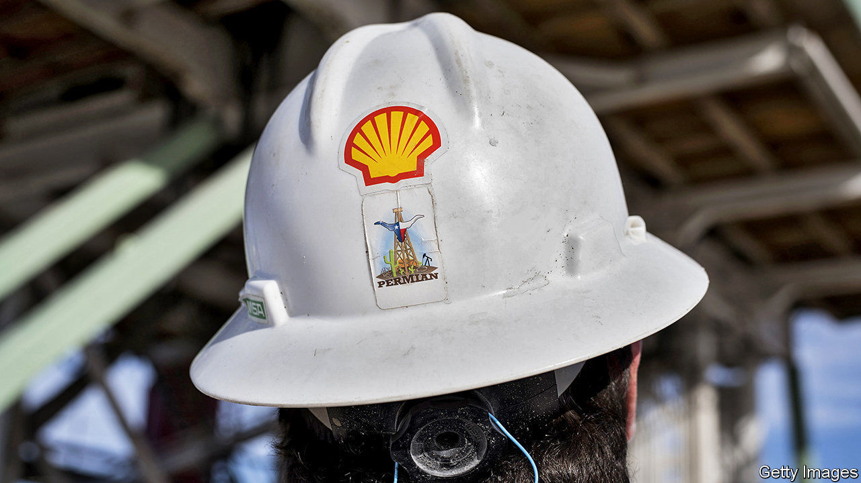

THE ANNUAL shareholder meetings of ExxonMobil, Chevron and BP, all held on May 27th, each resembled a yearly check-up in a burning clinic. Covid-19 has caused the deepest collapse of demand for the oil giants’ products in history. In April Royal Dutch Shell, an Anglo-Dutch firm, cut its dividend for the first time since the second world war. On May 1st ExxonMobil reported its first loss since the mega-merger that formed the group in 1999.

Even before the pandemic investors were searching elsewhere for lower risk and higher returns. Energy was the worst-performing sector in the S&P 500 index in four of the past six years. Yet the supermajors argue that, for all that, their prospects aren’t bad.

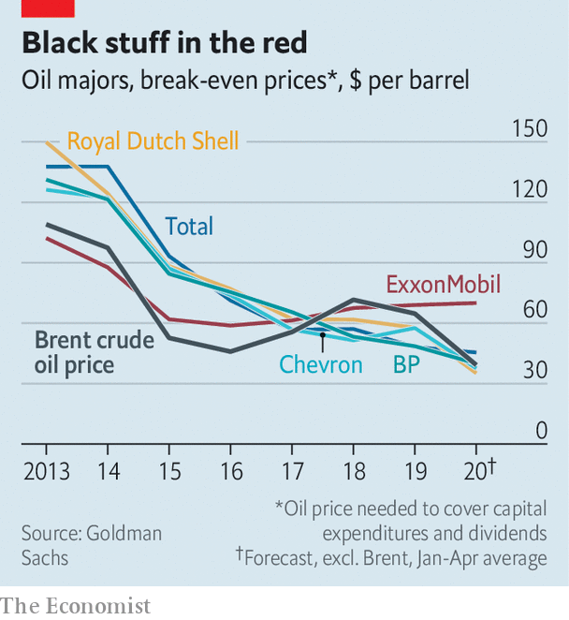

They have half a point. Many of them have become more resilient since the last downturn, in 2014, pursuing more profitable projects and cutting costs. The oil price required to cover capital spending and dividends for the seven biggest—ExxonMobil, Shell, Chevron, Total, BP, Equinor and Eni—is about half what it was in 2013, reckons Goldman Sachs, an investment bank (see chart).

More oil firms are also preparing for a low-carbon future. In December Repsol of Spain pledged to reach net-zero emissions from its operations and the sale of its products by 2050. BP, Shell, Eni and Total have since announced their own commitments.

Moreover, as smaller oil firms reel from the virus, particularly in America’s shale basins, bigger ones may scoop up their assets. The supermajors’ spending cuts may slow their oil production. But that is only a problem if you think there is value in production growth, says Michele Della Vegna of Goldman Sachs. If excessive growth is the problem, he says, then cuts could be part of the solution.

There are two hitches. The break-even price for some firms, though lower than it was, remains high. ExxonMobil’s stands at $70, double what oil trades at today. And it is unclear how quickly—or if—supermajors should move away from oil investments. ExxonMobil and Chevron, America’s biggest oil firms, think not. Neither has set a goal for curbing emissions from the sale of their products. On May 27th ExxonMobil’s shareholders voted against splitting the roles of chairman and chief executive. Green investors had hoped an independent chairman might spur change.

European supermajors look like Birkenstocked tree-huggers in comparison. Still, their promises are loose. Italy’s Eni said in February that its oil-and-gas production would plateau by 2025, but left wriggle room for a “flexible decline” for oil thereafter. On May 5th Total vowed to reach net-zero—but only for products sold in Europe. Shareholders will consider a resolution for more expansive goals on May 29th. BP, under pressure from activists, is working to explain how it can meet climate targets.

The firms have a way to go. Norway’s Equinor devoted about 8% of capital spending last year to renewables; Shell’s figure was 2%. Meanwhile, a new type of rival is emerging. At $68bn, the market value of Iberdrola, a Spanish utility that develops solar and wind farms, has overtaken Eni’s and Equinor’s, and is chasing BP’s. ■

This article was downloaded by calibre from <https://www.economist.com/business/2020/05/30/how-big-oil-is-trying-to-win-back-investors>

|  |  |  |  |
| --- | --- | --- | --- |
| Previous | Articles | Sections | Next |

|  |  |  |  |
| --- | --- | --- | --- |
| Previous | Articles | Sections | Next |

#### AI manoeuvres

# Business lessons from the Pentagon

How to introduce advanced technology into a stodgy organisation

May 28th 2020 | ARLINGTON

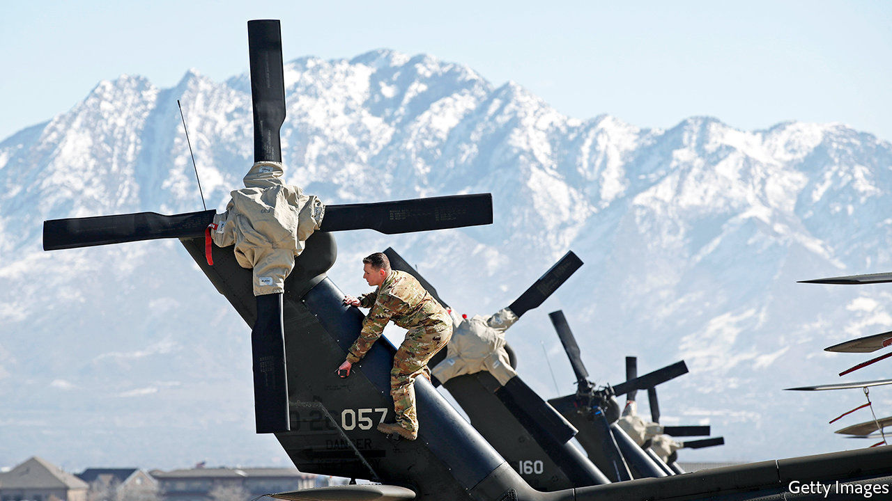

A SMALL REVOLUTION has just occurred in America’s armed forces. They have, for the first time, deployed artificial intelligence (AI) to determine when a thorough check-up of a Black Hawk helicopter is in order. The algorithm, trained on maintenance records and sensor data, calculates how long the aircraft can fly safely in, say, a desert, before its engines should be cleaned to prevent sand melting into glass that could cause them to fail.

Such predictive maintenance is the most tangible product so far of the Joint AI Centre (JAIC). With 176 employees and an expected budget of $240m next fiscal year, up from $90m in this one, it lies at the heart of an ambitious effort to use machine learning and other AI to help the Pentagon run more efficiently and keep its technological edge, especially over China.

Yet when its first director, Lieutenant-General Jack Shanahan, steps down on June 1st, JAIC’s main output will not be whizz-bang software or even weapons, but infrastructure to develop them. “I did not want to create a classic insurgency organisation, but one that survives me,” says Lieut-General Shanahan. The way he has gone about it offers a case study in how large organisations struggle to adopt advanced technology.

Like many company bosses, top brass at the Department of Defence (DoD) in recent years began feeling technologically inadequate. Not just China but Western tech giants were showing them up, in particular Google. So in 2017 the Pentagon’s Defence Innovation Board (DIB), chaired by Eric Schmidt, who was also executive chairman of Google’s parent, Alphabet, at the time, called for JAIC’s creation. A year later the DIB got its way—ironically around the same time that mostly pacifist Googlers pushed their bosses to abandon work for “Project Maven”, a DoD effort to analyse drone footage.

Things have moved surprisingly briskly since, by the DoD’s sluggish standards. JAIC ranks are set to almost double within a few years, to 300 or so. Its budget is now assured until 2025. Like many corporations flirting with innovation, it has hired outside help, recently signing its first big contract, worth $800m over five years, with Booz Allen Hamilton, an information-technology consultancy.

Booz Allen’s job will be to pull together JAIC’s IT infrastructure into something like a workbench to build AI applications. This will tap various sources of data, AI’s lifeblood, from a helicopter’s sensors to the DoD’s supply-chain software. It will provide the computing power to crunch them. And it will offer software tools that let developers create, test and run AI systems.

As many corporate bosses have learned the hard way, the best technology is not worth much without the right processes to use it. So Nand Mulchandani, JAIC’s technology chief and a noted Silicon Valley serial entrepreneur, wants the group to function a bit like a venture-capital fund. That means investing in “product teams”, internal startups of sorts, which develop prototype applications that can then be scaled up by outside contractors.

The group is still a long way from “mission accomplished”. Some problems are specific to the Pentagon. JAIC still awaits its own processing power, which has been held up by a legal challenge from Amazon; the tech giant argues that its cloud service was unfairly passed over in favour of Microsoft’s rival offering. JAIC has yet to extricate itself from the fangs of the DoD’s procurement bureaucracy: if it cannot sign its own contracts, it will not be able to move fast enough. And it must be careful not to put off private-sector partners as it moves from uncontroversial projects such as helicopter maintenance or forecasting forest fires to thornier ones. “Joint warfighting operations”, for instance, accelerate the “sensor-to-shooter” loop—the time it takes from spotting a target until it is attacked. (Google no longer seems fazed: it recently won a Pentagon contract to provide pieces of cloud software.)

Other issues will sound familiar to chief executives. Recruiting data scientists is tough; most would rather work for big tech, not big government. The DoD’s digital collections are, like many legacy corporate systems, a shambles, as the RAND Corporation, a think-tank, concluded in a recent report. Data are often thrown away or stored locally (the initial Maven drone footage had to be collected at bases on CD-ROMs). They come in all sorts of formats and are badly catalogued. As in many big companies, a chief data officer is supposed to sort these things out, but can expect resistance. “Personnel might view data as a means of retaining power,” write the RAND authors.

Lieut-General Shanahan is proud of his work. So are early JAIC supporters like Mr Schmidt. He has since left Alphabet but still chairs the DIB—and calls the general a “real American hero” for getting as far as he has. Whoever takes over at JAIC nevertheless has their work cut out—as does Mr Mulchandani, who will stand in as director until the Senate confirms a military replacement, which may take some time. As Robert Work, a tech-savvy former deputy defence secretary, puts it: “The foundation is in place; now all they have to do is execute.” Many bosses know the feeling.■

This article was downloaded by calibre from <https://www.economist.com/business/2020/05/28/business-lessons-from-the-pentagon>

|  |  |  |  |
| --- | --- | --- | --- |
| Previous | Articles | Sections | Next |

|  |  |  |  |
| --- | --- | --- | --- |
| Previous | Articles | Sections | Next |

#### Bartleby

# Working life has entered a new era

Farewell BC (before coronavirus). Welcome AD (after domestication)

May 30th 2020 |



ON MARCH 16TH Bartleby left the offices of The Economist to head home. That was the last day when all editorial staff assembled in our London redoubt. And, at the time of writing, no date for a return to the office is in sight.

It is remarkable how quickly we have adapted. The newspaper has been written, edited and produced from couches and kitchen tables. January and February seem like an ancient era—the BC (before coronavirus) to the new AD (after domestication). The shift may rival great workplace transformations in the 19th and 20th centuries. Twitter has already said that all its employees will be allowed to work from home permanently and Facebook expects half its staff to do so within a decade.

It has been a much more sudden transition than occurred with factories. Steam power meant they were designed around one great power system, complete with belts and pulleys that snaked through the building. A failure at some point in the system meant the whole thing might grind to a halt. Then electrification allowed individual machines to have their own power source. But it took half a century from the introduction of electricity in the 1880s before factories were reconfigured to take advantage of the new power source.

The current, rapid shift to AD was enabled by preconditions. First, broadband services are today quick enough to allow for document downloads and videoconferencing. Second, advanced economies revolve around services, not manufacturing. Back in the 1970s, when Britain adopted a three-day week (to combat a miners’ strike), there were power cuts and TV stations had to close down early. In other words, home life was severely affected as well. The pandemic has not turned the lights off.

Not only that, it has made remote work seem both normal and acceptable. In the past employees who stayed home had to overcome the suspicion that they were bunking off. Now those who insist on being at the office sound self-important.

Things are missing, of course. Video calls lack the spontaneity of a normal meeting; no off-the-cuff remarks to lighten the mood. Distance makes it difficult to generate camaraderie. Creativity is probably harder to foster. Octavius Black of Mindgym, a consultancy, says new ideas come from weak links in networks—ie, people you meet occasionally. Such “casual collisions” have become rarer.

Yet although offices will not disappear, it is hard to imagine that working life will return to BC ways. For more than a century workers have stuffed themselves onto crowded trains and buses, or endured traffic jams, to get into the office, and back, five days a week. For the past two months they have not had to commute, and will have enjoyed the hiatus.

Employers, for their part, have maintained expensive digs in city centres because they needed to gather staff in one place. The rent is only part of the cost; there is the cleaning, lighting, printers, catering and security on top. When you work at home, you pay for your own utilities and food.

Many businesses and employees may thus have had their “Wizard of Oz” moment: the corporate HQ is shown to be an old man behind the curtain. Faith in the centralised office may never be restored.

Another aspect of the AD era may be the disappearance of the five-day working week. Even before the pandemic many workers became used to taking phone calls or answering emails at the weekend. In the AD era the barrier between home and working life, a useful way of relieving stress, will be even harder to sustain.

It may be lost altogether. Without the Monday-to-Friday commute, the weekend seems a more nebulous concept, as does the 9-to-5 working day. In future employees may work and take breaks when they please, with the company video call the only fixture. The downside, however, is that the rhythm of life has been disrupted and new routines are needed: as Madness, a British pop group, sang about school in “Baggy Trousers”, people are reduced to “trying different ways to make a difference to the days”.

Looking further out, the AD era may bring other changes. Some may decide to live in small towns where housing costs are lower, since they have no need to commute. Men will have fewer excuses to skip cleaning or child care if they are not disappearing to the office. In a sense, this is a return to normal: until the 19th century most people worked at or close to their homes. But social historians may still regard 2020 as the start of a new age.

Editor’s note: Some of our covid-19 coverage is free for readers of The Economist Today, our daily [newsletter](https://my.economist.com/user#newsletter). For more stories and our pandemic tracker, see our [coronavirus hub](https://www.economist.com/news/2020/03/11/the-economists-coverage-of-the-coronavirus)

This article was downloaded by calibre from <https://www.economist.com/business/2020/05/30/working-life-has-entered-a-new-era>

|  |  |  |  |
| --- | --- | --- | --- |
| Previous | Articles | Sections | Next |

|  |  |  |  |
| --- | --- | --- | --- |
| Previous | Articles | Sections | Next |

#### Back to basics

# The Renault-Nissan alliance hunkers down

The fraying Franco-Japanese carmaking union wants to give it another go

May 30th 2020 |

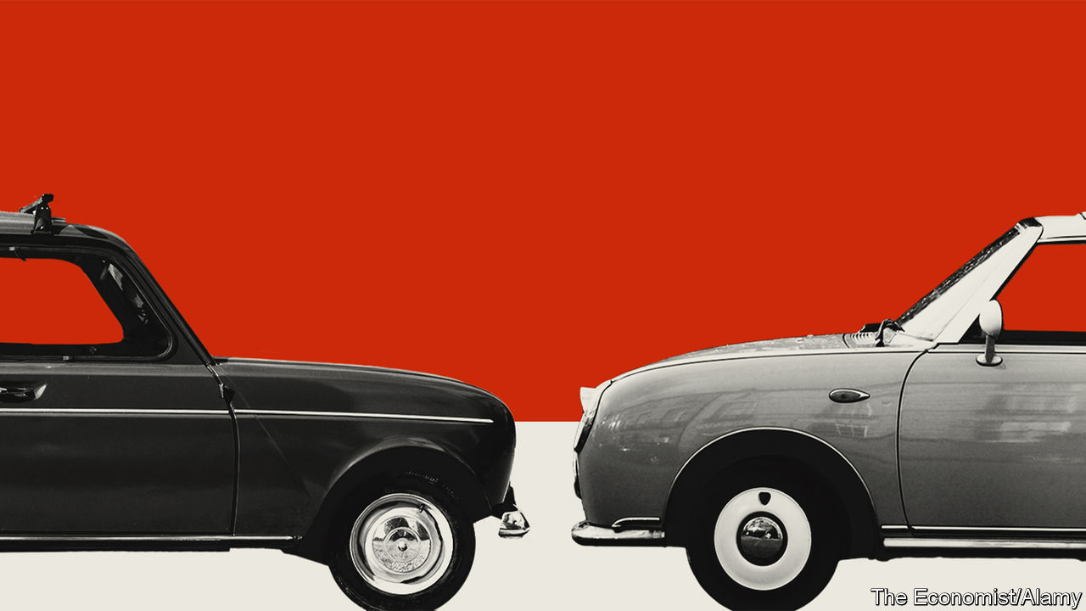

THE PANDEMIC may create a kinder, more united society. That is certainly the effect on the Renault-Nissan-Mitsubishi alliance. It has been vying for the title of the world’s biggest carmaker while teetering on the brink of dissolution. The fear that covid-19 will damage some car firms beyond repair led the union to announce on May 27th that, like a couple about to divorce rekindling lost romance under lockdown, they would give it another go.

The alliance, started in 1999, was an attempt to avoid the pitfalls of a full merger. In carmaking these had often ended in tears. But the cross-shareholdings that held Renault and Nissan together in particular bred discontent. Renault, which is French, owns a controlling 43.4% of Nissan, a Japanese firm; Nissan has a non-voting 15% stake in Renault. Nissan, recently the main source of the group’s profits, resented the French government’s sway through a 15% stake in Renault. The three firms’ engineers rarely saw eye to eye, making joint projects hard to manage. When the man who ran the tie-up, Carlos Ghosn, was arrested in 2018 in Japan, accused of financial misconduct, the end seemed nigh.

The new plan both speeds up and slams the brakes on Mr Ghosn’s ambitions. The ex-boss’s merger plans are dead, says Jean-Dominique Senard, chairman of both the alliance and Renault. So is his attempt at world domination. The alliance will put profitability before volume, a strategy that helped turn around PSA Group, Renault’s French rival. Each member will focus on becoming a regional force, not a global one: Renault in Europe, Africa and South America; Nissan in North America, China and Japan; Mitsubishi in South-East Asia.

The three firms will also cut costs, moving beyond sharing platforms, the basic underpinning of cars, to sharing parts. Mr Senard reckons that this novel approach will shave €2bn ($2.2bn) from the cost of developing a new small SUV. In a few years all this will make the alliance “the most powerful combination of companies in the world”, he says. Investors like the sound of it. Nissan’s share price gained 12.5% on the day; Renault’s shot up by 17%.

The enthusiasm may be premature. The trio has suffered from a recent downturn in the global car market and the fallout from Mr Ghosn’s arrest. Now the virus may dent industry sales by 20% this year. On May 28th Nissan reported an annual operating loss of ¥40.5bn ($372m), the first time in the red since 2009. Renault is in even worse shape. Bruno Le Maire, France’s finance minister, said it could “disappear” without state support. Renault’s own awful results may be accompanied by details, expected on May 29th, of a €5bn rescue package.

That will irk Nissan, which also announced it would reduce production capacity by 20%, close factories and diminish its range of vehicles. Renault should do the same but will have to keep factories open in France to appease its big shareholder. Luca de Meo, who successfully ran SEAT, part of Germany’s Volkswagen Group, takes over as Renault’s boss on July 1st. The former marketer will need all his powers of persuasion to keep the peace.■

This article was downloaded by calibre from <https://www.economist.com/business/2020/05/30/the-renault-nissan-alliance-hunkers-down>

|  |  |  |  |
| --- | --- | --- | --- |
| Previous | Articles | Sections | Next |

|  |  |  |  |
| --- | --- | --- | --- |
| Previous | Articles | Sections | Next |

#### Things get hairy

# The global grooming industry gets cut down to size

Itinerant hair stylists and barbers are a rare bright spot in a clobbered business

May 28th 2020 | ISTANBUL

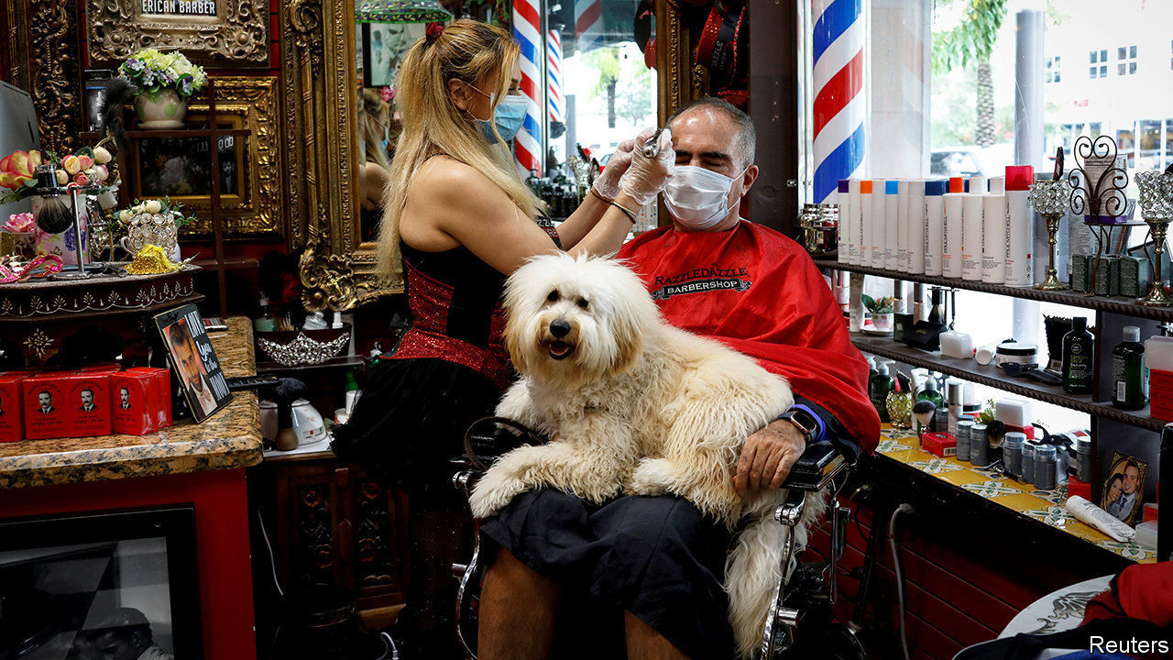

Editor’s note: Some of our covid-19 coverage is free for readers of The Economist Today, our daily [newsletter](https://my.economist.com/user#newsletter). For more stories and our pandemic tracker, see our [coronavirus hub](https://www.economist.com/news/2020/03/11/the-economists-coverage-of-the-coronavirus)

SOME THOUGHT a mirror and a pair of clippers from Amazon would do it. Some gave up after the first flesh wound. Some braved a trim by spouses or children. Now, as hair salons reopen the world over after a covid-19 hiatus, the bearded and bedraggled are flocking back to the pros. They find an industry—with annual sales of $20bn in America alone—transformed.

Social-distancing rules force hairdressers and barbers to serve fewer clients. “If we could seat ten people before, now we can only seat three,” says Cristina Solymosi, whose beauty salon in Madrid has gone from 40-50 customers a day before the pandemic to 15-20. Protective gear and disinfectant are a must. Salons, which often double as social clubs mixing gossip with endless arguments about sports and politics, may soon resemble labs.

If they survive at all, that is. Kline, a consultancy, sees a decrease of over 30% in salon revenues in a dozen big markets this year. That could kill many firms in a trade with razor-thin margins—with knock-on effects on global sales of cosmetics, perfumes and hair products, worth $500bn a year. McKinsey, another consulting firm, thinks these may decline by 20-30%.

The lockdown has spawned a market for house calls by roving covid coiffeurs, often in defiance of quarantine orders. Tahsin, a barber in Istanbul, says he has trimmed up to 15 beards a day, mostly in private homes but sometimes in abandoned depots, after Turkey’s government ordered barbershops to close. (They reopened on May 11th.) Hairdressers across Europe gripe that the rovers are poaching customers, says Jef Vermeulen, head of Coiffure EU, a trade body. “Even before the coronavirus, many of them did not respect health and safety rules,” he complains. Still, their future may be the industry’s bright spot. As salons, with higher fixed costs, go under, freelancers may pick up the slack, predicts Kline.

Some stylists were shifting to house calls before covid-19 hit. In France itinerant coiffeurs made up 8-10% of the market, says Pierre André, who runs Wecasa, an app which arranges home cuts. Hairdressers he works with are all licensed, he says; nine out of ten freelance. All must now wear masks and gloves. Wecasa paused work in March, after France locked down, and relaunched on May 11th. “That week”, says Mr André, “we received four times as many orders as in our best week on record.”■

This article was downloaded by calibre from <https://www.economist.com/business/2020/05/28/the-global-grooming-industry-gets-cut-down-to-size>

|  |  |  |  |
| --- | --- | --- | --- |
| Previous | Articles | Sections | Next |

|  |  |  |  |
| --- | --- | --- | --- |
| Previous | Articles | Sections | Next |

#### Schumpeter

# The e-commerce boom makes warehouses hot property

The warehouse king battles a master of the universe

May 30th 2020 |

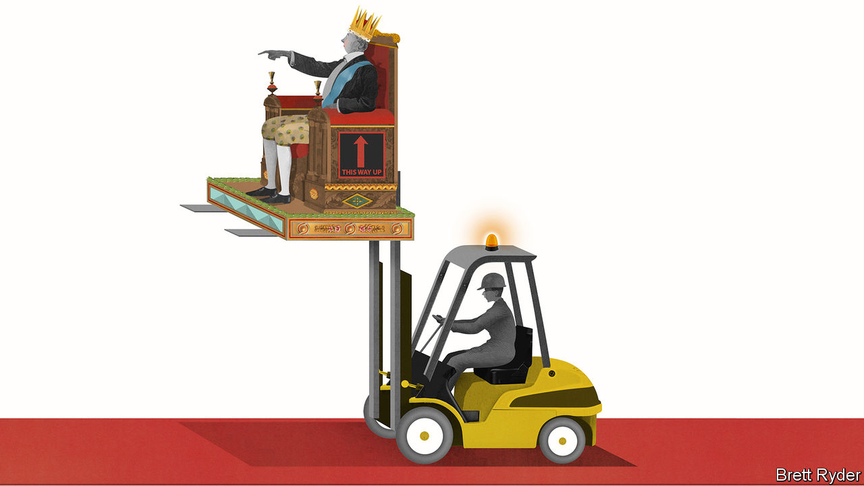

IN THE LATE 1990s Hamid Moghadam, an Iranian-born property developer, made a $5m bet on Webvan, an American online grocer. It was a bust. Webvan was one of the most spectacular casualties of the dotcom crash. More galling still, Mr Moghadam turned down the opportunity to invest in another e-commerce upstart called Amazon, thinking its focus on books was too narrow compared with groceries. Yet some people can win even by losing. Sensing a potential bounty in the online craze, the firm he co-founded, AMB, sold its portfolio of shopping centres and bought millions of square feet of warehouse space on the tarmac of American airports instead. “We got the company wrong, but we got the big trend right,” he says. Two decades later the company he heads, Prologis, is Amazon’s biggest landlord. Mr Moghadam, now 63, stands tall over the world’s warehouse business.

A Stanford graduate who got his start in property because no one else in America would hire him during the Iranian revolution, Mr Moghadam has made a career of bold bets. In 2011, with property still reeling from the financial crisis of 2007-09, he led a bumper deal to unite AMB and Prologis, a bigger rival, with a combined $46bn of owned and managed assets. Since then the property-investment firm has expanded globally. It has assets of $125bn and floor space of 1bn square feet (90 square kilometres, or a Manhattan-and-a-half). A surge of e-commerce during the covid-19 pandemic has helped underpin its share price; its market value of $68bn is just below an all-time high. Yet Mr Moghadam is not alone in realising that the humble shed can be as good an investment in the e-commerce era as shovels were during the Gold Rush. Blackstone, the world’s largest alternative-asset manager, invested more than $25bn last year in warehouses in America and Europe. It calls logistics its “highest-conviction global investment theme”. A battle over industrial wasteland is under way.

It is hard to imagine Stephen Schwarzman, Blackstone’s high-society boss, talking as passionately about the nitty-gritty of logistics as Mr Moghadam (who has a fraction of Mr Schwarzman’s wealth). Yet a contest between the king of warehouses and the baron of private equity will be worth watching. It will not just shape the future of e-commerce. It will change the urban landscape, too.

To see why, cycle, as Schumpeter did last weekend, up London’s Lea Valley, an idyll of canal boats and riverside vegetable gardens running from the graffiti-covered East End to the capital’s north. Stop at the Ravenside Retail Park, a place of shuttered stores like Mothercare, a well-known British brand, and Maplin, an electronics retailer. It is destined to become ground zero for the retail apocalypse. In January Prologis spent £51m ($68m) acquiring the site, just before covid-19 accelerated the agony of its remaining tenants. In a few years, once they, or their leases, expire, Prologis hopes to turn the area into a multistorey warehouse for e-commerce firms like Amazon. That is part of a global pattern. In America such logistics hubs are rising from the rubble of dead shopping malls.

It is easy to dismiss the warehouse business. As one industry boss puts it, investors used to think of it as “four walls and a roof that you hope doesn’t leak”—in other words, highly commoditised. Yet Mr Moghadam says it is enthralling. The first task, he says, is to decide on which end of the supply chain to be. He settled on mass consumer markets around the world rather than serving producers, because, as he puts it, “Consumers do not move, factories do.” As a result, his warehouses sit close to huge urban areas where land is scarce. It also requires patience. In America it has taken decades for e-commerce to eke out a double-digit share of retail spending. Lockdowns have turbocharged the shift. Before the pandemic about a fifth of Prologis’s warehouse construction was for e-commerce, and the rest for other forms of logistics. The e-commerce share is now as high as 40%, Mr Moghadam says.

## Storage-space race

Two other challenges for warehouse developers are ensuring customer loyalty and a stream of financing. Stockmarket analysts play down Blackstone as a threat on the first count. They say private equity’s “buy it, fix it, sell it” mentality prevents logistics firms from building the long-term relationships that enable them to move with their clients around the world. But Blackstone’s staying power should not be underestimated. It started its warehouse portfolio a decade ago. It currently owns 850m square feet of logistics space globally. It has $45bn of investor money earmarked for property transactions. Prologis says it has more than $13bn in such “dry powder”. It has also used stock in recent transactions.

The pandemic may make the warehouse business yet more attractive. As tenants struggle to pay rent, bad debts are rising. But unlike the slump a decade ago, pre-pandemic utilisation rates were high, and e-commerce increases demand for space, because online retailers must stock a wider variety of products. “This is the tightest real-estate market that I have ever seen,” Mr Moghadam says. That will put a floor under rents in the future, he believes.

That future is likely to be ever closer to large urban or suburban areas, as online retailers strive to shorten delivery times. Until recently, the trend was constrained by a lack of land and labour. Neither city officials nor workers looked favourably on warehouses. The pandemic may change that. The blight on shops and hotels will free up space. Unemployment will make logistics jobs more attractive, as Amazon has recently demonstrated.

Moreover, Prologis wants to burnish the industry’s image. To see how, cycle back down the Lea Valley to the heart of the East End, where it hopes to refurbish a listed four-storey warehouse dating back to the Victorian era. The aim is to include storage, light manufacturing, creative industries, a gym and a coffee shop. It will be solar-powered and surrounded by green space. A few decades ago abandoned industrial warehouses became trendy places to live. Those of the future may even be alluring places to work. ■

Editor’s note: Some of our covid-19 coverage is free for readers of The Economist Today, our daily [newsletter](https://my.economist.com/user#newsletter). For more stories and our pandemic tracker, see our [coronavirus hub](https://www.economist.com/news/2020/03/11/the-economists-coverage-of-the-coronavirus)

This article was downloaded by calibre from <https://www.economist.com/business/2020/05/30/the-e-commerce-boom-makes-warehouses-hot-property>

|  |  |  |  |
| --- | --- | --- | --- |
| Previous | Articles | Sections | Next |

|  |  |  |
| --- | --- | --- |
| Business | Sections | Schools brief |

Finance & economics

Private equity (1): More money, more problems

.

Private equity (2): From locusts to honey bees

.

Monetary policy in China: The thin red line

.

Buttonwood: The inflation bug

.

A change of plan: China's growth target

.

Carmen Reinhart: No fear of floating

.

Economic statistics: Crisis measures

.

Free exchange: A political economist

.

|  |  |  |
| --- | --- | --- |
| Business | Sections | Schools brief |

|  |  |  |  |
| --- | --- | --- | --- |
|  | Articles | Sections | Next |

#### More money, more problems

# Can private-equity firms turn a crisis into an opportunity?

Their performance matters both for investors and the wider economy

May 30th 2020 | NEW YORK

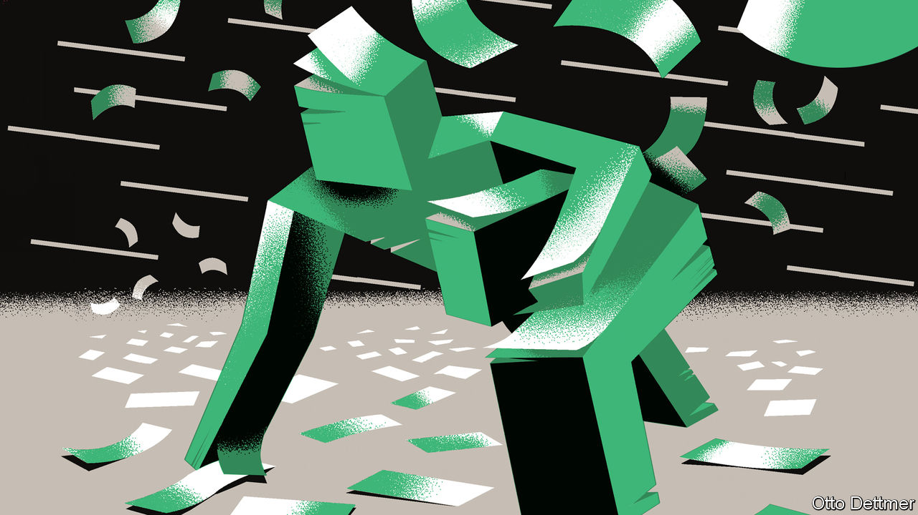

MOST APPARENTLY sound stewards of capital were revealed to be anything but during the 2007-09 financial crisis. Bank bosses were shown to have taken on too much risk. Star hedge-fund managers suffered losses. Nor have the years since then been kind. Banks have been tied up in regulatory knots and returns at hedge funds have been pedestrian at best.

The private-equity (PE) industry has been an exception to the trend. The funds it deployed during the crisis in 2007-09 have ended up yielding a median annualised return of 18%. And it has become far more important. Investors, from university endowments to public pension funds, have handed over ever more cash to PE managers (see chart). The biggest PE firms have evolved into financial conglomerates straddling buy-outs, property and credit markets, taking over some of the roles that Wall Street banks used to play. Assets under management have swollen to more than $4trn. The 8,000 firms run by PE in America account for 5% of its GDP, and a similar share of its workforce.

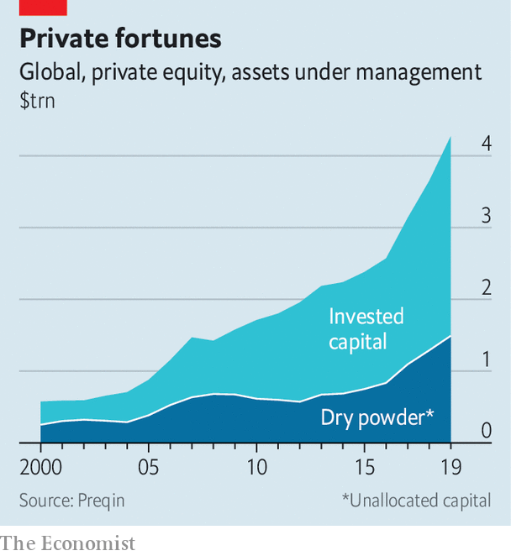

Now another savage recession is in full swing and the performance of PE is a crucial question for investors and the economy. The leveraged companies and debt instruments in PE portfolios are vulnerable and much depends on whether managers can tide these investments over. Meanwhile they have amassed $1.6trn in dry powder that they can deploy on new deals. PE shops’ fate depends on whether the hit to their existing investments is nasty enough to wipe out the potential gains from dealmaking afforded by the crisis.

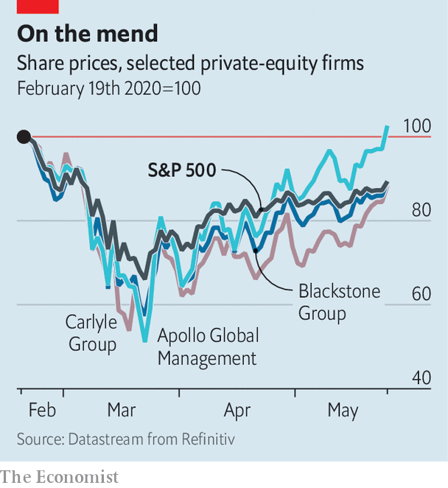

Start with the potential losses. In the first quarter of 2020 the four large listed PE firms, Apollo, Blackstone, Carlyle and KKR, reported paper losses on their portfolios of $90bn. That sounds big, but is just 7% of their assets under management, reflecting their ability to control how privately held assets are valued and, perhaps, their investment acumen. After an early scare PE firms’ shareholders have concluded that the outlook is fairly bright (see chart).

Are they right? Many PE managers have been juicing up returns by piling debt on to the companies they buy. In the years immediately after the last crisis most buy-out deals were done with debt worth no more than six times gross operating profits. By 2019, according to Bain & Company, a consultancy, three-quarters of deals were leveraged at over six times. That would suggest that PE-run firms are vulnerable. More than half of the 18 junk-rated firms that defaulted in the first quarter of the year were PE-owned, according to Moody’s, a rating agency. It expects the overall junk default rate to triple to 14% by 2021.

Over the past decade PE lending has shifted away from dopey, distracted banks towards specialist private-credit firms. These may be more hard-nosed about accepting a haircut on their debt in order to keep a PE-run business afloat. And making things trickier still, most big PE managers say that the firms they own are either ineligible for, or unwilling to tap, the American government’s business bail-out schemes, the Paycheck Protection Programme and the Main Street Lending Programme.

Even so, several other factors may have changed to work in PE’s favour. Much debt issued to back PE deals has become “covenant-light”, meaning that companies can endure a big slump in profits without triggering penalties from their lenders. Since the 2007-09 crisis many PE managers have also set up huge credit arms—for the big four firms, these now account for a third of their assets. They may give managers more in-house expertise and mechanisms for raising debt, making it easier to restructure the debts of fragile portfolio companies on favourable terms.

The strange nature of the recession may mean PE managers are unwilling to pull the plug, as activity is likely to resume after the shutdown. “There is a problematic gap,” says Marc Lipschultz, co-founder of Owl Rock, a private-credit fund. “We don’t know how deep or how wide it is, but funds need to find a bridge across.” And if PE-run firms cannot raise more debt, default or restructure their borrowings, the remaining option is an “equity cure”: PE shops stump up the cash to keep their firms afloat. Already around 70% of PE bosses polled by EY say they will need to inject fresh equity into their portfolio companies.

The way funds are structured means that managers cannot deploy their “dry powder” raised for new funds into firms owned by older ones. But most older funds do have big reserves. Michael Chae, the chief financial officer of Blackstone, says that around $30bn of its $152bn of dry powder is set aside for them. “We have those reserves ready to support companies on the defensive and also to go on the offensive when opportunities arise.” Funds are also gathering capital in other ways. Typically, a PE fund returns cash to its investors once it sells its stake in a company—but if the investment period is still ongoing, the fund can ask for it back. According to an industry body for PE investors, the number of calls for such “recycled capital” has risen.

Bailing out existing investments will drag down returns for PE shops. It remains to be seen if buying opportunities can make up for that. Most PE managers hope to use their newly expanded credit arms to scoop up bombed-out loans and bonds with collapsed prices—Leon Black, the founder of Apollo, has said the opportunity is “massive”. But the volume of traditional buy-outs dropped sharply in March, and only a few firms have since made purchases. For years PE barons have boasted of their huge piles of dry powder, which, if spent in a downturn, might generate outsized returns. Now it is time to pounce.■

Editor’s note: Some of our covid-19 coverage is free for readers of The Economist Today, our daily [newsletter](https://my.economist.com/user#newsletter). For more stories and our pandemic tracker, see our [coronavirus hub](https://www.economist.com/news/2020/03/11/the-economists-coverage-of-the-coronavirus)

This article was downloaded by calibre from <https://www.economist.com/finance-and-economics/2020/05/30/can-private-equity-firms-turn-a-crisis-into-an-opportunity>

|  |  |  |  |
| --- | --- | --- | --- |
|  | Articles | Sections | Next |

|  |  |  |  |
| --- | --- | --- | --- |
| Previous | Articles | Sections | Next |

#### Private equity

# Will covid-19 halt the rise of private equity in Europe?

PE firms are better prepared for a downturn, and seem to be more welcome

May 30th 2020 | BERLIN

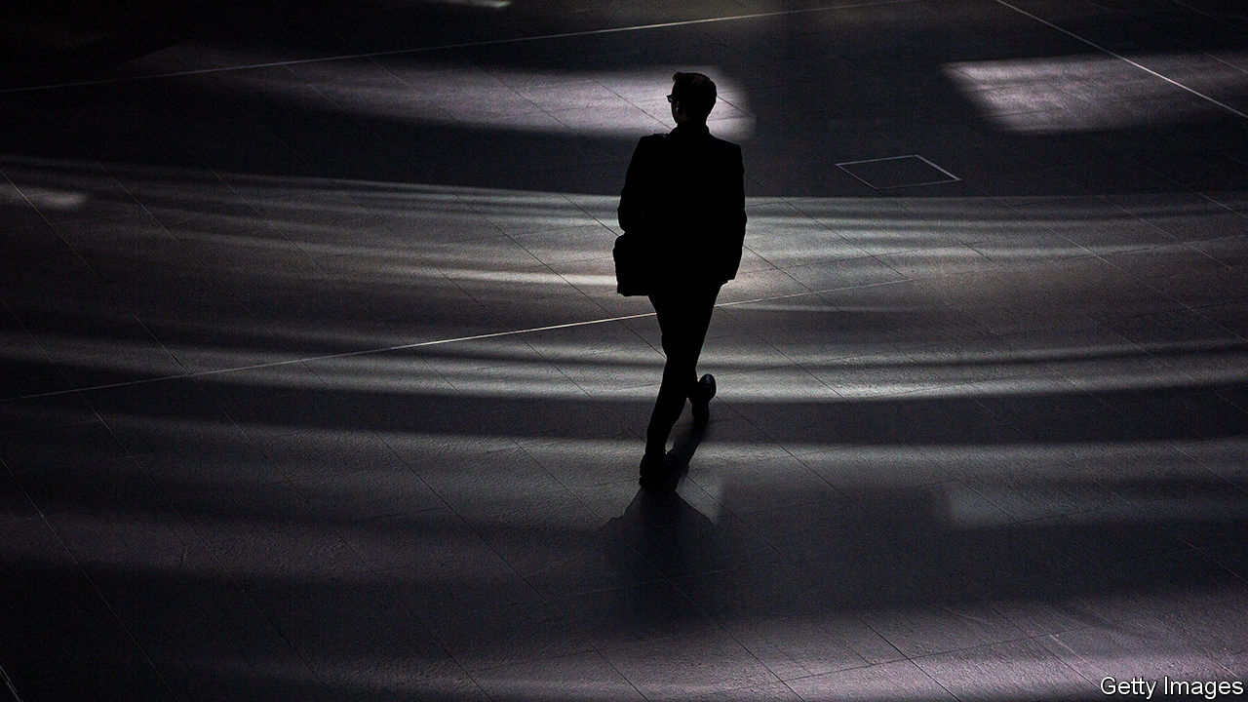

“DURING THE global financial crisis we devoted all our energy to rescuing companies we already owned,” says Johannes Huth, the European boss of KKR. This time the private-equity (PE) firm is well prepared to take advantage of economic calamity, as are many of its rivals. Four-fifths of KKR’s staff are looking after the companies in its portfolio, which range from Acciona, a Spanish renewable-energy firm, to Upfield, a Dutch margarine-maker. The rest are nosing around for opportunities.

The handful of deals taking place are mostly concentrated in tech and health care. Last month EQT, a Swedish PE firm, agreed to take over Schülke, a German maker of disinfectants, for roughly €900m ($990m). But “buy-out activity is pretty much dead,” says Lukas Schäfer of McKinsey, a consultancy.

Not much is expected to happen until August. Companies will publish earnings figures for the second quarter, when governments’ measures to contain the virus were at their strictest, making the extent of the corporate carnage clearer. Until then PE firms will focus on their most troubled existing investments. A tenth of EQT’s global portfolio, for instance, sits in the hard-hit leisure and travel industries.

Even so, Mr Huth reckons PE might largely be able to weather the crisis. In a world of negligible interest rates, demand for alternative assets will continue to hold up. Christian Sinding, EQT’s chief executive, even thinks the crisis will strengthen the industry, thanks to a mountain of “dry powder” that enables it to snap up bargains (see article).

PE-owned firms seem to be making little use of government aid in Europe. Some are using layoff schemes, such as Germany’s Kurzarbeit, which pays more than two-thirds of the net salaries of furloughed workers. But others are put off by the strings attached to the subsidies, such as job guarantees. And many do not qualify for state-backed loans, because their debt is too high. The European Union also bans firms with accumulated losses exceeding 50% of share capital from receiving state aid. The PE industry is lobbying the European Commission to relax the rule.

The crisis is a test of PE’s staying power in the continent. Britain used to be the most attractive market in Europe, says Detlef Mackewicz of Mackewicz & Partner, an investment adviser, followed by Scandinavia, the Netherlands and Germany. Germans, for their part, were once wary of PE: a senior politician branded the funds as asset-stripping “locusts”. But in recent years the mood has shifted. The value of disclosed deals in Germany reached an all-time high of €32bn in 2019. This year began with one of the biggest PE deals in Europe: the €17bn takeover of Thyssenkrupp Elevator by a consortium led by Advent International and Cinven, two PE firms.

With Germany expected to recover more quickly than other big European economies, it seems likely to retain its newfound position as the continent’s most attractive market. In 2007 Randolf Rodenstock of Rodenstock, a family firm that makes spectacles, said that his locusts were really honey bees. Bosses today are only more likely to share the sentiment. ■

Editor’s note: Some of our covid-19 coverage is free for readers of The Economist Today, our daily [newsletter](https://my.economist.com/user#newsletter). For more stories and our pandemic tracker, see our [coronavirus hub](https://www.economist.com/news/2020/03/11/the-economists-coverage-of-the-coronavirus)

This article was downloaded by calibre from <https://www.economist.com/finance-and-economics/2020/05/30/will-covid-19-halt-the-rise-of-private-equity-in-europe>

|  |  |  |  |
| --- | --- | --- | --- |
| Previous | Articles | Sections | Next |

|  |  |  |  |
| --- | --- | --- | --- |
| Previous | Articles | Sections | Next |

#### The thin red line

# China’s economists debate deficit monetisation

Inflation hawks seem to be prevailing—in theory, if not entirely in practice

May 30th 2020 | SHANGHAI

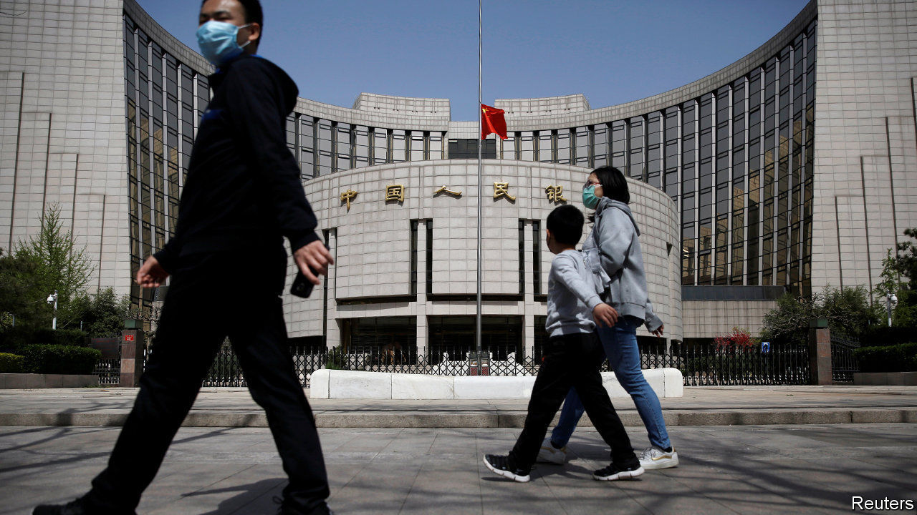

NO ONE WOULD ever describe the Chinese central bank as Germanic. After all, China’s broad money supply has tripled over the past decade alone, the kind of expansion that would send shivers through Germany’s inflation hawks. But listen closely and Teutonic inflections can be heard in Beijing. A ruckus about how to finance this year’s yawning fiscal deficit has brought out China’s own inflation hawks. They warn that moves by the People’s Bank of China (PBOC) to purchase government bonds directly, as dovish economists have recommended, could spell trouble. And their conservatism seems to be prevailing—in theory, if not entirely in practice.

The question of deficit financing has arisen because of the sheer amount of public spending needed in China, much as in other countries hit by the covid-19 pandemic. On May 22nd the finance ministry announced that the central and provincial governments would collectively issue 8.5trn yuan ($1.2trn) in new bonds in 2020, nearly twice as much as last year and equivalent to about 8% of GDP. That, however, threatens to push bond yields higher, raising the cost of financing just as the central bank is trying to keep it down.

Liu Shangxi, the head of a think-tank linked to the finance ministry, made a radical proposal in late April to tackle the problem: the PBOC should monetise the fiscal deficit, in effect printing money to buy and hold new government bonds that make no coupon payments. He rebutted the standard objection that deficit monetisation could lead to spiralling inflation, saying that a decade of quantitative easing abroad had shown that to be false.

Mr Liu’s idea has met with widespread criticism. Many commentators, both foreign and Chinese, have described the response as a debate, but that would imply that a substantial portion of other economists have taken Mr Liu’s side. The overwhelming majority have not: according to a rough tally by The Economist, 15 of the 17 prominent Chinese economists (including analysts and former officials) who have waded into the fray have argued against monetisation.

Most have noted that, unlike America or Japan, China still has space to cut interest rates. The yield on ten-year government bonds, for instance, is about 2.75%. But many have also described the idea of monetisation in much more alarming terms. Li Daokui, a former member of the PBOC’s monetary committee, called it a trap that will undermine the yuan. Ma Jun, formerly the chief economist for the PBOC’s research bureau, warned of a litany of problems: inflation, asset bubbles and a loss of faith in sovereign credit. Lou Jiwei, a former finance minister, observed that it would violate China’s central-bank law.

For some outside China, this restraint might seem odd. The government, after all, continues to save many state-owned companies from defaulting. But for Chinese economists it is precisely this backdrop that worries them. Deficit monetisation would erase the “last line of defence” in managing public finances, says Mr Ma. Whereas Germany’s concern with inflation stems from the Weimar era, China’s scars are fresher. In 1994—when Yi Gang, the PBOC’s governor, returned to China from a professorship in America—annual inflation ran as high as 28%.

The opponents of deficit monetisation appear to have won. In his annual address to the National People’s Congress on May 22nd, Prime Minister Li Keqiang said China would cut interest rates and reduce banks’ required reserves to expand the money supply; he studiously avoided any mention of bond purchases by the PBOC.

In reality, though, monetary lines are easily blurred. In 2007 the PBOC evaded the ban on monetary financing by arranging for the finance ministry to sell 1.35trn yuan in bonds to a state bank, which it then immediately bought from the bank. It also regularly engages in large re-lending operations, creating money that banks use for quasi-fiscal purposes.

With yields on government bonds rising steeply over the past few weeks, the PBOC may yet scoop up some of the debt hitting the market. But in the name of propriety, it will do so indirectly. ■

This article was downloaded by calibre from <https://www.economist.com/finance-and-economics/2020/05/30/chinas-economists-debate-deficit-monetisation>

|  |  |  |  |
| --- | --- | --- | --- |
| Previous | Articles | Sections | Next |

|  |  |  |  |
| --- | --- | --- | --- |
| Previous | Articles | Sections | Next |

#### Buttonwood

# What is the link between inflation and equity returns?

Stocks are a decent inflation hedge in the long run, but over shorter horizons, there is an inverse relationship

May 30th 2020 |

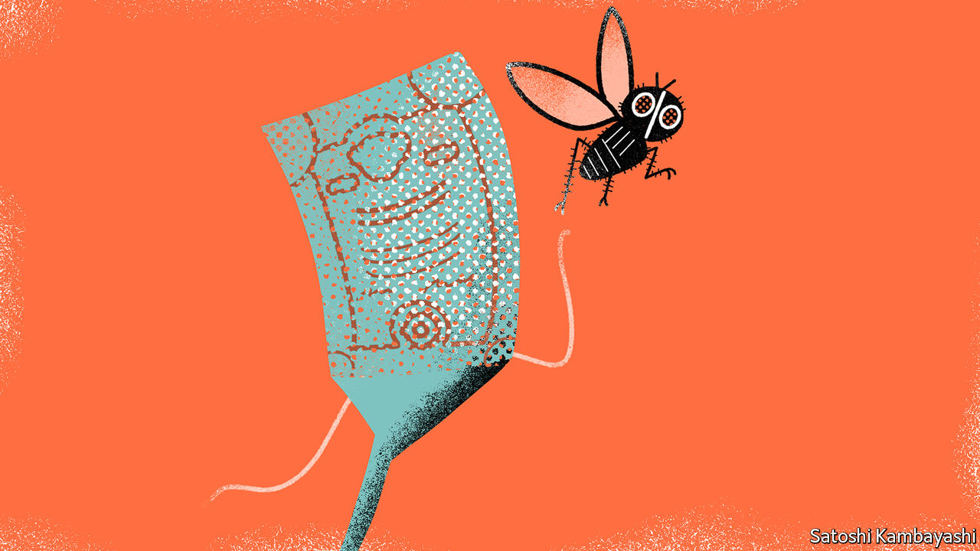

IN PLACES WHERE it has been long absent, it is hard to remember what a curse inflation is. In other places, it is hard to forget it. Take Zimbabwe. In 2008 it suffered an inflation rate in the squillions. Prices doubled every few weeks, then every few days. Banknotes were so much confetti. Some people turned to equities as a store of value. A share purchased on Monday might be sold on Friday. Harare’s stock exchange was almost like a cash machine.

In principle, equities are a good hedge against inflation. Business revenues should track consumer prices; and shares are claims on that revenue. In some cases, they may be the only available hedge. Iran, for instance, has had one of the better performing stockmarkets, because locals have sought protection from inflation. Sanctions make it dangerous to keep money offshore.

Rich-country investors have a different sort of headache. Though the immediate outlook is for inflation to stay low, it could plausibly pick up later on. If it does, edge cases like Zimbabwe or Iran are a bad guide. The link between inflation and equity returns is not straightforward. Stocks are a decent inflation hedge in the long run. But over shorter horizons, there is an inverse relationship. Rising inflation is associated with falling stock prices, and vice versa.

Start with the evidence that stocks beat inflation over the long haul. In the most recent Credit Suisse global investment returns yearbook, a long-running survey, Elroy Dimson, Paul Marsh and Mike Staunton show that global equities have returned an average 5.2% a year above inflation since 1900. You may quibble that the survey covers the sorts of stable places that have had a long run of stock prices in the first place, such as Britain and America. Even so, the finding fits with intuition. When you buy the equity market, you buy a cross-section of a country’s real assets.

Yet stock investors still need to be mindful of inflation. Markets tend to put a lower value on a stream of cash flows when inflation rises; and a higher price on cash flows when it falls. There are competing theories for the inverse relationship; many date from the late 1970s and early 1980s. A paper written by Franco Modigliani and Richard Cohn in 1979 put it down to “money illusion”: rising inflation leads to falling stock prices because investors discount future earnings by reference to higher nominal bond yields. The correct discount factor is a real yield (ie, excluding compensation for expected inflation). Other theories said that inflation is merely a reflection of deeper forces that hurt stock prices: an overheating economy; rising uncertainty; political instability.

In the decades since then, inflation has steadily declined. Stocks have re-rated. Investors have been willing to pay an ever-higher price for a given stream of future earnings. You might put this down to the Modigliani-Cohn effect in reverse, since nominal bond yields have also fallen. But so too have long-term real bond yields. The real rate of interest needed to keep inflation stable is lower.

Now for the headache. For the most part, financial markets reflect the view that inflation will remain low. Nominal bond yields are negative in much of Europe and barely positive in America. In stockmarkets, there has for a while been a sharp divide. Companies that do well in disinflationary environments (technology, branded goods) are expensive; businesses that might do better in inflationary ones (commodities, real-estate and banking) have generally lagged behind. The immediate prospect is indeed for an excess of supply. The unemployment rate in America is close to 15%. Inflation is already falling.

Further out, though, the outlook for inflation is murkier. There is no shortage of pundits who say it is primed to pick up. They have a case.

Globalisation, a key reason for the secular decline in inflation, is reversing. Big companies are likely to emerge from the crisis with more pricing power. The rise of populism in rich countries is hard to square with endlessly low inflation. Fiscal stimulus is in favour. The more government debt piles up, the greater the temptation to try to inflate it away.

For all such speculation, it is far from clear whether, how fast and by how much inflation might rise. A modest pickup might even be good for stock prices—especially in Europe, where bourses are tilted towards the cyclical stocks most hurt by unduly low inflation. But it is foolish to believe that inflation will leave your stock portfolio unharmed—and too easy to forget the damage it can do.

This article was downloaded by calibre from <https://www.economist.com/finance-and-economics/2020/05/30/what-is-the-link-between-inflation-and-equity-returns>

|  |  |  |  |
| --- | --- | --- | --- |
| Previous | Articles | Sections | Next |

|  |  |  |  |
| --- | --- | --- | --- |
| Previous | Articles | Sections | Next |

#### A change of plan

# For the first time in 30 years, China has no GDP target

The government will not set one this year, reflecting the pandemic’s uncertainties

May 30th 2020 |

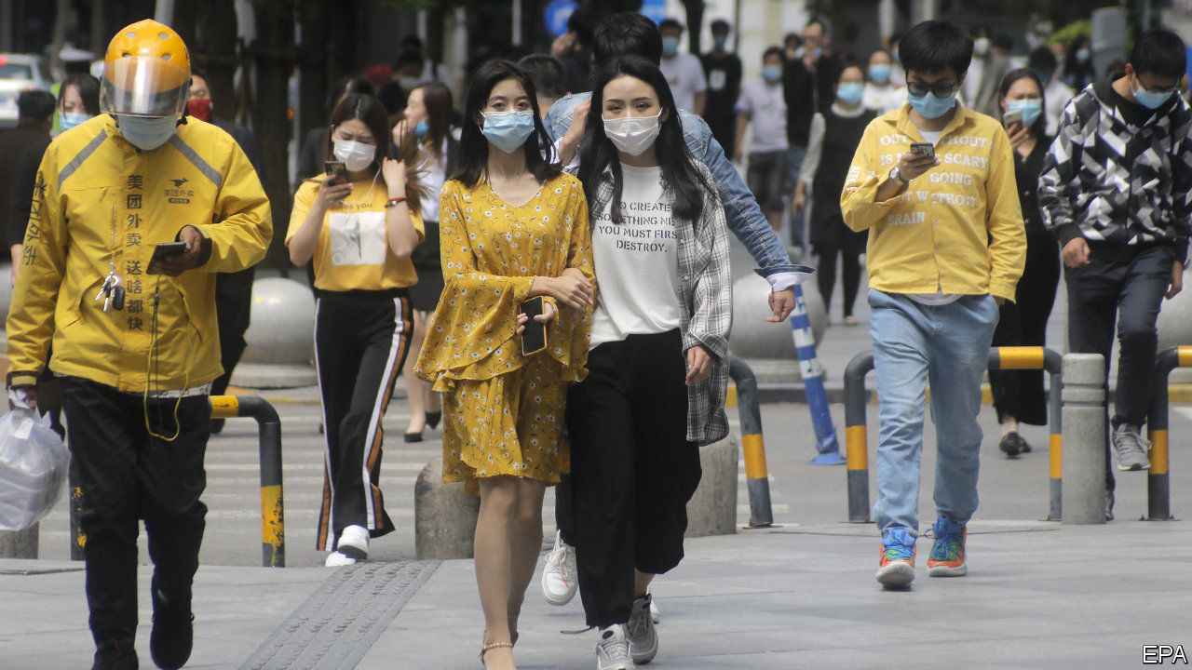

CHINA HAD long been the only large economy with an annual growth target. On May 22nd the government said it would not set one this year, so profound is the uncertainty wrought by the pandemic. Economists applauded: the target obsession led to much wasteful investment and some book-cooking. With a little digging you can still get an idea of how fast the government expects the economy to expand. Its budget projections suggest that it is implicitly aiming for nominal growth of 5.4% in 2020.

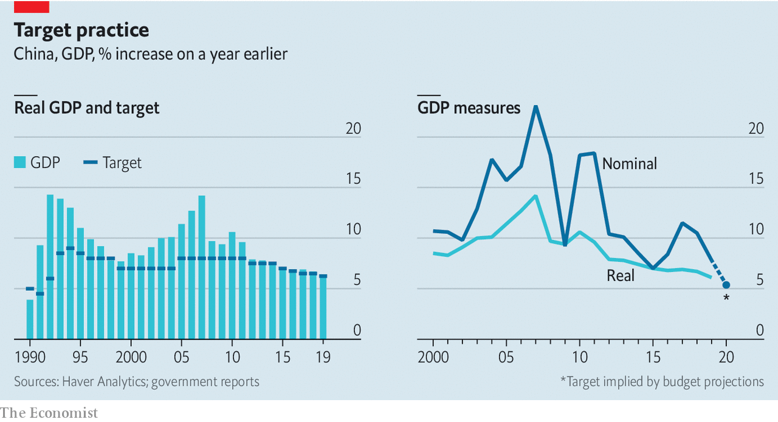

Editor’s note: Some of our covid-19 coverage is free for readers of The Economist Today, our daily [newsletter](https://my.economist.com/user#newsletter). For more stories and our pandemic tracker, see our [coronavirus hub](https://www.economist.com/news/2020/03/11/the-economists-coverage-of-the-coronavirus)

This article was downloaded by calibre from <https://www.economist.com/finance-and-economics/2020/05/30/for-the-first-time-in-30-years-china-has-no-gdp-target>

|  |  |  |  |
| --- | --- | --- | --- |
| Previous | Articles | Sections | Next |

|  |  |  |  |
| --- | --- | --- | --- |
| Previous | Articles | Sections | Next |

#### No fear of floating

# The World Bank lands Carmen Reinhart as chief economist

Ms Reinhart is one of the most widely cited economists in the world

May 30th 2020 | HONG KONG

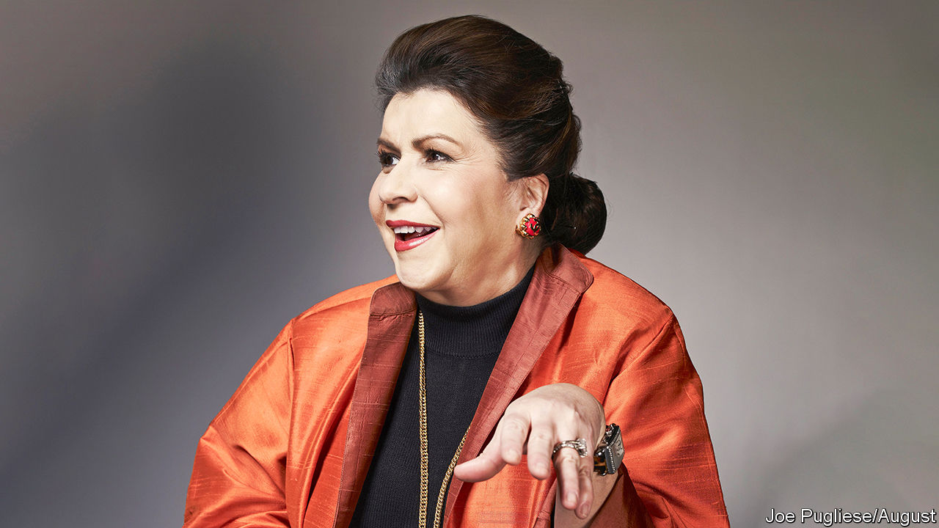

SOME OF THE best economists in the world have served as chief economist of the World Bank. But not all of them stay for long. Paul Romer, who subsequently won a Nobel prize, left after 15 months. His successor, Penny Goldberg, returned to academia just as quickly. And a new layer of management is soon to be inserted between the research department and the bank’s president. It was not obvious, therefore, that the bank would find another chief economist as illustrious as past holders of the post. The institution might have had to settle for a safer, more mundane choice. Instead it has hired Carmen Reinhart of Harvard University, one of the most widely cited economists in the world (and the most cited female economist).

She is, according to Guillermo Calvo of Columbia University, an “original”. Her family fled Cuba for America in 1966, when she was ten. A course on fashion merchandising at Miami Dade College introduced her to economics. Before she turned 30 she was chief economist of Bear Stearns, an investment bank, a post later occupied by her new boss, David Malpass, who became the World Bank’s president last year. Her two stints at the IMF mean she is accustomed to working at Bretton Woods institutions.

An article she wrote with Mr Calvo and Leonardo Leiderman at the IMF anticipated Mexico’s tequila crisis of 1994. It argued that capital inflows to Latin America reflected global conditions (including low American interest rates), not just domestic reforms. Any reversal of those conditions could trigger a reversal of flows, they warned. And in such a scenario, “policy options”, they noted tersely, “are limited”. The paper’s argument applies equally well to the recent troubles of Argentina, which relied too heavily on the passing enthusiasm of foreign investors from late 2016 to 2018.

Ms Reinhart’s best known work is her history of financial folly written with Kenneth Rogoff of Harvard, which spans eight centuries (why only the last eight, joked Dennis Snower of the Kiel Institute when presenting her with the Bernhard Harms prize in 2018). The book drew on a variety of historical sources, including prices culled from monastery records, and reports from the League of Nations, which her husband, Vincent, who was then working at the Federal Reserve, gave her as a Valentine’s gift. The authors’ aim was to create a run of data long enough to understand the kind of rare but deep financial crises that rocked the world in the 1930s and again in 2007-09.

Her most controversial work with Mr Rogoff claimed that government debt exceeding 90% of GDP is correlated with weaker growth. Critics argued over causality; one found a spreadsheet error. The 90% threshold became a favourite statistic for advocates of austerity. But Ms Reinhart herself has highlighted the importance of writing off debt. She was one of three lead authors of a recent open letter, signed by about 150 economists, defending the Argentine government’s offer to creditors to swap their bonds for new instruments with easier terms.

This concern with debt also animates a recent effort to fill in the statistical record. With Sebastian Horn and Christoph Trebesch of the Kiel Institute, Ms Reinhart has tried to measure China’s lending to the rest of the world, combining and cross-checking prior piecemeal efforts. “To say that [Chinese lending] is opaque is an understatement,” she has noted. Without a more accurate record, it is impossible to assess the macroeconomic vulnerabilities of many low-income countries, she argues. And any effort to relieve the debts of poor countries during the pandemic is likely to fall short if China’s loans are not included.

Her concern overlaps with Mr Malpass’s preoccupations. In his previous job at America’s Treasury, he voiced concerns that China was drawing countries into debt and thereby expanding its geopolitical influence. In his current role, he has insisted that countries should be more transparent about their lending and borrowing.

Ms Reinhart’s investigations do not always reflect badly on China. Her list of the 50 countries most indebted to the Middle Kingdom (relative to their GDP) includes few places of great geopolitical significance (exceptions include Pakistan and Sri Lanka). And she and her colleagues have uncovered 140 examples of China restructuring or relieving the debts of poor countries, although it rarely co-ordinates with other creditors. (China has also signed up to the G20’s recent initiative to suspend debt service on bilateral government loans to 73 poor countries.)

The World Bank, then, has found another world-class chief economist. Ms Reinhart’s tenure is unlikely to be much quieter than her predecessors’. The hope is that it is a little longer. ■

This article was downloaded by calibre from <https://www.economist.com/finance-and-economics/2020/05/30/the-world-bank-lands-carmen-reinhart-as-chief-economist>

|  |  |  |  |
| --- | --- | --- | --- |
| Previous | Articles | Sections | Next |

|  |  |  |  |
| --- | --- | --- | --- |
| Previous | Articles | Sections | Next |

#### Crisis measures

# The pandemic could lead statisticians to change how they estimate GDP

Data gaps are rife, but statisticians may eventually understand better how the economy works

May 30th 2020 |

AN AIR-CONDITIONER that overheats in hot weather, or an insurance policy that fails to pay out after a natural disaster: some things do not work as expected, just when you need them most. So it is with official statistics in the pandemic. As they try to gauge the depth of the downturn, policymakers and investors are keener to pore over the latest GDP figures than ever. But estimates have rarely been as uncertain.

Many economists expect the initial estimate of America’s output growth in the first quarter of 2020, published on April 29th, to be revised downwards eventually. Some of that may arrive as soon as May 28th, after The Economist went to press, when an update to the figures was due.

Analysts at Goldman Sachs, a bank, reckon that early estimates might capture only around 60% of the economic drag from the coronavirus. If the true year-on-year fall in America’s GDP is around 12% in the second quarter, as many economists expect, the initial release might indicate a decline of only 7-8%.

Statisticians are well aware of the uncertainty. Britain’s Office for National Statistics (ONS) has mulled introducing confidence intervals for its estimates—but no one knows quite how wide the bands should be. France’s statistical office says that its first-quarter estimate of GDP is “fragile”. Many are trying to fill in data gaps where they can.

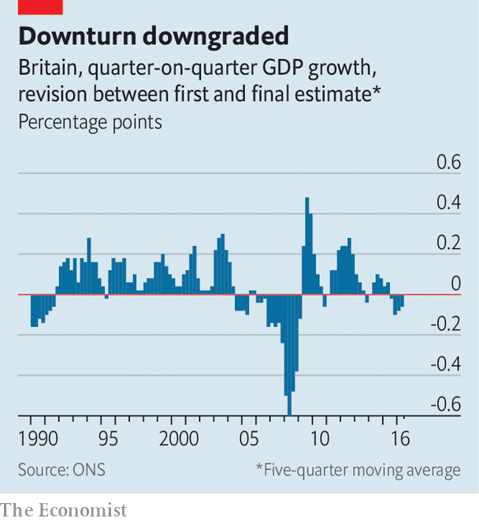

Estimates of GDP during downturns tend to be revised downwards significantly (see chart). Response rates to surveys often fall in slumps; because firms doing badly are particularly likely to stop responding, the data gleaned paint a misleadingly optimistic picture. Though statistics offices are encouraged, if not required by law, to produce estimates quickly, many data sources are only published with long lags. Wonks can temporarily fill in figures for the missing sectors, but their techniques for doing so may not be up to scratch during periods of economic stress. America’s GDP was first estimated to have fallen at an annual rate of 3.8% in the fourth quarter of 2008, compared with the previous three months. That was eventually revised to a decline of more than 8%, in part because statisticians’ guesses for some manufacturing inventories for the month of December were too optimistic.

During the pandemic, these problems have been turned up a notch. Many businesses have temporarily stopped trading and thus responding to surveys. The sectors of the economy most affected by lockdowns, such as education, leisure and hospitality, often have the longest lags in reporting, making early estimates especially unreliable. In some cases, collecting data is impossible. In Britain a survey of travellers at airports and ports, which helps measure activity accounting for 20% of its trade in services, was halted in March.

In response, statisticians are making quick fixes. In America the output of public-education services is usually estimated using teachers’ pay. But statisticians have weakened the link between pay and measured activity to reflect the fact that, though teachers continue to receive salaries, students have missed hours of instruction. Others are using conversations with companies, statistical techniques and guesswork to fill in gaps.

Many are also looking to make more drastic changes by incorporating “real-time” data. Timely figures ranging from restaurant reservations to prices on Amazon are already widely used by private-sector economists. Institutional inertia and tight budgets had led many statistics offices to shun them; now they have little choice but to experiment. A handful of those in the European Union are using credit-card data to help measure GDP. In place of the survey of international travellers, the ONS is looking at passenger numbers from the aviation regulator, ferries and the Eurostar—as well as meteorological data. Other statisticians are scraping web pages. Things are tough now, but the wonks could emerge from the pandemic with a better understanding of how the economy really works. ■

Editor’s note: Some of our covid-19 coverage is free for readers of The Economist Today, our daily [newsletter](https://my.economist.com/user#newsletter). For more stories and our pandemic tracker, see our [coronavirus hub](https://www.economist.com/news/2020/03/11/the-economists-coverage-of-the-coronavirus)

This article was downloaded by calibre from <https://www.economist.com/finance-and-economics/2020/05/30/the-pandemic-could-lead-statisticians-to-change-how-they-estimate-gdp>

|  |  |  |  |
| --- | --- | --- | --- |
| Previous | Articles | Sections | Next |

|  |  |  |  |
| --- | --- | --- | --- |
| Previous | Articles | Sections | Next |

#### Free exchange

# The legacy of Alberto Alesina

He traced the links between culture, politics and fiscal policy

May 28th 2020 |

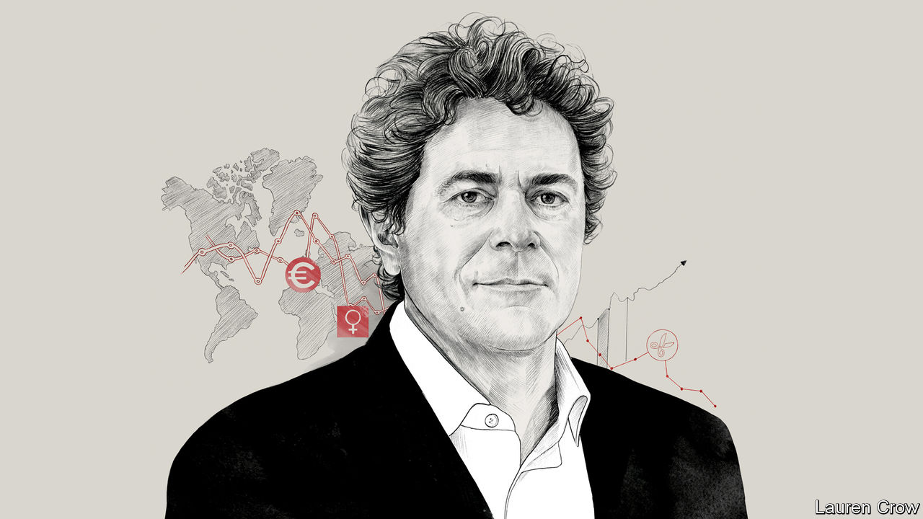

A DECADE AFTER the last global downturn, the economics establishment’s U-turn on austerity is complete. In 2010 the IMF praised Britain’s tough deficit-reduction plan. Now it recommends a big fiscal expansion to cope with the coronavirus pandemic. Politicians were once fond of citing research co-authored by Kenneth Rogoff, an economist, to warn that public debt exceeding 90% of a country’s GDP would crimp growth. Today Mr Rogoff advises spending more. But Alberto Alesina, an economist at Harvard University who died on May 23rd, stood his ground.

In a book written with Carlo Favero and Francesco Giavazzi and published last year, Mr Alesina once again defended austerity—as long as the right policies were used. Tax rises might damage economic growth more than cuts in public spending—which in some cases could actually boost the economy, perhaps because investors would expect their future tax burden to be lower. Other economists criticised the results. Yet Mr Alesina did not mind being a dissenting voice. His papers—and there were reams of them—showed that democracies, especially his beloved Italy, tend to accumulate public debt. Somebody had to remind politicians of the dangers of unsustainable fiscal policy.

Mr Alesina was primarily an economist of politics and culture. Back in the 1980s, when he was completing his PhD at Harvard, wonks sneered at those investigating such supposedly soft questions. But Mr Alesina showed that explaining economic outcomes—why some countries are rich and others poor, or why immigrants succeed in some places but not others—meant looking beyond prices and GDP to subjects such as history and sociology.

He sought, for instance, to explain the wide variation in women’s labour-force participation between countries (in Iceland 82% of working-age women are in work; in Italy, 50% are). The answer lay in differences in agricultural technologies used hundreds of years ago, some of which favoured female labour more than others. Talking to The Economist shortly before he died, Mr Alesina presented new evidence that cultural traits persist. The grandchildren of China’s elites of the first half of the 20th century, he found, today earn more than others. Despite revolution and expropriation, hard-wired preferences—eg, they are found to be more likely to believe in the power of hard work—seem to give them an edge.

At first glance, these questions might seem a million miles from tax rates and debt ratios. Not so for Mr Alesina. “The same historical, sociological, cultural variables which may have led to the choice of certain institutions may also be correlated with fiscal policies,” he said. He asked why America spent relatively little on welfare, but Europe spent lots. His answer was that it was a matter of culture. Americans blamed the poor for their predicament; Europeans worried about the disadvantages holding them back.

Culture and politics might also explain a worrying fiscal trend. It was reasonable, said Mr Alesina, to expect governments to run budget surpluses during good times and deficits during bad. But, he noted, this increasingly did not happen. He was fond of citing a study from 2014, which found that only four out of 20 rich countries had run a budget surplus for more than half the time since the 1960s. Italy ran a deficit every year. Structurally weaker growth and an ageing population made it all too easy for governments to accumulate debts—even in the absence of a crisis. Mr Alesina, who was known for being generous in both time and spirit to junior researchers, worried that the young bore the costs of such profligacy. “In countries like Italy”, he argued, “we are reaching paradoxes in which youngsters do not find jobs because of high labour taxes”, which exist in order to “pay pensions for the parents, who then support the unemployed children”.

Sociopolitical factors might explain the deviation from optimal fiscal policy. Once public spending had gone up, people’s expectations changed, making it difficult to bring it down again. Mr Alesina’s research cautiously suggested that proportional-representation systems—which have long characterised countries such as Italy—were likely to be more fiscally lax than other systems. They were more unstable, and ministers expecting to lose office at any moment might not worry about dealing with the consequences of their actions. He also wondered whether coalition governments, which are more common under proportional representation, found it more difficult to shrink budget deficits because they had to cater to vested interests.

## Rules for rule-makers

Mr Alesina puzzled over why fiscal irresponsibility had become acute. Perhaps, as the electorate aged, pressure to provide generous pensions and health care became overwhelming. Political polarisation may have allowed governments to feel little compunction in leaving a mess for their successors to clear up. In his research, and in emails that were notoriously riddled with typos, he encouraged others to explore the question further.

Whatever the explanation, something had to change. “If the French think that they can keep retiring at 60, they’re kidding themselves,” he argued. One solution was for governments to impose constraints on themselves. In the 1990s he argued for independent central banks, which made it harder for politicians to inflate debts away. Another solution was to adopt fiscal rules—for instance, a promise to balance the budget over the economic cycle. Yet Mr Alesina worried that these alone would not suffice. Could governments credibly commit themselves to upholding them?

Perhaps politicians could be persuaded to be more responsible. He found little evidence to support the idea that lawmakers who take tough decisions are booted out of office. But Mr Alesina also wanted them to recognise that, without vigilance, the logic of politics encourages unsustainable fiscal policy. As covid-19, rising health-care costs and an older population cause debt to mount, his arguments may soon seem more relevant than ever. ■

This article was downloaded by calibre from <https://www.economist.com/finance-and-economics/2020/05/28/the-legacy-of-alberto-alesina>

|  |  |  |  |
| --- | --- | --- | --- |
| Previous | Articles | Sections | Next |

|  |  |  |
| --- | --- | --- |
| Finance & economics | Sections | Science & ... |

Schools brief

Move fast, mend things: Softening the blow

.

|  |  |  |
| --- | --- | --- |
| Finance & economics | Sections | Science & ... |

|  |  |  |  |
| --- | --- | --- | --- |
|  | Articles | Sections | Next |

#### Softening the blow

# Climate adaptation policies are needed more than ever

People are already suffering from catastrophic losses as a result of extreme weather events like cyclone Amphan

May 30th 2020 |

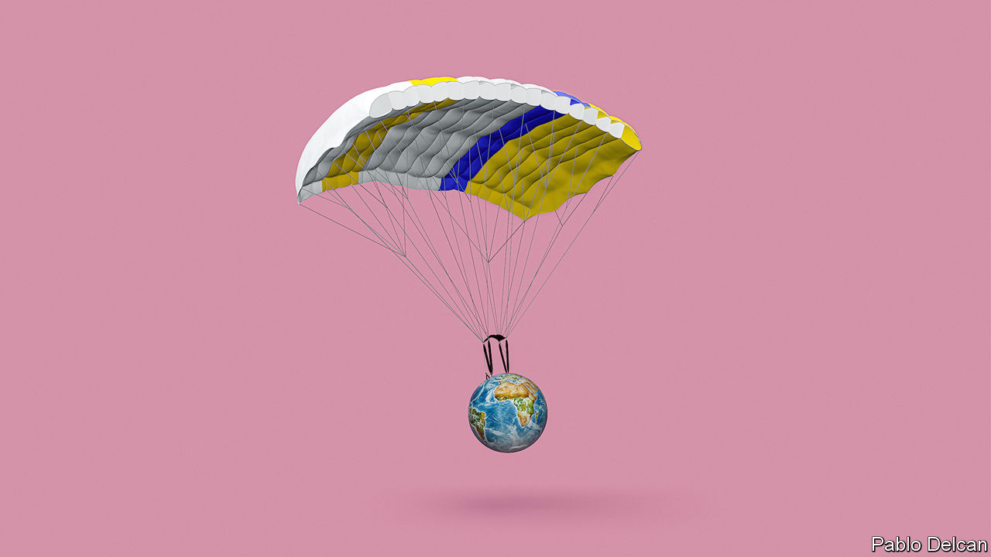

ON MAY 16TH a telltale anticlockwise spiral of clouds in satellite images taken over the Bay of Bengal warned of impending disaster. Four days later Supercyclone Amphan made landfall, the most powerful storm to do so in the region in 20 years. Winds gusting at up to 185km/hr pounded the coast of the Indian state of West Bengal, which took the brunt of the impact. Huge waves swept over the Indian and Bangladeshi coast. Trees were lifted out of the ground, city streets turned to rivers, tens of thousands lost their homes. Yet the number of deaths was relatively low. As of May 27th there had been around 100 overall, though the number could rise as emergency services reach the more remote areas. In Bangladesh there were just over 20.

For several decades now Bangladesh’s cyclone death tolls have been falling. The storms have not become less brutal; and rising sea levels, combined with the country’s flat-as-a-pancake coastline and growing population, have put ever more people at risk. But Bangladesh has developed a layered adaptation plan to cope with these disasters. It now has an early-warning system offering precious extra minutes for people to evacuate to concrete cyclone shelters, and sea walls to protect stretches of coastline. In 2019, Cyclone Fani—not a storm on Amphan’s scale, but one which at its peak would have been a Category 4 hurricane in the Atlantic—killed dozens. In the late 20th century and early 21st, death tolls for powerful storms were in the thousands to hundreds of thousands.

Bangladesh’s success shows what sort of adaptation to climate risks is possible. In the early 2000s the country’s policymakers recognised that international efforts to cut emissions would never be sufficient to protect it from many of the impacts of climate change. The country’s low-lying coastline and position at the top of the Bay of Bengal—a funnel for cyclones—meant that even without climate change there were benefits to be had from building storm defences. Starting in 2005, they began devising programmes to help its residents adapt their way of life to a warmer, more erratic climate. Today, that includes storm defences, cyclone shelters, new rice varieties and floating farms. But globally such successes remain rare.

## Pulling on the parachute

In the early days of political action on climate change adaptation was seen as, at best, a poor relation to cutting greenhouse-gas emissions—at worst as a distraction. In his first book on the subject, “Earth in the Balance” (1992) Al Gore, who became America’s vice-president the following year, described it as “a kind of laziness”.

In 2010, with attempts to agree on reductions in emissions stalled by the failure of the Copenhagen summit, and with emissions rising steeply as the world bounced back from the financial crisis of 2007-09, adaptation began to take its proper place as a topic of international concern. The countries party to the UN Framework Convention on Climate Change took on a commitment to a global adaptation framework and set up a Green Climate Fund, with the goal of raising $100bn annually by 2020 to help developing nations reduce their emissions and establish plans for adaptation.

A decade on, adaptation is more urgent than ever. Global average temperatures are already roughly 1°C warmer than they were in the 19th century, bringing more extreme and more erratic weather patterns. Intense, unprecedented and sustained effort co-ordinated among all the world’s large economies could see the total rise capped at less than twice what has been seen so far: the “well below 2°C” goal that features in the Paris agreement reached in 2015. But even such heroic efforts would still leave a lot of change to adapt to. And current trends suggest something more like 3°C.

Faced with these projections, the need to adapt societies and economies to be more resilient to a hotter climate is clear. The Global Commission on Adaptation, an NGO, estimates that, if nothing is done to prepare for climate change, it could lower global agriculture yields by as little as 5% and as much as 30% by 2050—depending on a range of assumptions. Roughly 5bn people could suffer water shortages at least one month a year. Hundreds of millions of people may have to abandon their homes in coastal cities. Adaptation is not just a matter for poor countries. The damage which Hurricane Sandy wreaked on New York City in 2012 showed that extreme events could bring one of the world’s most important financial centres to its knees. Damages topped $19bn. Such losses spurred a $19.5bn urban-adaptation plan.

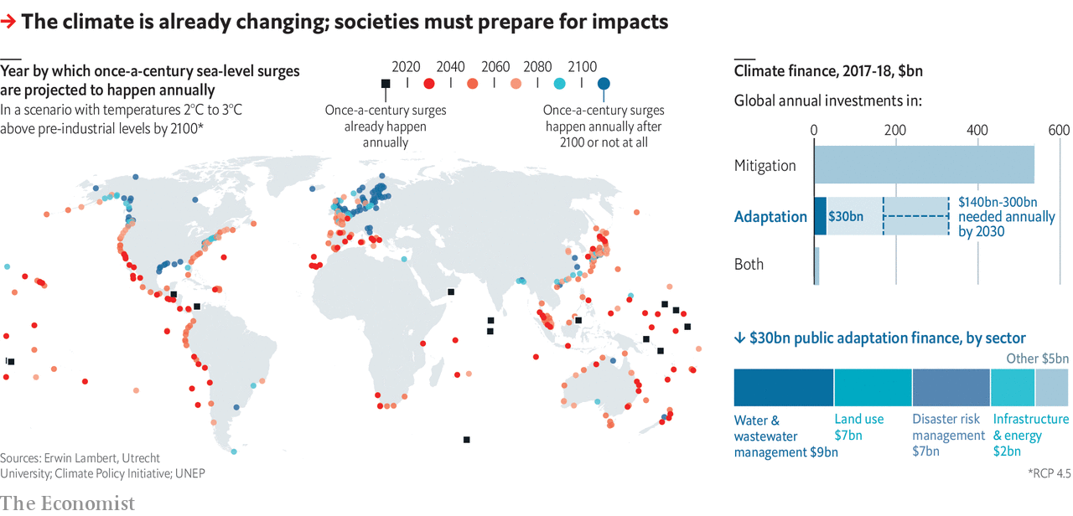

Businesses have also started to look at their vulnerabilities to climate change—partly because of pressure from activist investors. Several are adapting. Mylan, a pharmaceutical company, has reinforced its buildings in hurricane-prone Puerto Rico; Microsoft has built redundant cloud capacity in case servers are knocked out by extreme weather. Individuals in a few places are spending to ensure their future comfort and livelihood. The fact that some adaptation can be provided privately brings with it incentives that are lacking when it comes to mitigation, which is notoriously vulnerable to the free-rider problem. But it also brings worries of its own. If the wealthy can adapt for themselves, the pressure on states to help may decrease.

In some developed countries adaptation is already saving lives. An estimated 15,000 died in France in 2003 as a result of scorching August temperatures. A heatwave in 2019 is estimated to have killed 1,500. The improvement was thanks to increased awareness of the threat, public policy and private investment. There is now targeted support and medical attention for the most vulnerable. Opening hours for swimming pools were extended. The authorities put air-conditioning into some public buildings. Many private citizens installed it, too.

The successes in France and Bangladesh are both tailored to the needs of specific populations facing specific threats; this is a general truth about adaptation. What has to be done to reduce emissions is pretty similar around the world; providing resilience through adaptation depends on policies shaped by local needs and capacities. Sub-Saharan communities at risk of more intense droughts that threaten their food supply do not need to deploy the same toolkit as ones on the Florida coastline where the land beneath their homes is eroding.

## Working for a better landing

All this comes at a cost. Estimates vary a lot because they are based on so many assumptions. In 2016 the UN Environment Programme said that adaptation would cost $140bn-300bn annually by 2030. Those sums are widely thought to be outweighed by the benefits they bring. According to the Global Commission on Adaptation, investments totalling $1.8trn globally between 2020 and 2030 could generate $7.1trn in net benefits.

The problem is that flows of private capital and money from both governments and foreign-development funders fall short. Accounting is made hard by the overlap between funding for adaptation and more general flows of development finance. But the Climate Policy Initiative, a think-tank, estimates that in 2017-18 a paltry $30bn, primarily from public sources, was invested worldwide, compared with $537bn for mitigation.

One limit to adaptation is the ability to pay for it. Another is more fundamental. There are things even the best-funded adaptation programme cannot hold at bay: the consequences of climate change that must be avoided entirely. In Bangladesh rice is a major crop. Rising seas are turning the paddies salty. In response, agricultural researchers have developed salt-tolerant rice varieties, with each new generation able to grow in soil that is more saline than the last. But even they concede that this has limits. To expect agronomic advances to create rice that can grow in pure sea water would be daft.

For the people in the small village of Newtok in Alaska, the limits to adaptation are tangible. During the past decades, hotter summers have melted the permafrost from beneath their feet. In October last year they began the laborious process of resettlement. “Managed retreat” is an extreme form of climate adaptation that will become a reality for millions if the mercury does not stop rising. Earlier this month a study found that parts of the tropics could become too hot to sustain human life with 2.5°C of global warming.

Long before the world gets to that point, communities, especially in poorer regions, will suffer catastrophic losses. Many already are. Who pays for the losses and damages is yet another thorn in the side of UN climate talks. The calls from more vulnerable nations for international funds to help them foot the bill have fallen on deaf ears. Governments of wealthy nations want no part in any formal text that might contain a whiff of liability.

In the eyes of some, rich governments are not the only guilty parties. In December the Philippines’s Commission on Human Rights declared that events leading to devastating storms like Typhoon Haiyan, which killed thousands of people in 2013, were a violation of human rights. They pointed the finger at fossil-fuel companies and other corporations. The commission claimed these companies could, hypothetically, be held accountable. ■

This article was downloaded by calibre from <https://www.economist.com/schools-brief/2020/05/30/climate-adaptation-policies-are-needed-more-than-ever>

|  |  |  |  |
| --- | --- | --- | --- |
|  | Articles | Sections | Next |

|  |  |  |
| --- | --- | --- |
| Schools brief | Sections | Books & arts |

Science & technology

Covid-19 and face masks: We interrupt this transmission...

.

Antifouling technology: Keelhaul that ’bot!

.

Not yet, but soon: Crew Dragon is postponed

.

Recycling: Crackle, pop, snap

.

|  |  |  |
| --- | --- | --- |
| Schools brief | Sections | Books & arts |

|  |  |  |  |
| --- | --- | --- | --- |
|  | Articles | Sections | Next |

#### Face masks and the coronavirus

# Masks probably slow the spread of covid-19

But wearing one is mainly an act of altruism

May 30th 2020 |

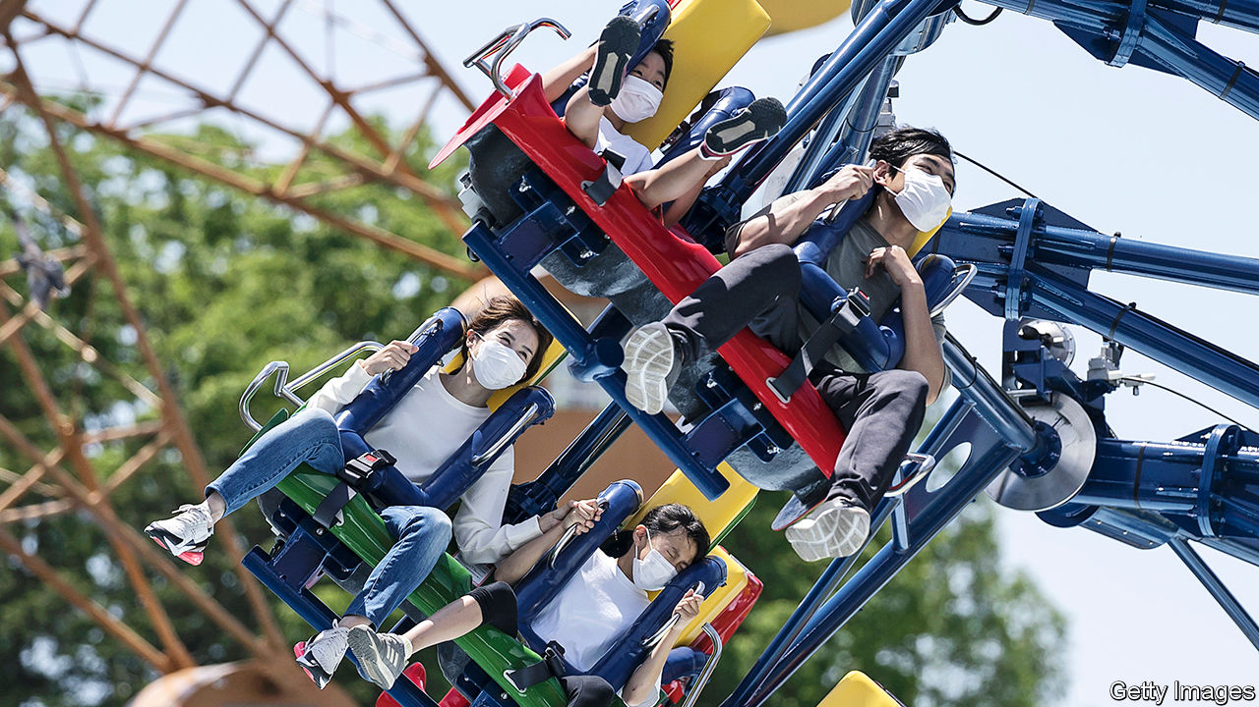

Editor’s note: Some of our covid-19 coverage is free for readers of The Economist Today, our daily [newsletter](https://my.economist.com/user#newsletter). For more stories and our pandemic tracker, see our [coronavirus hub](https://www.economist.com/news/2020/03/11/the-economists-coverage-of-the-coronavirus)

“THIS IS A, I would say, senseless dividing line,” said Doug Burgum, governor of North Dakota, his voice catching as he talked of the rows that have broken out in his state over the wearing of face-coverings. There are similar spats elsewhere in America, for masks have become the latest aspect of the culture war that has emerged there over how to deal with covid-19. Some shops refuse entry to maskwearers and Mike DeWine, the governor of Ohio, has rescinded an order requiring people to wear them, saying that he “went too far”.

Elsewhere in the world, by contrast, there is increasing acceptance that mask-wearing is a good thing. On May 5th, for example, the Royal Society, Britain’s top science academy, concluded that masks “could be an important tool for managing community transmission”. This is not so much because they protect the wearer—the normal reason people may put them on in times of pestilence—but rather because they stop the wearer infecting others.

In this context covid-19’s particular peculiarity—that people who test positive for it often do not have symptoms—is important. Research published last month in Nature Medicine, by Xi He of Guangzhou Medical University and Eric Lau of Hong Kong University, suggests that 44% of cases are caused by transmission from people without symptoms at the time of transmission.

## Taking cover

Those who do have symptoms should not, of course, be out and about at all. In their case masks are irrelevant. But to break the chain, it behoves even the symptomless to assume that they might be infected. Covid-19 is transmitted, above all, by virus-laden droplets of spit. Experiments show that face-coverings as simple as tea-towels are effective. One study found that a tea-towel worn around the face captured 60% of droplets. At 75%, a surgical mask did better, but not overwhelmingly so.

Governments are beginning to take this on board. As part of the loosening their lockdown, the Dutch are required to wear face-coverings on public transport—but not ones of medical grade, which should be reserved for professionals. This encourages people to make their own.

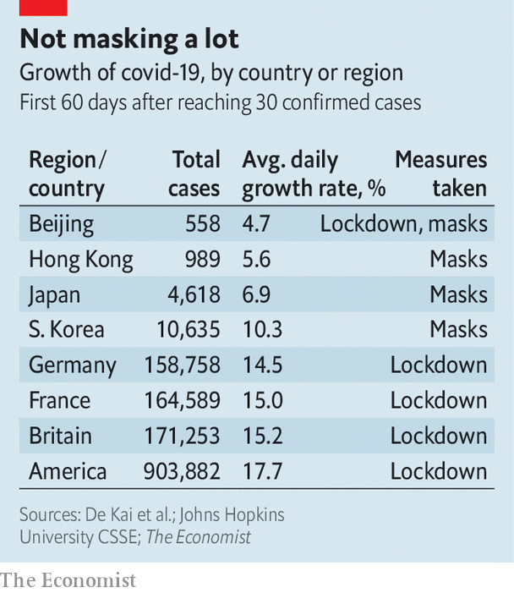

Neither laboratory studies nor the data on asymptomatic transmission provide watertight evidence of the efficacy of masks. That would need randomised controlled trials, in which one group wore masks and the other did not. This would be ethically tricky, since it might condemn one of the groups to a higher death rate. Hamsters, which are susceptible to covid-19, are the next best thing to people. So researchers at Hong Kong University put cages of healthy hamsters next to cages of infected ones, with a fan in between drawing air from the infected to the healthy cage. They sometimes also placed a stretched-out face mask in the air stream. With no interposed mask, two-thirds of the healthy animals were infected within a week. With a mask interposed close to the healthy hamsters (the equivalent of a healthy person wearing a mask), one-third were. With the mask close to the infected hamsters, only a sixth were.

Although scientists cannot experiment on human beings deliberately, some wonder if the world is now carrying out a natural experiment that tests the value of mask-wearing. In many East Asian countries it was common practice to sport masks, even before covid-19, to protect against respiratory diseases and pollution. A lot of people in these places therefore took immediately to wearing masks when the epidemic started. Countries that adopted masks early on did not, by and large, shut their economies down. Yet they suppressed the disease more effectively than those that locked down but did not wear masks.

There is a correlation between mask-wearing and rapid suppression of covid-19. According to Patricia Greenhalgh, professor of primary health care sciences at Oxford University, “there is not a single country in which mask wearing was introduced early and with high compliance, where the disease wasn’t quickly brought under control.” Sceptics point out that this does not prove masks work, since countries in which they are widely worn also tend to be those which have been threatened by epidemics in the past, and therefore have well-established systems of testing and contact tracing.

In the West nobody normally wears a mask, though the practice is spreading. Universal masking started in the Czech Republic after Petr Ludwig, a Czech YouTube star, posted a video on March 14th recommending the practice, and it went viral. Other social-media influencers posted pictures of themselves wearing masks. “Mask trees”, where people would hang home-made masks for others to use, sprang up on street corners. By March 19th masks were mandatory in the country. Slovakia and Slovenia followed swiftly.

The World Health Organisation has not advocated widespread mask-wearing, and has received some criticism for this. Jeremy Howard, a research scientist at the University of San Francisco and co-founder of Masks4all, a charity, says “they did a good job of recommending handwashing and social distancing, but they have been slow on masks.”

In light of all this, regulations requiring people to wear masks have spread, as an increasing number of governments view the evidence as strong enough to warrant compulsion. India now requires them to be worn in crowded public spaces, as do France, Germany, Italy and Spain. In most of the world, people either wear them in such spaces without being told to, or are required to by their governments.

Among big countries, Britain and America are outliers. In Britain the government advises people to wear masks, but to little effect. On the London Underground around a third of travellers do so. On the Paris metro where people risk a €135 fine if they fail to cover their faces, everybody does. In America the Centres for Disease Control and Prevention, which previously recommended mask-wearing only for health workers, changed its mind in early April. It now recommends that everybody should wear them in places where it is hard for people to stay far enough apart. Several states have passed regulations along those lines, as has New York City. But, as Governor Burgum noted, the rows go on.■

This article was downloaded by calibre from <https://www.economist.com/science-and-technology/2020/05/30/masks-probably-slow-the-spread-of-covid-19>

|  |  |  |  |
| --- | --- | --- | --- |
|  | Articles | Sections | Next |

|  |  |  |  |
| --- | --- | --- | --- |
| Previous | Articles | Sections | Next |

#### Antifouling technology

# A new robot may help keep ships’ bottoms clean

It stops shellfish and seaweed from growing

May 30th 2020 |

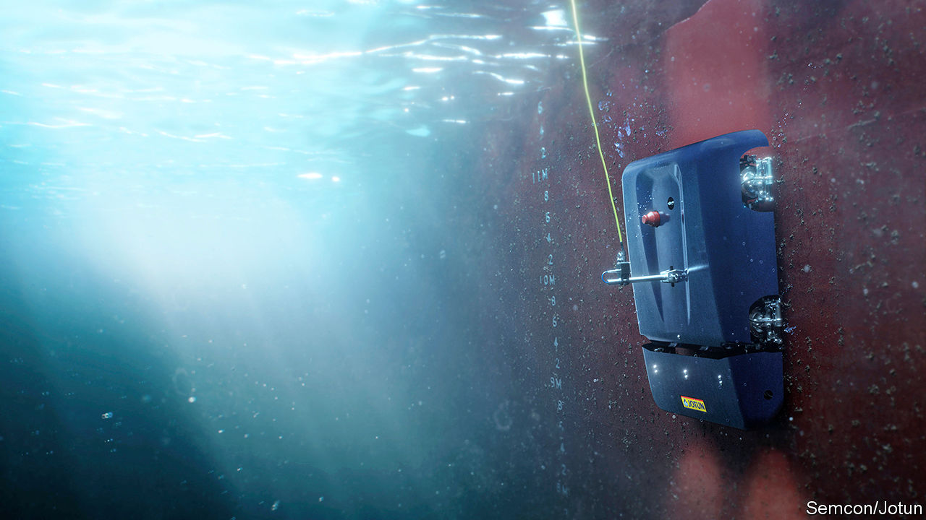

ALL SHIPS suffer from fouling: the build-up below the waterline of shellfish, seaweeds and other organisms. This causes drag, which slows the affected craft and increases its fuel consumption. Regular hull cleaning thus makes a considerable difference to the profitability of shipping. It also results in a useful reduction in the amount of planet-warming carbon dioxide emitted by the world’s merchant shipping—an industry that many environmentalists think is notoriously dirty and which could therefore do with burnishing its green credentials.

Roar Ådland, a shipping economist at the Norwegian School of Economics, in Bergen, says that a midsized oil tanker’s fuel consumption (and also, consequently, its emission of carbon dioxide) drops by around 9% after its hull is cleaned at sea—something that happens, on average, once every six or seven months. If the cleaning is done in a dry dock, which allows the process to be more thorough, that figure can be as much as 17%.

At the moment, cleaning at sea is done by teams of divers. In recent years, robots have sometimes been added to underwater cleaning crews, and have proved effective. Jotun, a Norwegian coatings company, and Semcon, a Swedish engineering firm, propose, however, to go one step further. They want to replace the divers completely with a machine. That machine, moreover, would not merely defoul a ship’s hull, but stop it fouling up in the first place.

HullSkater, as the consortium dub their invention, is a 200kg hull-crawling robot. It will reside permanently on-board ship, ready to be launched whenever the vessel is stationary—for example, when it is waiting in the roads outside a port for a berth to unload and load. To deploy the robot, it is first lowered overboard by a crane. Its four magnetic wheels, each of which is fitted with a motor, then clamp it to the hull and it can start trundling around. After this, the ship’s crew need do nothing. Wherever the vessel happens to be on the planet, the robot is piloted remotely by an operator on land, who may be half a world away, via a 4G phone connection.

Inspecting and cleaning a hull takes HullSkater between two and eight hours, depending on the size and design of the ship. The robot is fitted with special brushes that can probe the nooks and crannies of naval architecture—the areas around propellers, for example—and its four cameras provide its operators with a detailed view of what is going on, and also help to keep track of whereabouts on the hull the machine is.

The idea is to keep the hull permanently clean, by regularly removing from it the layers of slime-producing bacteria that are the first stage of the fouling process. Bacterial biofilms, as these layers are known technically, are used as anchorages by the larvae of so-called “hard growth” organisms, such as barnacles and molluscs, and by the spores of trailing seaweeds.

An absence of biofilms means fouling will never get going in the first place. Jotun claims that regular pre-emptive cleaning in this way of a typical bulk carrier will result in a continuous reduction in that ship’s fuel consumption of 12-13%, as opposed to the episodic reductions brought about by current cleaning regimes. This translates into a saving of 4,000 tonnes of oil a year, and a concomitant reduction of around $800,000 in fuel bills.

A bonus of all this effort is that an unfouled ship has little risk of carrying unwanted passengers in the form of alien animal species that might make a nuisance of themselves if they were to become established far from home. Asian paddle crabs, North Pacific seastars, Asian green mussels and European fan worms are four common hull-fouling animals that can turn into pests if introduced into the wrong settings.

That can easily happen with conventional cleaning-by-diving, because this leaves a mass of debris floating in the water and on the seabed which can harbour such undocumented migrants. Many ports have therefore introduced restrictions on what sorts of hull cleaning can be carried out in their waters. Widespread adoption of the International Maritime Organisation’s biofouling guidelines, which require an assessment of the risks associated with any cleaning carried out while afloat, is likely to tighten things up still further, so new cleaning methods are desirable.

The HullSkater approach is not perfect. Regular cleaning by robot could, the makers admit, wear away some types of antifouling coating, thus limiting the process’s efficacy. Jotun has, however, developed a special, hard-wearing coating, which it plans to sell in conjunction with the robot, to minimise this problem.

HullSkater is now being tested in various parts of the world (for rates of fouling depend on local conditions, such as sea temperatures), and the plan—at least at the moment—is to roll it out commercially this summer. If that is a success, according to Hans Peter Havdal, Semcon’s general manager, the next stage will be to develop a family of such robots, designed for ships of different sizes and types. Ideally, these will have higher levels of autonomy than HullSkater. They may even be able to learn the shape of the hull they have been designated to keep spick and span, and thus get on with the job unsupervised.■

This article was downloaded by calibre from <https://www.economist.com/science-and-technology/2020/05/30/a-new-robot-may-help-keep-ships-bottoms-clean>

|  |  |  |  |
| --- | --- | --- | --- |
| Previous | Articles | Sections | Next |

|  |  |  |  |
| --- | --- | --- | --- |
| Previous | Articles | Sections | Next |

#### Space flight

# Crew Dragon’s launch is postponed

The weather was unpropitious

May 30th 2020 |

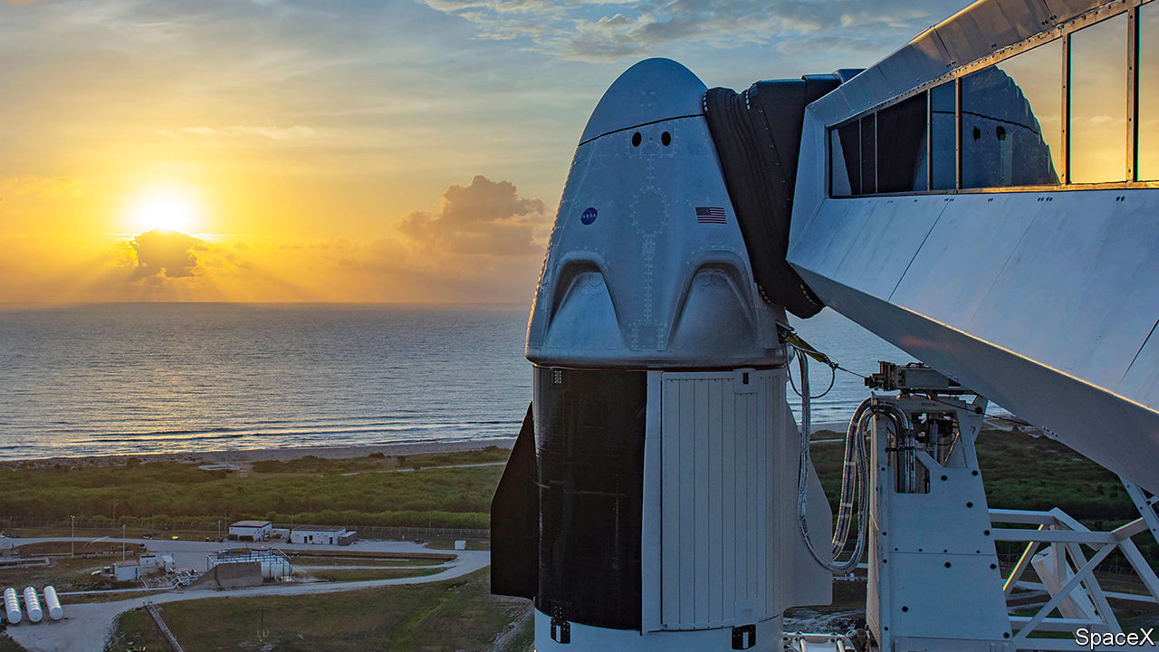

THE WORLD WILL have to wait a little longer for the first launch of human beings into space in a craft not run by a national government. Crew Dragon (pictured) is designed, built and operated by SpaceX, a private firm founded by Elon Musk—as is the Falcon 9 rocket its sits on. This was intended to carry it into orbit for a rendezvous and docking with the International Space Station after a lift-off from the Kennedy Space Centre at Cape Canaveral, Florida, on May 27th. It would have been the first crewed launch from American soil since the final Space Shuttle flight nine years ago, but it was scrubbed shortly before lift-off because of bad weather, and has been rescheduled for May 30th.

This article was downloaded by calibre from <https://www.economist.com/science-and-technology/2020/05/30/crew-dragons-launch-is-postponed>

|  |  |  |  |
| --- | --- | --- | --- |
| Previous | Articles | Sections | Next |

|  |  |  |  |
| --- | --- | --- | --- |
| Previous | Articles | Sections | Next |

#### Crackle, pop, snap

# Self-destructing glue solves a sticky environmental problem

Superannuated objects can now be taken to pieces more easily

May 30th 2020 |

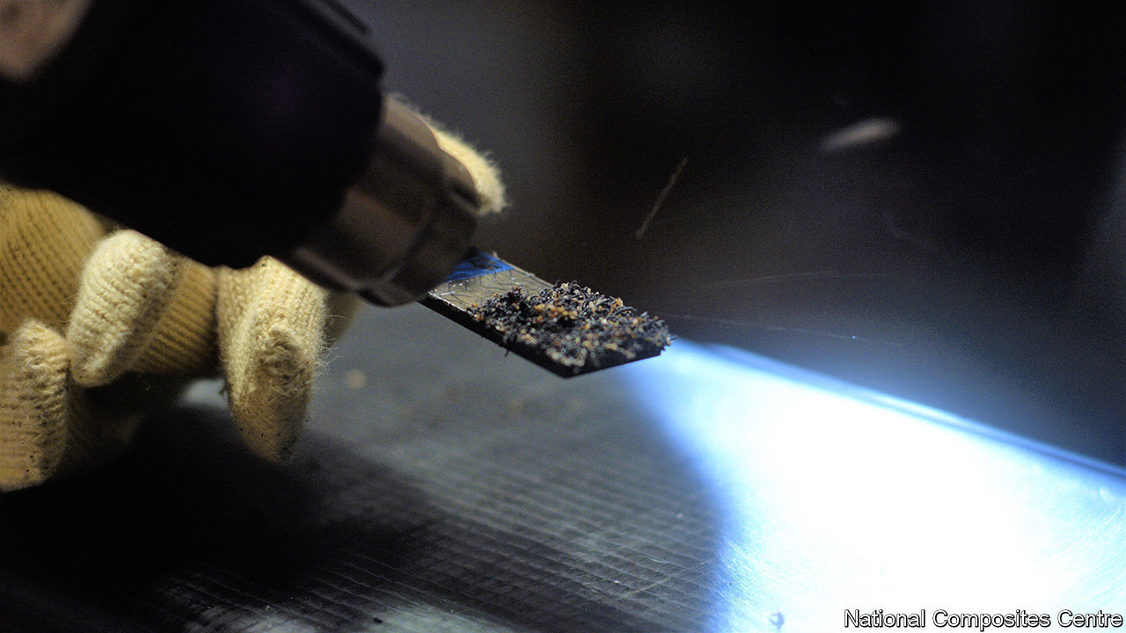

GLUE THAT deliberately comes unstuck sounds like a joke. But it is useful to be able to take things to pieces for recycling once their lives are over, so adhesive that becomes unadhesive on command could be valuable. James Broughton, a chemist at Oxford Brookes University, in Britain, thinks he has just the things. The inventions he and his colleagues have come up with are not new glues, per se, but rather “disbonding” agents that can be put into existing glues to break their grip when it is no longer needed.

In the past, when the components of machines like cars and aircraft were made mainly of metal, welding and soldering were the principal ways of joining them together. But the spread of plastics—and particularly of composites like glass fibre and carbon fibre—means that glued joints are much more common than they used to be. Effective recycling requires materials to be sorted and processed separately. Taking an object to pieces is the first stage of doing that. Recycling things that have been glued thus involves disbonding the glue.

Dr Broughton’s disbonding agents are called expandable graphite and thermally expandable microspheres. Expandable graphite is a powdery substance in which graphite’s famously flat and slippery carbon sheets are interspersed with sulphuric acid. When an adhesive containing this additive is heated appropriately, the acid decomposes into three gases: sulphur dioxide, sulphur trioxide and steam. That forces the graphite layers apart. This expansion, Dr Broughton observes, acts as a crack initiator. It breaks up the glue and frees the joined components.

Thermally expandable microspheres, by contrast, are plastic bubbles, ten microns across, that are filled with a hydrocarbon such as butane, pentane or octane. When solidified glue containing these bubbles is heated appropriately the hydrocarbon expands, inflates the bubbles and, as happens with expandable graphite, cracks the glue.

The crucial phrase in all this is “heated appropriately”. Dr Broughton and his colleagues have had to pick substances that do their stuff at a temperature sufficiently high as not to be encountered during a machine’s normal operation, but sufficiently low that it will not damage the components to be disbonded when they are heated up to disbond them—which may be done either in an oven or by using a hot-air gun that resembles a souped-up hair dryer.

In this context, having two approaches provides flexibility. Expandable graphite’s disruptive effect is triggered at a slightly higher temperature (160°C) than the 125°-150°C which causes the microspheres to inflate. (The exact behaviour of a microsphere depends on which hydrocarbon is inside it.) This process is, moreover, surprisingly quick. Dr Broughton’s colleague Lucy Eggleston, who works at the National Composites Centre, in Bristol, says that after a mere six seconds of heating, “the components just pop apart”.

Disbonding of this sort might have wide application. But one particular prize the team have in sight is the wind-turbine market. Turbine blades typically have glass-fibre skins, balsa-wood cores and metal or carbon-fibre spars. That makes them ideal candidates for disbonding at the ends of their lives. In Europe alone, 14,000 wind-turbine blades will be decommissioned over the next five years. For these, disbonding comes too late. They will, though, need to be replaced—and the green credentials of wind-farm operators would certainly be burnished further if those replacements were designed for easy recycling.■

This article was downloaded by calibre from <https://www.economist.com/science-and-technology/2020/05/30/self-destructing-glue-solves-a-sticky-environmental-problem>

|  |  |  |  |
| --- | --- | --- | --- |
| Previous | Articles | Sections | Next |

|  |  |  |
| --- | --- | --- |
| Science & ... | Sections | Economic & ... |

Books & arts

Artistic posterity: Still lives

.

Power in America: Clash of the titans

.

European history: A breed apart

.

The story of a cult novel: Perish and publish

.

Johnson: They can feel it all over

.

Home Entertainment: Damn fine coffee

.

Home Entertainment: Will to power

.

|  |  |  |
| --- | --- | --- |
| Science & ... | Sections | Economic & ... |

|  |  |  |  |
| --- | --- | --- | --- |
|  | Articles | Sections | Next |

#### Still lives

# It takes planning, not just talent, to be remembered as a great artist

Marketing the work of dead artists is increasingly big business

May 28th 2020 |



SOPHIE TAEUBER-ARP may be the most influential artist you’ve never heard of. Her joyously colourful geometric paintings, her elaborate dance routines and gift for sculpture, textile design (see picture) and architecture put her at the centre of the Dada movement in the 1920s. She was a close friend of Jean Cocteau and Marcel Duchamp. Then, in 1943, she died of carbon-monoxide poisoning from a badly installed stove in the Swiss home of a fellow artist. She was 53.

Her career was eclipsed by that of her husband, Hans Arp, who lived until 1966. The art market has all but ignored her. In the past quarter-century only seven of her paintings and six sculptures have come up for sale. Amid soaring prices, her auction record has been stuck since 2003.

All that is set to change. Hauser & Wirth, a leading commercial gallery, will now be representing Taeuber-Arp’s estate. As a first step a major travelling retrospective will open next spring, pandemic permitting, at the Kunstmuseum Basel. It will then go on to Tate Modern in London before appearing at the Museum of Modern Art (MOMA) in New York in 2022.

The conscious shaping and building of artists’ legacies is a recent trend. For centuries lasting artistic fame was a haphazard prospect, depending on myth and connections as well as talent. Johannes Vermeer was unknown for two centuries after he died in 1675, until Édouard Manet and Camille Pissarro noticed his quiet painterly eye. Vincent van Gogh sold only one picture before killing himself in 1890, but later became a megastar. By contrast, G.F. Watts, the Englishman who made the bronze equestrian statue called “Physical Energy” in Hyde Park, was one of the most famous artists of the Victorian age. He died in 1904 and his reputation has sunk ever since.

An important shift occurred after Mark Rothko, one of the great American abstract expressionists, committed suicide in 1970. Rather than seeking separate help with his artistic legacy, Rothko had entered into an agreement with his financial adviser, who after his death secretly sold much of his work on the cheap to the Marlborough Gallery. Rothko’s children sued, and Marlborough and the artist’s executors were eventually ordered to pay $9.2m in damages. But it took over a decade before Rothko’s dealer, Pace Gallery, began representing the estate. In 12 shows held since, Pace’s founder, Arne Glimcher, has demonstrated the breadth of Rothko’s vision, from his surrealism to his darkest murals. In 2012 Christie’s sold one of his works for $86.9m.

## Death becomes them

The Rothko case highlighted the risks for artists of not thinking clearly enough while they can about life after death. Galleries began advising the heirs of people they represented while those artists were alive. As the market in post-war and contemporary art has boomed, artists’ estates have become big business. These days some galleries tout for estate work; some even poach estates from others by winning over executors. About a third of the 90 or so artists represented by Hauser & Wirth are dead; it has signed up 12 estates in the past four years. Pace has 30, including Rothko’s; David Zwirner has 24 and Gagosian 16.

Before they map out exhibitions to show off dead artists, galleries commission a scholarly survey to pin down the location of every piece they made. The aim is to ensure that a supply is available for sale or “placing”, as they prefer to call the essential business of securing representation in the best museums and private collections.

Their most creative contribution lies in conjuring up a “context” for the deceased—fashioning a narrative for today’s viewers, helping them reassess the past through the lens of the present, so that the artists fit into a familiar pantheon. “Art history likes to put a label on people,” says Iwan Wirth. “If people can’t find that label, it’s very hard. You need to be able to tell a story.”

To help it develop compelling contexts, Hauser & Wirth represents clusters of connected artists, such as Taeuber-Arp, her husband and Max Bill (in whose house she died). Zwirner is expert at drawing out links and influences, ushering collectors from the blue paintings of Ad Reinhardt to the monochrome geometry of Josef Albers to the grey corrugated sculptures of Jan Schoonhoven, and on to the minimalism of Donald Judd and Dan Flavin, all of whose estates the gallery represents.

Gagosian uses its reach to put on museum-quality shows devoted to periods of an artist’s output that may have been overlooked. Its exhibition in 2009 of Picasso’s “Mousquetaire” paintings, long derided as the mud-coloured final scribblings of a lazy old man, reshaped how these works—many made in a day—are seen. (The gallery does not represent Picasso’s estate, but works closely with his heirs.) As collectors were coaxed by Gagosian into wanting a late Picasso, prices surged. On average, these pieces fetched two-thirds more at auction in the decade after the “Mousquetaire” show than in the one before it.

Galleries are often paid a flat fee to represent an estate. As they become the go-to outlet for an artist’s work, they also make commissions buying or selling it for others. Since 2018, when Zwirner took on the estate of Joan Mitchell (who died in 1992), it has sold more than 20 of her paintings, almost half consigned by the estate and the rest by other collectors. Her auction record is now $16.6m, having barely scraped $10m before Zwirner took charge.

Prices are only one way to measure the impact of legacy management. Another is exposure—or the lack of it. Scott Burton, an innovative American sculptor, left his estate to MOMA when he died of AIDS in 1989. But the museum has hardly ever promoted his work, and today he is virtually forgotten. Clyfford Still, a great but curmudgeonly abstract expressionist, avoided dealers and insisted on selling his work himself. When he died in 1980 he left 825 paintings and more than 1,500 works on paper to whichever American city would build a museum to him alone (stipulating that it have neither a shop nor a café). For over 30 years his art was locked away; only since 2011, when the Clyfford Still Museum opened in Denver, has it been shown regularly. Even now, though, there is hardly any market in Still’s work.

In their quest to do better by estates and reputations, the big galleries’ focus has thus far been on Still’s fellow abstract expressionists, the long-undervalued Italian modernists and the 20th-century Brazilian women now gaining world renown. The results have piqued the interest of living artists and set off a search among the dead for candidates deserving the same treatment—such as the post-war Japanese Gutai movement, or once-neglected African-American artists who have recently come to prominence. “We’re looking at opportunities that never existed before,” says Allan Schwartzman, an art adviser based in New York. “We’re just at the beginning.” ■

This article was downloaded by calibre from <https://www.economist.com/books-and-arts/2020/05/28/it-takes-planning-not-just-talent-to-be-remembered-as-a-great-artist>

|  |  |  |  |
| --- | --- | --- | --- |
|  | Articles | Sections | Next |

|  |  |  |  |
| --- | --- | --- | --- |
| Previous | Articles | Sections | Next |

#### Clash of the titans

# When Theodore Roosevelt took on John Pierpont Morgan

Two giants of American history do battle, and co-operate, in “The Hour of Fate”

May 30th 2020 |

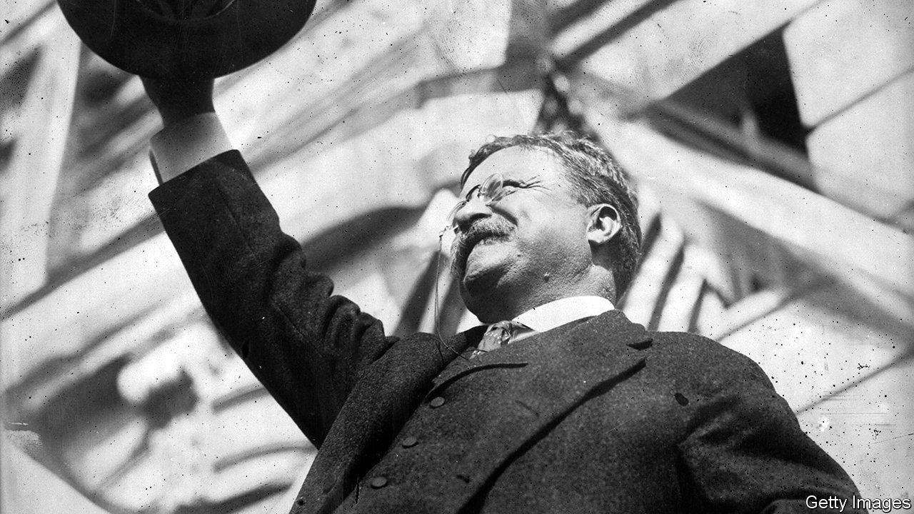

The Hour of Fate. By Susan Berfield. Bloomsbury; 416 pages; $30.

MOST AUTHORS might be content to write about either John Pierpont Morgan, possibly the world’s most famous banker, or Theodore Roosevelt (pictured), one of America’s best-loved presidents. But “The Hour of Fate” by Susan Berfield is richer for tackling them together. Set during Roosevelt’s first term, which saw the pair locked in battle, then co-operate to resolve a national crisis, her book vividly brings both men to life.

The story begins with the assassination of President William McKinley, which ended his business-friendly administration on September 14th 1901. Mark Hanna, a steelmaker, senator and adviser to McKinley, had warned that if Roosevelt became vice-president there would be “only one life between that madman and the presidency”. Bosses and financiers across America, including Morgan, echoed that concern when he inherited the top job. “I am afraid of Mr Roosevelt because I don’t know what he’ll do,” the banker reportedly said. “He’s afraid of me because he does know what I’ll do,” reckoned Roosevelt.

The book focuses on two linked events that thrust them together. In the first, Roosevelt shines as he doggedly dismantles Northern Securities, a coal and railroad behemoth that Morgan and other bigwigs put together in 1901 (the president used the new Sherman Antitrust Act, which has vexed big business ever since). The zenith of Roosevelt’s first term, in which he earned his stripes as a trustbuster, was the Supreme Court’s decision in 1903 to uphold the break-up.

Tales of hubristic tycoons being brought to heel often make for enjoyable reading. But Ms Berfield’s second event demonstrates how all-mighty Morgan had become. The coalminers’ strike of 1902 dragged on for months, despite Roosevelt’s desperate interventions. Ms Berfield describes how, as fuel supplies ran out, a school burned oil-soaked railroad sleepers to keep its pupils warm. New Yorkers sheltered in their homes; a shivery winter loomed. In October, when Roosevelt’s only remaining option seemed to be to send in the troops, Morgan went to Washington and—in an “hour of fate” that gives the book its title—brokered a peace.

Not long ago, this description of a crisis that closed schools and factories would have seemed an outlandish relic; today, the parallels with the pandemic-stricken economy are stark. Meanwhile, in her epilogue the author notes that although Roosevelt’s rhetoric about “malefactors” might sound outdated, his message of the need for corporate oversight might have been delivered by Elizabeth Warren. Wisely, Ms Berfield resists the temptation to dwell on such analogies. Her stories make her case.

This article was downloaded by calibre from <https://www.economist.com/books-and-arts/2020/05/30/when-theodore-roosevelt-took-on-john-pierpont-morgan>

|  |  |  |  |
| --- | --- | --- | --- |
| Previous | Articles | Sections | Next |

|  |  |  |  |
| --- | --- | --- | --- |
| Previous | Articles | Sections | Next |

#### A breed apart

# The Habsburgs’ marriages consolidated lands as well as faulty genes

European history is unimaginable without the once-imperious family

May 30th 2020 |

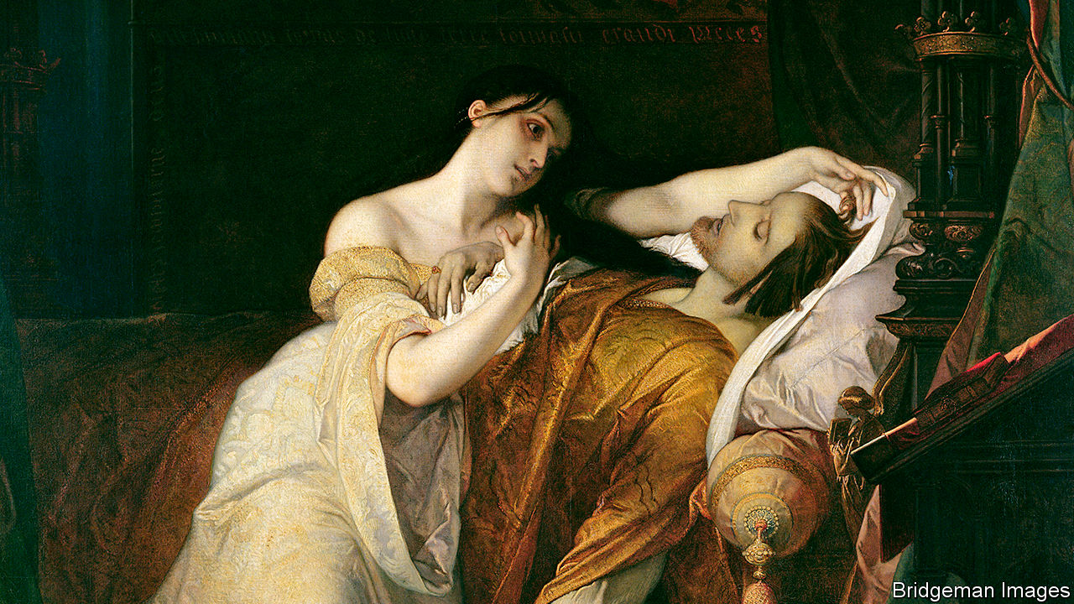

The Habsburgs. By Martyn Rady. Allen Lane; 416 pages; £30. To be published in America by Basic Books in August; $32.

THERE WERE early hints that the union of Philip of Habsburg with Juana the Mad (pictured) in 1496 might not be a happy one. It says a lot about the aristocracy of the era that the main problem came less from the bride’s line than from the groom’s: Philip counted among his ancestors such unpromising genetic material as Albert the Lame, Leopold the Fat and, in an age that excelled in the honest epithet, Frederick of the Empty Pockets.

Sure enough, the union proved disastrous. Eventually its worst sufferer was Don Carlos, the couple’s deformed and mentally delusional great-grandchild, in whom ancestral inbreedings echoed. The family anxiously treated its young heir to the most sophisticated medical cures then available but, despite being made to share a bed with the wizened body of a mummified saint, Don Carlos did not recover. Nor did the reputation of the Habsburgs.

Martyn Rady’s new book is billed as “the definitive history” of the clan. Not, it must be said, a hotly contested title. Once the names of Europe’s most powerful families—the Bourbons and Battenbergs and Garibaldis—were known across the world. Today, beyond the biscuit tin, they are largely forgotten.

Except, that is, for their eccentric matchmaking. If you have ever wondered why marrying your uncle is inadvisable, the Habsburgs can enlighten you. For centuries they experimented with marriages between first cousins, second cousins and cousins so multiply intertwined that the traditional familial vocabulary breaks down. A mother might double as a cousin; the wife of Leopold I referred to him throughout their marriage as “Uncle”.

The result was less a family tree, branching and widening, than a convoluted web. At one point the mortality rate of Habsburg children reached 80%, four times the average of the time. Of those who lived, many were hideously misshapen, with the infamous drooping lip and jutting Habsburg jaw. It is one of the abiding puzzles of European history that its aristocrats, so good at breeding horses, should have been so bad at breeding themselves.

However, the same marriages that consolidated faulty genes also consolidated lands. A list of the territories ruled by Charles V in 1521 notes that he was “King in Germany, of Castile, Aragon, Leon...”; the text runs to 13 further lines and still ends with a breezy “etc”. Look at a map of Europe between the 13th and 17th centuries and you see Habsburg territory spread, glacially slow but relentless, until a vast proportion of the continent was covered.

Like a glacier, their rule could have a chilling effect on the lands beneath it. Voltaire famously pointed out that the Holy Roman Empire was neither holy, nor Roman, nor an empire; but the Habsburgs, who presided over it for more than 300 years, often had other ideas. In the 16th century Philip II, convinced he had a divine mission to preserve Catholicism, exported the Spanish Inquisition to the New World. It did its job so effectively that even tattoos were censored. Over that entire century the output of the printing presses in Lima and Mexico City was limited to fewer than 200 titles, most unbearably dull.

In recounting these stories, Mr Rady may at times overestimate his readers’ familiarity with his material and, perhaps, their appetite for it. “Leopold I”, he writes, “is often criticised for spending too much on opera and too little on architecture, but this is unfair”—a useful corrective to the Leopold-and-opera camp but less interesting for others. Elsewhere his book seems exhaustive as much as definitive.

Nonetheless, it has fascinating moments. The story of the Habsburgs, whose last emperor died in 1922, is indelibly inscribed in European history. Dante popped a Habsburg in his Purgatory, Titian immortalised them and Velazquez painted for them. The creator of the original Mechanical Turk made his metaphor to amuse them. Pre-20th century Europe is unthinkable without the Habsburgs—as indeed is 20th-century Europe. For on June 28th 1914 a Habsburg named Archduke Franz Ferdinand got into an open-topped car and went for a drive in Sarajevo. ■

This article was downloaded by calibre from <https://www.economist.com/books-and-arts/2020/05/30/the-habsburgs-marriages-consolidated-lands-as-well-as-faulty-genes>

|  |  |  |  |
| --- | --- | --- | --- |
| Previous | Articles | Sections | Next |

|  |  |  |  |
| --- | --- | --- | --- |
| Previous | Articles | Sections | Next |

#### Perish and publish

# Behind the scenes of “A Confederacy of Dunces”

“I, John Kennedy Toole” tells the story of a cult novel and its ill-starred author

May 30th 2020 |

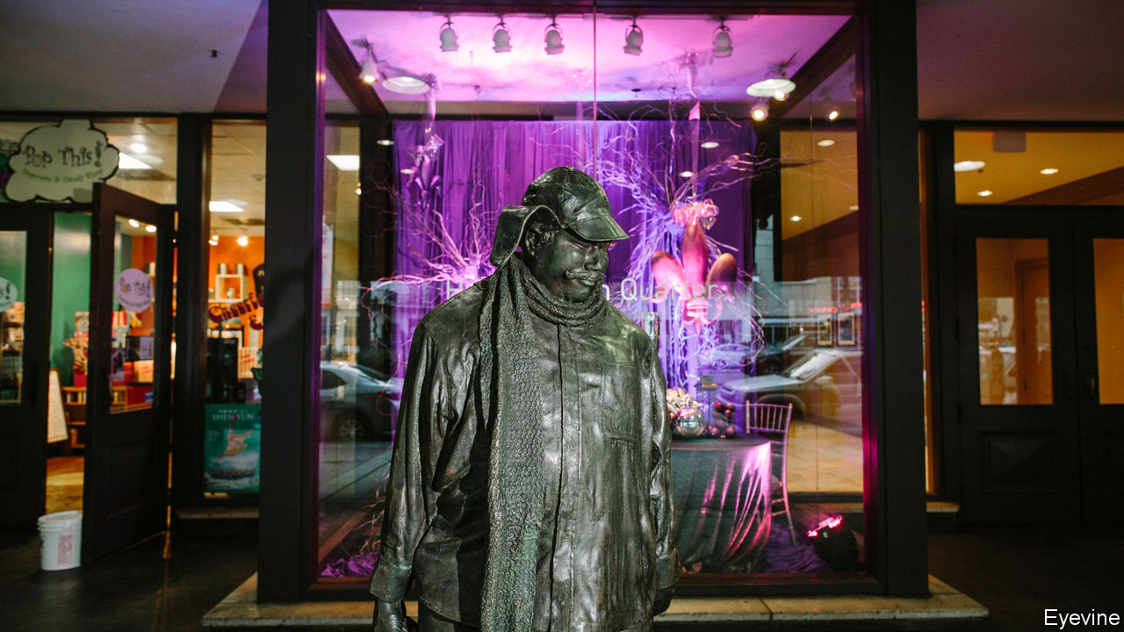

I, John Kennedy Toole. By Kent Carroll and Jodee Blanco. Pegasus Books; 256 pages; $25.95 and £20.

SLOTHFUL, FLATULENT and imperious, Ignatius Reilly was a wholly original anti-hero when he burst from the pages of “A Confederacy of Dunces” in 1980. American readers fell in love with this bloated, hapless misanthrope in a green hunting cap, and the bestselling comic novel won a Pulitzer—one of the few times the prize has been awarded posthumously. Distressed by a publisher’s rejection, haunted by paranoid thoughts and oppressed by the obligation to support his enfeebled father and overbearing mother, the author, John Kennedy Toole, had gassed himself in his car near Biloxi, Mississippi in 1969. He was 31.

The mythology around the man and his book has led to several biographies, a couple of plays and a few doomed screen adaptations. Steven Soderbergh, the latest film-maker to give up, called the project “cursed”. Now comes “I, John Kennedy Toole”, a fictionalised portrait of the short-lived author, by Kent Carroll, who as an editor at Grove Press helped bring “Confederacy” to light, and Jodee Blanco. They had planned to write another biography, but found Toole an elusive subject. Few of his papers, or his acquaintances, were still around. After years searching for answers to key questions—why exactly did Toole kill himself? Was he working on another book?—they decided to use artistic licence to fill in the gaps.

Theirs is a work of fiction, but it sticks to the known facts. Toole is a handsome academic star and “gentleman’s gentleman”, with refined southern manners and regular bouts of depression. An only child, he felt burdened by his demanding mother, Thelma, who saw him as her one shot at greatness. An army draft interrupted his literature PhD at Columbia University in 1961, but also gave him space to write. He moved back to New Orleans, the heart of his novel, where he lived with his parents, paid their bills by teaching at a local college and finished his manuscript.

He sent his book to Robert Gottlieb, an editor at Simon & Schuster who had published Joseph Heller’s “Catch-22”. Mr Gottlieb admired Toole’s wit and verve, but asked that he trim the story and sharpen the plot. He tried to be encouraging, but, after Toole spent years tinkering, his rejection of the final draft (“It isn’t really about anything”) stung.

The young author began drinking heavily, putting on weight and behaving erratically. Friends noticed that he was talking to himself, and students complained about his rants. Then, in January 1969, he set off in his car, and was found dead two months later. Ms Blanco and Mr Carroll suggest Toole killed himself to allow his characters to live on. “He loved so many writers who found fame only after they died,” says Ms Blanco. But no suicide note survives, so it is impossible to know for sure. Ms Blanco suspects Toole’s mother, who otherwise kept every postcard and clipping, burned the note to preserve the legend of her golden boy.

Just how “Confederacy” came to be published is a story Walker Percy, himself an acclaimed southern writer, partly tells in a foreword he wrote for the novel. In the mid-1970s Thelma hounded him to read the manuscript, which many publishers had already rejected. Percy intended to scan a few pages and tell her to push off—but the book was too good to put down.

Eventually, he convinced Louisiana State University (LSU) Press to publish the novel in a small, untrumpeted print run. It found fame largely because LSU offloaded the paperback rights to Mr Carroll, who knew he had a winner on his hands and had the savvy to sell it. “I was just entranced,” he recalls. Millions of copies are now in circulation in dozens of languages.

For a tribute to such an original writer, “I, John Kennedy Toole” is a straightforward effort. You can imagine Ignatius dismissing the workmanlike prose for its “lack of theology and geometry”. But given the aura around Toole’s life, it is a pleasure to spend some time with him, if only to rue the books he never had a chance to write. ■

This article was downloaded by calibre from <https://www.economist.com/books-and-arts/2020/05/30/behind-the-scenes-of-a-confederacy-of-dunces>

|  |  |  |  |
| --- | --- | --- | --- |
| Previous | Articles | Sections | Next |

|  |  |  |  |
| --- | --- | --- | --- |
| Previous | Articles | Sections | Next |

#### Johnson

# Is music a language, as Stevie Wonder sang?

A comparison between the two illuminates what is special about both

May 30th 2020 |

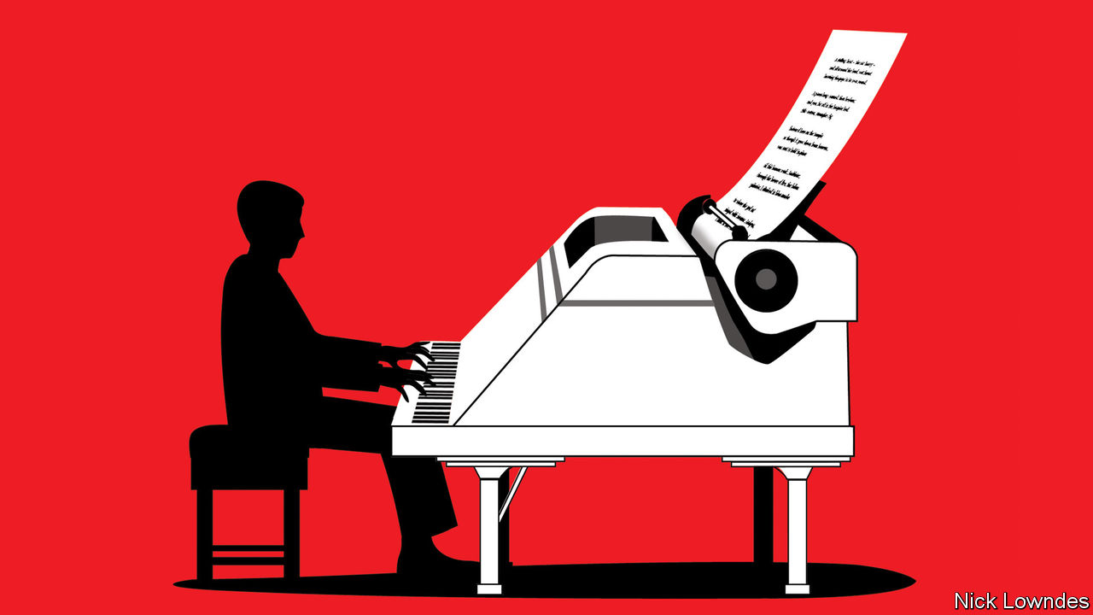

ONE OF THE liveliest debates in linguistics is over whether all languages share fundamental properties. If so, perhaps language is a universal feature of evolution. To find out, scholars have looked to other universal features, and one in particular: no society on Earth lacks music. The comparison illuminates what is special about both.

Music and language seem intimately linked, but how? Did language start with song, as Darwin believed? Or is music “auditory cheesecake” that developed from language and other useful faculties, as Steven Pinker, a Harvard psychologist, has said? Is music itself a language, as Stevie Wonder intoned? Might the two be fundamentally the same?

Some similarities are obvious. Both can utilise the unique human vocal tract. Both have a kind of beat. Both can express emotion. Both can be either carefully composed or spontaneously improvised. And both are highly social. Although the origin of music is unclear, it seems likely to have involved celebration, communal worship or martial inspiration and co-ordination.

At a structural level the parallels are striking, too. With a finite set of notes or words, and a finite set of rules, an inexhaustible variety of novel melodies or sentences can be created. This “discrete infinity” is often said to be the hallmark of human language. Animal communication, by contrast, is only able to convey a limited number of thoughts (the location of a source of food, for example, or the presence of a predator).

Aniruddh Patel of Tufts University has argued that music and language, rather than being essentially the same, rely on the same bit of the brain. In an experiment he presented his subjects with a sentence that contained a grammatical trick (“The scientist confirmed the hypothesis was being studied in his lab”), revealing one word at a time. The subjects were to press a button for each word at their own pace. Many paused at the unexpected “was”. “The scientist confirmed the hypothesis” seemed a complete sentence.

They also heard music as they performed this exercise. Some were treated to a new chord in a pleasing progression with every word that was revealed. Others heard a jarring chord at the moment they reached the trick word “was”. Both groups slowed down—but those given the discordant notes did so much more. Mr Patel hypothesises that this is because sentence structure, and the structure of the harmony, draw on shared, limited resources in the brain.

For all the overlap, there are big differences. Both music and language can make you feel and even think, but only language is truly propositional. A quip attributed to Bertrand Russell—“no matter how eloquently a dog may bark, he cannot tell you that his parents were poor but honest”—might be adapted for music. Language can express contingencies, pose counterfactuals and talk about the future. Music’s nuances are of a different order.

Another stark contrast lies in the range of human aptitude for each ability. Nearly all children produce complex sentences by the age of three and become fluent speakers just a few years after that. As adults, they create striking and novel utterances every day. Conversely, only a minority of adults are talented musicians; even fewer are skilled composers of new, hitherto unheard works.

Victor Wooten, a bass player and music teacher, has an explanation for that disparity. Children, he points out, learn to talk by being constantly surrounded by linguistic virtuosos—fluent older speakers who, in musical parlance, are “jamming” with the novices almost from birth. Their fumbling efforts are encouraged. On the other hand, students of music often keep company with other beginners, and are stopped every time they make a mistake.

It is not that simple, reckons Jay Keyser, an emeritus professor of linguistics at the Massachusetts Institute of Technology and a jazz trombonist. For him, music is not like spoken prose, which almost everyone can do proficiently, but instead resembles a specific, rhythmic form of language: poetry. And, he says, “most human beings are bad at poetry.” The number of grammatical sentences is vast. But the number that are fit for verse, in terms of both meaning and prosody, is much smaller. Finding those is hard—like composing music, or improvising jazz.

On Mr Keyser’s plausible view, using ordinary language is a less rarefied talent than making music. But while it may not instil wonder and joy, as music can, it is still a miracle—just an everyday one.

This article was downloaded by calibre from <https://www.economist.com/books-and-arts/2020/05/30/is-music-a-language-as-stevie-wonder-sang>

|  |  |  |  |
| --- | --- | --- | --- |
| Previous | Articles | Sections | Next |

|  |  |  |  |
| --- | --- | --- | --- |
| Previous | Articles | Sections | Next |

#### Home Entertainment

# The world of “Twin Peaks” chimes eerily with the mood of the lockdown

In David Lynch’s show, as in quarantine, time moves at a different pace

May 30th 2020 |

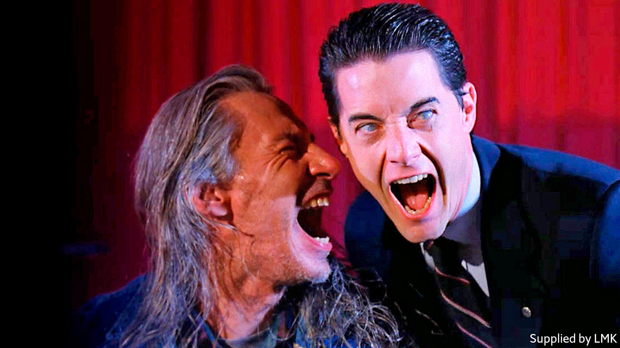

AFTER MONTHS of quarantine even the most unremarkable household fixtures may acquire numinous qualities—the ominous front door, say, or the beckoning fridge. That the mundane can be pregnant with mystery is an item of faith for David Lynch, co-creator (with Mark Frost) of “Twin Peaks”, a television drama first broadcast 30 years ago. No wonder that, according to American viewing figures, a fresh generation is discovering its delights.

“Twin Peaks” is set in a small town in Washington state, full of timber-bearing trucks, big skies, shimmering waterfalls and obscure secrets. A quest to find the killer of Laura Palmer, a high-school homecoming queen with a dark side, propels the narrative. But it is the extraordinary array of characters, scenes and motifs that capture the imagination.

Dale Cooper (Kyle MacLachlan), the coffee-loving FBI agent charged with solving the murder, blends lovable earnestness with a deep sense of moral purpose. Killer BOB, a murderous demon played by a set hand who caught Mr Lynch’s eye, haunted the nightmares of viewers for years. The series’ most captivating sequence, a spooky dream in which Cooper encounters a backwards-talking dwarf with a taste for snappy jazz, was memorable enough to earn a caricature on “The Simpsons”.

The defining feature of “Twin Peaks” is its seamless switching of registers, from melodrama to horror to police procedural, sometimes within a single scene. Angelo Badalamenti’s masterful soundtrack, slipping joyously from ominous synth patterns to groovy bebop, pulls off the same feat. Almost everything is suffused with what David Foster Wallace, an author and fan, called “ambient spiritual antimatter”. It is there in the sound design, the eccentric plot lines and especially in Mr Lynch’s patient, inquisitive camerawork, which invests everyday images—traffic lights changing from green to red, a rotating ceiling fan—with an almost mystical aura.

Few shows have been more influential. The lesson of “Twin Peaks”—that respecting the audience’s intelligence can reap rewards—inspired “The Wire” and “The Sopranos”. Its fusion of the quotidian and supernatural recurs in “The X-Files” and “Stranger Things”. Its stature has only grown over the years, spawning all the paraphernalia of the cult classic, from fan conventions to all-night watch parties (Mr MacLachlan hosted a virtual one in April).

Mr Lynch’s own interest waned after the suits at ABC, the network that first aired the programme, forced him to identify Laura’s killer part-way through the second season; so did the quality of the drama. A third season, broadcast in 2017, contains flashes of brilliance but its experiments test the patience. Highlights include a three-minute segment of a barman sweeping up peanut shells. In Mr Lynch’s world, as in a lockdown, time operates at a different pace. ■

This article was downloaded by calibre from <https://www.economist.com/books-and-arts/2020/05/30/the-world-of-twin-peaks-chimes-eerily-with-the-mood-of-the-lockdown>

|  |  |  |  |
| --- | --- | --- | --- |
| Previous | Articles | Sections | Next |

|  |  |  |  |
| --- | --- | --- | --- |
| Previous | Articles | Sections | Next |

#### Home Entertainment

# Take over the world in “Civilization”

In the video game, at least, your fate, and the world’s, are in your hands

May 30th 2020 |

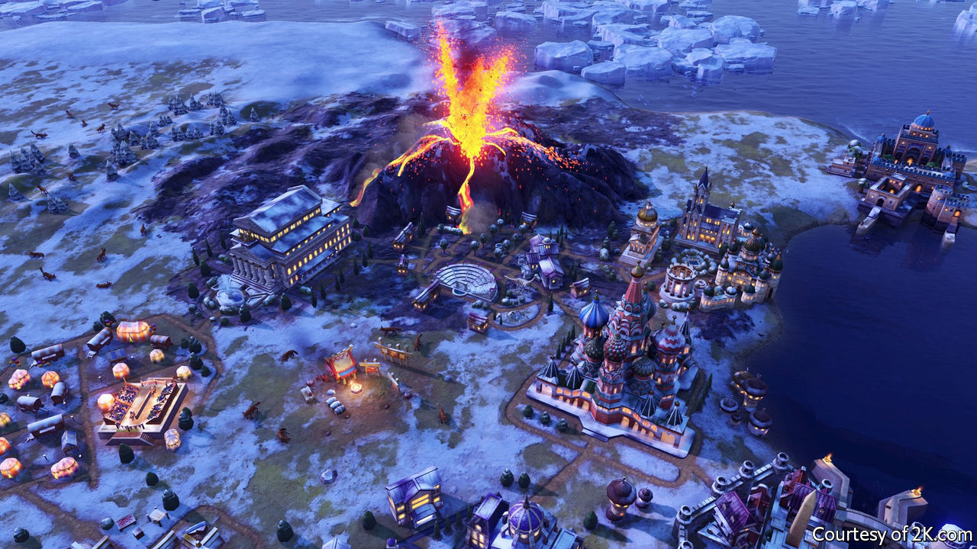

FOR MAX WEBER, a German social theorist, it was the Protestant work ethic that powered capitalism and thus Europe’s success in conquering the world. In “Guns, Germs and Steel” Jared Diamond thought the key to dominance was geography. For Daron Acemoglu and James Robinson, authors of “Why Nations Fail”, the important thing is inclusive institutions—governments designed to serve a whole nation, not just a venal elite.

For the players of “Civilization VI”, the latest in a series of video-games that has now lasted almost three decades, such debates are more than academic. The format lets participants take control of a band of settlers in 4000BC and build them into an empire, ultimately trying to take over the world. In one sense it is a more complicated version of the game “Risk”. But in another it is a sort of history simulator. Follow Mr Diamond’s advice and settle in the right environment—around fertile plains and mountains—and your people will thrive. But Messrs Acemoglu and Robinson are useful, too: unless you choose the right institutions you will eventually be overcome.

For the past couple of months your correspondent has been playing several rounds of “Civilization” with friends through the “cloud game” function, which works a little like old-fashioned chess-by-mail. Games stretch over weeks, with turns played several times a day. Cities rise and fall; wars rage; WhatsApp buzzes with negotiations and propaganda. It is the perfect diversion for life under lockdown. Taking your cherished people into battle injects some drama into monotonous days.

The game’s makers try to take their cues from history, says Ed Beach, the lead designer. Play as Gilgamesh, king of ancient Sumeria, and you start with a powerful war cart, inspired by ancient carvings, with which to conquer your neighbours. Play as Queen Victoria and you can build a trading empire backed by redcoats. But fun comes ahead of strict accuracy, says Mr Beach. In the first version of the game, a bug meant Gandhi was accidentally made the most likely historical leader to start a nuclear war, a feature retained ever since.

In that initial version, released as the Soviet Union collapsed in 1991, there were two paths to victory. You could conquer the world, or you could be first to send human settlers to the stars. Adopting liberal democracy, which brought big scientific benefits, was generally the easiest way to win. When it became clear that history had not ended, the game evolved. You can win by converting everybody to your religion or seducing them with your culture. In the latest version players can supplant democracy with “synthetic technocracy” or “corporate libertarianism”.

Perhaps what “Civilization” offers most in these queasy times is a world in which leaders’ decisions determine a nation’s fate. When your armies are routed and your cities sacked, you can usually tell what you got wrong. You can even plan for natural disasters. In real life, sadly, history often moves of its own accord. ■

This article was downloaded by calibre from <https://www.economist.com/books-and-arts/2020/05/30/take-over-the-world-in-civilization>

|  |  |  |  |
| --- | --- | --- | --- |
| Previous | Articles | Sections | Next |

|  |  |  |
| --- | --- | --- |
| Books & arts | Sections | Graphic detail |

Economic & financial indicators

Economic data, commodities and markets

.

|  |  |  |
| --- | --- | --- |
| Books & arts | Sections | Graphic detail |

|  |  |  |  |
| --- | --- | --- | --- |
|  | Articles | Sections | Next |

# Economic data, commodities and markets

May 30th 2020 |

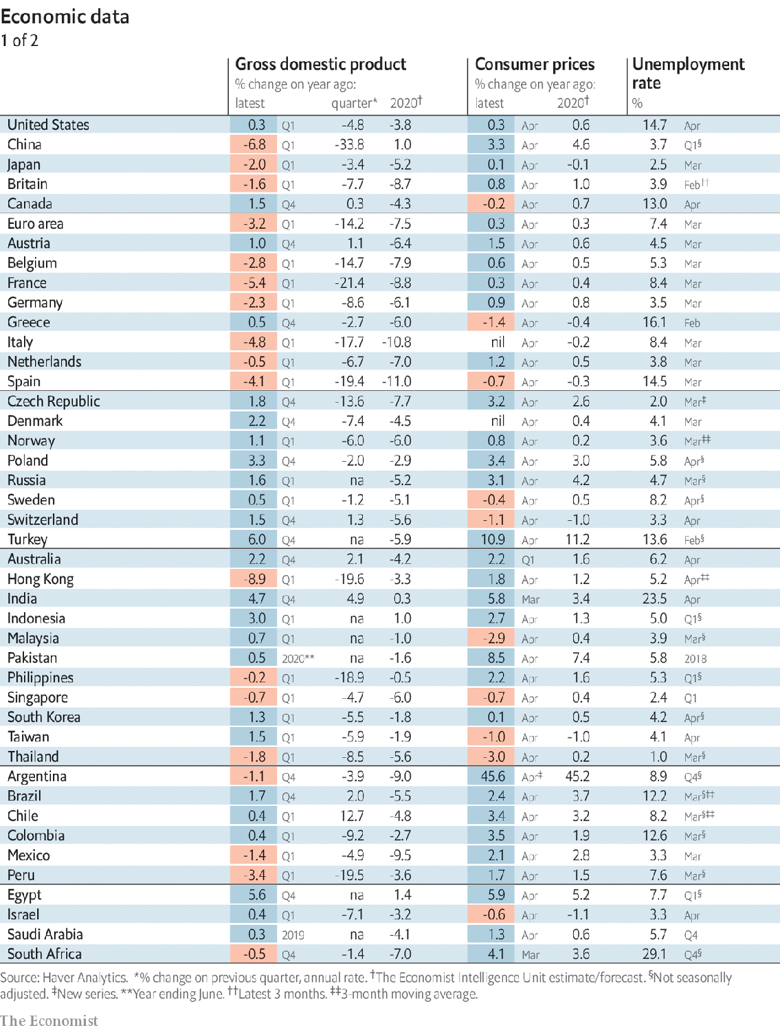

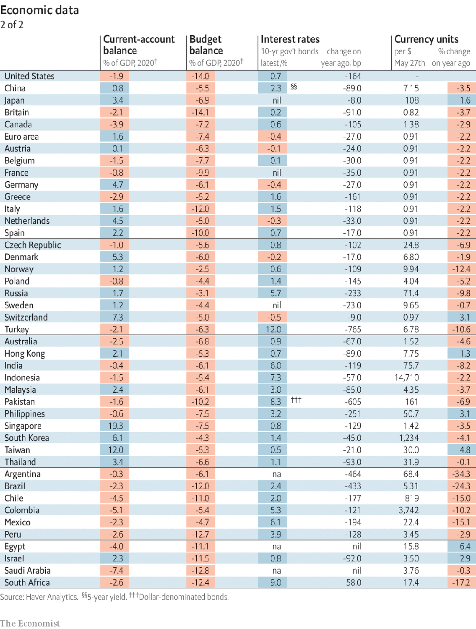

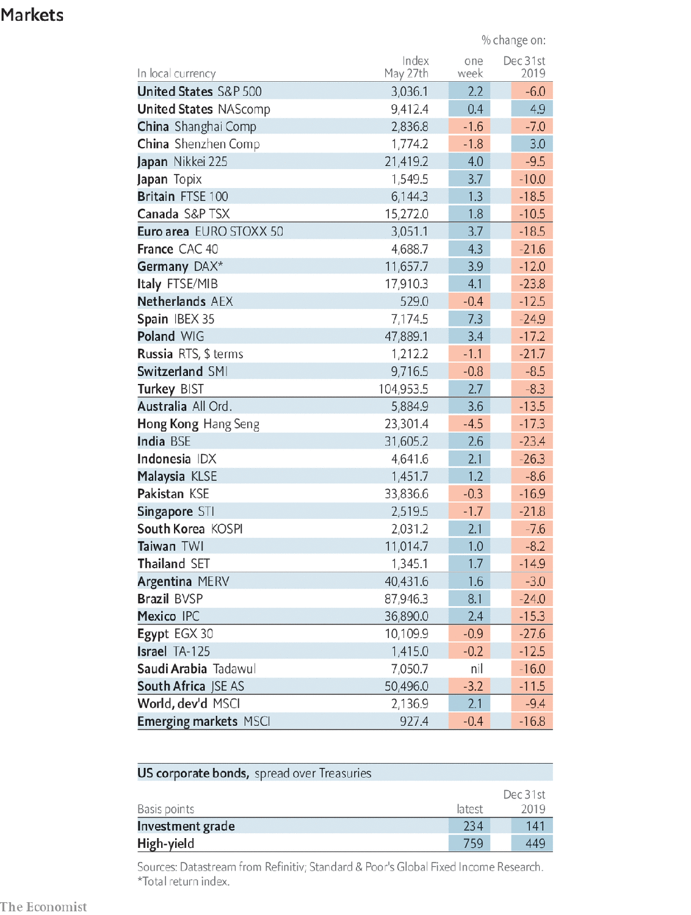

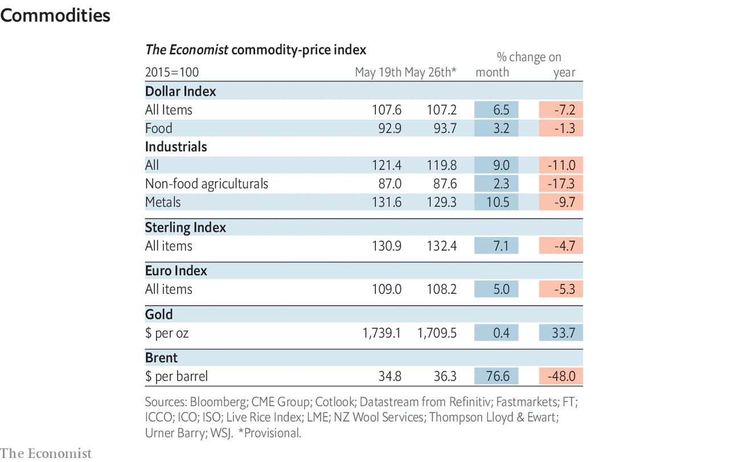

This article was downloaded by calibre from <https://www.economist.com/economic-and-financial-indicators/2020/05/30/economic-data-commodities-and-markets>

|  |  |  |  |
| --- | --- | --- | --- |
|  | Articles | Sections | Next |

|  |  |  |
| --- | --- | --- |
| Economic & ... | Sections | Obituary |

Graphic detail

Bogus academia: Garbage in

.

|  |  |  |
| --- | --- | --- |
| Economic & ... | Sections | Obituary |

|  |  |  |  |
| --- | --- | --- | --- |
|  | Articles | Sections | Next |

#### Garbage in

# How to spot dodgy academic journals

Missing back issues and speedy promised publication times are red flags

May 30th 2020 |

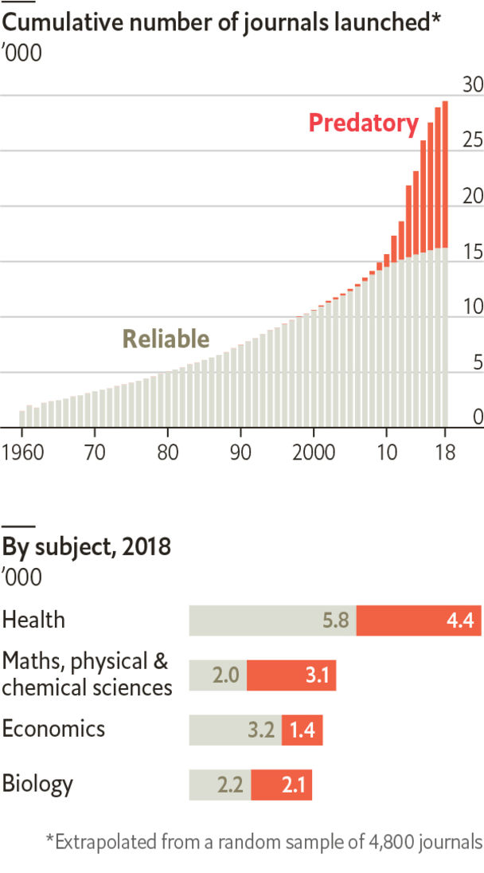

AS COVID-19 spreads, scientists are racing to study it. Although journals have tried to speed up peer review, many authors bypass it altogether by uploading working papers to preprint sites. Flimsy findings can then travel as fast as the virus.

Most scholars who share preprints are doing their best to make vital discoveries. However, some authors seek to pad thin résumés by publishing underwhelming, repetitive or fake research. As safeguards are relaxed, journalists and governments need to be on high alert to spot such studies.

These articles mostly appear in “predatory” journals, which make use of the popular “open-access” model—charging fees to authors, rather than to readers—to publish any old tosh for money. According to Cabells, a firm that maintains a blacklist of such journals in English, some 1,000 existed in 2010. Today there are at least 13,000.

Some scammers are careless. Mike Daube, a professor of public health, got his dog onto seven journals’ boards. Cabells uses 65 criteria to spot wilier frauds. “Severe” infractions, such as missing back issues, lead straight to blacklisting. Lesser ones, like poor spelling or offers of speedy publication, set off further investigation.

Journals’ fields offer few clues. The mix of topics is similar on Cabells’ whitelist, of 16,000 reliable journals, and its blacklist. On both, a third of titles relate to health.

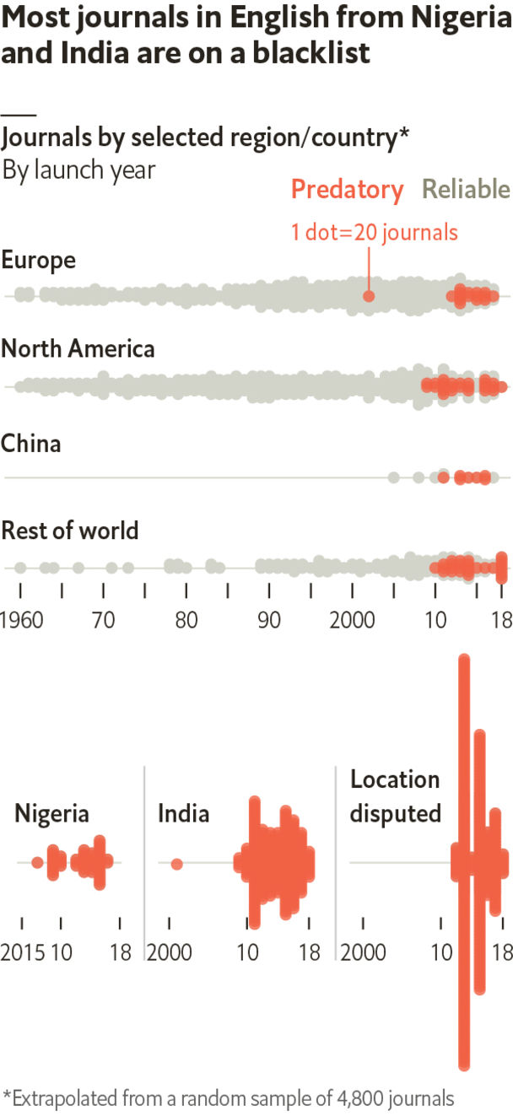

Geography is more revealing. Cabells lists only a few reliable Nigerian journals, but 1,100 predatory ones. India’s figures are 300 and 4,400. Another 5,800 blacklisted titles claim to be based in Europe or North America but do not provide evidence, such as a valid address. The authors of these papers are often from developing countries, but Western academics have been caught red-handed as well. Many scholars claim to have been duped into using such journals.

The average predatory journal publishes about 50 articles a year, less than half the output of a reliable title, according to Bo-Christer Björk of the Hanken School of Economics in Helsinki. And 60% of papers in such journals receive no future citations, compared with 10% of those in credible ones. Still, that leaves 250,000 questionable articles per year that do get cited.

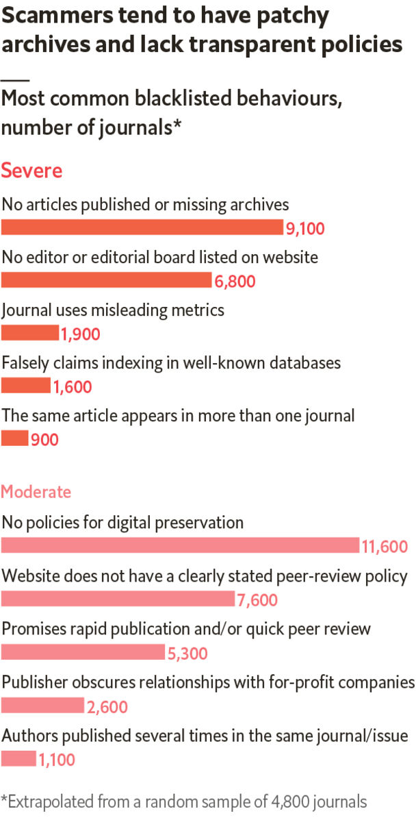

Cabells’ guidelines will only start to catch dodgy studies on covid-19 once they appear in predatory journals. But the fact that so many “scholars” use such outlets means that working papers on the disease should face extra-thorough scrutiny. ■

Source: Cabells

This article was downloaded by calibre from <https://www.economist.com/graphic-detail/2020/05/30/how-to-spot-dodgy-academic-journals>

|  |  |  |  |
| --- | --- | --- | --- |
|  | Articles | Sections | Next |

|  |  |  |
| --- | --- | --- |
| Graphic detail | Sections |  |

Obituary

Antonio Bolívar: The wisdom of the forest

.

|  |  |  |
| --- | --- | --- |
| Graphic detail | Sections |  |

|  |  |  |  |
| --- | --- | --- | --- |
|  | Articles | Sections | Next |

#### The wisdom of the forest

# Antonio Bolívar died on April 30th

The star of “The Embrace of the Serpent” and custodian of tribal stories was 75

May 30th 2020 |



WHEN HE SPOKE of Jaguar, lord of the forest, the embodiment of power, strength and violence, Antonio Bolívar would begin to growl deep in his throat. His head would move up and down, around, warily, as if he was on the prowl himself and hunting was his being. When he mentioned Anaconda, the great snake, god of the Amazon and of all water, his hands would slither, swim and twine around each other, getting faster, until—still smiling his tender penetrating smile—he might leap from his chair and fling his snake-arms round whoever was listening to him.

The gesture was a vivid reminder of the film that had made him famous, Ciro Guerra’s “The Embrace of the Serpent”. In 2016 it was nominated for an Academy Award for best foreign film, the first Colombian film to be so honoured, and he found himself in Hollywood, not in a loincloth on the red carpet (he had been warned not to), but in a feather headdress with his smart blue suit, and embraced by Cate Blanchett, who towered over him. He was glad then that he had not turned his friend Ciro down. He had refused to take the role at first because he had been tricked before, when he and some other indigenous actors had not been paid for their work; you could geld a cat once, but not twice. Ciro had promised him what he wanted, serious respect.

His part in the film had been that of Old Karamakate, a shaman guiding a white explorer, Evan, in his search through the Amazon rainforest for the magic yakruna flower. As a young man he had guided another white explorer, 40 years earlier, on the same quest. Both journeys displayed how the forest was being defiled and colonised by outsiders: rubber-seekers who bled the trees and massacred the tribes, crazed religious sects. The later expedition also became a search for wisdom. Both Evan and Karamakate had come into the forest to fill the empty shells of themselves, their chullachaquis, with memories, understanding and dreams. Karamakate did so as the last of his tribe. As much as Evan needed him to find the magic flower, he needed this white man in order to pass on, with his jaguar-tooth necklace, his knowledge and his power. And, even though he did not fully trust him, he did so.

Many who saw the film assumed that Antonio Bolívar and Old Karamakate were one and the same. (In 2019 too, for a Netflix crime-thriller series of Ciro Guerra’s called “The Green Frontier”, he played a detective thoroughly steeped in ancestral wisdom.) He was not a shaman, but he came close. His role was to gather and preserve his tribe’s myths and tales, its knowledge of medicinal botany, its ways of hunting and planting. He was everyone’s grandfather, the one who, round the fire or in the longhouse, would vividly and emphatically retell the old stories. Father-God when he walked on Earth had left footprints there, handprints there, and huge rocks carved like seats. When humans appeared, some of the great beings who had come before them remained as animals and hence as gods. The stars, too, had once been living beings inside the Earth (some were still there, as diamonds or emeralds), but with evolution over thousands of years had moved up to the sky.

He passed on cures, too. The ancestors, who had no hospitals, would take water, pray over it and use it. Before there were vaccines, they would make red annatto dye from the achiote tree to paint protective stripes on their skin. He did not, like Karamakate, crush yakruna leaves into powder to give people psychedelic dreams. But if he found himself sitting by some unfamiliar plant he would instinctively pluck a leaf and squeeze it, maybe bite into it, to test what it could do.

And he too, like Karamakate, was almost the last of his tribe. He was Ocaina; there were perhaps 60 left. His blue eyes marked him out, but because his family had been displaced by rubber-seekers he had been brought up among the Huitoto people. His own language had become strange to him, though he knew Tikuna and Cubeo as well as Huitoto, and acted as an interpreter and script-translator on the film set. Well, people naturally dispersed and intermarried; some tribes were bound to disappear, just as the noise and glitter of modern life meant that the young inevitably had no interest in hunting or weaving baskets, or piercing their cheeks with sticks. They wanted to walk around looking good, in white people’s fashions, with headphones on their ears and phones in their pockets and fizzy drinks in their hands.

Part of him accepted that most people hoped to progress and change. But a great truth was disappearing along with the old ways: that Nature was the interconnected life of all things, from soil to fish, from trees to humans, and that any harm done to the forest did violence to all beings. The rubber barons who had destroyed his family and much of the region in the early 20th century had been only the bloodiest in a string of invaders and exploiters going back, he reckoned, to Columbus’s time. And their place had now been taken by narcotraficantes, by loggers and miners doing “black” or illegal work while governments did nothing, and even by the tourists who took quick day-trips from the cities, threw their money around and left again, proclaiming that all was well.

All was not well. The Amazon, as he constantly repeated, was the lungs of the world, the great purifying filter of all its modern filth. Those lungs had a cancer now, and if it went on growing both they, and all living things, would be finished. Like Karamakate, he had to pass on this truth to his white brothers. The rainforest and its tribes must be supported and protected against invaders. He did not include among those the new illness that crept (from Brazil, the government feared), into his home town of Leticia, where Brazil, Peru and Colombia all met on the great river, and where most of the people were indigenous. For a while, infection rates there were Colombia’s worst. He caught it at the end of April.

But he still had bigger worries. Often he felt like one of those dogs that went on barking, yap! yap! yap! until everyone was tired of it. He refused to be patted quiet. As he spoke of the dog he writhed and barked, while his blue eyes continued to smile with a wisdom barely known in the wider world, and fast vanishing.■

This article was downloaded by calibre from <https://www.economist.com/obituary/2020/05/30/antonio-bolivar-died-on-april-30th>

|  |  |  |  |
| --- | --- | --- | --- |
|  | Articles | Sections | Next |